New Subproject: On the Overview of the “NKSoft HR Systems” project I clicked “+ New Subproject”…

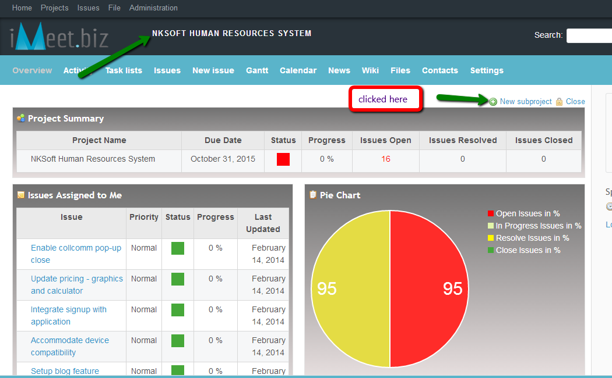

And was taken to this page below within Kit Carson project.

