First, I had to create the “Task List” and add Tasks for the work and tasks that I will use a Parent Tasks using this straight list making feature.

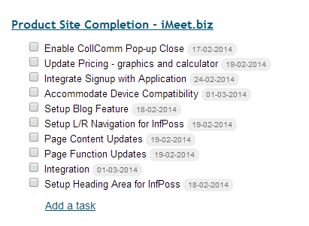

Then, I have to go into each one and enter Parent, Dates, Hours, Assignee:

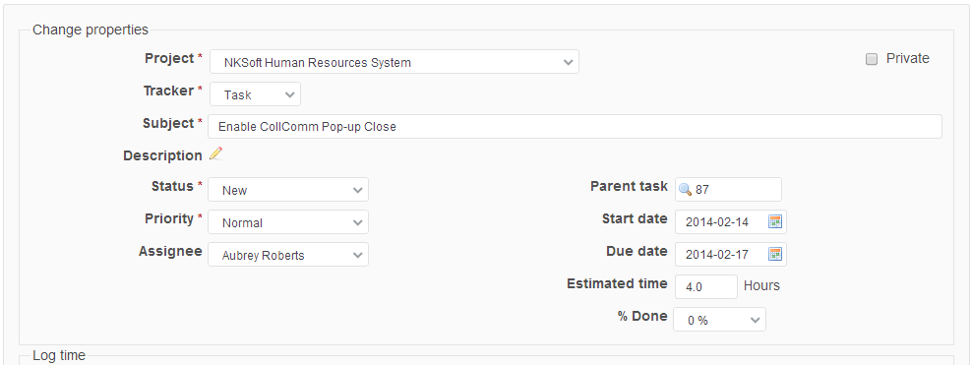

I lose sight of the other tasks and relationships and get lost. Then, I need to go to Gantt to see what happened not back to the simple Task List.

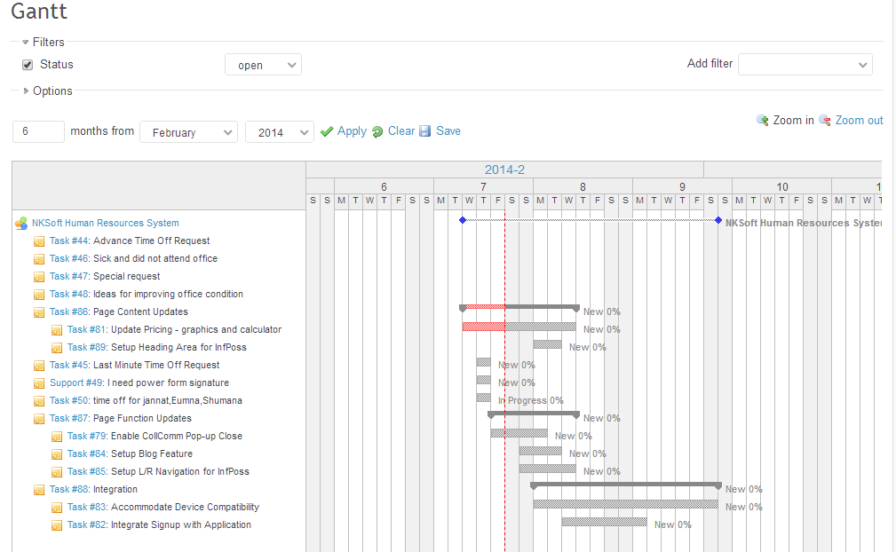

Now, I decide I want phases for the work. So I have to go back here and add them to the list, then go into the tasks that belong to the phases and link it to the phase:

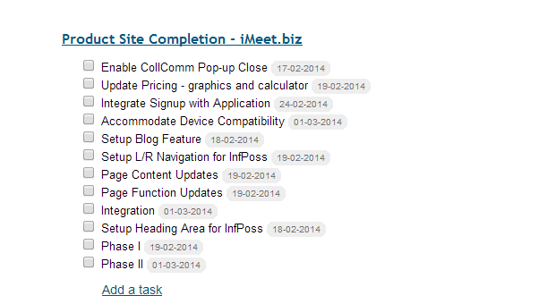

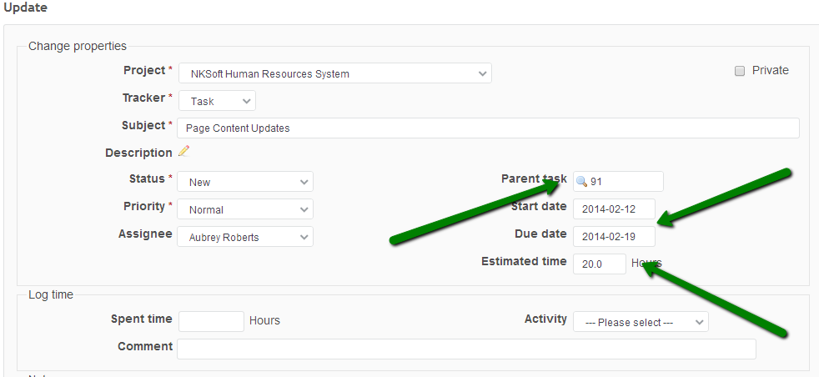

Then, go to the Gantt again and see what happened in my setup.

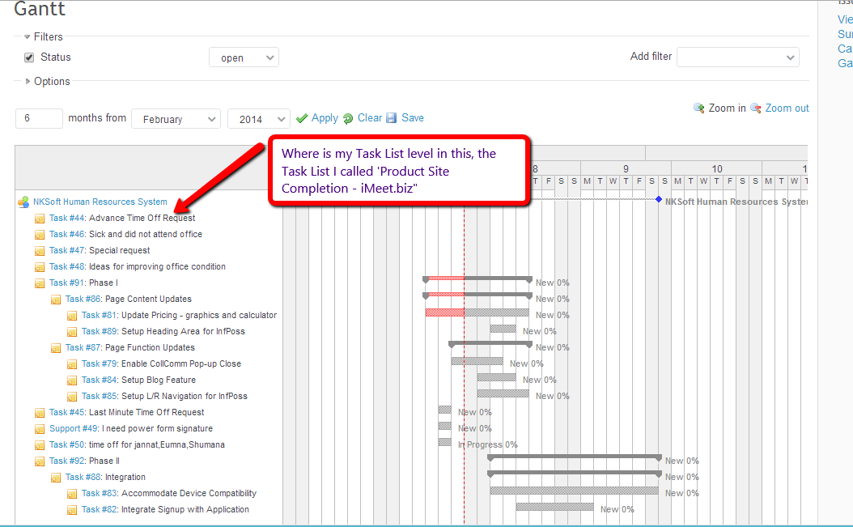

I would like to work from the Gantt chart from start to finish of setting up my project. Or at least have an easy way to see what I’m doing.