First, I had to create the “Task List” and add Tasks for the work and tasks that I will use a Parent Tasks using this straight list making feature.

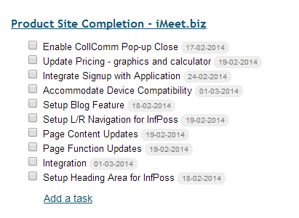

Then, I have to go into each one and enter Parent, Dates, Hours, Assignee:

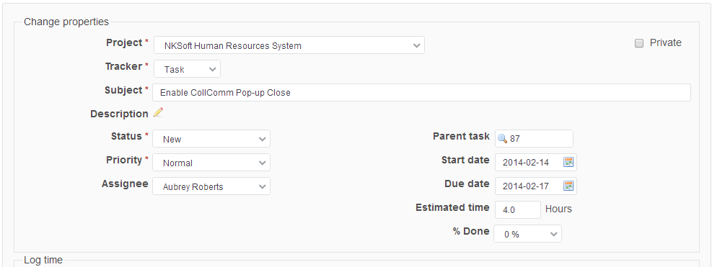

I lose sight of the other tasks and relationships and get lost. Then, I need to go to Gantt to see what happened not back to the simple Task List.

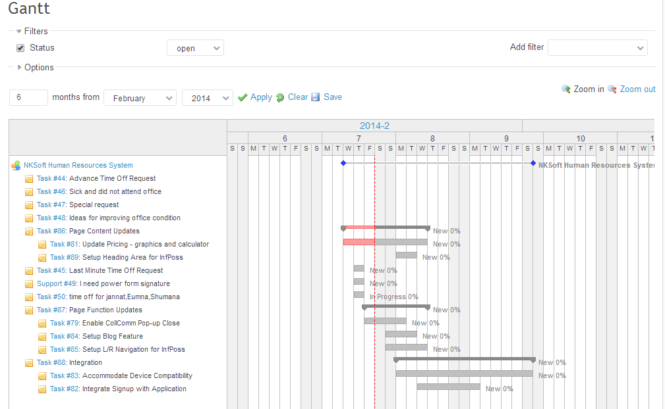

Now, I decide I want phases for the work. So I have to go back here and add them to the list, then go into the tasks that belong to the phases and link it to the phase:

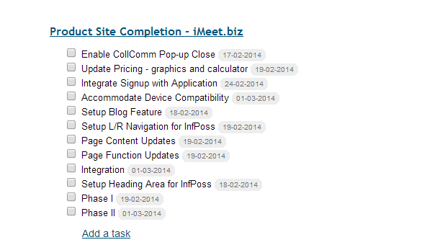

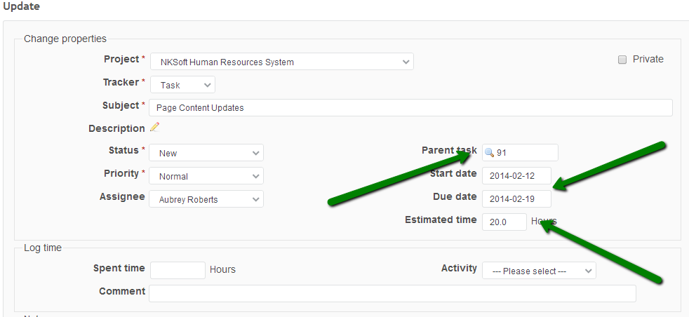

Then, go to the Gantt again and see what happened in my setup.

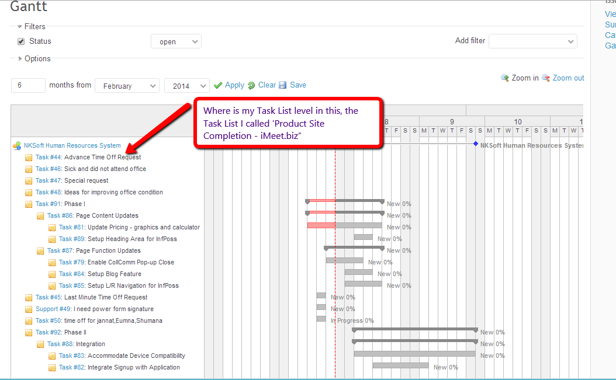

We need a simpler and easier way to see Tasks so if we added Task Lists on the Gantt it might help.

If task lists we’re on here the tasks would group under them and it would be easy to see how the work is arranged in each Task List.

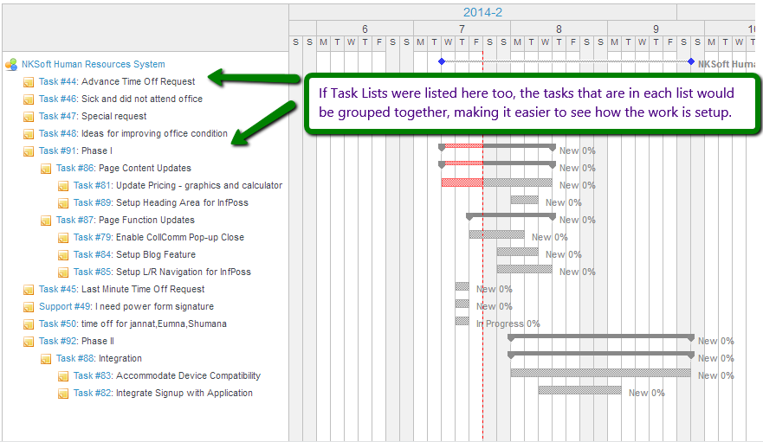

This is what it might look like:

