Go here: <http://ui-patterns.com/collections/modal-windows/entry/2829> then click on see it live.

Here is the actual page where the “Screenshots” are: <http://www.visual-paradigm.com/product/?favor=vpuml>

It opens with a click on “Screenshots” and closes on the next mouse click, no scroll here though. It also blacks out the background and I want to do the same.

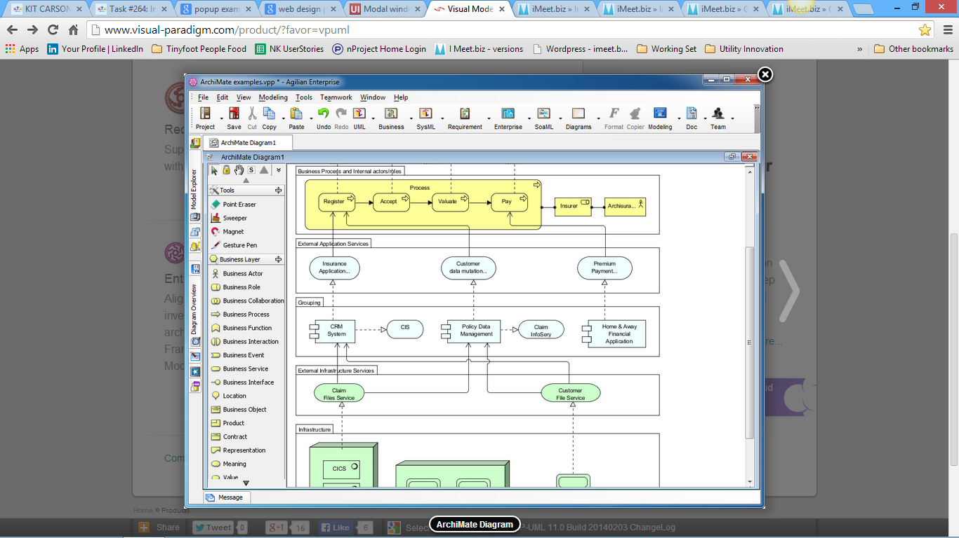

If you make the text small enough or arrange the text differently, you can make all the text fit so scrolling will not be necessary. Use creativity to make the text more colorful and appealing within the modal window. Get a picture that represent each scenario and arrange text around the image. Below is an example of color and arrangement, it is here: <http://ui-patterns.com/collections/modal-windows/entry/2406>

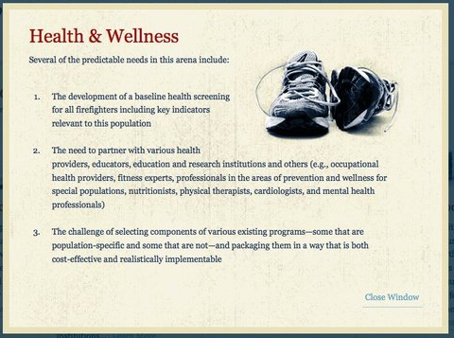

Here is another example with a “Next” and a “Previous” button: <http://ui-patterns.com/collections/modal-windows/entry/2364> 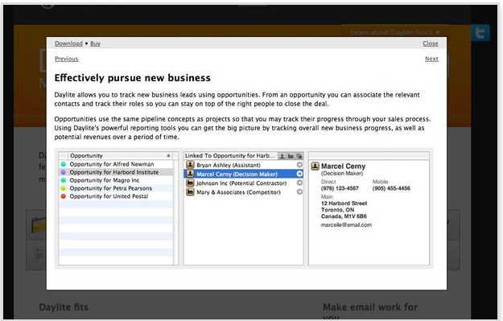

We could put the titles next to the Next and Previous button and if the user wanted to just click through them all they could or they could close it and go back and pick the next one they want to see.