Inference of an SIR difference equation model using dynamic survival analysis and Turing.jl - Wave 2 of the Ebola outbreak data
Sandra Montes (@slmontes) and Simon Frost (@sdwfrost)
2026-04-13

Introduction
The second wave of the 2018–2020 DRC Ebola epidemic was centred on Butembo, Katwa, Mabalako, and Mandima. This notebook analyses Wave 2 up to 27 May 2019, using 1,104 records and retaining all cases regardless of data completeness.
Wave 2 has the largest share of incomplete records among the three waves: 392 of 1,104 (35.5%) have known onset but no recorded hospitalisation, and 6 have hospitalisation but no known onset. Each group contributes a different likelihood component:
Group | Count | Likelihood contribution
Complete (e1=1, e2=1) | 706 | Multinomial (onset) + Geometric (recovery) + Binomial
Onset-only (e1=1, e2=0) | 392 | Multinomial (onset) + Binomial only
Hosp-only (e1=0, e2=1) | 6 | Convolution over unknown onset + Binomial

Libraries
using Turing # For probabilistic programming
using Distributions # For probability distributions
using SpecialFunctions # For lgamma (log gamma function)
using Random # For random number generation
using Plots # For plotting
using StatsPlots # For advanced plotting
using MCMCChains # For handling MCMC output
using Dates # For now()
using CSV # For reading CSV files
using DataFrames # For data manipulation
using Statistics # For statistical functions
We set a random seed for reproducibility.
Random.seed!(1234);

Utility functions
This function converts a rate, r over a unit time interval to a proportion.
@inline function rate_to_proportion(r, t=1.0)
if r < 0 || isnan(r)
return 0.0
elseif isinf(r)
return 1.0
else
result = 1 - exp(-r * t)
return isnan(result) ? 0.0 : max(min(result, 1.0), 0.0)
end
end;
This function evaluates log(exp(a) + exp(b)) by rescaling around max(a,b), avoiding underflow when summing many very small probabilities expressed on the log scale.
function logaddexp(a::Real, b::Real)
m = max(a, b)
isfinite(m) ? m + log(exp(a - m) + exp(b - m)) : m
end;
This function generates a vector of counts from a vector of times and the total number of timesteps in a simulation.
function time_counts(times::AbstractVector{<:Integer}, nsteps::Integer)
counts = zeros(Int, nsteps)
@inbounds for t in times
1 ≤ t ≤ nsteps && (counts[t] += 1)
end
return counts
end;

Transitions
We start by defining the deterministic SIR model in discrete time using a system of difference equations. The model tracks the proportion of susceptible (S), infected (I), cumulative infections (C), and new infections per time step (Y).
function sir_map!(du, u, p, t)
(S, I, C, Y) = u
(β, γ) = p
infection = rate_to_proportion(β*I)*S # New infections
recovery = rate_to_proportion(γ)*I # New recoveries
@inbounds begin
du[1] = S - infection # Update susceptibles
du[2] = I + infection-recovery # Update infected
du[3] = C + infection # Update cumulative infections
du[4] = infection # Store new infections
end
nothing
end;
This function solves a map with the above function signature.
function solve_map(f, u0, nsteps, p)
# Pre-allocate array with correct type
sol = similar(u0, length(u0), nsteps + 1)
# Initialize the first column with the initial state
sol[:, 1] = u0
# Iterate over the time steps
@inbounds for t in 2:nsteps+1
u = @view sol[:, t-1] # Get the current state
du = @view sol[:, t] # Prepare the next state
f(du, u, p, t) # Call the function to update du
end
return sol
end;
Alternatively, we could use the DifferentialEquations.jl ecosystem (via defining a DiscreteSystem and solving using SimpleFunctionMap from SimpleDiffEq.jl) to simulate the model, although this incurs an overhead in computational cost, in addition to introducing another dependency.
This function simulates the SIR model and returns the solution, the final epidemic size (τ) and the probability distribution of infection times (f).
function simulate(β, γ, ρ, nsteps)
tspan = (0, nsteps)
# Preserve type by using zero/one of the promoted type
T = promote_type(typeof(β), typeof(γ), typeof(ρ))
zero_T = zero(T)
one_T = one(T)
u0 = [one_T - ρ, ρ, zero_T, zero_T] # Initial conditions: S, I, C, Y
p = [β, γ]
sol = solve_map(sir_map!, u0, nsteps, p)
τ = sol[3,end] # Final size (total infected)
f = Vector{eltype(sol)}(sol[4,2:end]) # Copy to preserve type
f = abs.(f) # Ensure non-negative values
# Handle edge cases for probability vector
if τ <= 0 || any(isnan.(f)) || any(isinf.(f))
f = fill(one(eltype(f))/nsteps, nsteps)
else
f = f/τ # Normalise frequencies to sum to 1
end
return sol, τ, f
end;

Data loading
We load the Ebola outbreak data from EVD_Wave2.csv.
# Load the data
df_all = CSV.read("EVD_Wave2.csv", DataFrame);
# Split into three groups by data availability
df_complete = df_all[(df_all.event1 .== 1) .& (df_all.event2 .== 1), :]
df_onset_only = df_all[(df_all.event1 .== 1) .& (df_all.event2 .== 0), :]
df_hosp_only = df_all[(df_all.event1 .== 0) .& (df_all.event2 .== 1), :]
# Total observed infections for the Binomial final-size term
K_total = nrow(df_all)
# Use all records with a known onset time: complete + onset_only
onset_times_all = vcat(df_complete.onset, df_onset_only.onset)
nsteps = Int(ceil(maximum(onset_times_all))) + 1
ti_onset = max.(1, min.(Int.(round.(onset_times_all)) .+ 1, nsteps))
K_onset = length(ti_onset) # used in Multinomial
th_onset = time_counts(ti_onset, nsteps)
# Complete records only: hosp - onset
raw_delta_complete = df_complete.hosp .- df_complete.onset
@assert all(raw_delta_complete .>= 0) "Found complete records with hosp < onset."
same_day_complete = count(<(1), raw_delta_complete)
delta_complete = max.(1, Int.(round.(raw_delta_complete)))
# The "onset" column for e1=0 records contains the hospitalisation time.
T_hosp_only = max.(1, min.(Int.(round.(df_hosp_only.hosp)) .+ 1, nsteps))
# Minimum N: at least as many susceptibles as total observed infections
N_min = K_total
Summary of the loaded data:
Wave 2 data summary:
Total records (K_total, Binomial): 1104
With known onset (K_onset, Multinomial): 1098
of which complete (e1=1, e2=1): 706
of which onset-only (e1=1, e2=0): 392
Hosp-only (e1=0, e2=1, convolution): 6
nsteps: 90
Same-day/sub-day complete intervals (<1 day): 89
Recovery intervals range: 1–36 days

Turing Model
The Turing.jl probabilistic model for the model, specifies priors, simulates the difference equations, and defines the likelihood for observed data by defining the distributions of (a) the total infected (b) the distribution of infection times, (c) the distribution of recovery times and (d) the convolution over unknown onset time for recovery-only records. We place uniform priors on the parameters, as upper and lower bounds are typically easy for the user to define. Here, we take advantage of the discrete nature of the data, by fitting a histogram of the infection times using a multinomial distribution, rather than a series of categorical distributions.
@model function dsa_ebola_allrecords(nsteps::Int,
K_total::Int,
K_onset::Int,
th_onset::Vector{Int},
delta_complete::Vector{Int},
T_hosp_only::Vector{Int},
N_min::Int)
# Priors for model parameters
β ~ Uniform(0.01, 1.0) # Transmission rate
γ ~ Uniform(0.01, 1.0) # Recovery rate
ρ ~ Beta(1.0, 500.0) # Initial infected proportion
N_float ~ Uniform(Float64(N_min), Float64(N_min + 20000))
# Convert to integer for Binomial: use floor and clamp to ensure N >= N_min
# The conversion is done after sampling, so NUTS can sample continuously
N = Int(floor(max(Float64(N_min), N_float)))
# Simulate deterministic model
_, τ, f = simulate(β, γ, ρ, nsteps)
# Ensure τ is valid for binomial distribution
τ_valid = clamp(τ, 1e-6, 1.0 - 1e-6)
# Ensure f is valid for multinomial distribution
f_valid = max.(f, 1e-10) # Add small positive value to avoid zeros
f_valid = f_valid / sum(f_valid) # Normalise
log_f_valid = log.(f_valid)
# (1) Binomial final-size: all K_total infections
K_total ~ Binomial(N, τ_valid)
# (2) Multinomial onset histogram: records with known onset (K_onset)
th_onset ~ Multinomial(K_onset, f_valid)
# (3) Geometric recovery intervals: complete records only.
# Build a 1-indexed geometric by shifting Julia's 0-indexed Geometric(p)
# so the support matches recovery intervals in days (δ = 1,2,...).
ϵ = 1e-8
pγ = clamp(rate_to_proportion(γ), ϵ, 1 - ϵ)
G1 = LocationScale(1, 1, Geometric(pγ))
for i in eachindex(delta_complete)
delta_complete[i] ~ G1
end
# (4) Convolution for hosp-only records: marginalise over unknown onset u.
# L_i = Σ_{u=1}^{T_rem-1} f[u] · P(W = T_rem - u), using the same
# 1-indexed geometric distribution G1 as above.
for T_rem in T_hosp_only
u_max = min(T_rem - 1, nsteps)
log_terms = (log_f_valid[u] + logpdf(G1, T_rem - u) for u in 1:u_max)
Turing.@addlogprob! foldl(logaddexp, log_terms; init = -Inf)
end
return (β=β, γ=γ, ρ=ρ, N=N_float)
end;

Inference
We now perform inference using the Turing model. We start by setting the number of samples to be used in the sampler and instantiating the model.
n_samples = 5000
model = dsa_ebola_allrecords(nsteps, K_total, K_onset,
th_onset, delta_complete, T_hosp_only, N_min);
Next, we run inference using the No U-Turn Sampler (NUTS).
# Warmup
_ = sample(model, NUTS(), 1)
# Run sampler on 4 chains
@time chain = sample(model,
NUTS(500, 0.65; max_depth=12, Δ_max=1000.0, init_ϵ=0.2),
MCMCThreads(),
n_samples,
4);
We can pass different samplers from Turing.jl (e.g. MH, SGLD, HMC), external samplers (e.g. DynamicHMC.NUTS, AdvancedMH.RWMH) via wrapping with external_sampler, and can also pass the model to other packages, e.g. Pathfinder.jl.

Results Analysis
Once we have run the sampler, we can get a summary of the parameter estimates, along with the expected number of samples.
describe(chain)
Chains MCMC chain (5000×18×4 Array{Float64, 3}):
Iterations = 501:1:5500
Number of chains = 4
Samples per chain = 5000
Wall duration = 868.95 seconds
Compute duration = 2467.92 seconds
parameters = β, γ, ρ, N_float
internals = n_steps, is_accept, acceptance_rate, log_density, hamiltonian_energy, hamiltonian_energy_error, max_hamiltonian_energy_error, tree_depth, numerical_error, step_size, nom_step_size, lp, logprior, loglikelihood
Summary Statistics
parameters mean std mcse ess_bulk ess_tail rha ⋯
Symbol Float64 Float64 Float64 Float64 Float64 Float6 ⋯
β 0.2249 0.0073 0.0001 3047.6071 4626.5717 1.000 ⋯
γ 0.2024 0.0075 0.0001 2940.2871 4616.0564 1.000 ⋯
ρ 0.0053 0.0004 0.0000 3630.3922 6178.7737 1.000 ⋯
N_float 3981.9688 446.6995 6.3888 5460.7332 5474.8743 1.000 ⋯
2 columns omitted
Quantiles
parameters 2.5% 25.0% 50.0% 75.0% 97.5%
Symbol Float64 Float64 Float64 Float64 Float64
β 0.2106 0.2200 0.2250 0.2299 0.2391
γ 0.1878 0.1973 0.2024 0.2075 0.2173
ρ 0.0044 0.0050 0.0052 0.0055 0.0062
N_float 3280.3611 3667.8617 3925.8462 4230.7837 5009.2867
NUTS diagnostics:
NUTS internals available: [:n_steps, :is_accept, :acceptance_rate, :log_density, :hamiltonian_energy, :hamiltonian_energy_error, :max_hamiltonian_energy_error, :tree_depth, :numerical_error, :step_size, :nom_step_size, :lp, :logprior, :loglikelihood]
Divergent transitions: 0 / 20000
Max tree depth reached: 12.0
Step size ε (median [min, max]): 0.00186 [0.0013, 0.0209]
We can also plot posterior distributions for each parameter.
β_mean = mean(chain[:β])
γ_mean = mean(chain[:γ])
ρ_mean = mean(chain[:ρ])
N_mean = mean(chain[:N_float])
# Vossler et al. (2022) Wave 1 reference values
p1 = histogram(chain[:β], label="", title="β", density=true)
vline!(p1, [0.217], label="Ref (Vossler et al.)", color=:black, linestyle=:dash, linewidth=2)
vline!(p1, [β_mean], label="Posterior mean", color=:red, linestyle=:dash, linewidth=2)
p2 = histogram(chain[:γ], label="", title="γ", density=true)
vline!(p2, [0.197], label="Ref -log(1- γ)(Vossler et al.)", color=:black, linestyle=:dash, linewidth=2)
vline!(p2, [γ_mean], label="Posterior mean", color=:red, linestyle=:dash, linewidth=2)
p3 = histogram(chain[:ρ], label="", title="ρ", density=true)
vline!(p3, [0.0054], label="Ref (Vossler et al.)", color=:black, linestyle=:dash, linewidth=2)
vline!(p3, [ρ_mean], label="Posterior mean", color=:red, linestyle=:dash, linewidth=2)
# N is wave-specific
p4 = histogram(chain[:N_float], label="", title="N (Wave 2)", density=true, bins=50)
vline!(p4, [N_mean], label="Posterior mean", color=:red, linestyle=:dash, linewidth=2)
plot(p1, p2, p3, p4, layout=(2,2), plot_title="Posterior Distributions — Wave 2")
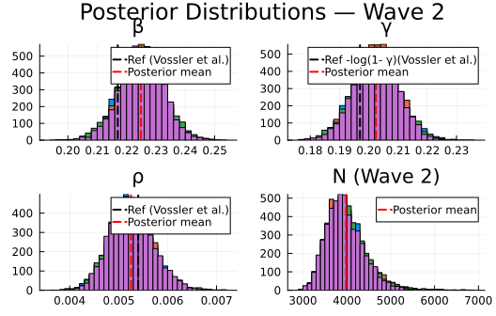
Plot trace plots for MCMC diagnostics.
plot(chain, plot_title="Trace Plots — Wave 2")
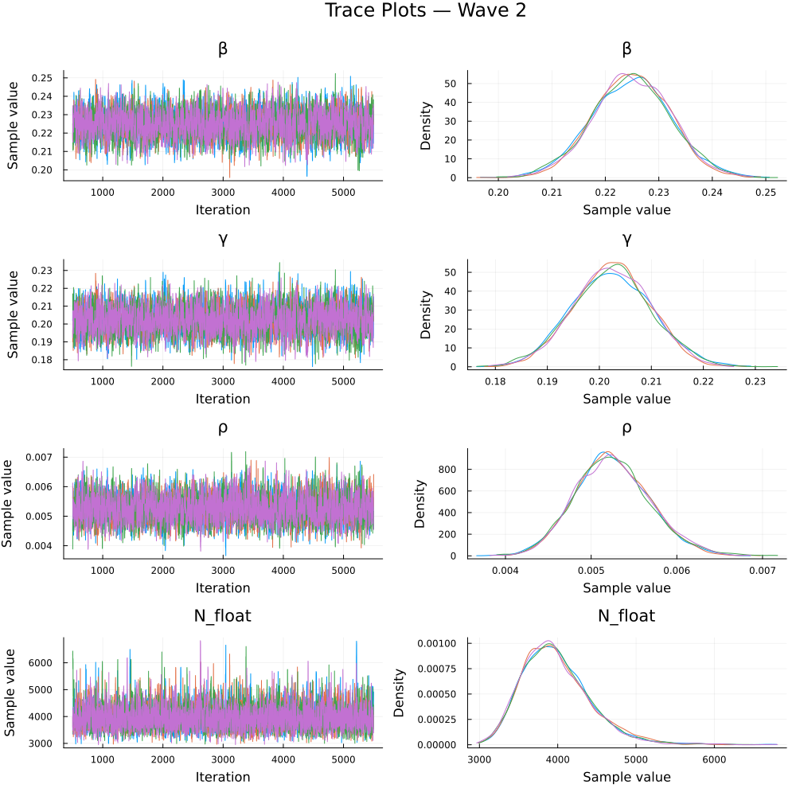

Parameter Estimates
We summarise the posterior estimates for the model parameters.
Parameter Estimates — Wave 2 (all records, posterior means with 95% CI):
β: 0.225 [0.211, 0.239] (Vossler: 0.217)
γ: 0.202 [0.188, 0.217] (Vossler: 0.179)
pγ=1-e⁻ᵞ: 0.183
ρ: 0.0053 [0.0044, 0.0062] (Vossler: 0.0054)
N: 3982.0 [3280.0, 5009.0]
I₀=ρ·N: 20.9 [16.3, 26.4] (implied initial infected)
R₀=β/pγ: 1.227 (Vossler β/γ: 1.214)
mean IP=1/pγ: 5.46 days (Vossler 1/γ: 5.6 d)

Recovery interval fit check
# Empirical δ histogram vs fitted Geometric(pγ_post) PMF (1-indexed)
δ = delta_complete
kmax = maximum(δ)
ks = 1:kmax
pmf = pdf.(LocationScale(1, 1, Geometric(pγ_post)), ks)
pδ = histogram(δ;
normalize=true,
bins=1:kmax,
alpha=0.5,
label="Empirical δ (complete records)",
xlabel="δ (days)",
ylabel="Probability",
title="Wave 2: Recovery interval check"
)
plot!(pδ, ks, pmf; linewidth=2, color=:red, label="Fitted Geometric(pγ)")
pδ
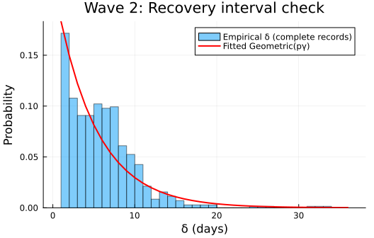

Epidemic curve
sol, τ, f = simulate(β_post, γ_post, ρ_post, nsteps)
n_samples_ci = min(500, length(chain[:β]))
sample_idx = rand(1:length(chain[:β]), n_samples_ci)
f_samples = Matrix{Float64}(undef, nsteps, n_samples_ci)
for (idx, i) in enumerate(sample_idx)
_, _, f_i = simulate(chain[:β][i], chain[:γ][i], chain[:ρ][i], nsteps)
f_samples[:, idx] = f_i
end
f_lower = [quantile(f_samples[t, :], 0.025) for t in 1:nsteps]
f_upper = [quantile(f_samples[t, :], 0.975) for t in 1:nsteps]
p1 = plot(1:nsteps, th_onset ./ K_onset,
label="Observed (onset-known)",
title="Wave 2 (all records): Onset times",
xlabel="Time step", ylabel="Proportion of infections",
linewidth=2, marker=:circle, markersize=3)
plot!(p1, 1:nsteps, f_lower,
fillrange=f_upper, fillalpha=0.3, fillcolor=:orange,
linecolor=:orange, label="95% CI", linewidth=0)
plot!(p1, 1:nsteps, f, label="Posterior mean", linewidth=3, color=:red)
plot(p1, size=(800, 500))
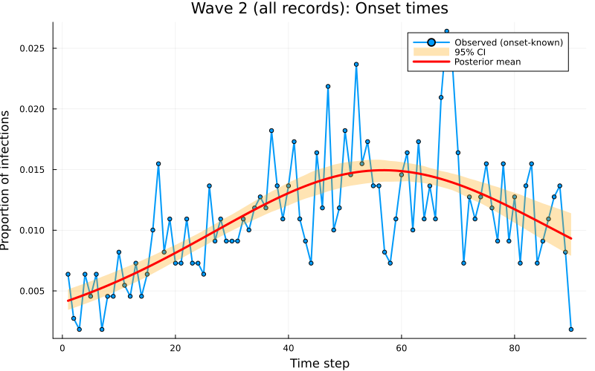

Discussion
Among the three waves, Wave 2 has the largest fraction of onset-only records: 392 of 1,104 (35.5%), compared with 24.5% in Wave 1 (222 of 907) and ~30.0% in Wave 3 (321 of 1,069). Despite this higher missingness in the removal time, the DDSA estimates remain consistent with those reported by Vossler et al. (2022).

