Inference using dynamic survival analysis and Turing.jl: WSU Data
Simon Frost (@sdwfrost), Sandra Montes (@slmontes)
2025-08-15

Introduction
In this example, we use a discrete-time SIR model and Turing.jl to infer key epidemiological parameters from a dataset. This dataset originates from a study conducted on the H1N1 outbreak at Washington State University (WSU) in 2009, recording the number of daily cases over a period of 105 days. The dataset was obtained from KhudaBukhsh et al. (2019). They modified the original raw data, that only included daily counts of new infections, by reconstructing individual infection times from the daily case counts and generating individual recovery times from a Gamma distribution fitted to the recovery process. The resulting dataset (WSU.csv) contains individual-level infection times (first column) and recovery times (second column) for 2,276 cases, including 10 individuals whose recovery occurred after the 105-day observation window and are therefore treated as right-censored.

Libraries
using Distributions
using Turing
using StatsPlots
using Plots
using Statistics
using Random
using CSV
using DataFrames
using MCMCDiagnosticTools
Set random seed for reproducibility
seed = 1234
Random.seed!(seed)

Utility functions
"""
Convert a rate to a probability over time t.
"""
@inline function rate_to_proportion(r, t=1.0)
if r < 0 || isnan(r)
return 0.0
elseif isinf(r)
return 1.0
else
result = 1 - exp(-r * t)
return isnan(result) ? 0.0 : max(min(result, 1.0), 0.0)
end
end
"""
Generate a vector of counts from a vector of times and the total number of timesteps.
"""
function time_counts(times::AbstractVector{<:Integer}, nsteps::Integer)
counts = zeros(Int, nsteps)
@inbounds for t in times
1 ≤ t ≤ nsteps && (counts[t] += 1)
end
return counts
end
"""
Prepare real data from DataFrame for analysis.
"""
function prep_sds(df::DataFrame, Tmax)
ti = Float64[]
delta = Float64[]
cens = Bool[]
for r in eachrow(df)
t_inf, t_rec = r[1], r[2]
t_inf ≥ Tmax && continue # infection after cut-off - ignore
# Calculate recovery interval
recovery_interval = t_rec - t_inf
# Only include valid recovery intervals
if recovery_interval > 0
push!(ti, t_inf)
if t_rec < Tmax # full recovery observed
push!(delta, recovery_interval)
push!(cens, false)
else # right-censored
push!(delta, Tmax - t_inf)
push!(cens, true)
end
end
end
return ti, delta, cens
end
"""
Load and prepare real epidemic data from WSU.csv file.
"""
function load_real_data(csv_file::String, Tmax::Float64)
# Load the data
df = CSV.read(csv_file, DataFrame)
# Prepare the data
ti, delta, cens = prep_sds(df, Tmax)
# Convert to appropriate format for analysis
K = length(ti) # Total number of infections
# Convert infection times to discrete time steps
ti_discrete = round.(Int, ti)
nsteps = max(maximum(ti_discrete), 105) # 105 days of data
# Create histogram of infection times
th = time_counts(ti_discrete, nsteps)
# Convert recovery intervals to integers (rounding to nearest day)
delta_discrete = round.(Int, delta)
return Dict(
:K => K,
:ti => ti_discrete,
:delta => delta_discrete,
:th => th,
:nsteps => nsteps,
:cens => cens,
:ti_original => ti,
:delta_original => delta
)
end

SIR model
The model is a discrete-time SIR model with geometric recovery times. In this model we assume that the recovery time is the same for all individuals and that the recovery time is independent of the infection time.
function sir_map!(du, u, p, t)
(S, I, C, Y) = u
(β, γ) = p
infection = rate_to_proportion(β*I)*S # New infections
recovery = rate_to_proportion(γ)*I # New recoveries
@inbounds begin
du[1] = S - infection # Update susceptibles
du[2] = I + infection-recovery # Update infected
du[3] = C + infection # Update cumulative infections
du[4] = infection # Store new infections
end
nothing
end
function solve_map(f, u0, nsteps, p)
# Pre-allocate array
sol = similar(u0, length(u0), nsteps + 1)
# Initialise the first column with the initial state
sol[:, 1] = u0
# Iterate over the time steps
@inbounds for t in 2:nsteps+1
u = @view sol[:, t-1] # Get the current state
du = @view sol[:, t] # Prepare the next state
f(du, u, p, t) # Call the function to update du
end
return sol
end
function simulate(β, γ, ρ, nsteps)
tspan = (0, nsteps)
u0 = [1-ρ, ρ, 0.0, 0.0] # Initial conditions: S, I, C, Y
p = [β, γ]
sol = solve_map(sir_map!, u0, nsteps, p)
τ = sol[3,end] # Final size (total infected)
f = sol[4,2:end] # New infections per time step
f = abs.(f) # Ensure non-negative values
# Handle edge cases
if τ <= 0 || any(isnan.(f)) || any(isinf.(f))
f = fill(one(eltype(f))/nsteps, nsteps)
else
f = f/τ # Normalise frequencies to sum to 1
end
return sol, τ, f
end

Data loading and preparation
Load the WSU data and prepare the data for inference.
Tmax = 105.0
real_data = load_real_data("WSU.csv", Tmax)
Plot of the infection time observations
bar(1:real_data[:nsteps], real_data[:th], title="Infection time observations", xlabel="Time step", ylabel="Observations", legend=false)
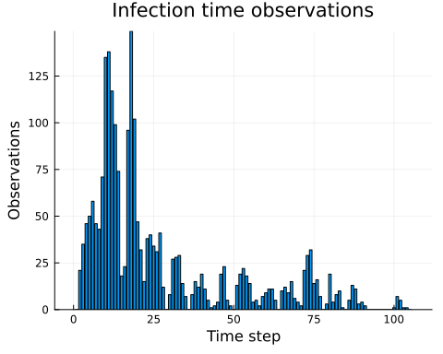
Total infections: 2276
Time steps: 105
Number of censored observations: 10
Mean infection time: 26.64
Mean recovery interval: 5.0
Peak infections: 149 at time step 18

Turing model
The Turing.jl probabilistic model used to infer the parameters from this dataset employs the previously defined discrete-time SIR model.
@model function dsa_discrete_turing_multinomial(N::Int, # Initial susceptibles
M::Int, # Initial infected
nsteps::Int, # Number of time steps
K::Int, # Observed total infections
th::Vector{Int}, # Histogram of infection times
delta::Vector{Int}, # Observed recovery intervals
cens::Vector{Bool}) # Censoring (true=right-censored)
# Priors for model parameters
β ~ Uniform(0.01, 5.0) # Transmission rate
γ ~ Uniform(0.01, 1.0) # Recovery rate
ρ ~ Beta(0.01, 1.0) # Initial infected proportion
# Simulate deterministic model
_, τ, f = simulate(β, γ, ρ, nsteps)
# Ensure τ is valid for binomial distribution
τ_valid = max(min(τ, 1.0), 0.0)
# Ensure f is valid for multinomial distribution
f_valid = max.(f, 1e-10) # Add small positive value to avoid zeros
f_valid = f_valid / sum(f_valid) # Normalise
# Likelihood for number of infections
K ~ Binomial(N, τ_valid)
# Likelihood for infection times
th ~ Multinomial(K, f_valid)
# Likelihood for recovery times
ϵ = 1e-8
pγ = rate_to_proportion(γ)
pγ_valid = min(max(pγ, ϵ), 1 - ϵ)
log_surv = log1p(-pγ_valid)
for i in 1:length(delta)
if cens[i]
Turing.@addlogprob!(delta[i] * log_surv) # log P(not yet recovered by step delta[i])
else
delta[i] ~ Geometric(pγ_valid)
end
end
return (β=β, γ=γ, ρ=ρ)
end
Model parameters:
N = 7250 # Population size
M = 1 # Initial infected
th = real_data[:th] # Infection times
K = sum(th) # Total infections
delta = real_data[:delta] # Recovery intervals
cens = real_data[:cens] # Censoring
nsteps = real_data[:nsteps] # Number of time steps

Running the inference
model = dsa_discrete_turing_multinomial(N, M, nsteps, K, th, delta, cens);
n_samples = 1000;
_ = sample(model, NUTS(), 1)
@time chain = sample(model,
NUTS(500, 0.65; max_depth=10, Δ_max=1000.0, init_ϵ=0.2),
n_samples);

Results
Once we have run the sampler, we can get a summary of the parameter estimates
describe(chain)
Chains MCMC chain (1000×17×1 Array{Float64, 3}):
Iterations = 501:1:1500
Number of chains = 1
Samples per chain = 1000
Wall duration = 0.86 seconds
Compute duration = 0.86 seconds
parameters = β, γ, ρ
internals = n_steps, is_accept, acceptance_rate, log_density, hamiltonian_energy, hamiltonian_energy_error, max_hamiltonian_energy_error, tree_depth, numerical_error, step_size, nom_step_size, logprior, loglikelihood, logjoint
Summary Statistics
parameters mean std mcse ess_bulk ess_tail rhat e ⋯
Symbol Float64 Float64 Float64 Float64 Float64 Float64 ⋯
β 0.1803 0.0037 0.0002 320.9411 358.8715 1.0011 ⋯
γ 0.1787 0.0035 0.0002 322.2589 396.3053 1.0014 ⋯
ρ 0.0486 0.0020 0.0001 439.7394 439.1222 1.0001 ⋯
1 column omitted
Quantiles
parameters 2.5% 25.0% 50.0% 75.0% 97.5%
Symbol Float64 Float64 Float64 Float64 Float64
β 0.1734 0.1778 0.1802 0.1826 0.1881
γ 0.1721 0.1762 0.1787 0.1809 0.1859
ρ 0.0448 0.0472 0.0484 0.0500 0.0529
Plot trace plots for MCMC diagnostics
plot(chain, plot_title="Trace plots")
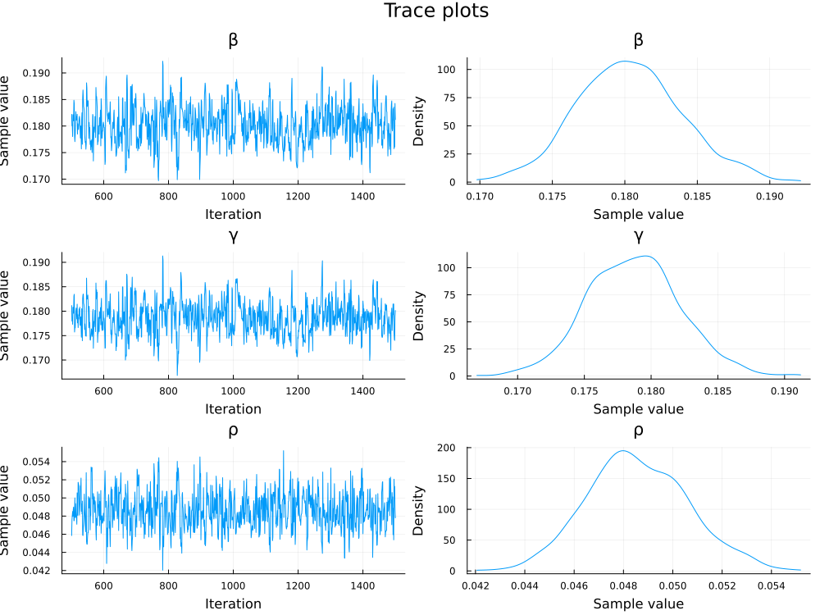
Extract parameter estimates mean values
# Extract parameter estimates
β_post = mean(chain[:β])
γ_post = mean(chain[:γ])
ρ_post = mean(chain[:ρ])
Plot model fit
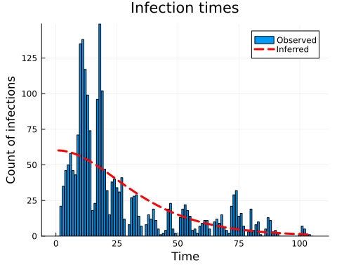
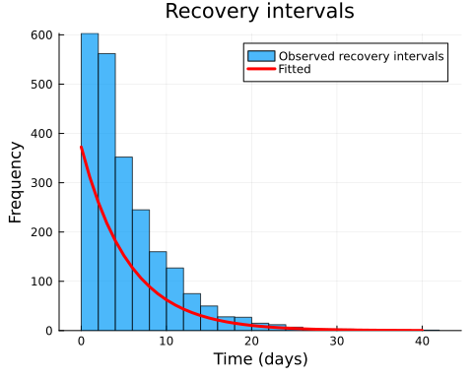
Final epidemic size (simulated): τ * N = 2238.86
Total observed infections: 2265
Mean recovery time (observed): 5.0 days
Mean recovery time (fitted): 5.6 days
Observed total infections: 2265
Predicted total infections: 2238.9
Recovery time fit error: 12.2%

Comparison to KhudaBukhsh et al. (2019) results
We plot the S_t curve and the final epidemic size distribution to compare our observed and simulated data, with that obtained in KhudaBukhsh et al. (2019).
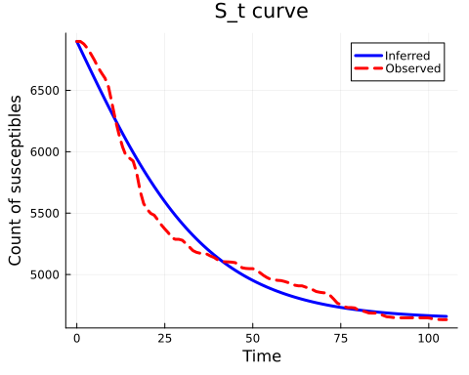
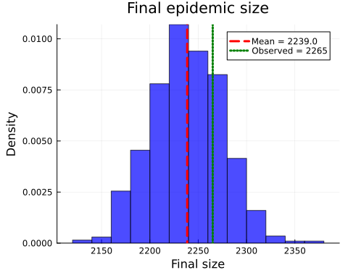

Discussion
The analysis performed on the WSU H1N1 outbreak dataset from 2009 showed that the discrete SIR model, with geometric recovery times, captured the dynamics of the epidemic. It was able to infer key parameters from the data and provided estimations that approximate the timing of infections and the distribution of recovery times.
This approach offers several advantages: a simple and interpretable modelling framework, fast computation and inference through Turing.jl, and clear parameter interpretation (transmission rate β, recovery rate γ, and initial infected proportion ρ). However, it’s important to note that the model relies on key assumptions, including geometric recovery times and the modification of the original dataset to include recovery intervals, as the primary data only contained daily infection counts.

