Hagelloch 1861 measles: GLCT vs Boxcar DDSA comparison (M_θ analogue)
Sandra Montes (@slmontes)
2026-03-25

Introduction
We apply discrete dynamic survival analysis (DDSA) to the 1861 measles outbreak in Hagelloch, Germany (188 cases over 86 days). The line list of this outbreak was used on an individual-level analysis by Neal & Roberts (2004, hereafter NR), which we use as a reference point.
This study treats the Hagelloch measles outbreak as a stress test of our stratified mean-field DDSA model. The Hagelloch data are a challenging case because transmission is strongly shaped by individual-level contact structure (household and classroom links), which is explicitly represented in the Neal and Roberts framework. By contrast, our specification intentionally aggregates transmission into three interacting groups and therefore does not attempt to reproduce the full contact network.
Our goal is not to reproduce NR’s individual-level household/contact likelihood, but to assess what a mean-field DDSA analogue can recover from the case line list with a simplified model: the qualitative hierarchy of transmission parameters (specifically $β_{C1}>β_{C2}$ and $β_{H}>0$, together with correct epidemic sequencing of the three groups) and the susceptible group sizes, which NR treat as fixed but DDSA infers via final-size constraints. Because the contact structure is aggregated into mean-field terms, we expect per-group attack rates to be underestimated relative to the data.
The dataset is available in R’s outbreaks package as measles_hagelloch_1861. Individual prodrome-onset dates and rash-onset dates are recorded for all cases, allowing us to:
- Construct the infection-time histogram (th) from prodrome-onset dates.
- Compute observed infectious-period durations (delta) as $δ_{i}=\left(t_{ERU,i}−t_{PRO,i}\right)+4$ days, following Neal & Roberts (2004) with $d_{0}=3$ (child remains infectious 3 days after rash onset) and $d_{1}=1$ (child becomes infectious 1 day before prodrome onset), so the +4 = $d_{0}+d_{1}$.
The infectious period has empirical mean $≈$ 8 days. We model it with a NegBin discrete phase-type (DPH) distribution (rather than a simple geometric period).
Neal & Roberts (2004) partitions the 188 cases into three groups based on school enrolment:
- Class 0 (not yet enrolled): No initial cases; infected via household transmission, peaked later (infection times 8–28 days).
- Class 1 (younger school class): No initial cases; concentrated wave peaking around days 21–28.
- Class 2 (older school class): Contains index case; infection times span the full epidemic window (days 0–40), with the main wave peaking around day 28–30.
We use the four transmission parameters from NR’s model $M_{θ}$: within-class 1 ($β_{C1}$), within-class 2 ($β_{C2}$), a household-route term from school to pre-school ($β_{H}$), and a global uniform-mixing term ($β_{G}$). The infectious period is shared across classes and modelled with a NegBin DPH. Inference uses a Gibbs scheme: $β_{C1}$, $β_{C2}$, $β_{H}$, $β_{G}$, and the calendar mean $E\left[δ\right]$ are updated jointly by one NUTS step; while the phase count $r$ and population sizes $N_{0}$, $N_{1}$, $N_{2}$ are updated by Metropolis–Hastings. We set $p=r/\left(E\left[δ\right]−δ_{min}+r\right)$ given $E\left[δ\right]$ and $r$. Calendar infectious period $δ$ includes NR’s fixed $+4$ days, so we prepend $\left(δ_{min}−r\right)$ deterministic day-states to that DPH (with $δ_{min}=\min_{i}δ_{i}=4$ here), giving support $\{δ_{min},δ_{min}+1,…\}$ and $E\left[δ\right]=\left(δ_{min}−r\right)+r/p$.
NR parameterise the per-day rate at which infectious individual $i$ infects susceptible $j$ as
$$α_{ij}=β_{H}1_{\{\text{same household}\}}+β_{C}^{1}1_{\{L_{i}=L_{j}=1\}}+β_{C}^{2}1_{\{L_{i}=L_{j}=2\}}+β_{G},$$
where the global term $β_{G}$ replaces the distance-decay $β_{G}exp\left(−θρ\left(i,j\right)\right)$ of the full model M by setting $θ=0$. Our mean-field analogue translates this individual-level rate into group-level forces of infection:
$$λ_{0}=\left(1−e^{−\left[β_{H}\left(I_{1}+I_{2}\right)+β_{G}\left(I_{0}+I_{1}+I_{2}\right)\right]}\right)S_{0}$$
$$λ_{1}=\left(1−e^{−\left[β_{C1} I_{1}+β_{G}\left(I_{0}+I_{1}+I_{2}\right)\right]}\right)S_{1}$$
$$λ_{2}=\left(1−e^{−\left[β_{C2} I_{2}+β_{G}\left(I_{0}+I_{1}+I_{2}\right)\right]}\right)S_{2}$$
Here $S_{k}$ and $I_{k}$ are the susceptible and infectious fractions of group $k$ (each ranging over $\left[0,1\right]$), and $N_{0}$, $N_{1}$, $N_{2}$ are inferred via Binomial final-size likelihoods.
We treat Class 0 as downstream of the school epidemic via the household-route term $β_{H}$ and allow mixing between the school classes through $β_{G}$. No spatial coordinates enter the model ($θ=0$ in the NR notation).
We fit the model using two function-map implementations (GLCT and Boxcar) that share the same likelihood terms and recovery model. The agreement between them is used as an implementation check.

Libraries
using Random, LinearAlgebra
import Statistics: mean, std, median, quantile
using Distributions
using Turing
# Compatibility patch for Turing Gibbs/MH warmup copy behavior (needed for some versions of Turing).
let Ti = Turing.Inference
if isdefined(Ti, :StoreLinkedValues)
Ty = getfield(Ti, :StoreLinkedValues)
@eval Base.copy(::$Ty) = $Ty()
end
if isdefined(Ti, :StoreUnspecifiedPriors)
Ty = getfield(Ti, :StoreUnspecifiedPriors)
@eval Base.copy(x::$Ty) = $Ty(copy(x.vns_with_proposal))
end
end
using StatsPlots, Plots
using ForwardDiff
using CSV, DataFrames
using MCMCDiagnosticTools
include("./PhaseTypeDistributions.jl")
import .PhaseTypeDistributions
Random.seed!(1234)

Data
df = CSV.read("hagelloch.csv", DataFrame)
# CSV.jl return type IDs / class labels as Int
function _line_list_id(v)
ismissing(v) && return nothing
if v isa Union{Integer, AbstractFloat}
x = Float64(v)
isfinite(x) || return nothing
return Int(round(x))
end
s = strip(string(v))
(isempty(s) || uppercase(s) in ("NA", "N/A", ".")) && return nothing
return tryparse(Int, s)
end
df0 = filter(r -> coalesce(_line_list_id(r.class), -1) == 0, df)
df1 = filter(r -> coalesce(_line_list_id(r.class), -1) == 1, df)
df2 = filter(r -> coalesce(_line_list_id(r.class), -1) == 2, df)
K0 = nrow(df0)
K1 = nrow(df1)
K2 = nrow(df2)
# Census-based bounds from Neal & Roberts (2004): infer N0,N1,N2 from K0,K1,K2 with N_total=197.
N_total = 197
N0_max = N_total - K1 - K2 # = 197 - 30 - 68 = 99
N1_max = N_total - K0 - K2 # = 197 - 90 - 68 = 39
N2_max = N_total - K0 - K1 # = 197 - 90 - 30 = 77
# Shared epidemic window across all three classes
Tmax = maximum(vcat(df0.t_infection, df1.t_infection, df2.t_infection))
# Shared recovery intervals (all three groups)
delta = vcat(df0.inf_period, df1.inf_period, df2.inf_period)
# Buffer beyond Tmax: a couple of mean infectious periods
nsteps = Tmax + 2 * round(Int, mean(delta))
# Infection-time histograms (1-indexed)
th0 = zeros(Int, nsteps)
th1 = zeros(Int, nsteps)
th2 = zeros(Int, nsteps)
for row in eachrow(df0); idx = row.t_infection + 1; idx <= nsteps && (th0[idx] += 1); end
for row in eachrow(df1); idx = row.t_infection + 1; idx <= nsteps && (th1[idx] += 1); end
for row in eachrow(df2); idx = row.t_infection + 1; idx <= nsteps && (th2[idx] += 1); end
# Support condition for offset NegBin DPH: r ≤ δ_min.
nb_r_max = minimum(delta)
K0=90 (class 0), K1=30 (class 1), K2=68 (class 2)
nsteps = 102 (covers epidemic window to day 86 + buffer)
Recovery intervals: mean=7.95 d, min=4, max=17, CV=0.219
nb_r_max = 4 (geometric CV would be 1.0; empirical CV=0.22 → NegBin DPH warranted)
# Data-derived: source of infection for class 0 (pre-school) cases
class_lookup = Dict{Int, Int}()
for row in eachrow(df)
kid = _line_list_id(row.case_ID)
kid === nothing && continue
cid = _line_list_id(row.class)
cid === nothing && continue
class_lookup[kid] = cid
end
c0_from_school = count(eachrow(df0)) do row
inf = row.infector
iid = _line_list_id(inf)
iid === nothing && return false
cls = get(class_lookup, iid, nothing)
cls !== nothing && cls in (1, 2)
end
c0_from_c0 = count(eachrow(df0)) do row
inf = row.infector
iid = _line_list_id(inf)
iid === nothing && return false
cls = get(class_lookup, iid, nothing)
cls !== nothing && cls == 0
end
c0_unresolved = K0 - c0_from_school - c0_from_c0
Class 0 infection source (from `infector` column):
from school siblings (class 1 or 2): 53 / 90 (58.9%)
from class 0 (community play): 34 / 90 (37.8%)
unresolved (missing or unknown infector): 3 / 90 (3.3%)
Plot of the infection-time histograms extracted from the data:
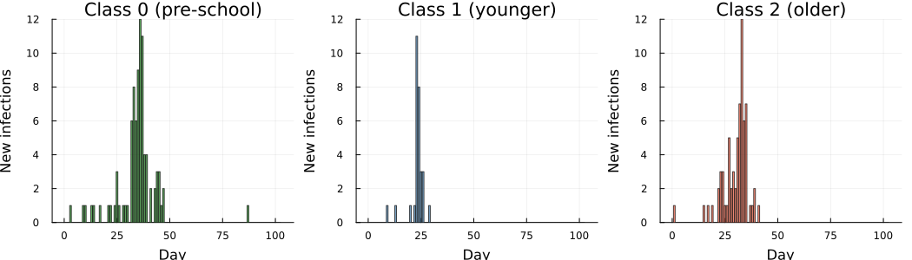

Models
Both the GLCT and Boxcar maps implement the same three-group $M_{θ}$ force-of-infection structure and the same NegBin DPH infectious-period distribution. They differ only in how the infectious-period distribution is propagated in time: the GLCT updates a phase-vector by matrix multiplication, while the Boxcar tracks infection-age cohorts using a discrete hazard vector derived from that same DPH.

GLCT
The SIR map tracks susceptible fractions $S_{k}$ and phase-vector $x_{k}$ for each group $k∈\{0,1,2\}$. Transmission follows the forces of infection $λ_{k}$ previously defined, and there is no feedback from class 0 to school classes.
"""GLCT model (M_θ analogue).
Propagates three phase-vectors using the exponential rate-to-probability force of infection"""
function run_sir_mtheta(T_mat, alpha, beta_C1, beta_C2, beta_H, beta_G,
rho0, rho1, rho2, nsteps)
T_el = promote_type(eltype(T_mat), eltype(alpha),
typeof(beta_C1), typeof(beta_C2),
typeof(beta_H), typeof(beta_G),
typeof(rho0), typeof(rho1), typeof(rho2))
S0 = one(T_el) - T_el(rho0); x0 = T_el.(alpha) .* T_el(rho0)
S1 = one(T_el) - T_el(rho1); x1 = T_el.(alpha) .* T_el(rho1)
S2 = one(T_el) - T_el(rho2); x2 = T_el.(alpha) .* T_el(rho2)
S0_hist = T_el[S0]
S1_hist = T_el[S1]
S2_hist = T_el[S2]
for _ in 1:nsteps
I0 = sum(x0); I1 = sum(x1); I2 = sum(x2)
I_total = I0 + I1 + I2
# Forces of infection (M_θ)
# p = 1 − exp(−rate·Δt) with Δt=1; clamp to [0, Sk] for numerical safety
r0 = T_el(beta_H) * (I1 + I2) + T_el(beta_G) * I_total
r1 = T_el(beta_C1) * I1 + T_el(beta_G) * I_total
r2 = T_el(beta_C2) * I2 + T_el(beta_G) * I_total
λ0 = min(max((one(T_el) - exp(-r0)) * S0, zero(T_el)), S0)
λ1 = min(max((one(T_el) - exp(-r1)) * S1, zero(T_el)), S1)
λ2 = min(max((one(T_el) - exp(-r2)) * S2, zero(T_el)), S2)
x0 = T_mat' * x0 .+ T_el.(alpha) .* λ0
x1 = T_mat' * x1 .+ T_el.(alpha) .* λ1
x2 = T_mat' * x2 .+ T_el.(alpha) .* λ2
S0 -= λ0; S1 -= λ1; S2 -= λ2
push!(S0_hist, S0)
push!(S1_hist, S1)
push!(S2_hist, S2)
end
function to_pmf(S_hist)
f = T_el[max(S_hist[t] - S_hist[t+1], zero(T_el)) for t in 1:nsteps]
sF = sum(f)
sF > T_el(1e-12) ? f ./ sF : fill(one(T_el)/nsteps, nsteps)
end
tau0 = S0_hist[1] - S0_hist[end]
tau1 = S1_hist[1] - S1_hist[end]
tau2 = S2_hist[1] - S2_hist[end]
return (tau0=tau0, f0=to_pmf(S0_hist),
tau1=tau1, f1=to_pmf(S1_hist),
tau2=tau2, f2=to_pmf(S2_hist))
end

Boxcar
The Boxcar model uses infection-age cohort bookkeeping: newly infected individuals enter age class 1 and advance one step per day, exiting at the discrete hazard $h\left(k\right)=P\left(W=k∣W≥k\right)$ derived from the same offset NegBin DPH. Both representations share the same marginal recovery-time distribution and the same $1−e^{−\text{rate}}$ discretisation of the force of infection.
The hazard vector $h$ is computed by iterating the transient-state vector $x_{k+1}=S^{⊤}x_{k}$ (starting from $x_{1}=α$) and setting $h\left(k\right)=\left(x_{k}⋅s\right)/∑x_{k}$, where $s$ is the absorption probability vector. The implementation is ForwardDiff-compatible (Dual-valued parameters), other AD methods may also work but have not been tested here.
"""Compute discrete hazard h[k] = P(W=k|W≥k) from a DPH by iterating the state vector.
If dph has ForwardDiff Dual parameters, returns a Dual-typed vector."""
function hazard_vector_from_dph(dph, K_age::Integer)
T = eltype(dph.α)
s = dph.s
h = Vector{T}(undef, K_age)
x = copy(dph.α) # state probability vector at infection-age 1
for k in 1:K_age
sf_val = sum(x)
pmf_val = dot(x, s)
h[k] = (sf_val > T(1e-15) && isfinite(sf_val)) ? pmf_val / sf_val : T(0.01)
x = dph.S' * x # advance to next infection age
end
h[end] = one(T) # boundary: everyone at the last class recovers
return clamp.(h, zero(T), one(T))
end
"""Three-group SIR Boxcar map (M_θ analogue).
Propagates three infection-age vectors using discrete hazard h_rec and the same exponential rate-to-probability force."""
function run_sir_mtheta_boxcar(h_rec, K_age::Int,
beta_C1, beta_C2, beta_H, beta_G,
rho0, rho1, rho2, nsteps::Int)
T_el = promote_type(eltype(h_rec), typeof(beta_C1), typeof(beta_C2),
typeof(beta_H), typeof(beta_G),
typeof(rho0), typeof(rho1), typeof(rho2))
S0 = one(T_el) - T_el(rho0)
S1 = one(T_el) - T_el(rho1)
S2 = one(T_el) - T_el(rho2)
# All initial infecteds placed in age class 1 (consistent with offset DPH α[1]=1)
x0 = zeros(T_el, K_age); x0[1] = T_el(rho0)
x1 = zeros(T_el, K_age); x1[1] = T_el(rho1)
x2 = zeros(T_el, K_age); x2[1] = T_el(rho2)
S0_hist = T_el[S0]; S1_hist = T_el[S1]; S2_hist = T_el[S2]
for _ in 1:nsteps
I0 = sum(x0); I1 = sum(x1); I2 = sum(x2)
I_total = I0 + I1 + I2
# Exponential rate-to-probability discretisation — identical to run_sir_mtheta
r0 = T_el(beta_H) * (I1 + I2) + T_el(beta_G) * I_total
r1 = T_el(beta_C1) * I1 + T_el(beta_G) * I_total
r2 = T_el(beta_C2) * I2 + T_el(beta_G) * I_total
λ0 = min(max((one(T_el) - exp(-r0)) * S0, zero(T_el)), S0)
λ1 = min(max((one(T_el) - exp(-r1)) * S1, zero(T_el)), S1)
λ2 = min(max((one(T_el) - exp(-r2)) * S2, zero(T_el)), S2)
x0_new = zeros(T_el, K_age)
x1_new = zeros(T_el, K_age)
x2_new = zeros(T_el, K_age)
# New infections enter age class 1
x0_new[1] += λ0; x1_new[1] += λ1; x2_new[1] += λ2
# Advance age classes; h[k] fraction absorbs (recovers), 1−h[k] advances
@inbounds for k in 1:(K_age - 1)
h_k = T_el(h_rec[k])
x0_new[k+1] += x0[k] * (one(T_el) - h_k)
x1_new[k+1] += x1[k] * (one(T_el) - h_k)
x2_new[k+1] += x2[k] * (one(T_el) - h_k)
end
# k == K_age: h[K_age]=1, all remaining mass is absorbed
x0 = x0_new; x1 = x1_new; x2 = x2_new
S0 = max(zero(T_el), S0 - λ0)
S1 = max(zero(T_el), S1 - λ1)
S2 = max(zero(T_el), S2 - λ2)
push!(S0_hist, S0); push!(S1_hist, S1); push!(S2_hist, S2)
end
function to_pmf(S_hist)
f = T_el[max(S_hist[t] - S_hist[t+1], zero(T_el)) for t in 1:nsteps]
sF = sum(f)
sF > T_el(1e-12) ? f ./ sF : fill(one(T_el)/nsteps, nsteps)
end
tau0 = S0_hist[1] - S0_hist[end]
tau1 = S1_hist[1] - S1_hist[end]
tau2 = S2_hist[1] - S2_hist[end]
return (tau0=tau0, f0=to_pmf(S0_hist),
tau1=tau1, f1=to_pmf(S1_hist),
tau2=tau2, f2=to_pmf(S2_hist))
end
K_age_boxcar = 40 (99.99th-percentile truncation for Boxcar age dimension)

Inference
Inference uses a Gibbs scheme: $β_{C1}$, $β_{C2}$, $β_{H}$, $β_{G}$, $E\left[δ\right]$ are updated jointly by one NUTS step, while the four discrete parameters (nb_r, $N_{0}$, $N_{1}$, $N_{2}$) are sampled by Metropolis–Hastings (NegBin–DPH with Neal–Roberts offset). The epidemic is seeded by a single index case in Class 2 ($ρ_{2}=1/N_{2}$) with no initial infections in Classes 0 or 1 ($ρ_{0}=ρ_{1}=0$), consistent with the Hagelloch data where the first recorded case belongs to Class 2.
The group population sizes are not recoverable from hagelloch.csv, which records only the 188 infected individuals. All three susceptible population sizes are therefore inferred from the data via the Binomial final-size constraints $K_{k}∼Binomial\left(N_{k},τ_{k}\right)$ for $k∈\{0,1,2\}$. By contrast, in the Hagelloch analysis of Neal & Roberts (2004), population size is treated as given (they assume $m=n=188$) within an individual event-history likelihood. Thus, their framework does not identify group denominators from aggregate case counts alone.
Each $N_{k}$ is given a $DiscreteUniform\left(K_{k},N_{k,max}\right)$ prior. The lower bound $K_{k}$ is the minimum possible group size (cannot have fewer susceptibles than observed cases). For the upper bound we use an external population count: Pfeilsticker’s original epidemic documentation (as cited in Neal & Roberts, 2004) records 197 children under 14 in Hagelloch at the time of the outbreak. Of these, 185 were infected and are present in the line list (plus 3 teenagers aged 14–15, giving $K=188$ total); the 12 non-infected children each had a documented reason for non-infection (7 infants with placental immunity, 3 kept in total isolation, 1 two-year-old, 1 immigrant who had previously had measles). Neal & Roberts therefore conclude that virtually all truly susceptible children were infected, and treat the total susceptible population as $N_{total}=197$.
Assuming all 197 children belong to one of the three groups, the maximum possible size of group $k$ is:
$$N_{k,max}=N_{total}−K_{k′}−K_{k″}.$$
This gives $N_{0}∈\left[90,99\right]$, $N_{1}∈\left[30,39\right]$, $N_{2}∈\left[68,77\right]$, tight ranges reflecting the near-complete attack rate (188/197 = 95%).

GLCT Turing model
function safe_normalise(f::AbstractVector{T}, n::Int) where T
f_pos = ifelse.(isnan.(f) .| .!isfinite.(f), zero(T), max.(f, zero(T)))
sF = sum(f_pos)
(sF > T(1e-15) && isfinite(sF)) ? f_pos ./ sF : fill(one(T)/n, n)
end
# Infectious period: offset NegBin DPH with minimum δ_floor.
@model function ddsa_hagelloch_mtheta(K0::Int, K1::Int, K2::Int,
N0_max::Int, N1_max::Int, N2_max::Int,
th0::Vector{Int}, th1::Vector{Int},
th2::Vector{Int},
delta::Vector{Int},
nsteps::Int,
δ_floor::Int)
# Priors — population sizes inferred within census-derived bounds
N0 ~ DiscreteUniform(K0, N0_max)
N1 ~ DiscreteUniform(K1, N1_max)
N2 ~ DiscreteUniform(K2, N2_max)
# Index case in class 2; rho2 seeds one case out of N2 susceptibles
rho0 = 0.0
rho1 = 0.0
rho2 = 1.0 / N2
# Exponential priors to avoid near-zero-rate initialisation.
beta_C1 ~ Exponential(0.2)
beta_C2 ~ Exponential(0.1)
beta_H ~ Exponential(0.1)
beta_G ~ Exponential(0.1)
# Reparameterise (r, p) by mean δ for better Gibbs/NUTS geometry.
mean_δ ~ Uniform(δ_floor + 0.5, 25.0)
nb_r ~ DiscreteUniform(1, nb_r_max)
nb_p = nb_r / (mean_δ - δ_floor + nb_r)
dph = PhaseTypeDistributions.dph_negative_binomial_min_support(nb_r, nb_p, δ_floor)
sim = run_sir_mtheta(dph.S, dph.α, beta_C1, beta_C2, beta_H, beta_G,
rho0, rho1, rho2, nsteps)
tau0 = clamp(sim.tau0, 0.001, 0.999)
tau1 = clamp(sim.tau1, 0.001, 0.999)
tau2 = clamp(sim.tau2, 0.001, 0.999)
f0 = safe_normalise(sim.f0, nsteps)
f1 = safe_normalise(sim.f1, nsteps)
f2 = safe_normalise(sim.f2, nsteps)
# Binomial final-size constraints for all three groups
K0 ~ Binomial(N0, tau0)
K1 ~ Binomial(N1, tau1)
K2 ~ Binomial(N2, tau2)
# Infection-time histograms
if K0 > 0 && all(isfinite, f0) && abs(sum(f0) - 1) < 0.01
th0 ~ Multinomial(K0, f0)
else
Turing.@addlogprob! -Inf
end
if K1 > 0 && all(isfinite, f1) && abs(sum(f1) - 1) < 0.01
th1 ~ Multinomial(K1, f1)
else
Turing.@addlogprob! -Inf
end
if K2 > 0 && all(isfinite, f2) && abs(sum(f2) - 1) < 0.01
th2 ~ Multinomial(K2, f2)
else
Turing.@addlogprob! -Inf
end
# Shared NegBin DPH recovery likelihood
n_δ = length(delta)
for i in 1:n_δ
delta[i] ~ dph
end
end

Boxcar Turing model
@model function ddsa_hagelloch_mtheta_boxcar(K0::Int, K1::Int, K2::Int,
N0_max::Int, N1_max::Int, N2_max::Int,
th0::Vector{Int}, th1::Vector{Int},
th2::Vector{Int},
delta::Vector{Int},
nsteps::Int,
δ_floor::Int,
K_age::Int)
N0 ~ DiscreteUniform(K0, N0_max)
N1 ~ DiscreteUniform(K1, N1_max)
N2 ~ DiscreteUniform(K2, N2_max)
rho0 = 0.0; rho1 = 0.0; rho2 = 1.0 / N2
beta_C1 ~ Exponential(0.2)
beta_C2 ~ Exponential(0.1)
beta_H ~ Exponential(0.1)
beta_G ~ Exponential(0.1)
mean_δ ~ Uniform(δ_floor + 0.5, 25.0)
nb_r ~ DiscreteUniform(1, nb_r_max)
nb_p = nb_r / (mean_δ - δ_floor + nb_r)
dph = PhaseTypeDistributions.dph_negative_binomial_min_support(nb_r, nb_p, δ_floor)
h_rec = hazard_vector_from_dph(dph, K_age)
sim = run_sir_mtheta_boxcar(h_rec, K_age, beta_C1, beta_C2, beta_H, beta_G,
rho0, rho1, rho2, nsteps)
tau0 = clamp(sim.tau0, 0.001, 0.999)
tau1 = clamp(sim.tau1, 0.001, 0.999)
tau2 = clamp(sim.tau2, 0.001, 0.999)
f0 = safe_normalise(sim.f0, nsteps)
f1 = safe_normalise(sim.f1, nsteps)
f2 = safe_normalise(sim.f2, nsteps)
K0 ~ Binomial(N0, tau0)
K1 ~ Binomial(N1, tau1)
K2 ~ Binomial(N2, tau2)
if K0 > 0 && all(isfinite, f0) && abs(sum(f0) - 1) < 0.01
th0 ~ Multinomial(K0, f0)
else
Turing.@addlogprob! -Inf
end
if K1 > 0 && all(isfinite, f1) && abs(sum(f1) - 1) < 0.01
th1 ~ Multinomial(K1, f1)
else
Turing.@addlogprob! -Inf
end
if K2 > 0 && all(isfinite, f2) && abs(sum(f2) - 1) < 0.01
th2 ~ Multinomial(K2, f2)
else
Turing.@addlogprob! -Inf
end
# Recovery likelihood: same offset DPH PMF
n_δ = length(delta)
for i in 1:n_δ
delta[i] ~ dph
end
end

Sampler
Both models use an identical sampler configuration: independence Metropolis–Hastings for nb_r, one joint Metropolis–Hastings block for ($N_{0}$, $N_{1}$, $N_{2}$), and one joint NUTS step for the five continuous parameters ($β_{C1}$, $β_{C2}$, $β_{H}$, $β_{G}$, mean_δ) each full Gibbs sweep. Four parallel chains are run with cold starts (initial nb_r spread over $\{1,…,4\}$; moderate $β$’s and mean_δ).
GLCT
n_samples = 20_000
nuts_adapt = 2_000
n_chains = 4
gibbs_sampler = Gibbs(
:nb_r => MH(:nb_r => DiscreteUniform(1, nb_r_max)),
(:N0, :N1, :N2) =>
MH(:N0 => DiscreteUniform(K0, N0_max),
:N1 => DiscreteUniform(K1, N1_max),
:N2 => DiscreteUniform(K2, N2_max)),
(:beta_C1, :beta_C2, :beta_H, :beta_G, :mean_δ) => NUTS(nuts_adapt, 0.8; max_depth=12, Δ_max=1000.0)
)
delta_bar = mean(delta)
# Spread initial β_C2 across chains so cold starts are less likely to lock all chains in the same ridge.
init_params_vec = [
(nb_r = i,
mean_δ = delta_bar,
N0 = K0 + 5, N1 = K1 + 5, N2 = K2 + 5,
beta_C1 = 0.2, beta_C2 = 0.05 + 0.05 * (i - 1), beta_H = 0.1, beta_G = 0.1)
for i in 1:n_chains
]
δ_floor_ip = minimum(delta)
model_mtheta = ddsa_hagelloch_mtheta(K0, K1, K2, N0_max, N1_max, N2_max,
th0, th1, th2, delta, nsteps, δ_floor_ip)
# Warm-up sample to trigger JIT
_ = sample(model_mtheta, gibbs_sampler, 1;
progress=false, initial_params=init_params_vec[1])
chain = sample(model_mtheta, gibbs_sampler, MCMCThreads(), n_samples, n_chains;
progress=false, initial_params=init_params_vec)
Chains MCMC chain (20000×12×4 Array{Float64, 3}):
Iterations = 1:1:20000
Number of chains = 4
Samples per chain = 20000
Wall duration = 113.92 seconds
Compute duration = 438.39 seconds
parameters = N0, N1, N2, beta_C1, beta_C2, beta_H, beta_G, mean_δ, nb_r
internals = logprior, loglikelihood, logjoint
Summary Statistics
parameters mean std mcse ess_bulk ess_tail rhat ⋯
Symbol Float64 Float64 Float64 Float64 Float64 Float64 ⋯
N0 98.4736 0.8422 0.0239 1086.4295 NaN 1.0035 ⋯
N1 34.0093 2.0787 0.0682 935.1152 991.6362 1.0042 ⋯
N2 76.6068 0.7031 0.0192 1221.6998 NaN 1.0010 ⋯
beta_C1 0.1273 0.0362 0.0020 337.5476 264.6465 1.0187 ⋯
beta_C2 0.0315 0.0220 0.0013 223.6748 194.5032 1.0588 ⋯
beta_H 0.0206 0.0142 0.0008 229.6769 231.4739 1.0920 ⋯
beta_G 0.0598 0.0083 0.0005 248.8292 275.1339 1.0519 ⋯
mean_δ 8.3618 0.2241 0.0030 5425.2417 11702.9635 1.0004 ⋯
nb_r 3.9993 0.0302 0.0003 7470.9684 NaN 1.0003 ⋯
1 column omitted
Quantiles
parameters 2.5% 25.0% 50.0% 75.0% 97.5%
Symbol Float64 Float64 Float64 Float64 Float64
N0 96.0000 98.0000 99.0000 99.0000 99.0000
N1 31.0000 32.0000 34.0000 35.0000 38.0000
N2 75.0000 76.0000 77.0000 77.0000 77.0000
beta_C1 0.0506 0.1045 0.1282 0.1516 0.1956
beta_C2 0.0021 0.0147 0.0271 0.0433 0.0856
beta_H 0.0023 0.0095 0.0178 0.0291 0.0543
beta_G 0.0413 0.0549 0.0607 0.0655 0.0740
mean_δ 7.9386 8.2074 8.3572 8.5112 8.8144
nb_r 4.0000 4.0000 4.0000 4.0000 4.0000
Boxcar
gibbs_boxcar = Gibbs(
:nb_r => MH(:nb_r => DiscreteUniform(1, nb_r_max)),
(:N0, :N1, :N2) =>
MH(:N0 => DiscreteUniform(K0, N0_max),
:N1 => DiscreteUniform(K1, N1_max),
:N2 => DiscreteUniform(K2, N2_max)),
(:beta_C1, :beta_C2, :beta_H, :beta_G, :mean_δ) =>
NUTS(nuts_adapt, 0.8; max_depth=12, Δ_max=1000.0)
)
init_params_bc = [
(nb_r = i,
mean_δ = delta_bar,
N0 = K0 + 5, N1 = K1 + 5, N2 = K2 + 5,
beta_C1 = 0.2, beta_C2 = 0.05 + 0.05 * (i - 1), beta_H = 0.1, beta_G = 0.1)
for i in 1:n_chains
]
model_boxcar = ddsa_hagelloch_mtheta_boxcar(K0, K1, K2, N0_max, N1_max, N2_max,
th0, th1, th2, delta, nsteps,
δ_floor_ip, K_age_boxcar)
_ = sample(model_boxcar, gibbs_boxcar, 1;
progress=false, initial_params=init_params_bc[1])
chain_bc = sample(model_boxcar, gibbs_boxcar, MCMCThreads(), n_samples, n_chains;
progress=false, initial_params=init_params_bc)
Chains MCMC chain (20000×12×4 Array{Float64, 3}):
Iterations = 1:1:20000
Number of chains = 4
Samples per chain = 20000
Wall duration = 142.32 seconds
Compute duration = 525.31 seconds
parameters = N0, N1, N2, beta_C1, beta_C2, beta_H, beta_G, mean_δ, nb_r
internals = logprior, loglikelihood, logjoint
Summary Statistics
parameters mean std mcse ess_bulk ess_tail rhat ⋯
Symbol Float64 Float64 Float64 Float64 Float64 Float64 ⋯
N0 98.3954 0.8939 0.0214 1495.5551 NaN 1.0033 ⋯
N1 34.0935 2.1558 0.0634 1218.8205 1604.2959 1.0054 ⋯
N2 76.5513 0.7646 0.0184 1478.8069 NaN 1.0014 ⋯
beta_C1 0.1244 0.0335 0.0017 383.2430 449.3048 1.0243 ⋯
beta_C2 0.0293 0.0233 0.0015 204.0762 191.6891 1.0915 ⋯
beta_H 0.0209 0.0128 0.0007 242.4354 289.1144 1.0600 ⋯
beta_G 0.0603 0.0078 0.0005 253.8788 433.8472 1.0587 ⋯
mean_δ 8.3541 0.2248 0.0029 5844.4537 11809.4201 1.0002 ⋯
nb_r 3.9996 0.0255 0.0002 16027.3532 NaN 1.0002 ⋯
1 column omitted
Quantiles
parameters 2.5% 25.0% 50.0% 75.0% 97.5%
Symbol Float64 Float64 Float64 Float64 Float64
N0 96.0000 98.0000 99.0000 99.0000 99.0000
N1 31.0000 32.0000 34.0000 36.0000 39.0000
N2 74.0000 76.0000 77.0000 77.0000 77.0000
beta_C1 0.0611 0.1009 0.1235 0.1468 0.1928
beta_C2 0.0007 0.0093 0.0255 0.0437 0.0837
beta_H 0.0044 0.0113 0.0180 0.0275 0.0522
beta_G 0.0419 0.0561 0.0614 0.0658 0.0726
mean_δ 7.9348 8.1991 8.3471 8.5027 8.8138
nb_r 4.0000 4.0000 4.0000 4.0000 4.0000

Results

Convergence
GLCT
ESS and R̂:
ESS/R-hat
parameters ess rhat ess_per_sec
Symbol Float64 Float64 Float64
N0 1086.4295 1.0035 2.4782
N1 935.1152 1.0042 2.1331
N2 1221.6998 1.0010 2.7868
beta_C1 337.5476 1.0187 0.7700
beta_C2 223.6748 1.0588 0.5102
beta_H 229.6769 1.0920 0.5239
beta_G 248.8292 1.0519 0.5676
mean_δ 5425.2417 1.0004 12.3755
nb_r 7470.9684 1.0003 17.0420
Boxcar
Boxcar — ESS and R̂:
ESS/R-hat
parameters ess rhat ess_per_sec
Symbol Float64 Float64 Float64
N0 1495.5551 1.0033 2.8470
N1 1218.8205 1.0054 2.3202
N2 1478.8069 1.0014 2.8151
beta_C1 383.2430 1.0243 0.7296
beta_C2 204.0762 1.0915 0.3885
beta_H 242.4354 1.0600 0.4615
beta_G 253.8788 1.0587 0.4833
mean_δ 5844.4537 1.0002 11.1257
nb_r 16027.3532 1.0002 30.5103

Posterior summaries
GLCT posterior medians:
β_C1 median = 0.1282 (mean 0.1273; within-class 1)
β_C2 median = 0.0271 (mean 0.0315; within-class 2)
β_H median = 0.0178 (mean 0.0206; household: school → class 0)
β_G median = 0.0607 (mean 0.0598; global uniform mixing)
nb_r = 4, nb_p = 0.479 (derived), mean δ = 8.36 d (joint NUTS on β's + mean_δ; δ_floor=4), CV = 0.361
N0 = 99 (K0=90) prior: [90, 99]
N1 = 34 (K1=30) prior: [30, 39]
N2 = 77 (K2=68) prior: [68, 77]
Observed attack rate K_k/N_k (sample-by-sample, median [95% CI]):
K0/N0 = 0.909 [0.909, 0.938]
K1/N1 = 0.882 [0.789, 0.968]
K2/N2 = 0.883 [0.883, 0.907]
Comparison with Neal and Roberts M_θ structure:
β_C1/β_C2 ratio = 4.72 (expect > 1: younger class has higher within-class rate)
β_H/β_G ratio = 0.29 (mean-field β_H diluted over all class-0 × school pairs; expect < 1 vs NR individual-level)
GLCT 95% credible intervals:
beta_C1 : (0.0506, 0.1956)
beta_C2 : (0.0021, 0.0856)
beta_H : (0.0023, 0.0543)
beta_G : (0.0413, 0.074)
mean_δ : (7.9386, 8.8144)
nb_p (derived): (0.4537, 0.5039)
nb_r : (4, 4)
N0 : (96, 99)
N1 : (31, 38)
N2 : (75, 77)
Boxcar posterior medians:
β_C1 = 0.1235
β_C2 = 0.0255
β_H = 0.018
β_G = 0.0614
nb_r = 4, nb_p = 0.479, mean δ = 8.35 d
N0 = 99 (K0=90)
N1 = 34 (K1=30)
N2 = 77 (K2=68)
Observed attack rate K_k/N_k (sample-by-sample, median [95% CI]):
K0/N0 = 0.909 [0.909, 0.938]
K1/N1 = 0.882 [0.769, 0.968]
K2/N2 = 0.883 [0.883, 0.919]
The table below displays the posterior medians for all parameters, and both GLCT and Boxcar maps should recover essentially the same parameter values.
Parameter GLCT Boxcar
------------------------------------------
β_C1 0.1282 0.1235
β_C2 0.0271 0.0255
β_H 0.0178 0.018
β_G 0.0607 0.0614
mean δ 8.3572 8.3471
nb_p 0.4786 0.4792
N0 99.0 99.0
N1 34.0 34.0
N2 77.0 77.0
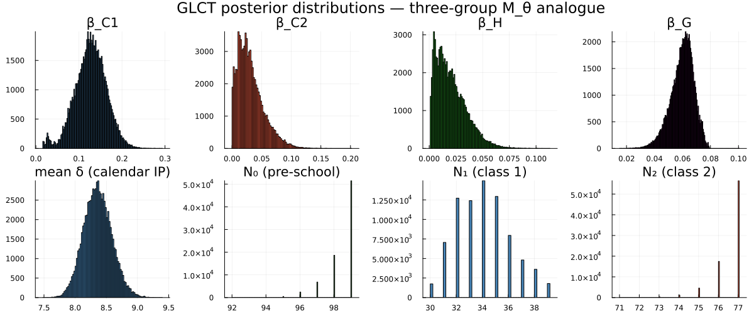
Figure 1

R0
The basic reproduction number for the three-group model is the dominant eigenvalue of the next-generation matrix $K$, where entry $K_{ij}$ gives the expected number of secondary infections in group $i$ caused by a single infectious individual in group $j$, introduced into a fully susceptible population.
From the M_θ force-of-infection equations the NGM is:
$$K=mean_ip×\left(\begin{matrix}\frac{N_{0}}{N_{0}}β_{G} & \frac{N_{0}}{N_{1}}\left(β_{H}+β_{G}\right) & \frac{N_{0}}{N_{2}}\left(β_{H}+β_{G}\right) \\ \frac{N_{1}}{N_{0}}β_{G} & \frac{N_{1}}{N_{1}}\left(β_{C1}+β_{G}\right) & \frac{N_{1}}{N_{2}}β_{G} \\ \frac{N_{2}}{N_{0}}β_{G} & \frac{N_{2}}{N_{1}}β_{G} & \frac{N_{2}}{N_{2}}\left(β_{C2}+β_{G}\right)\end{matrix}\right)$$
where entry $K_{ij}$ equals $\left(N_{i}/N_{j}\right)×β_{ij}×mean_ip$, with the $N_{i}/N_{j}$ factor arising because the model state variables are per-group fractions (one infected in group $j$ corresponds to fraction $1/N_{j}$).
GLCT: median = 2.18 95% CI = (2.024, 2.389)
Boxcar: median = 2.171 95% CI = (2.021, 2.377)

Posterior predictive checks
function posterior_predictions_mtheta(chain, n_draws=200)
n_total = length(vec(chain[:beta_C1]))
idx = round.(Int, range(1, n_total, length=n_draws))
τ0_v = zeros(n_draws)
τ1_v = zeros(n_draws)
τ2_v = zeros(n_draws)
f0_m = zeros(nsteps, n_draws)
f1_m = zeros(nsteps, n_draws)
f2_m = zeros(nsteps, n_draws)
for (k, i) in enumerate(idx)
bC1 = vec(chain[:beta_C1])[i]
bC2 = vec(chain[:beta_C2])[i]
bH = vec(chain[:beta_H])[i]
bG = vec(chain[:beta_G])[i]
nr = round(Int, vec(chain[:nb_r])[i])
mδ = vec(chain[:mean_δ])[i]
np = nr / (mδ - δ_floor_ip + nr)
n2_i = round(Int, vec(chain[:N2])[i])
dph_i = PhaseTypeDistributions.dph_negative_binomial_min_support(nr, np, δ_floor_ip)
sim = run_sir_mtheta(dph_i.S, dph_i.α, bC1, bC2, bH, bG,
0.0, 0.0, 1.0/n2_i, nsteps)
τ0_v[k] = sim.tau0
τ1_v[k] = sim.tau1
τ2_v[k] = sim.tau2
f0_m[:, k] .= sim.f0
f1_m[:, k] .= sim.f1
f2_m[:, k] .= sim.f2
end
return τ0_v, τ1_v, τ2_v, f0_m, f1_m, f2_m
end
τ0_post, τ1_post, τ2_post, f0_ppc, f1_ppc, f2_ppc =
posterior_predictions_mtheta(chain)
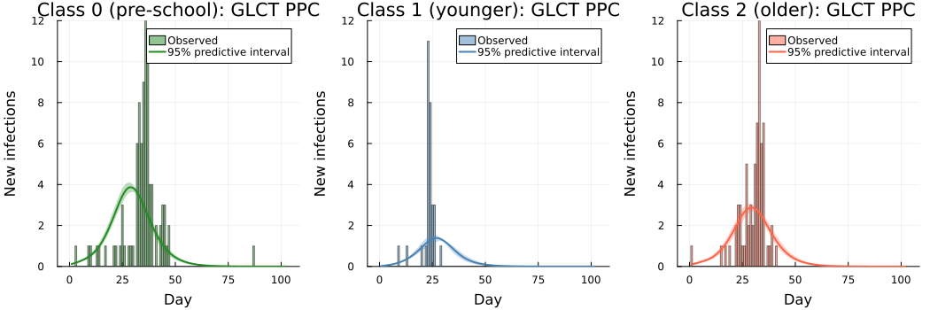
Figure 2
function posterior_predictions_mtheta_boxcar(chain, n_draws=200)
n_total = length(vec(chain[:beta_C1]))
idx = round.(Int, range(1, n_total, length=n_draws))
τ0_v = zeros(n_draws); τ1_v = zeros(n_draws); τ2_v = zeros(n_draws)
f0_m = zeros(nsteps, n_draws)
f1_m = zeros(nsteps, n_draws)
f2_m = zeros(nsteps, n_draws)
for (k, i) in enumerate(idx)
bC1 = vec(chain[:beta_C1])[i]; bC2 = vec(chain[:beta_C2])[i]
bH = vec(chain[:beta_H])[i]; bG = vec(chain[:beta_G])[i]
nr = round(Int, vec(chain[:nb_r])[i])
mδ = vec(chain[:mean_δ])[i]
np = nr / (mδ - δ_floor_ip + nr)
n2_i = round(Int, vec(chain[:N2])[i])
dph_i = PhaseTypeDistributions.dph_negative_binomial_min_support(nr, np, δ_floor_ip)
h_i = hazard_vector_from_dph(dph_i, K_age_boxcar)
sim = run_sir_mtheta_boxcar(h_i, K_age_boxcar, bC1, bC2, bH, bG,
0.0, 0.0, 1.0/n2_i, nsteps)
τ0_v[k] = sim.tau0; τ1_v[k] = sim.tau1; τ2_v[k] = sim.tau2
f0_m[:, k] .= sim.f0; f1_m[:, k] .= sim.f1; f2_m[:, k] .= sim.f2
end
return τ0_v, τ1_v, τ2_v, f0_m, f1_m, f2_m
end
τ0_bc, τ1_bc, τ2_bc, f0_ppc_bc, f1_ppc_bc, f2_ppc_bc =
posterior_predictions_mtheta_boxcar(chain_bc)
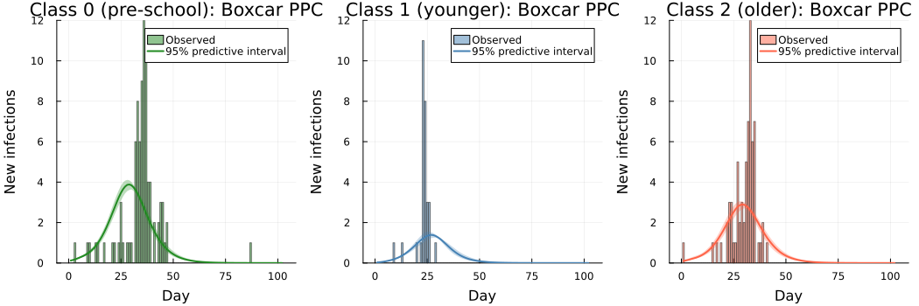
Figure 3

Recovery interval fit
Empirical mean δ = 7.95 d, DPH posterior mean δ = 8.36 d
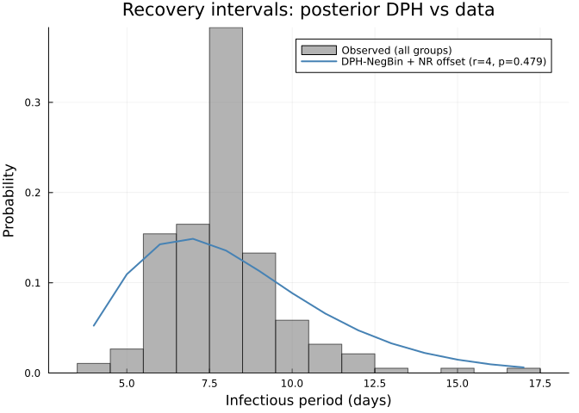
Figure 4

Discussion
We developed a mean-field analogue of Neal & Roberts (2004) with grouped compartments. Neal & Roberts (2004) explicitly set $n=m=188$ for their analysis: the susceptible population size equals the total number of infected individuals, implying a 100% attack rate across all three groups. They justify this by noting that 185 of 197 children under 14 were infected, and that the 12 non-infected children were either infants carrying placental immunity, children kept in total isolation, a two-year-old who did not attend school, or an immigrant who had previously had measles.
In our DDSA model, all three susceptible population sizes are inferred jointly via Binomial final-size constraints, with priors derived from the number of children under 14: $N_{total}=197$ (Neal & Roberts, 2004). This yields $N_{0}∈\left[90,99\right]$, $N_{1}∈\left[30,39\right]$, $N_{2}∈\left[68,77\right]$, ranges that are consistent with Neal & Roberts’ n=m=188 assumption (nearly 100% attack rate) while allowing the data to determine where within those bounds the posterior concentrates.
We note that the $β$ parameter values are not directly comparable in scale: Neal & Roberts use individual-to-individual per-day rates; our mean-field formulation uses $β×I×S$. Thus, we present a qualitative comparison of the parameter structure.
Neal & Roberts’ full model included a spatial distance-decay term; in the non-spatial comparison considered here, this corresponds to setting $θ=0$ so the global component reduces to uniform mixing. A separate distinction concerns household transmission. In the NR individual-level model, $β_{H}$ applies only to genuine household pairs (a Class 0 child is exposed via $β_{H}$ only to infectious school-age siblings in the same household). In our mean-field analogue, the household term enters at the group level and is applied across all (Class 0) $×$ (Class 1 + Class 2) pairs. This difference affects the scale of $β_{H}$: to match an aggregate household contribution, the mean-field $β_{H}$ is typically smaller (spread over many more potential pairs), and transmission not attributed to $β_{H}$ is absorbed by $β_{G}$.
Population treatment (all three N inferred via Binomial final-size):
N0 = 99 [90, 99] → K0=90/N0=99 = 90.9%
N1 = 34 [30, 39] → K1=30/N1=34 = 88.2%
N2 = 77 [68, 77] → K2=68/N2=77 = 88.3%
(NR n=m=188 implies 100% attack rate; DDSA infers from data within census bounds)
Qualitative checks:
1. β_C1 > β_C2: true (NR: evidence for different classroom rates)
2. β_H > 0: true (NR: strong household effect)
3. β_G > 0: true (NR: global mixing component)
4. P(β_C1>β_C2) = 0.994
The posterior attack rate for Class 1 (${\hat{τ}}_{1}≈K_{1}/N_{1}$) is consistent with DDSA recovering both the transmission dynamics and final size for internally homogeneous groups. The underprediction of attack rates for Classes 0 and 2 ($\hat{τ}≈0.74$–$0.77$ vs observed $≈0.88$–$0.92$) is a consequence of the mean-field approximation applied to groups with heterogeneous internal contact structure, and the $β$ estimates for these groups should be interpreted accordingly. A wider choice of $N_{total}$ (i.e. relaxing the census bound of 197 children under 14) would increase the uncertainty on $N_{0}$ and $N_{2}$ but would not qualitatively change the recovered parameter ordering or the $β_{C1}>β_{C2}$ finding.
For the infectious period, dph_negative_binomial_min_support enforces $r≤δ_{min}$ when $δ_{min}$ is the calendar minimum (here, 4 days), so $r$ cannot exceed 4 in this construction. The dwell-time parameters are in any case estimated jointly with transmission. A hard upper bound on $r$ can make residual marginal misfit interpretable as a model-class limit rather than as precise identification of $r$, but the fit is still consistent with the data.
Class 0: K=90, N=99 [96, 99] K/N (median [95% CI]) = 0.909 [0.909, 0.938] model-implied τ = 0.772 [0.716, 0.83]
Class 1: K=30, N=34 [31, 38] K/N (median [95% CI]) = 0.882 [0.789, 0.968] model-implied τ = 0.884 [0.822, 0.919]
Class 2: K=68, N=77 [75, 77] K/N (median [95% CI]) = 0.883 [0.883, 0.907] model-implied τ = 0.744 [0.668, 0.803]
In the observed data, Class 1 infection times cluster around days 21–28 while Class 2’s main wave spans days 26–40, so P(Class 1 peaks after Class 2) near zero. Another check is that P(Class 0 peaks after Class 1) should be close to 1, confirming that the household-driven pre-school epidemic is correctly identified as a downstream consequence of the school outbreak.
Mean peak days: Class 0=28.9, Class 1=26.9, Class 2=29.3
P(Class 1 peaks after Class 2) = 0.02
→ expected near 0: Class 1 should peak before Class 2's main wave
P(Class 0 peaks after Class 1) = 1.0
→ expected near 1: pre-school wave is driven by household transmission from school children
In sum, both GLCT and Boxcar implementations produce consistent posteriors across all parameters, confirming that the two formulations are equivalent. Convergence is clean for $β_{C1}$ ($\hat{R}≈1.01$–$1.03$ across the two implementations) but remains only marginal for $β_{C2}$, $β_{H}$, and $β_{G}$ ($\hat{R}≈1.05$–$1.09$), reflecting the limited identifiability of the household and global terms under mean-field contact structure. Despite this, the model captures the primary qualitative dynamics by recovering a higher transmission rate in the younger school class compared to the older class with posterior probability $P\left(β_{C1}>β_{C2}\right)=0.994$. It also identifies a positive household transmission route ($β_{H}>0$), which characterises the pre-school epidemic as a secondary wave following the school outbreak, and gives consistent reproduction-number estimates between implementations (GLCT $R_{0}=2.18$, 95% CI $\left[2.02, 2.39\right]$ vs. Boxcar $R_{0}=2.17$, 95% CI $\left[2.02, 2.38\right]$, both posterior medians). Although the model underpredicts attack rates for certain classes due to aggregating heterogeneous contact structure into mean-field terms, these results do not alter the directional findings.

