Optimisation of Multiple Control Strategies on a Dengue Fever Model.

Sandra Montes (@slmontes)

2025-03-10

Sandra Montes (@slmontes), 2025-02-20

## Introduction

This example explores the optimal control on a dengue fever model using multiple combinations of NPIs strategies. The model and strategies tested match those presentented by [Asamoah et al. (2021)](https://www.sciencedirect.com/science/article/pii/S2211379721009487?via%3Dihub). The model takes into account 2 populations: human and female mosquito or vector population. The human population is divided into 5 compartments: susceptible S_h, infected (symptomatic) I_h, carrier (asymptomatic) I_hA, partially immune P, and recovered R_h. While the mosquito population is formed by 2 compartments: susceptible S_v and infected I_v.

The model is described by the following differential equations:

## Libraries

using JuMP  
using Ipopt  
using OrdinaryDiffEq  
using Plots  
using Measures  
using MAT

## Functions

Model

function dengue_ode!(du,u,p,t)  
 (S_h, I_h, I_hA, P, R_h, S_v, I_v) = u  
 (β1, β2, β3, ρ, ψ, γ_h, ω, μ_h, μ_v, φ, r_0, u1, u2, u3, u4) = p  
 N_h = S_h + I_h + I_hA + P + R_h  
 N_v = S_v + I_v  
 λ_h = ((1 - u1) * b * β1 / N_h) * I_v  
 λ_h1 = ((1 - u1) * b * β2 / N_h) * I_v  
 λ_v = (b * β3 / N_h) * (I_h + I_hA)  
 @inbounds begin  
 du[1] = μ_h * N_h - λ_h * S_h - S_h * u2 - μ_h * S_h # dS_h/dt  
 du[2] = ψ * λ_h * S_h + ω * λ_h1 * P - (μ_h + u3 + γ_h) * I_h # dI_h/dt  
 du[3] = (1 - ψ) * λ_h * S_h + (1 - ω) * λ_h1 * P - (μ_h + γ_h) * I_hA # dI_hA/dt  
 du[4] = u2 * S_h + ρ * u3 * I_h + φ * γ_h * (I_h + I_hA) - λ_h1 * P - μ_h * P # dP/dt  
 du[5] = (1 - ρ) * u3 * I_h + (1 - φ) * γ_h * (I_h + I_hA) - μ_h * R_h # dR_h/dt  
 du[6] = μ_v * N_v * (1 - u4) - λ_v * S_v - μ_v * S_v - r_0 * u4 * S_v # dS_v/dt  
 du[7] = λ_v * S_v - μ_v * I_v - r_0 * u4 * I_v # dI_v/dt  
 end  
 nothing  
end;

To create plots

function create_combined_plot(ts, u_opts, S_h_opts, I_h_opts, I_hA_opts, P_opts, R_h_opts, S_v_opts, I_v_opts, scenario_label; P_axis=3000, P_legend=:topright, save=false)  
 color_palette = [:red, :blue, :green, :magenta, :purple, :cyan, :orange, :yellow];  
 linestyle_palette = [:solid, :dash, :dot, :dashdot, :dashdotdot, :dash, :dot, :dashdot];  
  
 combined_plot = plot(layout = (3, 2), dpi=300, size=(1200,1500),  
 left_margin=10mm, right_margin=10mm, top_margin=10mm, bottom_margin=10mm)  
  
 # First subplot:   
 for (i, I_h_opt) in enumerate(I_h_opts)  
 plot!(combined_plot[1, 1], ts, I_h_opt,   
 label="Scenario $(scenario_label[i])",   
 linewidth=3, color=color_palette[i], thickness_scaling=1,  
 xlim=(0, ts[end]),  
 ylim=(0, 600),  
 xtickfontsize=12, ytickfontsize=12,  
 xguidefontsize=14, yguidefontsize=14,  
 legendfontsize=12, legend=:topright)  
 end  
 xlabel!(combined_plot[1, 1], "Time (days)")  
 ylabel!(combined_plot[1, 1], "Symptomatic humans, I_h")  
 title!(combined_plot[1, 1], "Symptomatic humans, I_h")  
   
   
 # Second subplot:   
 for (i, I_hA_opt) in enumerate(I_hA_opts)  
 plot!(combined_plot[1, 2], ts, I_hA_opt,   
 label="Scenario $(scenario_label[i])",   
 linewidth=3, color=color_palette[i], thickness_scaling=1,  
 xlim=(0, ts[end]+1),  
 ylim=(0, 800),  
 xtickfontsize=12, ytickfontsize=12,  
 xguidefontsize=14, yguidefontsize=14,  
 legendfontsize=12, legend=:topright)  
 end  
 xlabel!(combined_plot[1, 2], "Time (days)")  
 ylabel!(combined_plot[1, 2], "Asymptomatic humans, I_hA")  
 title!(combined_plot[1, 2], "Asymptomatic humans, I_hA")  
   
 # Third subplot:   
 for (i, S_v_opt) in enumerate(S_v_opts)  
 plot!(combined_plot[2, 1], ts, S_v_opt,   
 label="Scenario $(scenario_label[i])",   
 linewidth=3, color=color_palette[i], thickness_scaling=1,  
 xlim=(0, ts[end]),  
 ylim=(0, 6500),  
 xtickfontsize=12, ytickfontsize=12,  
 xguidefontsize=14, yguidefontsize=14,  
 legendfontsize=12,  
 legend=:right)  
 end  
 xlabel!(combined_plot[2, 1], "Time (days)")  
 ylabel!(combined_plot[2, 1], "Susceptible mosquitoes, S_v")  
 title!(combined_plot[2, 1], "Susceptible mosquitoes, S_v")  
  
 # Fourth subplot:   
 for (i, I_v_opt) in enumerate(I_v_opts)  
 plot!(combined_plot[2, 2], ts, I_v_opt,   
 label="Scenario $(scenario_label[i])",   
 linewidth=3, color=color_palette[i], thickness_scaling=1,  
 xlim=(0, ts[end]),  
 ylim=(0, 3500),  
 xtickfontsize=12, ytickfontsize=12,  
 xguidefontsize=14, yguidefontsize=14,  
 legendfontsize=12, legend=:topright)  
 end  
 xlabel!(combined_plot[2, 2], "Time (days)")  
 ylabel!(combined_plot[2, 2], "Infected mosquitoes, I_v")  
 title!(combined_plot[2, 2], "Infected mosquitoes, I_v")  
  
 # Fifth subplot:   
 for (i, P_opt) in enumerate(P_opts)  
 plot!(combined_plot[3, 1], ts, P_opt,   
 label="Scenario $(scenario_label[i])",   
 linewidth=3, color=color_palette[i], thickness_scaling=1,  
 xlim=(0, ts[end]),  
 ylim=(0, P_axis),  
 xtickfontsize=12, ytickfontsize=12,  
 xguidefontsize=14, yguidefontsize=14,  
 legendfontsize=12, legend=(P_legend))  
 end  
 xlabel!(combined_plot[3, 1], "Time (days)")  
 ylabel!(combined_plot[3, 1], "Partially immune, P")  
 title!(combined_plot[3, 1], "Partially immune, P")  
  
 if !isempty(u_opts)  
 # u_opts = [u1_opt_1, u2_opt_1, u3_opt_1, u4_opt_1]  
 for (i, u_opt) in enumerate(u_opts)  
 plot!(combined_plot[3, 2], ts, u_opt, label="u$i", linewidth=3, color=color_palette[i], linestyle=linestyle_palette[i], thickness_scaling=1,  
 xlim=(0, ts[end]+1),  
 ylim=(0, 1.1),  
 xtickfontsize=12, ytickfontsize=12,  
 xguidefontsize=14, yguidefontsize=14,  
 legendfontsize=12, legend_columns=4,  
 legend=:topright)  
 end  
 xlabel!(combined_plot[3, 2], "Time (days)")  
 title!(combined_plot[3, 2], "Control Profiles Scenario $(scenario_label[2])")  
 end  
   
 display(combined_plot)  
  
 # Save the plot if `save=true`  
 if save  
 filename = "OptControl_Dengue_$((scenario_label[2])).png"  
 savefig(combined_plot, filename)  
 println("Plot saved as $filename")  
 end  
end;

To easily run the optimisation of different strategies

function run_optimization(u1_max, u2_max, u3_max, u4_max)  
  
 # Model definition with Ipopt optimizer  
 model = Model(Ipopt.Optimizer)  
 set_optimizer_attribute(model, "max_iter", 10000)  
 set_optimizer_attribute(model, "print_level", 5)   
 set_optimizer_attribute(model, "tol", 1e-6)  
  
 u1_init = 0  
 u2_init = 0  
 u3_init = 0  
 u4_init = 0  
  
 T = Int(tf/dt)  
  
 @variable(model, S_h[1:(T+1)] >= 0) # Susceptible humans  
 @variable(model, I_h[1:(T+1)] >= 0) # Infected symptomatic  
 @variable(model, I_hA[1:(T+1)] >= 0) # Carriers asymptomatic  
 @variable(model, P[1:(T+1)] >= 0) # Partially immune  
 @variable(model, R_h[1:(T+1)] >= 0) # Recovered humans  
 @variable(model, S_v[1:(T+1)] >= 0) # Susceptible mosquitoes  
 @variable(model, I_v[1:(T+1)] >= 0) # Infected mosquitoes   
   
 @variable(model, 0 <= u1[1:(T+1)] <= u1_max) # Treated bednet   
 @variable(model, 0 <= u2[1:(T+1)] <= u2_max) # Vaccination  
 @variable(model, 0 <= u3[1:(T+1)] <= u3_max) # Treatment (prophylactics)  
 @variable(model, 0 <= u4[1:(T+1)] <= u4_max) # Insecticides  
   
 # Initial conditions  
 @constraints(model, begin  
 S_h[1] == S_h0  
 I_h[1] == I_h0  
 I_hA[1] == I_hA0  
 P[1] == P0  
 R_h[1] == R_h0  
 S_v[1] == S_v0  
 I_v[1] == I_v0  
 u1[1] == u1_init  
 u2[1] == u2_init  
 u3[1] == u3_init  
 u4[1] == u4_init  
 [t=(T+1)], u1[t] == u1[t-1]  
 [t=(T+1)], u2[t] == u2[t-1]  
 [t=(T+1)], u3[t] == u3[t-1]  
 [t=(T+1)], u4[t] == u4[t-1]  
 end);  
  
 # Population sizes and infection rates  
 @expressions(model, begin  
 N_h[t=1:T], (S_h[t] + I_h[t] + I_hA[t] + P[t] + R_h[t])  
 N_v[t=1:T], (S_v[t] + I_v[t])  
 lambda_h[t=1:T], ((1 - u1[t]) * b * beta_1 / N_h[t]) * I_v[t]  
 lambda_h1[t=1:T], ((1 - u1[t]) * b * beta_2 / N_h[t]) * I_v[t]  
 lambda_v[t=1:T], (b * beta_3 / N_h[t]) * (I_h[t] + I_hA[t])  
 end)  
  
 # ODEs  
 @constraints(model, begin  
 [t=1:T], S_h[t+1] == S_h[t] + (mu_h * N_h[t] - lambda_h[t] * S_h[t] - S_h[t] * u2[t] - mu_h * S_h[t]) * dt  
 [t=1:T], I_h[t+1] == I_h[t] + (psi * lambda_h[t] * S_h[t] + omega * lambda_h1[t] * P[t] - (mu_h + u3[t] + gamma_h) * I_h[t]) * dt  
 [t=1:T], I_hA[t+1] == I_hA[t] + ((1 - psi) * lambda_h[t] * S_h[t] + (1 - omega) * lambda_h1[t] * P[t] - (mu_h + gamma_h) * I_hA[t]) * dt  
 [t=1:T], P[t+1] == P[t] + (u2[t] * S_h[t] + rho * u3[t] * I_h[t] + phi * gamma_h * (I_h[t] + I_hA[t]) - lambda_h1[t] * P[t] - mu_h * P[t]) * dt  
 [t=1:T], R_h[t+1] == R_h[t] + ((1 - rho) * u3[t] * I_h[t] + (1 - phi) * gamma_h * (I_h[t] + I_hA[t]) - mu_h * R_h[t]) * dt  
 [t=1:T], S_v[t+1] == S_v[t] + (mu_v * N_v[t] * (1 - u4[t]) - lambda_v[t] * S_v[t] - mu_v * S_v[t] - r_0 * u4[t] * S_v[t]) * dt  
 [t=1:T], I_v[t+1] == I_v[t] + (lambda_v[t] * S_v[t] - mu_v * I_v[t] - r_0 * u4[t] * I_v[t]) * dt  
 end);  
  
  
 # Objective function  
 @objective(model, Min, sum(  
 C_1 * I_h[t] + C_2 * I_hA[t] + C_3 * (S_v[t] + I_v[t]) + (D_1 * u1[t]^2)/2 + (D_2 * u2[t]^2)/2 + (D_3 * u3[t]^2)/2 + (D_4 * u4[t]^2)/2  
 for t in 1:T  
 ));  
  
 if silent  
 set_silent(model)  
 end  
  
 # Run optimization  
 optimize!(model)  
 println("Termination status: $(termination_status(model))")  
  
 return value.(u1), value.(u2), value.(u3), value.(u4), value.(S_h), value.(I_h), value.(I_hA), value.(P), value.(R_h), value.(S_v), value.(I_v)  
end;

## Running the model without interventions

Parameters

beta_1 = 0.75; #Transmission prob from I_v to S_h  
beta_2 = 0.375; #Transmission prob from I_h to S_v  
beta_3 = 0.75; #Transmission prb from I_v to P  
b = 0.5; #Avg bitting rate per mosquito per person  
rho = 0.01; #Proportion of treated individuals with partial immunity  
psi = 0.4; #Proportion of incidence rate from S_h to I_h  
gamma_h = 0.3288330; #Disease related death rate of humans  
omega = 0.54; #Proportion of incidence rate from P to I_h  
mu_h = 0.0045; #Natural mortality rate and recruitment rate of humans  
mu_v = 0.0323; #Natural mortality rate and recruitment rate of vector  
phi = 0.48; #Proportion of natural Recovery  
r_0 = 0.005; #Enhance death rate  
  
u_1 = 0.0; #Treated bednet  
u_2 = 0.0; #Vaccination  
u_3 = 0.0; #Treatment (prophylactics)  
u_4 = 0.0; #Insecticides

Time and initial conditions

t0 = 0.0;  
tf = 300.0;  
dt = 0.5;  
ts = collect(0:dt:tf);  
  
S_h0 = 10000;  
I_h0 = 100;  
I_hA0 = 500;  
P0 = 100;  
R_h0 = 1000;  
S_v0 = 6000;  
I_v0 = 600;  
  
δ = 0.001;  
  
alg = Tsit5();  
  
u0 = [S_h0, I_h0, I_hA0, P0, R_h0, S_v0, I_v0];  
params = [beta_1, beta_2, beta_3, rho, psi, gamma_h, omega, mu_h, mu_v, phi, r_0, u_1, u_2, u_3, u_4];

prob_base = ODEProblem(dengue_ode!, u0, (t0, tf), params)  
sol_base = solve(prob_base, alg, saveat=ts);

Extract data:

t_base = sol_base.t;  
S_h_baseline = sol_base[1, :];  
I_h_baseline = sol_base[2, :];  
I_hA_baseline = sol_base[3, :];  
P_baseline = sol_base[4, :];  
R_h_baseline = sol_base[5, :];  
S_v_baseline = sol_base[6, :];  
I_v_baseline = sol_base[7, :];

Plot baseline

Scenario_test = create_combined_plot(t_base,   
[],   
[S_h_baseline],   
[I_h_baseline],  
[I_h_baseline],   
[P_baseline],   
[R_h_baseline],   
[S_v_baseline],   
[I_v_baseline],  
["Baseline"], save=false)

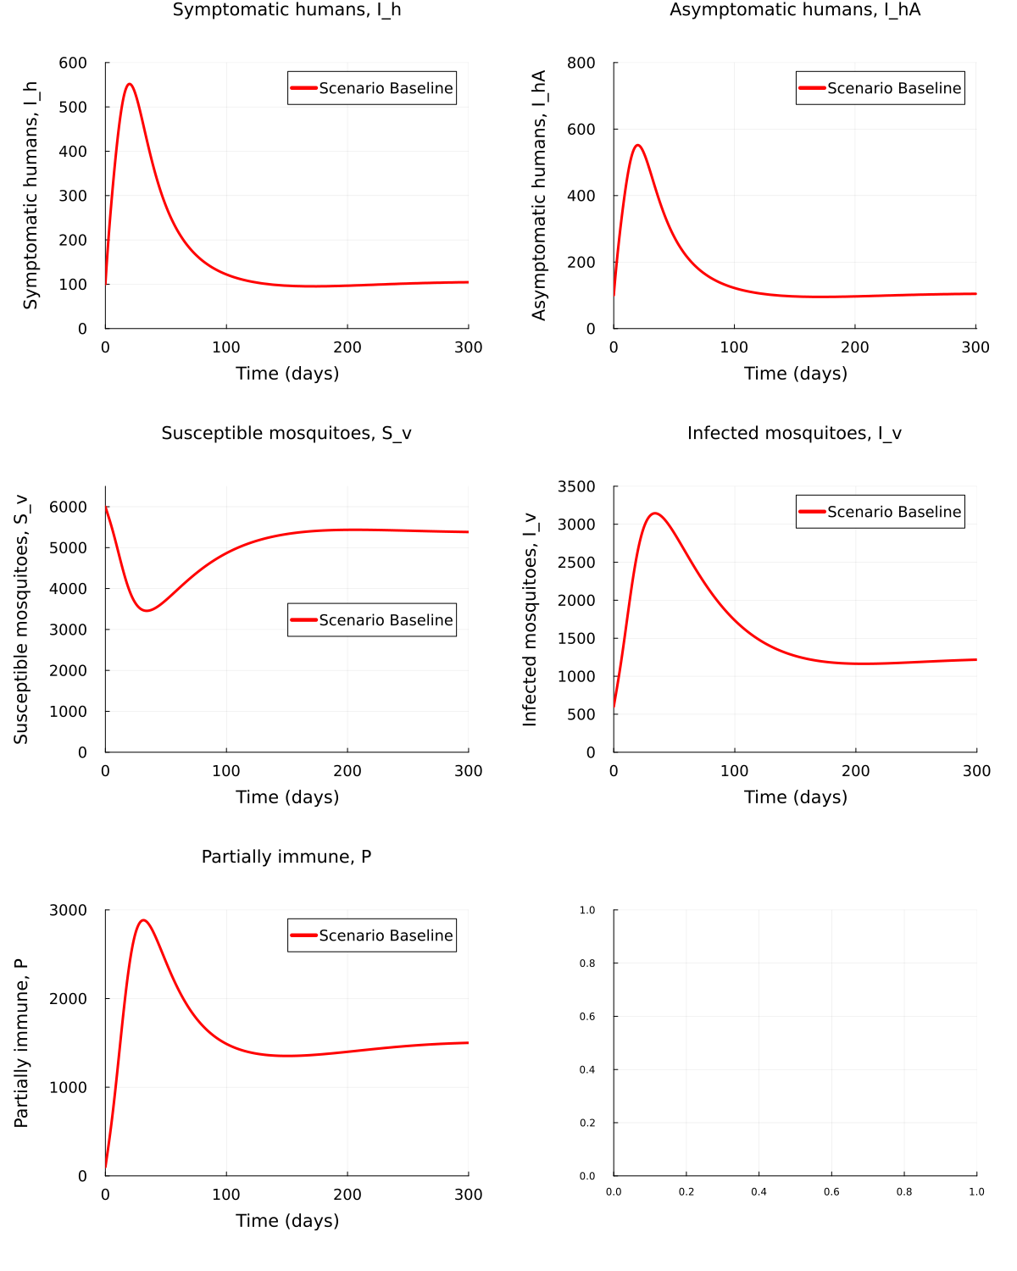

# Strategies

# Weights for the objective function  
C_1 = 5;   
C_2 = 5;   
C_3 = 5;   
D_1= 16.62;   
D_2 = 2.5;   
D_3 = 5;   
D_4 = 16.62;  
  
silent = true;

### Strategy A

This strategy combines the use of treated bednets and insectisides

outputA_values = open("OptDengue_StratA_log.txt", "w") do file  
 redirect_stdout(file) do  
 return run_optimization(0.75, 0, 0, 0.75)  
 end  
end  
  
# Now extract values from output_values  
u1_opt_A, u2_opt_A, u3_opt_A, u4_opt_A, S_h_opt_A, I_h_opt_A, I_hA_opt_A, P_opt_A, R_h_opt_A, S_v_opt_A, I_v_opt_A = outputA_values;

┌ Warning: Axis contains one element: 601. If intended, you can safely ignore this warning. To explicitly pass the axis with one element, pass `[601]` instead of `601`.  
└ @ JuMP.Containers ~/.julia/packages/JuMP/xlp0s/src/Containers/DenseAxisArray.jl:185  
┌ Warning: Axis contains one element: 601. If intended, you can safely ignore this warning. To explicitly pass the axis with one element, pass `[601]` instead of `601`.  
└ @ JuMP.Containers ~/.julia/packages/JuMP/xlp0s/src/Containers/DenseAxisArray.jl:185  
┌ Warning: Axis contains one element: 601. If intended, you can safely ignore this warning. To explicitly pass the axis with one element, pass `[601]` instead of `601`.  
└ @ JuMP.Containers ~/.julia/packages/JuMP/xlp0s/src/Containers/DenseAxisArray.jl:185  
┌ Warning: Axis contains one element: 601. If intended, you can safely ignore this warning. To explicitly pass the axis with one element, pass `[601]` instead of `601`.  
└ @ JuMP.Containers ~/.julia/packages/JuMP/xlp0s/src/Containers/DenseAxisArray.jl:185

Plot optimal results obtained from Strategy A vs Baseline

Scenario_A = create_combined_plot(t_base,   
 [u1_opt_A, u2_opt_A, u3_opt_A, u4_opt_A],   
 [S_h_baseline, S_h_opt_A],   
 [I_h_baseline, I_h_opt_A],  
 [I_h_baseline, I_h_opt_A],   
 [P_baseline, P_opt_A],   
 [R_h_baseline, R_h_opt_A],   
 [S_v_baseline, S_v_opt_A],   
 [I_v_baseline, I_v_opt_A],  
 ["Baseline", "Strategy A"], save=false)

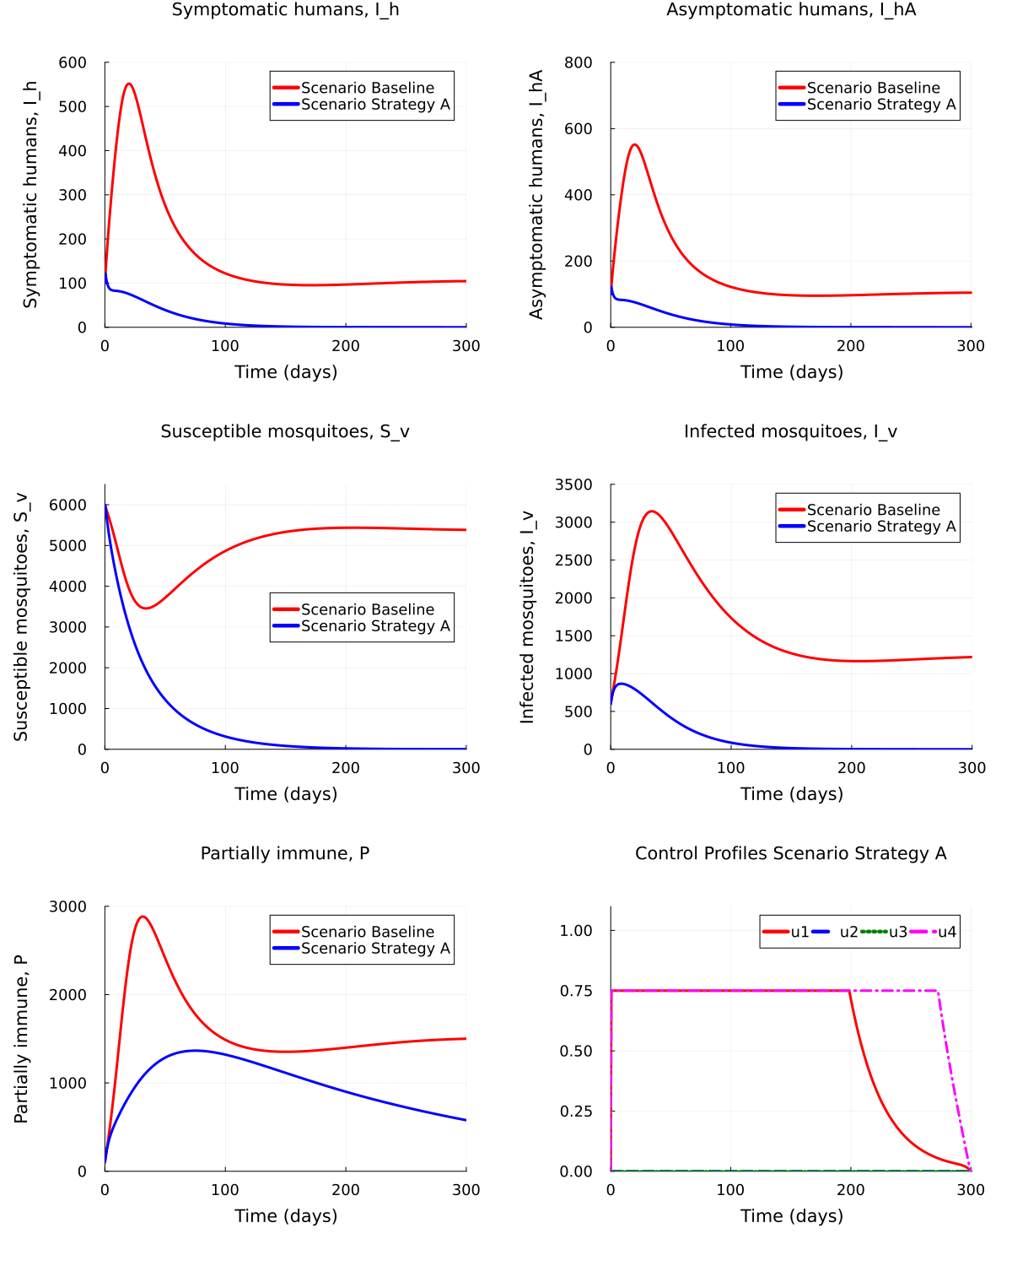

### Strategy B

This strategy combines the use of treatment (prophylactics) and vaccination

outputB_values = open("OptDengue_StratB_log.txt", "w") do file  
 redirect_stdout(file) do  
 return run_optimization(0, 0.75, 0.75, 0)  
 end  
end  
  
# Now extract values from output_values  
u1_opt_B, u2_opt_B, u3_opt_B, u4_opt_B, S_h_opt_B, I_h_opt_B, I_hA_opt_B, P_opt_B, R_h_opt_B, S_v_opt_B, I_v_opt_B = outputB_values;

┌ Warning: Axis contains one element: 601. If intended, you can safely ignore this warning. To explicitly pass the axis with one element, pass `[601]` instead of `601`.  
└ @ JuMP.Containers ~/.julia/packages/JuMP/xlp0s/src/Containers/DenseAxisArray.jl:185  
┌ Warning: Axis contains one element: 601. If intended, you can safely ignore this warning. To explicitly pass the axis with one element, pass `[601]` instead of `601`.  
└ @ JuMP.Containers ~/.julia/packages/JuMP/xlp0s/src/Containers/DenseAxisArray.jl:185  
┌ Warning: Axis contains one element: 601. If intended, you can safely ignore this warning. To explicitly pass the axis with one element, pass `[601]` instead of `601`.  
└ @ JuMP.Containers ~/.julia/packages/JuMP/xlp0s/src/Containers/DenseAxisArray.jl:185  
┌ Warning: Axis contains one element: 601. If intended, you can safely ignore this warning. To explicitly pass the axis with one element, pass `[601]` instead of `601`.  
└ @ JuMP.Containers ~/.julia/packages/JuMP/xlp0s/src/Containers/DenseAxisArray.jl:185

Plot optimal results obtained from Strategy B vs Baseline

Scenario_B = create_combined_plot(t_base,   
 [u1_opt_B, u2_opt_B, u3_opt_B, u4_opt_B],   
 [S_h_baseline, S_h_opt_B],   
 [I_h_baseline, I_h_opt_B],  
 [I_h_baseline, I_h_opt_B],   
 [P_baseline, P_opt_B],   
 [R_h_baseline, R_h_opt_B],   
 [S_v_baseline, S_v_opt_B],   
 [I_v_baseline, I_v_opt_B],  
 ["Baseline", "Strategy B"], P_axis=10000, save=false)

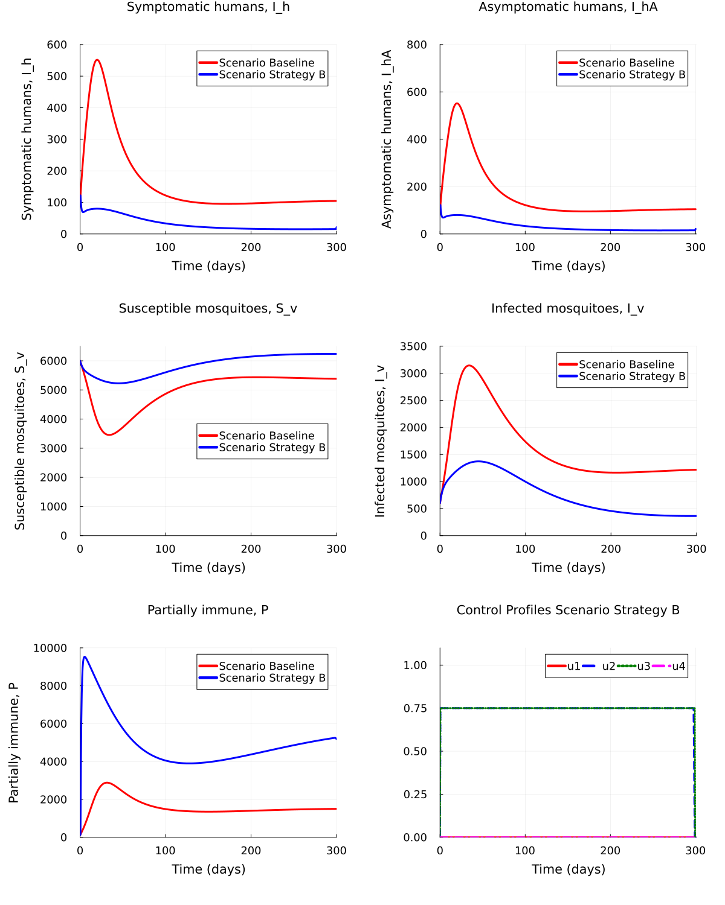

### Strategy C

This strategy combines the use of treated bednets, treatment (prophylactics) and insectisides

outputC_values = open("OptDengue_StratC_log.txt", "w") do file  
 redirect_stdout(file) do  
 return run_optimization(0.75, 0, 0.75, 0.75)  
 end  
end  
  
# Now extract values from output_values  
u1_opt_C, u2_opt_C, u3_opt_C, u4_opt_C, S_h_opt_C, I_h_opt_C, I_hA_opt_C, P_opt_C, R_h_opt_C, S_v_opt_C, I_v_opt_C = outputC_values;

┌ Warning: Axis contains one element: 601. If intended, you can safely ignore this warning. To explicitly pass the axis with one element, pass `[601]` instead of `601`.  
└ @ JuMP.Containers ~/.julia/packages/JuMP/xlp0s/src/Containers/DenseAxisArray.jl:185  
┌ Warning: Axis contains one element: 601. If intended, you can safely ignore this warning. To explicitly pass the axis with one element, pass `[601]` instead of `601`.  
└ @ JuMP.Containers ~/.julia/packages/JuMP/xlp0s/src/Containers/DenseAxisArray.jl:185  
┌ Warning: Axis contains one element: 601. If intended, you can safely ignore this warning. To explicitly pass the axis with one element, pass `[601]` instead of `601`.  
└ @ JuMP.Containers ~/.julia/packages/JuMP/xlp0s/src/Containers/DenseAxisArray.jl:185  
┌ Warning: Axis contains one element: 601. If intended, you can safely ignore this warning. To explicitly pass the axis with one element, pass `[601]` instead of `601`.  
└ @ JuMP.Containers ~/.julia/packages/JuMP/xlp0s/src/Containers/DenseAxisArray.jl:185

Plot optimal results obtained from Strategy C vs Baseline

Scenario_C = create_combined_plot(t_base,   
 [u1_opt_C, u2_opt_C, u3_opt_C, u4_opt_C],   
 [S_h_baseline, S_h_opt_C],   
 [I_h_baseline, I_h_opt_C],  
 [I_h_baseline, I_h_opt_C],   
 [P_baseline, P_opt_C],   
 [R_h_baseline, R_h_opt_C],   
 [S_v_baseline, S_v_opt_C],   
 [I_v_baseline, I_v_opt_C],  
 ["Baseline", "Strategy C"], save=false)

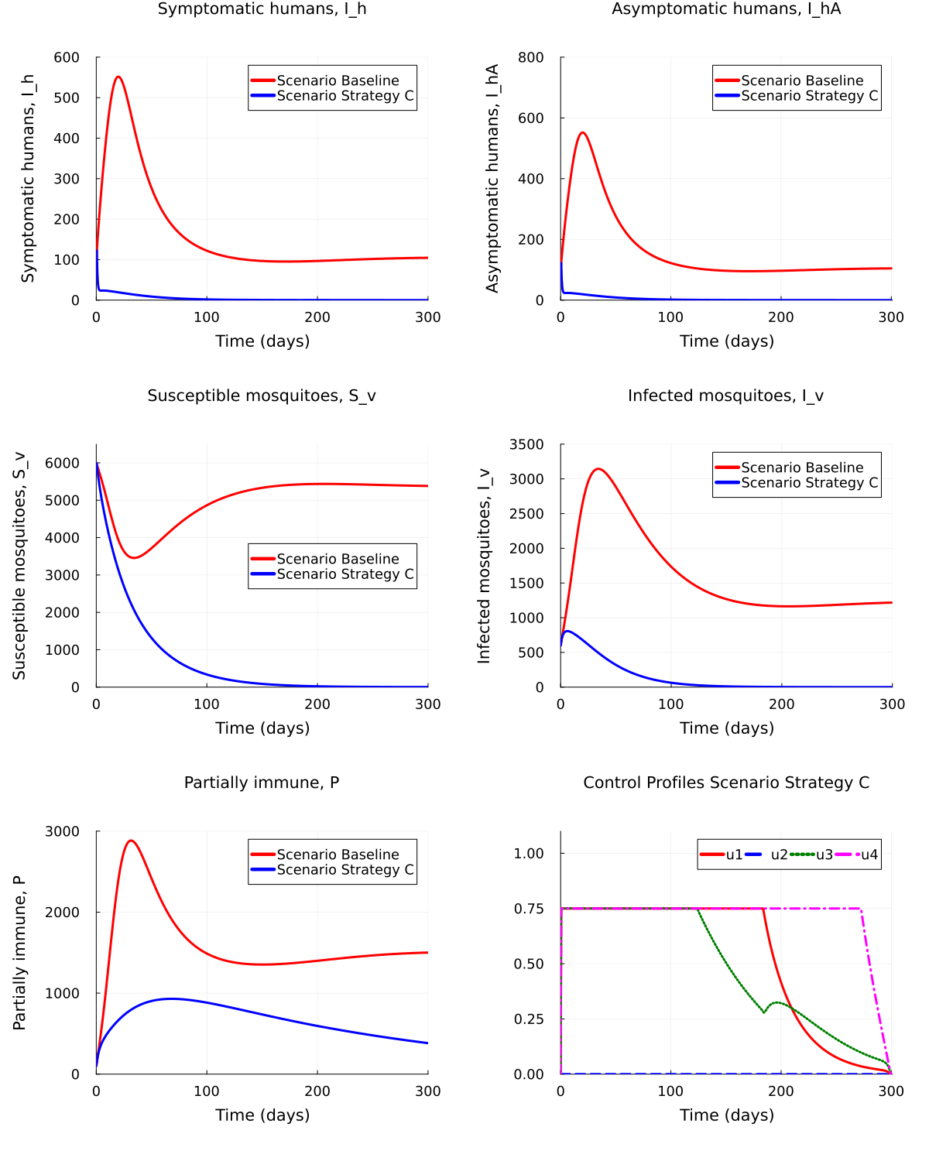

### Strategy D

This strategy combines the use of treated bednets, insectisides and vaccination

outputD_values = open("OptDengue_StratD_log.txt", "w") do file  
 redirect_stdout(file) do  
 return run_optimization(0.75, 0.75, 0, 0.75)  
 end  
end  
  
# Now extract values from output_values  
u1_opt_D, u2_opt_D, u3_opt_D, u4_opt_D, S_h_opt_D, I_h_opt_D, I_hA_opt_D, P_opt_D, R_h_opt_D, S_v_opt_D, I_v_opt_D = outputD_values;

┌ Warning: Axis contains one element: 601. If intended, you can safely ignore this warning. To explicitly pass the axis with one element, pass `[601]` instead of `601`.  
└ @ JuMP.Containers ~/.julia/packages/JuMP/xlp0s/src/Containers/DenseAxisArray.jl:185  
┌ Warning: Axis contains one element: 601. If intended, you can safely ignore this warning. To explicitly pass the axis with one element, pass `[601]` instead of `601`.  
└ @ JuMP.Containers ~/.julia/packages/JuMP/xlp0s/src/Containers/DenseAxisArray.jl:185  
┌ Warning: Axis contains one element: 601. If intended, you can safely ignore this warning. To explicitly pass the axis with one element, pass `[601]` instead of `601`.  
└ @ JuMP.Containers ~/.julia/packages/JuMP/xlp0s/src/Containers/DenseAxisArray.jl:185  
┌ Warning: Axis contains one element: 601. If intended, you can safely ignore this warning. To explicitly pass the axis with one element, pass `[601]` instead of `601`.  
└ @ JuMP.Containers ~/.julia/packages/JuMP/xlp0s/src/Containers/DenseAxisArray.jl:185

Plot optimal results obtained from Strategy D vs Baseline

Scenario_D = create_combined_plot(t_base,   
 [u1_opt_D, u2_opt_D, u3_opt_D, u4_opt_D],   
 [S_h_baseline, S_h_opt_D],   
 [I_h_baseline, I_h_opt_D],  
 [I_h_baseline, I_h_opt_D],   
 [P_baseline, P_opt_D],   
 [R_h_baseline, R_h_opt_D],   
 [S_v_baseline, S_v_opt_D],   
 [I_v_baseline, I_v_opt_D],  
 ["Baseline", "Strategy D"], P_axis=12000, P_legend=:right, save=false)

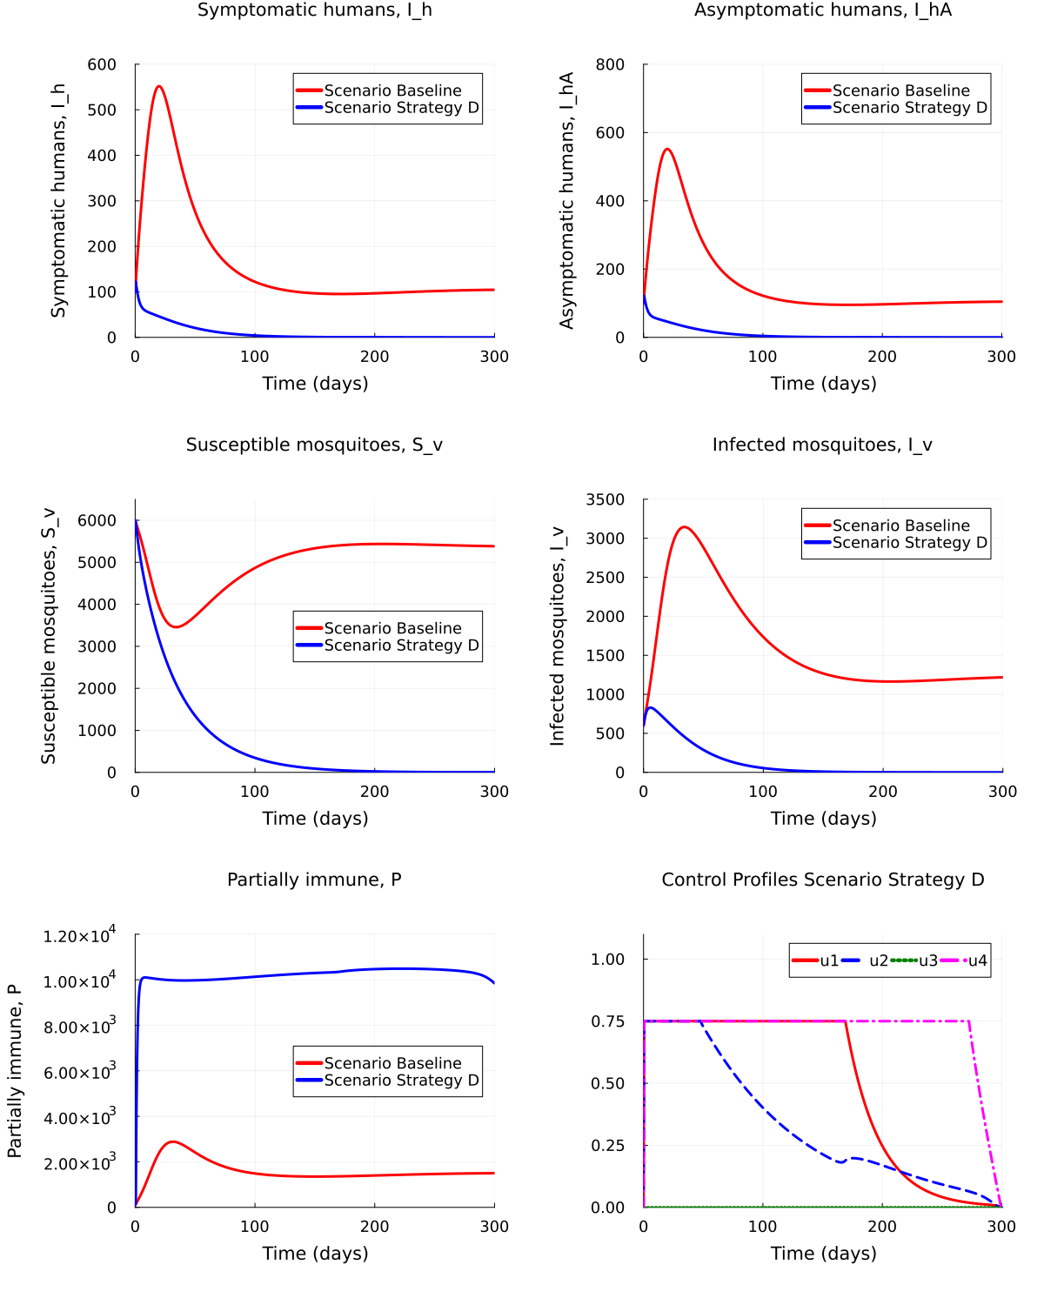

### Strategy E

This strategy combines the use of the four control interventions treated bednets, insectisides, treatment and vaccination

outputE_values = open("OptDengue_StratE_log.txt", "w") do file  
 redirect_stdout(file) do  
 return run_optimization(0.75, 0.75, 0.75, 0.75)  
 end  
end  
  
# Now extract values from output_values  
u1_opt_E, u2_opt_E, u3_opt_E, u4_opt_E, S_h_opt_E, I_h_opt_E, I_hA_opt_E, P_opt_E, R_h_opt_E, S_v_opt_E, I_v_opt_E = outputE_values;

┌ Warning: Axis contains one element: 601. If intended, you can safely ignore this warning. To explicitly pass the axis with one element, pass `[601]` instead of `601`.  
└ @ JuMP.Containers ~/.julia/packages/JuMP/xlp0s/src/Containers/DenseAxisArray.jl:185  
┌ Warning: Axis contains one element: 601. If intended, you can safely ignore this warning. To explicitly pass the axis with one element, pass `[601]` instead of `601`.  
└ @ JuMP.Containers ~/.julia/packages/JuMP/xlp0s/src/Containers/DenseAxisArray.jl:185  
┌ Warning: Axis contains one element: 601. If intended, you can safely ignore this warning. To explicitly pass the axis with one element, pass `[601]` instead of `601`.  
└ @ JuMP.Containers ~/.julia/packages/JuMP/xlp0s/src/Containers/DenseAxisArray.jl:185  
┌ Warning: Axis contains one element: 601. If intended, you can safely ignore this warning. To explicitly pass the axis with one element, pass `[601]` instead of `601`.  
└ @ JuMP.Containers ~/.julia/packages/JuMP/xlp0s/src/Containers/DenseAxisArray.jl:185

Plot optimal results obtained from Strategy E vs Baseline

Scenario_E = create_combined_plot(t_base,   
 [u1_opt_E, u2_opt_E, u3_opt_E, u4_opt_E],   
 [S_h_baseline, S_h_opt_E],   
 [I_h_baseline, I_h_opt_E],  
 [I_h_baseline, I_h_opt_E],   
 [P_baseline, P_opt_E],   
 [R_h_baseline, R_h_opt_E],   
 [S_v_baseline, S_v_opt_E],   
 [I_v_baseline, I_v_opt_E],  
 ["Baseline", "Strategy E"], P_axis=12000, P_legend=:right, save=false)

