Exponential infection model with a lockdown control using indirect and direct methods

Sandra Montes (@slmontes), 2025-04-07

## Introduction

This example explores the optimal control of an SIR (Susceptible-Infected-Recovered) model using a time-varying intervention that reduces the infection rate. To simplify the dynamics, it is assumed that the susceptible population remains approximately constant throughout the time horizon, i.e., S ≈ N. This assumption is valid during the early stages of an outbreak when the number of infections is still relatively small compared to the total population.

Under this simplification, the model focuses on a single compartment of infected individuals (I). The intervention is modelled as a time-dependent control variable υ(t) that reduces the effective transmission rate by a factor of 1 - υ(t), where υ(t) ∈ [0, 1] represents the intensity of the applied control (e.g., social distancing or lockdown measures).

The model is described by:

$$\begin{matrix}\frac{dI}{dt} & =\left(β*\left(1−υ\left(t\right)\right)*N−γ\right)*I\end{matrix}$$

Here, β is the transmission rate, γ is the recovery rate, and N is the total population.

In this example, the goal is to minimise the number of infected individuals over time. To determine whether an optimal policy can be derived both analytically and numerically, we apply Pontryagin’s Maximum Principle (PMP) using Euler discretisation to establish the optimality conditions and perform the numerical simulations using the forward-backwards method. We then compare this analytical solution with a numerical optimisation approach implemented in JuMP.jl, utilising the IPOPT solver.

## Optimal control formulation

Objective functional:

$$\begin{matrix}J=\int_{0}^{T_{f}}{\left[AI\left(t\right)+Bυ{\left(t\right)}^{2}\right]}dt\end{matrix}$$

where: - A: weight for the number of infected individuals  
- B: weight for the control effort quadratically - υ: control variable $0≤υ\left(t\right)≤υ_{max}$

Hamiltonian:

$$\begin{matrix}H\left(I,υ,λ\right)=AI+Bυ^{2}+λ⋅\left(\left(β\left(1−υ\right)N−γ\right)I\right)\end{matrix}$$

where $λ$ is the adjoint variable associated with the state I

Adjoint equation:

$$\begin{matrix}\frac{dλ}{dt}=−\frac{∂H}{∂I}=−A−λ\left(β\left(1−υ\right)N−γ\right)\end{matrix}$$

Optimality condition:

$$\begin{matrix}\frac{∂H}{∂υ}=2Bυ−λ⋅βNI=0\end{matrix}$$

we then solve for υ

$$\begin{matrix}υ^{*}=\frac{λ⋅βNI}{2B}\end{matrix}$$

and add the control bounds

$$\begin{matrix}υ^{*}\left(t\right)=min\left(max\left(0,\frac{λ\left(t\right)⋅βNI\left(t\right)}{2B}\right),υ_{max}\right)\end{matrix}$$

## Running the model without intervention

## Libraries

using OrdinaryDiffEq  
using JuMP  
using Ipopt  
using Plots;

Model

function infection!(du,u,p,t)  
 I = u[1]  
 (β, γ, υ, N) = p  
 @inbounds begin  
 du[1] = (β * (1 - υ) * N - γ) * I  
 end  
 nothing  
end;

Parameters

u0 = [0.1]; #I  
p = [0.5, 0.25, 0.0, 0.9]; # β, γ, υ, N  
t0 = 0.0  
tf = 100  
dt = 0.1  
ts = collect(t0:dt:tf)  
alg = Tsit5();

Solve using ODEProblem

prob_base = ODEProblem(infection!, u0, (t0, tf), p)  
sol_base = solve(prob_base, alg, saveat=ts);

plot(sol_base,  
 xlim = [0, 25],  
 ylim = [0, 15],  
 linewidth=5, color=:red,  
 xtickfontsize=14,ytickfontsize=14,  
 xguidefontsize=16,yguidefontsize=16,  
 label="I", legendfontsize=14,  
 xlabel="Time (days)",  
 ylabel="Population", size=(700,500), dpi=300)  
 # savefig("baseline_expinf.png")

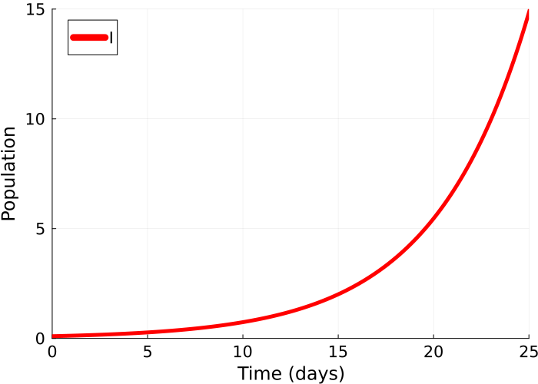

fianl_I_base = sol_base[end][1]  
println("Without control the final number of infectees is: ",   
 round(fianl_I_base, digits=-5)," at t=", tf)

Without control the final number of infectees is: 4.85e7 at t=100

# Numerical simulations using the analytical formulation from PMP and forward-backward sweep

Forward-Backward Sweep Method

function exp_sir_forward_backward(I₀, β, γ, υ_max, N, tf, dt, A=1.0, B=1.0; tol=1e-6)  
 T = Int(tf / dt)  
 t = range(0, tf, length=T+1)  
  
 I = zeros(T+1); I[1] = I₀  
 λI = zeros(T+1)  
 υ = zeros(T+1)  
  
 δ = 1e-3  
 sweep = 0  
 test = -1.0  
 max_iter = 10000  
  
 while test < 0 && sweep < max_iter  
 sweep += 1  
  
 I_old = copy(I)  
 υ_old = copy(υ)  
 λI_old = copy(λI)  
  
 # FORWARD SWEEP  
 for k in 1:T  
 infection = dt * β * (1 - υ[k]) * N * I[k]  
 recovery = dt * γ * I[k]  
 I[k+1] = I[k] + infection - recovery  
 end  
  
 # BACKWARD SWEEP  
 λI[T+1] = 0.0  
 for k in T:-1:1  
 λI[k] = λI[k+1] + dt * (-A + λI[k+1] * (β * (1 - υ[k]) * N - γ))  
 end  
  
 # CONTROL UPDATE  
 temp = -λI.*β.*N.*I./(2 .* B)  
 υ_new = clamp.(temp, 0.0, υ_max)  
 υ .= 0.5 .* (υ_new .+ υ_old)  
  
 test = minimum([  
 δ * sum(abs.(υ)) - sum(abs.(υ .- υ_old)),  
 δ * sum(abs.(I)) - sum(abs.(I .- I_old)),  
 δ * sum(abs.(λI)) - sum(abs.(λI .- λI_old))  
 ])  
 end  
  
 if test ≥ 0  
 println("Converged in $sweep sweeps.")  
 else  
 println("Did not converge in $sweep sweeps.")  
 end  
  
 # Final forward pass to get the optimal I under optimal υ  
 I_opt = zeros(T+1)  
 I_opt[1] = I₀  
 for k in 1:T  
 infection = dt * β * (1 - υ[k]) * N * I_opt[k]  
 recovery = dt * γ * I_opt[k]  
 I_opt[k+1] = I_opt[k] + infection - recovery  
 end  
  
 return (; t, I=I_opt, υ, λI)  
end

exp_sir_forward_backward (generic function with 3 methods)

Parameters

p2 = copy(p)  
υ_max = p2[3] = 0.5 #Set υ to 0.5  
β = p2[1]  
γ = p2[2]  
N = p2[4]  
A = 10  
B = 0.01  
I0 = u0[1];

res = exp_sir_forward_backward(I0, β, γ, υ_max, N, tf, dt, A, B)

Converged in 14 sweeps.

(t = 0.0:0.1:100.0, I = [0.1, 0.09975013732910157, 0.09950089897174622, 0.09925228336800745, 0.09900428896185647, 0.09875691420115236, 0.09851015753763248, 0.0982640174269027, 0.09801849232842773, 0.09777358070552154 … 0.008380708698505991, 0.008359768435911687, 0.008338880495216793, 0.008318044745688416, 0.008297261056920312, 0.008276529298832075, 0.008255849341668321, 0.008235221055997877, 0.008260890931513616, 0.008356005254263348], υ = [0.499969482421875, 0.499969482421875, 0.499969482421875, 0.499969482421875, 0.499969482421875, 0.499969482421875, 0.499969482421875, 0.499969482421875, 0.499969482421875, 0.499969482421875 … 0.499969482421875, 0.499969482421875, 0.499969482421875, 0.499969482421875, 0.499969482421875, 0.499969482421875, 0.499969482421875, 0.3751759118514946, 0.18858201578102318, 0.0], λI = [-367.5826563867217, -367.50039801176143, -367.4179337025231, -367.3352629434491, -367.25238521769114, -367.1693000071071, -367.08600679225754, -367.00250505240274, -366.91879426549923, -366.8348739081966 … -8.915981485799078, -7.935799187444237, -6.953162997505451, -5.968066772652123, -4.9805043541737914, -3.990469567941634, -2.9979562243698625, -2.0029581183770278, -1.0, 0.0])

t = res.t  
u_fb_opt = res.υ  
I_fb_opt = res.I  
  
p1 = plot(t, I_fb_opt,   
 linewidth=5, color=:red,  
 xtickfontsize=14, ytickfontsize=14,  
 xguidefontsize=16, yguidefontsize=16,  
 label="I", legendfontsize=14,  
 xlabel="Time (days)",  
 ylabel="Population")  
  
p2 = plot(t, u_fb_opt,   
 linewidth=5, color=:green,  
 xtickfontsize=14, ytickfontsize=14,  
 xguidefontsize=16, yguidefontsize=16,  
 label="F-B optimal υ", legendfontsize=14,  
 xlabel="Time (days)",  
 ylabel="Control value",  
 legend=:left)  
  
plot(p1, p2, layout=(2,1), size=(700,800), dpi=300)  
# savefig("FB_expinf.png")

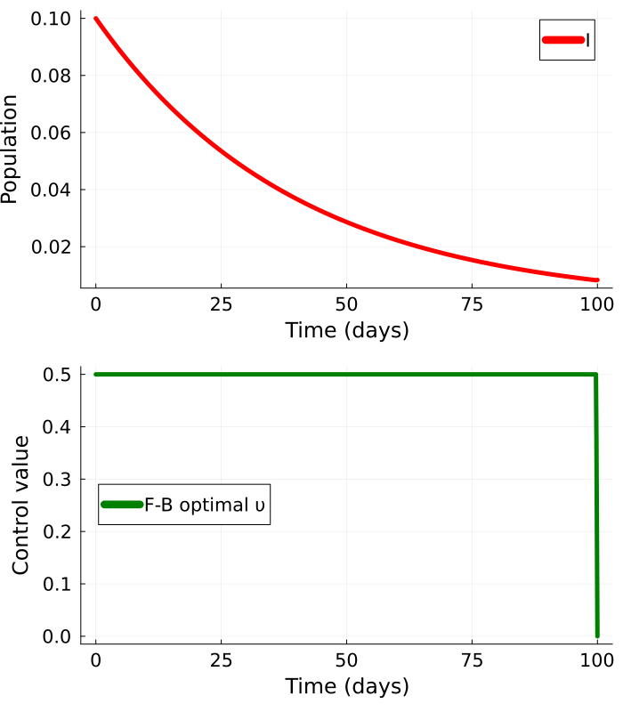

fianl_I_fb = I_fb_opt[end][1]  
println("Applying optimal control (Forward-Backward method)   
the final number of infectees is: ",   
round(fianl_I_fb, digits=3)," at t=", tf)

Applying optimal control (Forward-Backward method)   
the final number of infectees is: 0.008 at t=100

# Solving optimal problem using JuMP

Parameters (same as before)

T = Int(tf/dt);

Model setup

model = Model(Ipopt.Optimizer)  
set_optimizer_attribute(model, "max_iter", 1000)

Variables

@variable(model, 0 <= I[1:(T+1)] <= 1)  
@variable(model, 0 <= υ[1:(T+1)] <= υ_max);

Model expressions

@expressions(model, begin  
 infection[t in 1:T], (1 - υ[t]) * β * N * I[t] * dt # Linear approximation of infection rate  
 recovery[t in 1:T], γ * dt * I[t] # Recoveries at each time step  
 end);

Model constraints described by the expressions

@constraints(model, begin  
 I[1]==I0  
 [t=1:T], I[t+1] == I[t] + infection[t] - recovery[t]  
end);

Minimise the objective function

@objective(model, Min, sum(dt * (A * I[t] + B * υ[t]^2) for t in 1:T+1));

Set model to silent to prevent printing full optimisation output

silent = true  
if silent  
 set_silent(model)  
end  
if !silent  
 set_optimizer_attribute(model, "output_file", "JuMP_lockdown.txt")  
 set_optimizer_attribute(model, "print_timing_statistics", "yes")  
end  
optimize!(model);

termination_status(model)

LOCALLY_SOLVED::TerminationStatusCode = 4

I_opt = value.(I)  
υ_opt = value.(υ);

p3 = plot(t, I_opt,   
 linewidth=5, color=:red,  
 xtickfontsize=14, ytickfontsize=14,  
 xguidefontsize=16, yguidefontsize=16,  
 label="I", legendfontsize=14,  
 xlabel="Time (days)",  
 ylabel="Population")  
  
p4 = plot(t, υ_opt,   
 linewidth=5, color=:purple,  
 xtickfontsize=14, ytickfontsize=14,  
 xguidefontsize=16, yguidefontsize=16,  
 label="JuMP optimal υ", legendfontsize=14,  
 xlabel="Time (days)",  
 ylabel="Control value",  
 legend=:left)  
  
plot(p3, p4, layout=(2,1), size=(700,800), dpi=300)  
# savefig("JuMP_expinf.png")

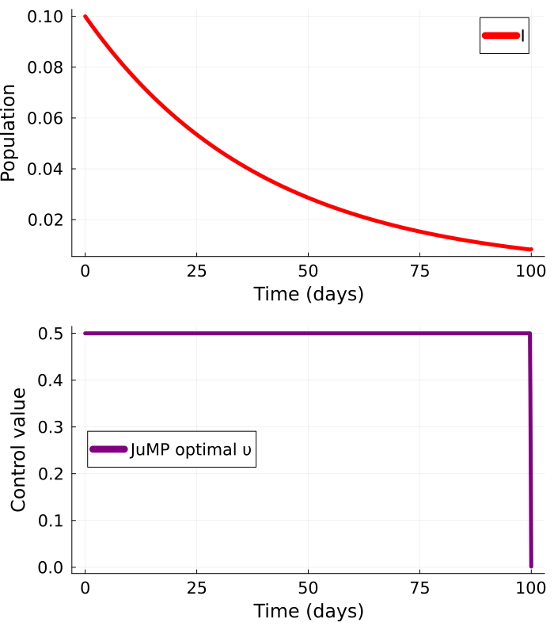

fianl_I_jump = I_opt[end]  
println("Applying optimal control (JuMP)   
the final number of infectees is: ",   
round(fianl_I_jump, digits=3)," at t=", tf)

Applying optimal control (JuMP)   
the final number of infectees is: 0.008 at t=100