Solver comparison on lockdown optimisation case scenario using JuMP.jl
Simon Frost (@sdwfrost) and Sandra Montes (@slmontes)
2026-01-10

Introduction
This example explores the optimal control of an SIR (Susceptible-Infected-Recovered) model using a time-varying intervention that reduces the infection rate. The population is divided into three categories: susceptible individuals (S), infected individuals (I), and the total number of cases (C). The intervention is modelled as a time-dependent control variable υ(t) that reduces the transmission rate by a factor of 1 - υ(t). The goal is to determine the optimal timing and application of this intervention to minimise the final number of cases (C) under the following constraints: (a) υ cannot exceed a maximum value, and (b) the total cost, measured as the integral of υ over time, must remain within a specified limit.
The model is described by the following differential equations:
$$\begin{matrix}\frac{dS}{dt} & =−β\left(1−υ\left(t\right)\right)SI, \\ \frac{dI}{dt} & =β\left(1−υ\left(t\right)\right)SI−γI, \\ \frac{dC}{dt} & =β\left(1−υ\left(t\right)\right)SI,\end{matrix}$$
Here, β is the transmission rate, and γ is the recovery rate.
In a study by Britton and Leskela (2022), it was demonstrated that the optimal strategy for controlling the epidemic under the above model involves a single lockdown at a set maximum intervention level for υ, sustained until the cost reaches the specified threshold. To determine whether the optimal policy can be identified numerically, we use a simple Euler discretisation and then use JuMP.jl to formulate the optimisation problem.
We compare three nonlinear programming solvers—Ipopt, MadNLP, and UnoSolver—to assess their performance in terms of solution, convergence, and computational efficiency.

Libraries
using OrdinaryDiffEq
using DiffEqCallbacks
using JuMP
using Ipopt
using MadNLP
using UnoSolver
using Plots
Plots.default(fmt = :png) # or :svg
using Measures
using DataInterpolations
using NonlinearSolve
using BenchmarkTools
using DataFrames
using Printf
using Statistics;

Parameters
β = 0.5
γ = 0.25
υ_max = 0.5
υ_total = 10.0
S0 = 0.99
I0 = 0.01
C0 = 0.0
t0 = 0.0
tf = 100.0
dt = 0.1
T = Int(tf/dt)
ts = [t0 + i*dt for i in 0:T]

Methods
We discretise the NLP problem using Euler’s method with a time step of dt = 0.1 over the time horizon [0, 100] days, resulting in T = 1000 time steps. The optimisation problem is formulated using JuMP.jl, with the objective of minimising the final cumulative cases C[T+1] subject to the discretised ODE constraints and the cost constraint on the total intervention.

Solver Configuration
To ensure a fair comparison, we set consistent tolerances, iteration limits, and time limits across all solvers. All solvers are configured with a convergence tolerance of 1e-6, a constraint violation tolerance of 1e-6, a maximum iteration limit of 10,000, and a time limit of 1,800 seconds (30 minutes).
# Common solver settings
const COMMON_TOL = 1e-6 # Convergence tolerance
const COMMON_CONSTR_TOL = 1e-6 # Constraint violation tolerance
const COMMON_MAX_ITER = 10000 # Maximum iterations
const COMMON_TIME_LIMIT = (600.0*3) # Time limit in seconds (30 minutes)
# Benchmarking settings
n_samples_sir = 5 # Samples for benchmarking
n_sec_sir = 60 # Seconds to run the benchmark per sample
n_samples_dengue = 5 # Samples for benchmarking
n_sec_dengue = 300 # Seconds to run the benchmark per sample
function configure_solver!(model, solver_type::Symbol)
set_silent(model)
if solver_type == :Ipopt
set_optimizer_attribute(model, "tol", COMMON_TOL)
set_optimizer_attribute(model, "constr_viol_tol", COMMON_CONSTR_TOL)
set_optimizer_attribute(model, "max_iter", COMMON_MAX_ITER)
set_optimizer_attribute(model, "max_wall_time", COMMON_TIME_LIMIT)
set_optimizer_attribute(model, "warm_start_init_point", "no")
elseif solver_type == :MadNLP
set_optimizer_attribute(model, "tol", COMMON_TOL)
set_optimizer_attribute(model, "constr_viol_tol", COMMON_CONSTR_TOL)
set_optimizer_attribute(model, "max_iter", COMMON_MAX_ITER)
set_optimizer_attribute(model, "max_wall_time", COMMON_TIME_LIMIT)
elseif solver_type == :UnoSolver
set_optimizer_attribute(model, "tolerance", COMMON_TOL)
set_optimizer_attribute(model, "max_iterations", COMMON_MAX_ITER)
set_optimizer_attribute(model, "time_limit", COMMON_TIME_LIMIT)
end
return model
end

SIR Model Optimisation
We solve the SIR optimal control problem using each of the three solvers. For each solver, we benchmark the optimisation time and record the objective value and termination status. All benchmarks use the same number of samples (5) to ensure fair comparison. As benchmark times can vary between runs due to diverse factors such as system load and background processes; the standard deviation quantifies the variability within a single benchmark run across the samples.
function optimize_model(opt, solver_type::Symbol)
model = Model(opt)
# Apply consistent solver configuration
configure_solver!(model, solver_type)
# Variables
@variable(model, 0 <= S[1:(T+1)] <= 1)
@variable(model, 0 <= I[1:(T+1)] <= 1)
@variable(model, 0 <= C[1:(T+1)] <= 1)
@variable(model, 0 <= υ[1:(T+1)] <= υ_max)
@expressions(model, begin
infection[t in 1:T], (1 - υ[t]) * β * I[t] * dt * S[t] # Linear approximation of infection rate
recovery[t in 1:T], γ * dt * I[t] # Recoveries at each time step
end)
@constraints(model, begin
S[1]==S0
I[1]==I0
C[1]==C0
[t=1:T], S[t+1] == S[t] - infection[t]
[t=1:T], I[t+1] == I[t] + infection[t] - recovery[t]
[t=1:T], C[t+1] == C[t] + infection[t]
dt * sum(υ[t] for t in 1:T+1) <= υ_total
end)
# Set consistent starting values for all solvers
set_start_value.(S, S0)
set_start_value.(I, I0)
set_start_value.(C, C0)
set_start_value.(υ, 0.0)
@objective(model, Min, C[T+1])
optimize!(model)
return model
end
ipopt_bench = @benchmark ipopt_model = optimize_model(Ipopt.Optimizer, :Ipopt) samples=n_samples_sir seconds=n_sec_sir
BenchmarkTools.Trial: 5 samples with 1 evaluation per sample.
Range (min … max): 1.341 s … 1.623 s ┊ GC (min … max): 0.00% … 0.00%
Time (median): 1.415 s ┊ GC (median): 0.00%
Time (mean ± σ): 1.450 s ± 120.030 ms ┊ GC (mean ± σ): 0.00% ± 0.00%
█ █ █ █ █
█▁█▁▁▁▁▁▁▁▁▁▁▁▁█▁▁▁▁▁▁▁▁▁▁▁▁▁▁▁▁▁▁▁▁▁█▁▁▁▁▁▁▁▁▁▁▁▁▁▁▁▁▁▁▁█ ▁
1.34 s Histogram: frequency by time 1.62 s <
Memory estimate: 86.02 MiB, allocs estimate: 1547823.
ipopt_time = round(mean(ipopt_bench.times) / 1e9, digits=4) # Convert from nanoseconds to seconds
ipopt_time_std = round(std(ipopt_bench.times) / 1e9, digits=4) # Standard deviation in seconds
ipopt_model = optimize_model(Ipopt.Optimizer, :Ipopt)
ipopt_obj = objective_value(ipopt_model)
ipopt_status = termination_status(ipopt_model)
LOCALLY_SOLVED::TerminationStatusCode = 4
madnlp_bench = @benchmark madnlp_model = optimize_model(MadNLP.Optimizer, :MadNLP) samples=n_samples_sir seconds=n_sec_sir
BenchmarkTools.Trial: 5 samples with 1 evaluation per sample.
Range (min … max): 1.483 s … 1.868 s ┊ GC (min … max): 7.62% … 23.77%
Time (median): 1.584 s ┊ GC (median): 9.32%
Time (mean ± σ): 1.629 s ± 144.803 ms ┊ GC (mean ± σ): 12.30% ± 6.71%
█ █ █ █ █
█▁▁▁▁▁▁▁▁▁▁▁▁█▁█▁▁▁▁▁▁█▁▁▁▁▁▁▁▁▁▁▁▁▁▁▁▁▁▁▁▁▁▁▁▁▁▁▁▁▁▁▁▁▁▁█ ▁
1.48 s Histogram: frequency by time 1.87 s <
Memory estimate: 7.82 GiB, allocs estimate: 1947816.
madnlp_time = round(mean(madnlp_bench.times) / 1e9, digits=4)
madnlp_time_std = round(std(madnlp_bench.times) / 1e9, digits=4)
madnlp_model = optimize_model(MadNLP.Optimizer, :MadNLP)
madnlp_obj = objective_value(madnlp_model)
madnlp_status = termination_status(madnlp_model)
LOCALLY_SOLVED::TerminationStatusCode = 4
uno_bench = @benchmark uno_model = optimize_model(() -> UnoSolver.Optimizer(preset="ipopt"), :UnoSolver) samples=n_samples_sir seconds=n_sec_sir
BenchmarkTools.Trial: 5 samples with 1 evaluation per sample.
Range (min … max): 1.649 s … 1.797 s ┊ GC (min … max): 0.00% … 0.00%
Time (median): 1.707 s ┊ GC (median): 0.00%
Time (mean ± σ): 1.713 s ± 64.347 ms ┊ GC (mean ± σ): 0.00% ± 0.00%
██ █ █ █
██▁▁▁▁▁▁▁▁▁▁▁▁▁▁▁▁▁▁▁▁█▁▁▁▁▁▁▁▁▁▁▁▁▁▁▁▁▁█▁▁▁▁▁▁▁▁▁▁▁▁▁▁▁█ ▁
1.65 s Histogram: frequency by time 1.8 s <
Memory estimate: 85.99 MiB, allocs estimate: 1537605.
uno_time = round(mean(uno_bench.times) / 1e9, digits=4)
uno_time_std = round(std(uno_bench.times) / 1e9, digits=4)
uno_model = optimize_model(() -> UnoSolver.Optimizer(preset="ipopt"), :UnoSolver)
uno_obj = objective_value(uno_model)
uno_status = termination_status(uno_model)
LOCALLY_SOLVED::TerminationStatusCode = 4

Results Summary
# Create summary table
sir_results = DataFrame(
Solver = ["Ipopt", "MadNLP", "UnoSolver"],
Objective_Value = [ipopt_obj, madnlp_obj, uno_obj],
Solve_Time_s = [ipopt_time, madnlp_time, uno_time],
Solve_Time_std_s = [ipopt_time_std, madnlp_time_std, uno_time_std],
Status = [string(ipopt_status), string(madnlp_status), string(uno_status)]
)
# Format for display
sir_results_formatted = DataFrame(
Solver = sir_results.Solver,
Objective_Value = [@sprintf("%.6f", x) for x in sir_results.Objective_Value],
Solve_Time_s = [@sprintf("%.4f", x) for x in sir_results.Solve_Time_s],
Solve_Time_std_s = [@sprintf("%.4f", x) for x in sir_results.Solve_Time_std_s],
Status = sir_results.Status
)
println("SIR Model - Solver Comparison Results:")
println(" ")
sir_results_formatted
SIR Model - Solver Comparison Results:

Trajectory Comparison
# Create comparison plot with better formatting
p1 = plot(title="SIR model: cumulative cases",
xlabel="Time (days)",
ylabel="Cumulative cases",
ylim=(0,1),
xlim=(0,100),
legend=:bottomright,
size=(700, 500),
dpi=300,
xtickfontsize=14, ytickfontsize=14,
xguidefontsize=16, yguidefontsize=16,
right_margin=10pt)
plot!(p1, ts, value.(ipopt_model.obj_dict[:C]), label="Ipopt", linewidth=2, linestyle=:solid)
plot!(p1, ts, value.(madnlp_model.obj_dict[:C]), label="MadNLP", linewidth=2, linestyle=:dash)
plot!(p1, ts, value.(uno_model.obj_dict[:C]), label="UnoSolver", linewidth=2, linestyle=:dashdot)
p1
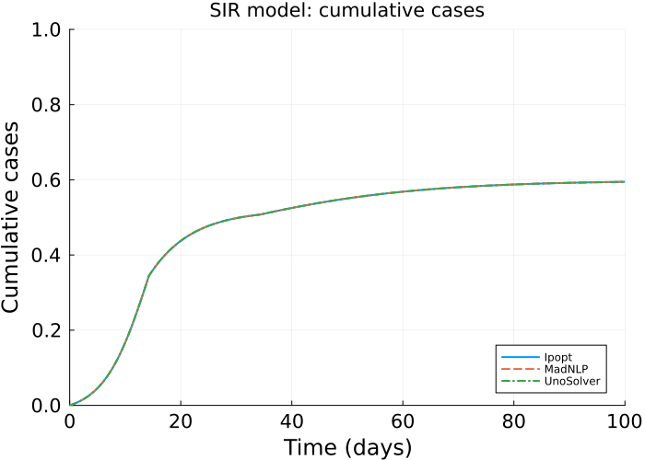
# Plot control variable comparison
p2 = plot(title="SIR model: control variable",
xlabel="Time (days)",
ylabel="Control level",
ylim=(0,1),
xlim=(0,100),
legend=:topright,
size=(700, 500),
dpi=300,
xtickfontsize=14, ytickfontsize=14,
xguidefontsize=16, yguidefontsize=16,
right_margin=10pt)
plot!(p2, ts, value.(ipopt_model.obj_dict[:υ]), label="Ipopt", linewidth=2, linestyle=:solid)
plot!(p2, ts, value.(madnlp_model.obj_dict[:υ]), label="MadNLP", linewidth=2, linestyle=:dash)
plot!(p2, ts, value.(uno_model.obj_dict[:υ]), label="UnoSolver", linewidth=2, linestyle=:dashdot)
plot!(p2, ts, fill(υ_max, length(ts)), color=:orange, alpha=0.7, label="Max υ", linewidth=1.5, linestyle=:dot)
p2
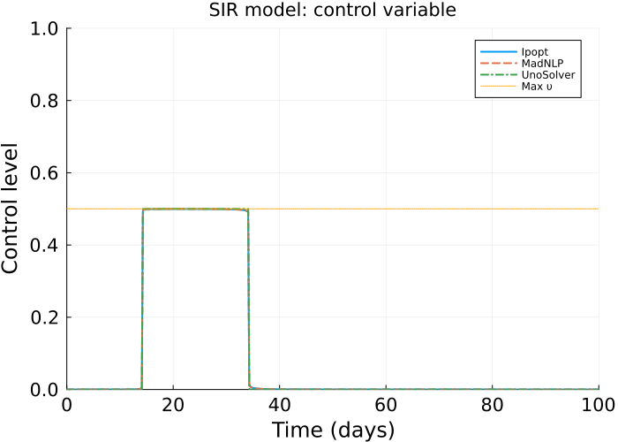

Dengue Model Comparison
To assess solver performance on more complex problems, we also test a Dengue transmission model with multiple states and controls. This model includes seven state variables (susceptible humans S_h, symptomatic infected humans I_h, asymptomatic carriers I_hA, partially immune individuals P, recovered humans R_h, susceptible mosquitoes S_v, and infected mosquitoes I_v) and four control variables (treated bednets u1, vaccination u2, treatment u3, and insecticides u4). The objective function minimises a weighted combination of infected populations and control costs over a 300-day time horizon with a time step of dt = 0.5 days.
function optimize_dengue(opt, solver_type::Symbol; u1_max=0.75, u2_max=0.75, u3_max=0.75, u4_max=0.75)
# Model definition
model = Model(opt)
# Apply consistent solver configuration
configure_solver!(model, solver_type)
u1_init = 0
u2_init = 0
u3_init = 0
u4_init = 0
t0 = 0.0
tf = 300.0
dt = 0.5
ts = collect(0:dt:tf)
S_h0 = 10000
I_h0 = 100
I_hA0 = 500
P0 = 100
R_h0 = 1000
S_v0 = 6000
I_v0 = 600
beta_1 = 0.75 # Transmission prob from I_v to S_h
beta_2 = 0.375 # Transmission prob from I_h to S_v
beta_3 = 0.75 # Transmission prb from I_v to P
b = 0.5 # Avg bitting rate per mosquito per person
rho = 0.01 # Proportion of treated individuals with partial immunity
psi = 0.4 # Proportion of incidence rate from S_h to I_h
gamma_h = 0.3288330 # Disease related death rate of humans
omega = 0.54 # Proportion of incidence rate from P to I_h
mu_h = 0.0045 # Natural mortality rate and recruitment rate of humans
mu_v = 0.0323 # Natural mortality rate and recruitment rate of vector
phi = 0.48 # Proportion of natural Recovery
r_0 = 0.005 # Enhance death rate
# Weights for the objective function
C_1 = 5
C_2 = 5
C_3 = 5
D_1 = 16.62
D_2 = 2.5
D_3 = 5
D_4 = 16.62
δ = 0.001
T = Int(tf/dt)
@variable(model, S_h[1:(T+1)] >= 0) # Susceptible humans
@variable(model, I_h[1:(T+1)] >= 0) # Infected symptomatic
@variable(model, I_hA[1:(T+1)] >= 0) # Carriers asymptomatic
@variable(model, P[1:(T+1)] >= 0) # Partially immune
@variable(model, R_h[1:(T+1)] >= 0) # Recovered humans
@variable(model, S_v[1:(T+1)] >= 0) # Susceptible mosquitoes
@variable(model, I_v[1:(T+1)] >= 0) # Infected mosquitoes
@variable(model, 0 <= u1[1:(T+1)] <= u1_max) # Treated bednet
@variable(model, 0 <= u2[1:(T+1)] <= u2_max) # Vaccination
@variable(model, 0 <= u3[1:(T+1)] <= u3_max) # Treatment (prophylactics)
@variable(model, 0 <= u4[1:(T+1)] <= u4_max) # Insecticides
# Set consistent starting values for all solvers
set_start_value.(S_h, S_h0)
set_start_value.(I_h, I_h0)
set_start_value.(I_hA, I_hA0)
set_start_value.(P, P0)
set_start_value.(R_h, R_h0)
set_start_value.(S_v, S_v0)
set_start_value.(I_v, I_v0)
set_start_value.(u1, u1_init)
set_start_value.(u2, u2_init)
set_start_value.(u3, u3_init)
set_start_value.(u4, u4_init)
# Initial conditions
@constraints(model, begin
S_h[1] == S_h0
I_h[1] == I_h0
I_hA[1] == I_hA0
P[1] == P0
R_h[1] == R_h0
S_v[1] == S_v0
I_v[1] == I_v0
u1[1] == u1_init
u2[1] == u2_init
u3[1] == u3_init
u4[1] == u4_init
[t=[T+1]], u1[t] == u1[t-1]
[t=[T+1]], u2[t] == u2[t-1]
[t=[T+1]], u3[t] == u3[t-1]
[t=[T+1]], u4[t] == u4[t-1]
end)
# Population sizes and infection rates
@expressions(model, begin
N_h[t=1:T], (S_h[t] + I_h[t] + I_hA[t] + P[t] + R_h[t])
N_v[t=1:T], (S_v[t] + I_v[t])
lambda_h[t=1:T], ((1 - u1[t]) * b * beta_1 / N_h[t]) * I_v[t]
lambda_h1[t=1:T], ((1 - u1[t]) * b * beta_2 / N_h[t]) * I_v[t]
lambda_v[t=1:T], (b * beta_3 / N_h[t]) * (I_h[t] + I_hA[t])
end)
# ODEs
@constraints(model, begin
[t=1:T], S_h[t+1] == S_h[t] + (mu_h * N_h[t] - lambda_h[t] * S_h[t] - S_h[t] * u2[t] - mu_h * S_h[t]) * dt
[t=1:T], I_h[t+1] == I_h[t] + (psi * lambda_h[t] * S_h[t] + omega * lambda_h1[t] * P[t] - (mu_h + u3[t] + gamma_h) * I_h[t]) * dt
[t=1:T], I_hA[t+1] == I_hA[t] + ((1 - psi) * lambda_h[t] * S_h[t] + (1 - omega) * lambda_h1[t] * P[t] - (mu_h + gamma_h) * I_hA[t]) * dt
[t=1:T], P[t+1] == P[t] + (u2[t] * S_h[t] + rho * u3[t] * I_h[t] + phi * gamma_h * (I_h[t] + I_hA[t]) - lambda_h1[t] * P[t] - mu_h * P[t]) * dt
[t=1:T], R_h[t+1] == R_h[t] + ((1 - rho) * u3[t] * I_h[t] + (1 - phi) * gamma_h * (I_h[t] + I_hA[t]) - mu_h * R_h[t]) * dt
[t=1:T], S_v[t+1] == S_v[t] + (mu_v * N_v[t] * (1 - u4[t]) - lambda_v[t] * S_v[t] - mu_v * S_v[t] - r_0 * u4[t] * S_v[t]) * dt
[t=1:T], I_v[t+1] == I_v[t] + (lambda_v[t] * S_v[t] - mu_v * I_v[t] - r_0 * u4[t] * I_v[t]) * dt
end)
# Objective function
@objective(model, Min, sum(
C_1 * I_h[t] + C_2 * I_hA[t] + C_3 * (S_v[t] + I_v[t]) + (D_1 * u1[t]^2)/2 + (D_2 * u2[t]^2)/2 + (D_3 * u3[t]^2)/2 + (D_4 * u4[t]^2)/2
for t in 1:T
))
# Run optimisation
optimize!(model)
return model
end
ipopt_dengue_bench = @benchmark ipopt_dengue_model = optimize_dengue(Ipopt.Optimizer, :Ipopt) samples=n_samples_dengue seconds=n_sec_dengue
BenchmarkTools.Trial: 5 samples with 1 evaluation per sample.
Range (min … max): 27.509 s … 29.684 s ┊ GC (min … max): 0.26% … 0.18%
Time (median): 29.493 s ┊ GC (median): 0.20%
Time (mean ± σ): 28.855 s ± 1.015 s ┊ GC (mean ± σ): 0.19% ± 0.11%
█ █ █ █ █
█▁▁▁▁▁▁▁▁▁▁▁▁█▁▁▁▁▁▁▁▁▁▁▁▁▁▁▁▁▁▁▁▁▁▁▁▁▁▁▁▁▁▁▁▁▁▁▁▁▁█▁▁█▁█ ▁
27.5 s Histogram: frequency by time 29.7 s <
Memory estimate: 296.96 MiB, allocs estimate: 4961699.
ipopt_dengue_time = round(mean(ipopt_dengue_bench.times) / 1e9, digits=4)
ipopt_dengue_time_std = round(std(ipopt_dengue_bench.times) / 1e9, digits=4)
ipopt_dengue_model = optimize_dengue(Ipopt.Optimizer, :Ipopt)
ipopt_dengue_obj = objective_value(ipopt_dengue_model)
ipopt_dengue_status = termination_status(ipopt_dengue_model)
LOCALLY_SOLVED::TerminationStatusCode = 4
madnlp_dengue_bench = @benchmark madnlp_dengue_model = optimize_dengue(MadNLP.Optimizer, :MadNLP) samples=n_samples_dengue seconds=n_sec_dengue
BenchmarkTools.Trial: 5 samples with 1 evaluation per sample.
Range (min … max): 44.993 s … 49.369 s ┊ GC (min … max): 1.30% … 2.46%
Time (median): 47.802 s ┊ GC (median): 1.28%
Time (mean ± σ): 47.597 s ± 1.718 s ┊ GC (mean ± σ): 1.70% ± 0.60%
█ █ █ █ █
█▁▁▁▁▁▁▁▁▁▁▁▁▁▁▁▁▁▁▁▁▁▁▁▁▁█▁▁▁▁▁▁▁▁▁█▁▁▁▁▁▁▁▁▁▁▁▁█▁▁▁▁▁▁█ ▁
45 s Histogram: frequency by time 49.4 s <
Memory estimate: 19.43 GiB, allocs estimate: 6638091.
madnlp_dengue_time = round(mean(madnlp_dengue_bench.times) / 1e9, digits=4)
madnlp_dengue_time_std = round(std(madnlp_dengue_bench.times) / 1e9, digits=4)
madnlp_dengue_model = optimize_dengue(MadNLP.Optimizer, :MadNLP)
madnlp_dengue_obj = objective_value(madnlp_dengue_model)
madnlp_dengue_status = termination_status(madnlp_dengue_model)
LOCALLY_SOLVED::TerminationStatusCode = 4
uno_dengue_bench = @benchmark uno_dengue_model = optimize_dengue(() -> UnoSolver.Optimizer(preset="ipopt"), :UnoSolver) samples=n_samples_dengue seconds=n_sec_dengue
BenchmarkTools.Trial: 5 samples with 1 evaluation per sample.
Range (min … max): 22.780 s … 25.429 s ┊ GC (min … max): 0.45% … 0.26%
Time (median): 24.205 s ┊ GC (median): 0.27%
Time (mean ± σ): 24.130 s ± 1.087 s ┊ GC (mean ± σ): 0.26% ± 0.17%
█ █ █ █ █
█▁▁▁▁▁▁▁▁▁▁▁█▁▁▁▁▁▁▁▁▁▁▁▁▁▁▁▁▁█▁▁▁▁▁▁▁▁▁▁▁▁▁▁█▁▁▁▁▁▁▁▁▁▁█ ▁
22.8 s Histogram: frequency by time 25.4 s <
Memory estimate: 295.79 MiB, allocs estimate: 4859815.
uno_dengue_time = round(mean(uno_dengue_bench.times) / 1e9, digits=4)
uno_dengue_time_std = round(std(uno_dengue_bench.times) / 1e9, digits=4)
uno_dengue_model = optimize_dengue(() -> UnoSolver.Optimizer(preset="ipopt"), :UnoSolver)
uno_dengue_obj = objective_value(uno_dengue_model)
uno_dengue_status = termination_status(uno_dengue_model)
LOCALLY_SOLVED::TerminationStatusCode = 4

Results Summary
# Create summary table for Dengue model
dengue_results = DataFrame(
Solver = ["Ipopt", "MadNLP", "UnoSolver"],
Objective_Value = [ipopt_dengue_obj, madnlp_dengue_obj, uno_dengue_obj],
Solve_Time_s = [ipopt_dengue_time, madnlp_dengue_time, uno_dengue_time],
Solve_Time_std_s = [ipopt_dengue_time_std, madnlp_dengue_time_std, uno_dengue_time_std],
Status = [string(ipopt_dengue_status), string(madnlp_dengue_status), string(uno_dengue_status)]
)
# Format for display
dengue_results_formatted = DataFrame(
Solver = dengue_results.Solver,
Objective_Value = [@sprintf("%.2f", x) for x in dengue_results.Objective_Value],
Solve_Time_s = [@sprintf("%.4f", x) for x in dengue_results.Solve_Time_s],
Solve_Time_std_s = [@sprintf("%.4f", x) for x in dengue_results.Solve_Time_std_s],
Status = dengue_results.Status
)
println("Dengue Model - Solver Comparison Results:")
println(" ")
dengue_results_formatted
Dengue Model - Solver Comparison Results:

Control variable comparison
We plot the control variable trajectories for each solver.
# Create time vector for Dengue model
t0_dengue = 0.0
tf_dengue = 300.0
dt_dengue = 0.5
T_dengue = Int(tf_dengue/dt_dengue)
ts_dengue = [t0_dengue + i*dt_dengue for i in 0:T_dengue]
# Plot control variable comparison
p4_u1 = plot(title="u1",
xlabel="Time (days)",
ylabel="Control level",
ylim=(0,1),
xlim=(0,300),
legend=:topright,
xtickfontsize=12, ytickfontsize=12,
xguidefontsize=14, yguidefontsize=14)
plot!(p4_u1, ts_dengue, value.(ipopt_dengue_model.obj_dict[:u1]), label="Ipopt", linewidth=2, linestyle=:solid)
plot!(p4_u1, ts_dengue, value.(madnlp_dengue_model.obj_dict[:u1]), label="MadNLP", linewidth=2, linestyle=:dash)
plot!(p4_u1, ts_dengue, value.(uno_dengue_model.obj_dict[:u1]), label="UnoSolver", linewidth=2, linestyle=:dashdot)
plot!(p4_u1, ts_dengue, fill(0.75, length(ts_dengue)), color=:orange, alpha=0.7, label="Max", linewidth=1.5, linestyle=:dot)
p4_u2 = plot(title="u2",
xlabel="Time (days)",
ylabel="Control level",
ylim=(0,1),
xlim=(0,300),
legend=:topright,
xtickfontsize=12, ytickfontsize=12,
xguidefontsize=14, yguidefontsize=14)
plot!(p4_u2, ts_dengue, value.(ipopt_dengue_model.obj_dict[:u2]), label="Ipopt", linewidth=2, linestyle=:solid)
plot!(p4_u2, ts_dengue, value.(madnlp_dengue_model.obj_dict[:u2]), label="MadNLP", linewidth=2, linestyle=:dash)
plot!(p4_u2, ts_dengue, value.(uno_dengue_model.obj_dict[:u2]), label="UnoSolver", linewidth=2, linestyle=:dashdot)
plot!(p4_u2, ts_dengue, fill(0.75, length(ts_dengue)), color=:orange, alpha=0.7, label="Max", linewidth=1.5, linestyle=:dot)
p4_u3 = plot(title="u3",
xlabel="Time (days)",
ylabel="Control level",
ylim=(0,1),
xlim=(0,300),
legend=:topright,
xtickfontsize=12, ytickfontsize=12,
xguidefontsize=14, yguidefontsize=14)
plot!(p4_u3, ts_dengue, value.(ipopt_dengue_model.obj_dict[:u3]), label="Ipopt", linewidth=2, linestyle=:solid)
plot!(p4_u3, ts_dengue, value.(madnlp_dengue_model.obj_dict[:u3]), label="MadNLP", linewidth=2, linestyle=:dash)
plot!(p4_u3, ts_dengue, value.(uno_dengue_model.obj_dict[:u3]), label="UnoSolver", linewidth=2, linestyle=:dashdot)
plot!(p4_u3, ts_dengue, fill(0.75, length(ts_dengue)), color=:orange, alpha=0.7, label="Max", linewidth=1.5, linestyle=:dot)
p4_u4 = plot(title="u4",
xlabel="Time (days)",
ylabel="Control level",
ylim=(0,1),
xlim=(0,300),
legend=:topright,
xtickfontsize=12, ytickfontsize=12,
xguidefontsize=14, yguidefontsize=14)
plot!(p4_u4, ts_dengue, value.(ipopt_dengue_model.obj_dict[:u4]), label="Ipopt", linewidth=2, linestyle=:solid)
plot!(p4_u4, ts_dengue, value.(madnlp_dengue_model.obj_dict[:u4]), label="MadNLP", linewidth=2, linestyle=:dash)
plot!(p4_u4, ts_dengue, value.(uno_dengue_model.obj_dict[:u4]), label="UnoSolver", linewidth=2, linestyle=:dashdot)
plot!(p4_u4, ts_dengue, fill(0.75, length(ts_dengue)), color=:orange, alpha=0.7, label="Max", linewidth=1.5, linestyle=:dot)
p4 = plot(p4_u1, p4_u2, p4_u3, p4_u4,
layout=(2, 2),
size=(1400, 1000),
dpi=300)
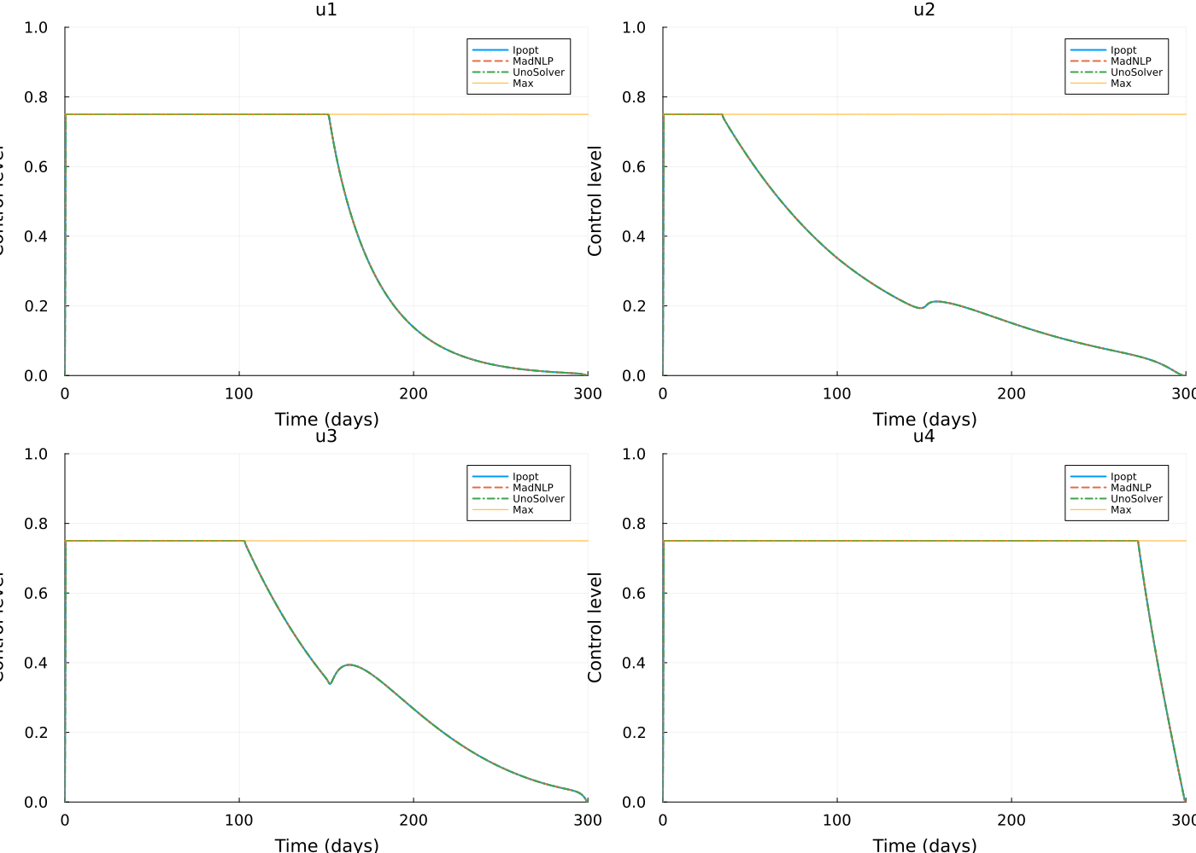

Overall results
sir_obj_min = minimum(sir_results.Objective_Value)
sir_obj_max = maximum(sir_results.Objective_Value)
sir_obj_range = sir_obj_max - sir_obj_min
sir_obj_rel_diff = (sir_obj_range / sir_obj_min) * 100
dengue_obj_min = minimum(dengue_results.Objective_Value)
dengue_obj_max = maximum(dengue_results.Objective_Value)
dengue_obj_range = dengue_obj_max - dengue_obj_min
dengue_obj_rel_diff = (dengue_obj_range / dengue_obj_min) * 100
sir_fastest = sir_results.Solver[argmin(sir_results.Solve_Time_s)]
sir_slowest = sir_results.Solver[argmax(sir_results.Solve_Time_s)]
sir_speedup = maximum(sir_results.Solve_Time_s) / minimum(sir_results.Solve_Time_s)
dengue_fastest = dengue_results.Solver[argmin(dengue_results.Solve_Time_s)]
dengue_slowest = dengue_results.Solver[argmax(dengue_results.Solve_Time_s)]
dengue_speedup = maximum(dengue_results.Solve_Time_s) / minimum(dengue_results.Solve_Time_s)
println("SIR Model:")
println(" Objective value relative difference: ", @sprintf("%.2f", sir_obj_rel_diff), "%")
println(" Fastest solver: ", sir_fastest)
println(" Slowest solver: ", sir_slowest)
println(" Speedup factor: ", @sprintf("%.1f", sir_speedup), "×")
println("\nDengue Model:")
println(" Objective value relative difference: ", @sprintf("%.2f", dengue_obj_rel_diff), "%")
println(" Fastest solver: ", dengue_fastest)
println(" Slowest solver: ", dengue_slowest)
println(" Speedup factor: ", @sprintf("%.1f", dengue_speedup), "×")
SIR Model:
Objective value relative difference: 0.01%
Fastest solver: Ipopt
Slowest solver: UnoSolver
Speedup factor: 1.2×
Dengue Model:
Objective value relative difference: 0.00%
Fastest solver: UnoSolver
Slowest solver: MadNLP
Speedup factor: 2.0×

