Chapter 2

## 2.3 Numerical integration of the SIR model

using OrdinaryDiffEq  
using LabelledArrays  
using DataFrames  
using Plots;

Step 1: define the function.

function sirmod(u, p, t)  
 S,I,R = u  
 β = p.β  
 μ = p.μ  
 γ = p.γ  
 N = p.N  
 dS = μ*(N-S) - β*S*I/N  
 dI = β*S*I/N - (μ+γ)*I  
 dR = γ*I - μ*R  
 [dS, dI, dR]  
end;

Steps 2-4: define the time, the parameters, and the initial conditions.

t0 = 0.0  
t1 = 0.5  
δt = 1.0/365  
p = LVector(μ=0.0, N=1.0, R₀=4.0, γ=365.0/14)  
p = [p; LVector(β=p.R₀*p.γ + p.μ)]  
u0 = [0.999, 0.001, 0.0] .* p.N;

Step 5: solve the model.

prob = ODEProblem(sirmod, u0, (t0, t1), p)  
sol = solve(prob, Rodas5P(); saveat=δt);

out = DataFrame(sol)  
rename!(out, [:time, :S, :I, :R])  
first(round.(out, digits = 3), 6)

plot(out.time, out.S, ylabel="Fraction", xlabel="Time", color=:black, label="S", legend=:right)  
plot!(out.time, out.I, color=:red, label="I")  
plot!(out.time, out.R, color=:green, label="R")

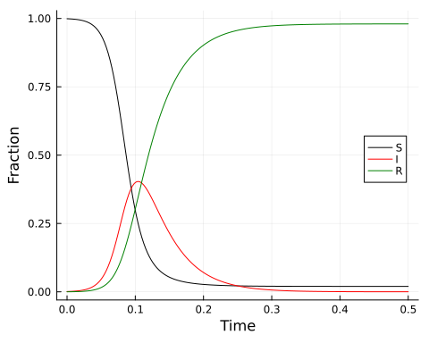

## 2.4 Final epidemic size

Find final epidemic size by running to steady state.

using SteadyStateDiffEq  
ssprob = SteadyStateProblem(sirmod, u0, p)  
sssol = solve(ssprob, DynamicSS(Rodas5P()))  
round.(sssol, digits=2)

3-element Vector{Float64}:  
 0.02  
 -0.0  
 0.98

Calculate final size over a range of values of R₀.

nsims = 50  
R₀ = range(0.1, 5, nsims)  
betas = R₀ .* p.γ .+ p.μ  
fs = Array{Float64}(undef, nsims)  
for i in 1:nsims  
 sp = remake(ssprob, p=LVector(μ=0.0, N=1.0, γ=365.0/14, β=betas[i]))  
 ss = solve(sp, DynamicSS(Rodas5P()))  
 fs[i] = ss[3]  
end

plot(R₀, fs, xlabel="R₀", ylabel="Final size", legend=false)  
x = 1:0.1:5  
plot!(x, 1 .- exp.(-x), color=:red)

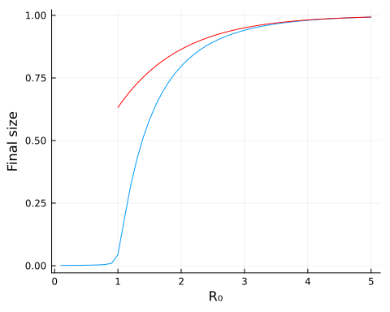

Use root-finding to calculate the final size.

using NonlinearSolve  
fn(u, p) = exp(-(p[1]*(1-u[1]))) - u[1]  
rprob = IntervalNonlinearProblem(fn, (0.0, 1.0 - 1e-9), [2.0])  
rsol = solve(rprob, Falsi())  
1.0 - rsol.u[1]

0.7968121300200202

## 2.5 The open epidemic

t0 = 0.0  
t1 = 50.0  
δt = 1.0/365  
p = LVector(μ=1.0/50, N=1.0, R₀=4.0, γ=365.0/14)  
p = [p; LVector(β=p.R₀*p.γ + p.μ)]  
u0 = [0.1999, 0.0001, 0.8] .* p.N  
prob = ODEProblem(sirmod, u0, (t0, t1), p)  
sol = solve(prob, Rodas5P(); saveat=δt)  
out = DataFrame(sol)  
rename!(out, [:time, :S, :I, :R]);

l = @layout [a b]  
p1 = plot(t0:δt:t1, out.I, xlabel="Time", ylabel="Fraction", legend=false)  
p2 = plot(out.S, out.I, xlabel="Susceptible", ylabel="Infected", legend=false)  
plot(p1, p2, layout=l)

