Eric Pires, John Lamanuzzi, Richard Harrison

25 September 2016

ECE 388

Team 3

Design Requirements

**Overview**

The room occupancy and climate control system aims to detect motion and temperature within an enclosed environment. The system will display temperature and humidity readings for the user to observe and control using a simple interface system. Motion within the environment will be detected and used to control the lighting system. This design will focus on a scaled environment and will use inexpensive components.

**Component List**

The following components will be utilized in the prototype of this design:

* ATmega328p microcontroller
* DHT22 digital temperature and humidity sensor
* PIR Motion Sensor
* Character LCD 1602A
* 2x LED
* Servo DC motor

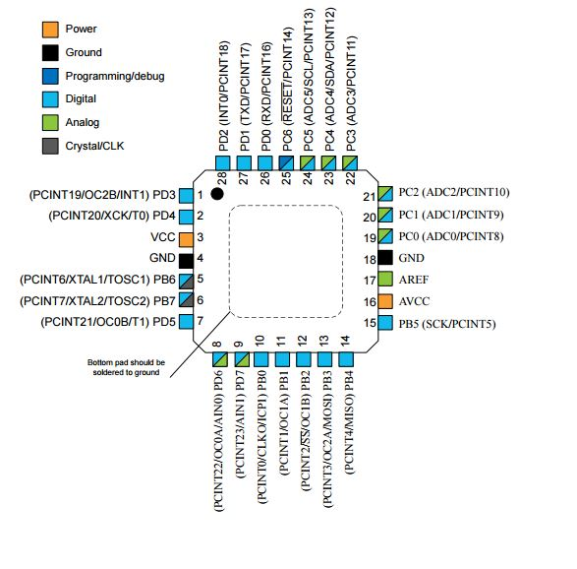**Microcontroller**

The ATmega328p microcontroller has been selected for this design to utilize the vast collection of libraries written for this chip that will help the software design process much easier to follow. This device will enable all other sensors and actuators to communicate between one another and compute valuable data. The 328p contains 23 I/O pins and 32KB of flash memory, which will be sufficient for this design.

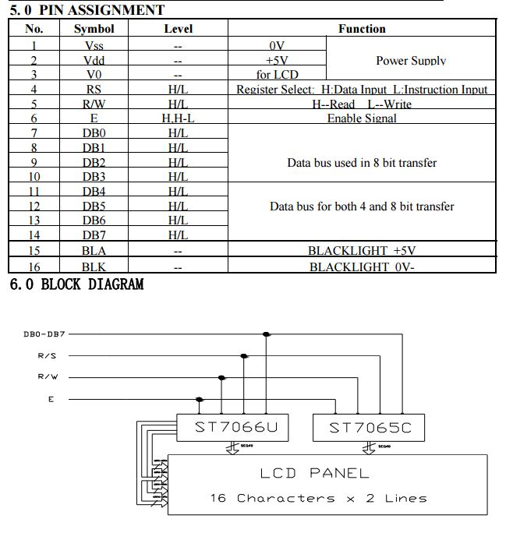

**Character LCD**

The 1602A Character LCD display has been selected due to its small form factor. This device will display the main outputs of the system by writing temperature readings on the screen. The device requires around 5V for sufficient operation.