Programming in GIS I

Practical 3

# Practical 3: Operators in JavaScript

Q1. Convert the following and print the converted value and its type:

1. Number into String
   1. 20
   2. 345
   3. 9

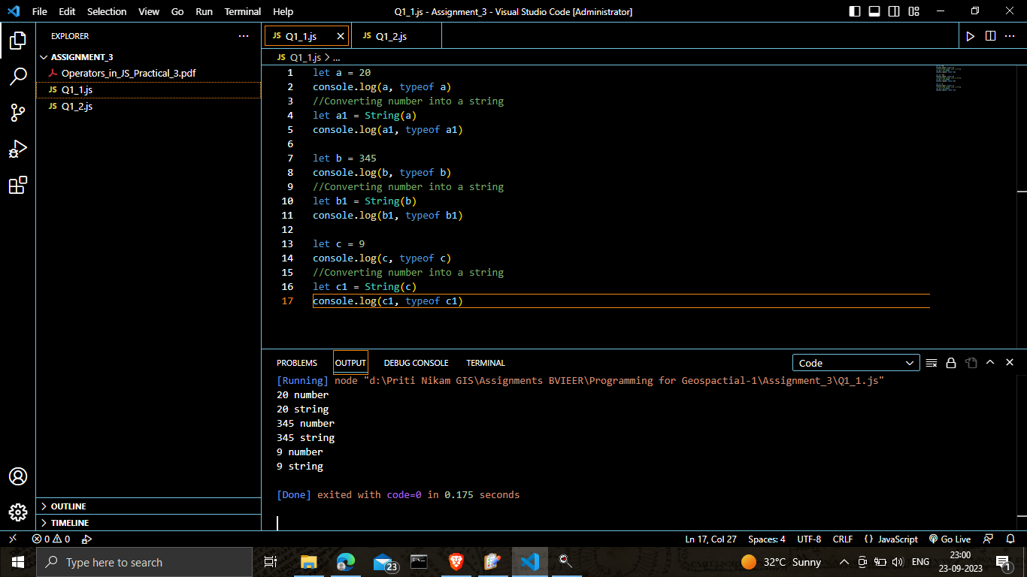

1. String into Number
   1. 12
   2. 32
   3. 987

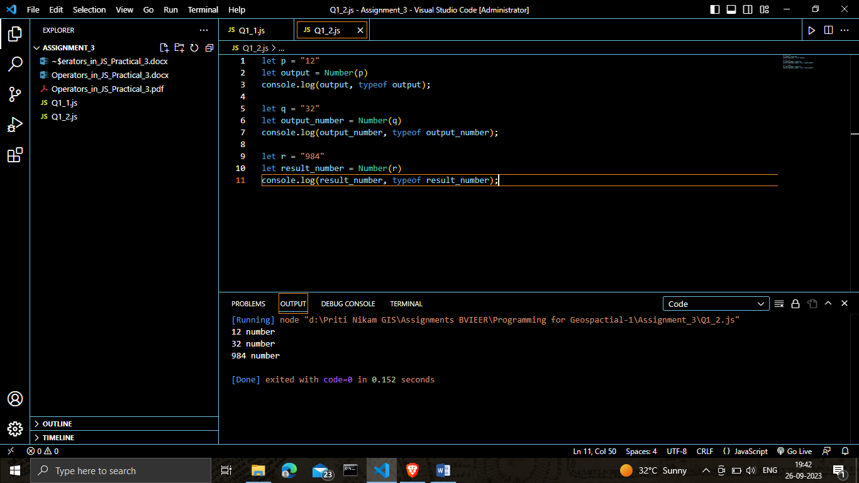

1. Number into Boolean
   1. 34
   2. 0
   3. -234

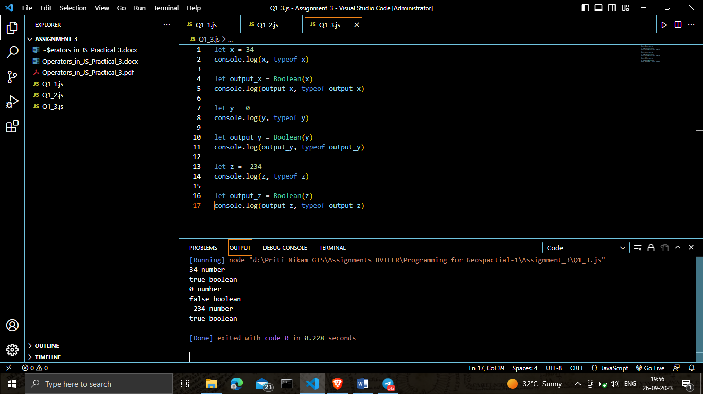

Q2. Declare two number variable and perform arithmetic operations like addition, subtraction, multiplication and division and print each result properly using template literal.

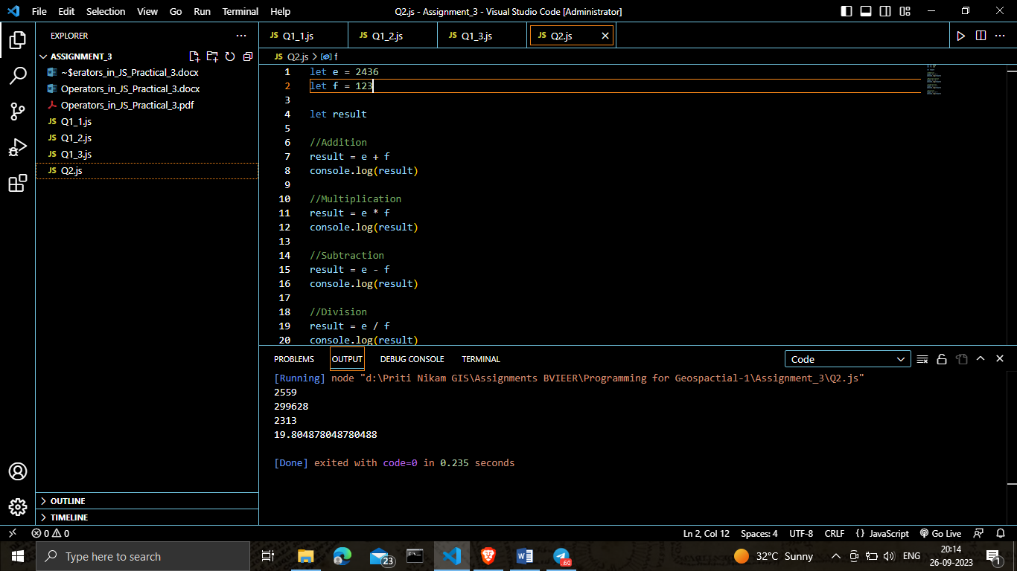

Q3. Declare one number variable and perform pre and post increment operations on it.

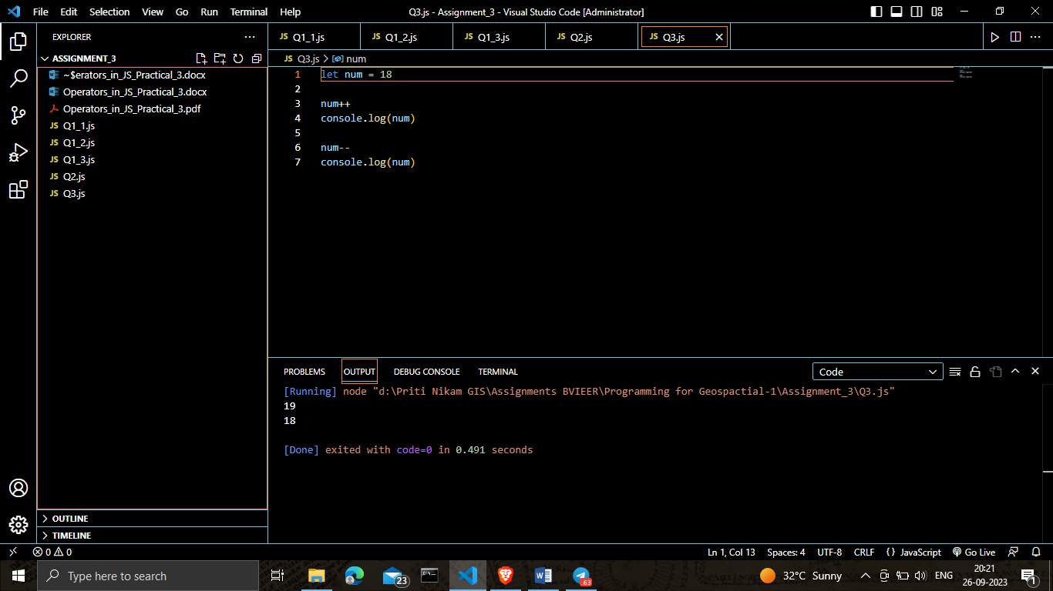

Q4. Compare the below values using relational operator and print the returned Boolean value

1. (22 > 22)
2. (87 <= 87)
3. (32 === 64)

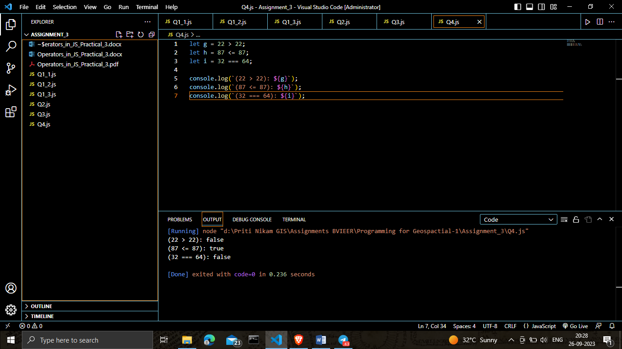

Q5. Declare three number variables and check which variable is greatest using relational and logical operators.

