Programming in GIS I

Practical 4

# Practical 4: Statements in JS

Q1. Declare a number variable called time. If the time is less than 10, print “Good Morning”, if not, but time is less than 20, print “Good day'', otherwise print “Good Evening”.

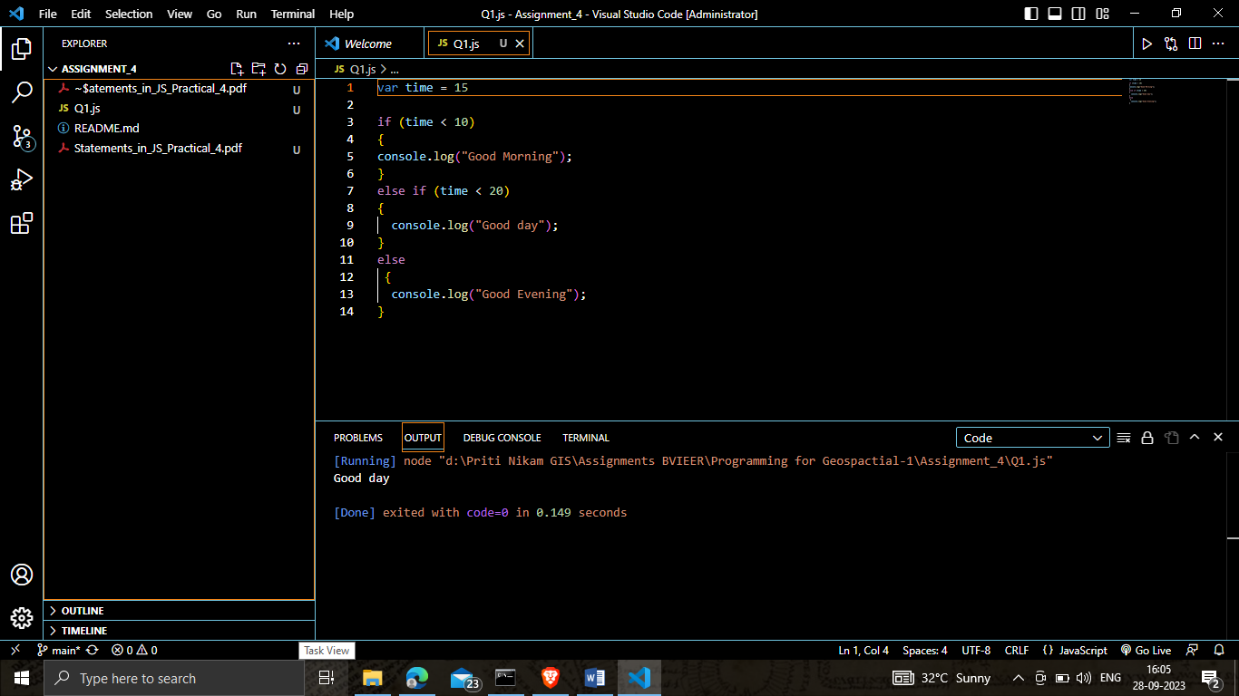

Q2. Create a switch statement that will print “Hello” if fruit is Apple, and “Bye” if fruit is “Banana”.

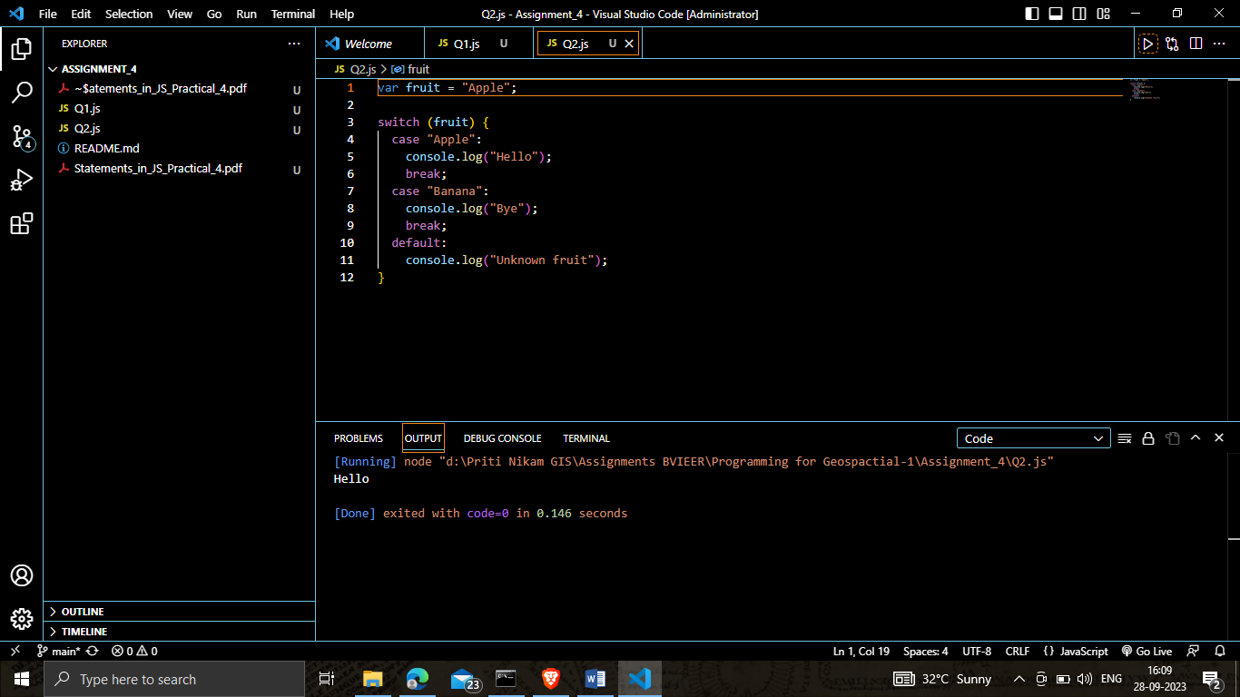

Q3. Declare a number variable and use a conditional statement to check if the given number is odd or even.

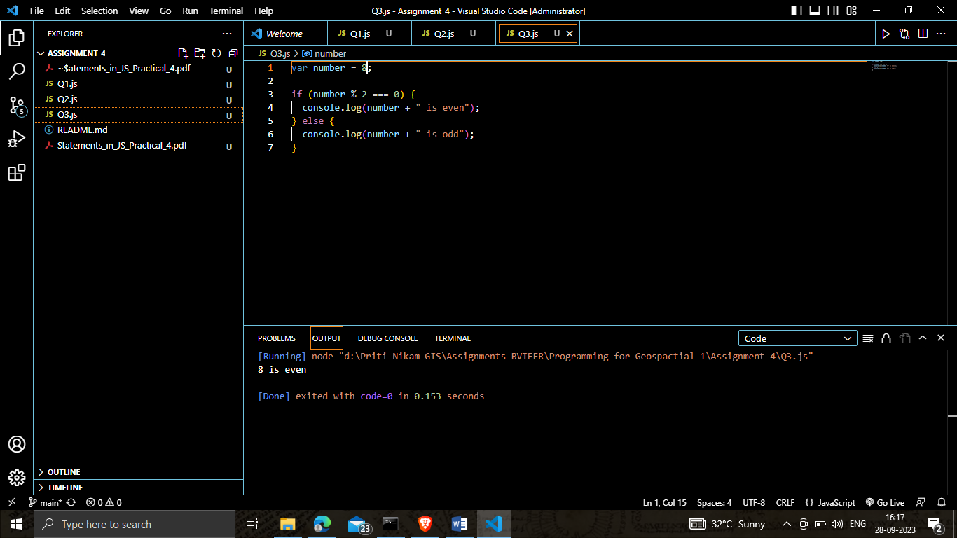

Q4. Use a JavaScript switch statement to get the day of the week based on a day number.

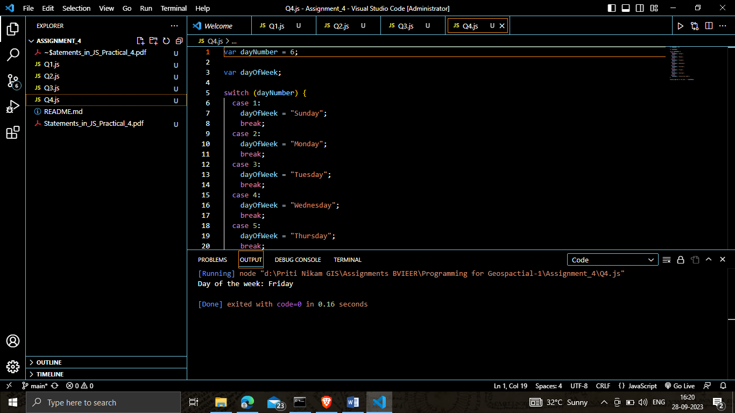

Q5. Use a Ternary operator to find if the given number is divisible by 3 or not.

