Programming in GIS I

Practical 5

Name: Nikam Priti Raju

RollNo: 05

# Practical 5: Loops in JS

Q1. Print numbers 1 to 10 using a while loop. (Use increment operator)

🡪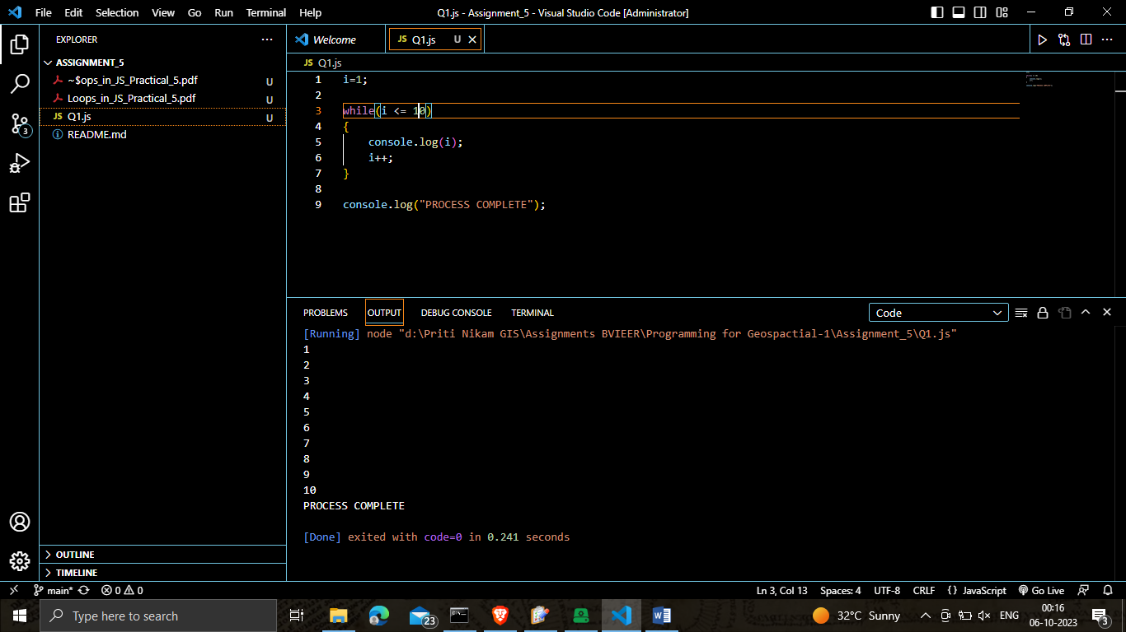

Q2. What is the difference between while and do-while loop?

|  |  |
| --- | --- |
| While Loop | Do-while Loop |
| In a "while" loop, the condition is evaluated before the loop body is executed. If the condition is false initially, the loop body may never execute | In a "do-while" loop, the loop body is executed at least once before the condition is checked. This ensures that the loop body is executed at least once, even if the condition is false from the start |
| The loop body of a "while" loop will only execute if the condition is true. If the condition is false initially, the loop may not execute at all. | The loop body of a "do-while" loop always executes at least once, regardless of the condition. After the first iteration, the condition is checked, and the loop may continue if it's true or terminate if it's false. |
| while (condition):  # Code to execute as long as the condition is true | do {  # Code to execute at least once  } while (condition); |

Q3. Perform multiplication on any number 5 times using a do-while loop and print the result.

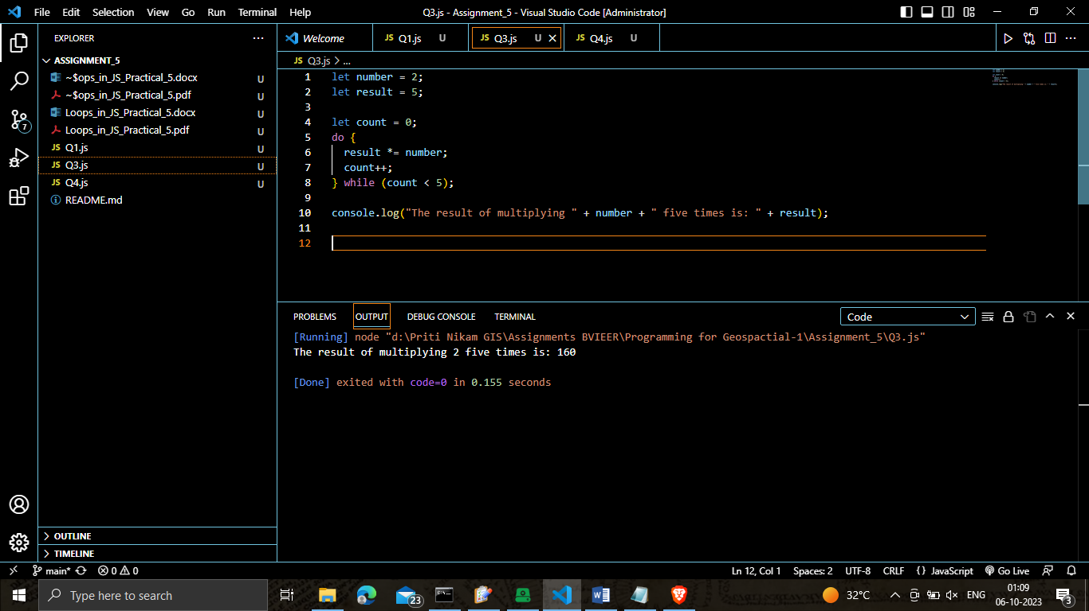

Q4. Print a text five times using for loop.

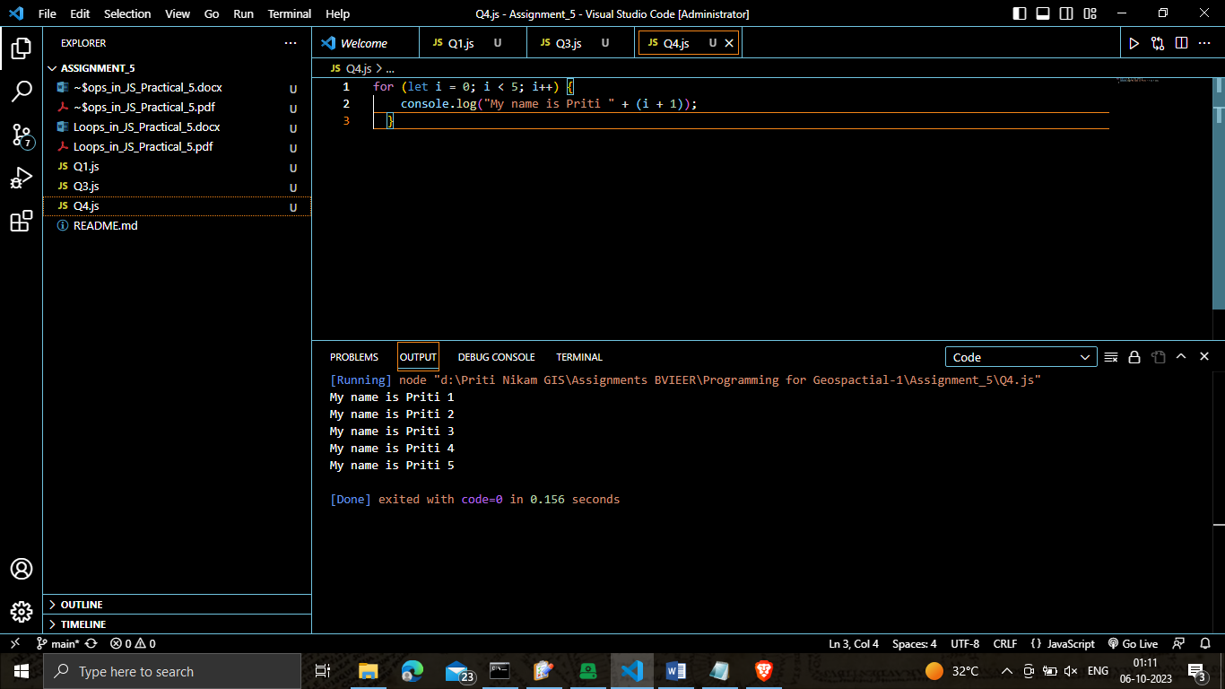

Q5. Loop through numbers 1 to 50 and print all the even numbers. (Use any loop)

