Programming in GIS I

Practical 6

# Name: NIKAM PRITI RAJU

Roll No: 05

Course: MSC. (Geoinformatics)

# **Practical 6: Objects in JS**

**Q1. What is the difference between “==” and “===”?**

* **“==”: (Double Equals to):**
* If you compare a string and a number using "==", JavaScript will attempt to convert the string to a number and then compare them.
* "==" is a loose equality operator.
* **“===”: (Triple Equals to):**
* "===" is a strict equality operator.
* Both the value and the type of the operands must be the same for "===" to return true.

**Q2. What is an object in JavaScript? Create an empty object and print it and its type.**

* An object is a complex data type that allows you to store and organize data using a collection of values.

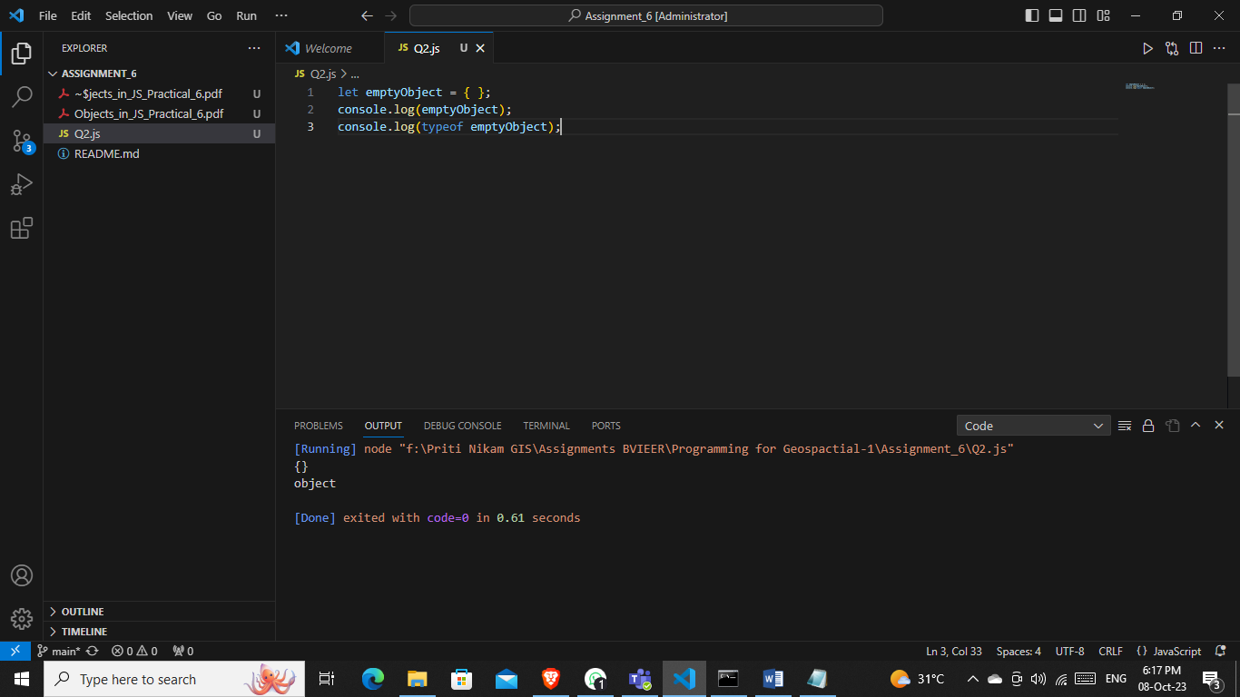

**Q3. Create an object with the property as the name of the country and the capital as its value and print one of the property value.**

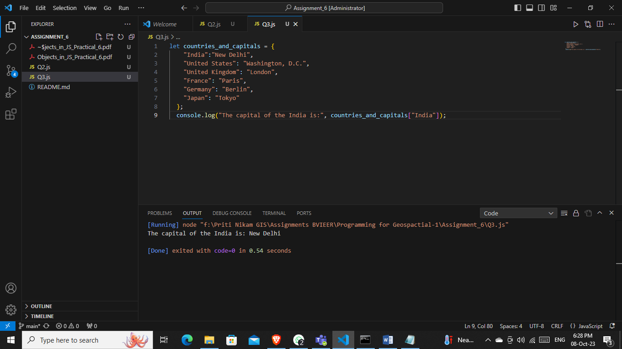

**Q4. Create an object person with property: first name, last name, age, blood group, and use the for-in loop to print all the properties and their value.**

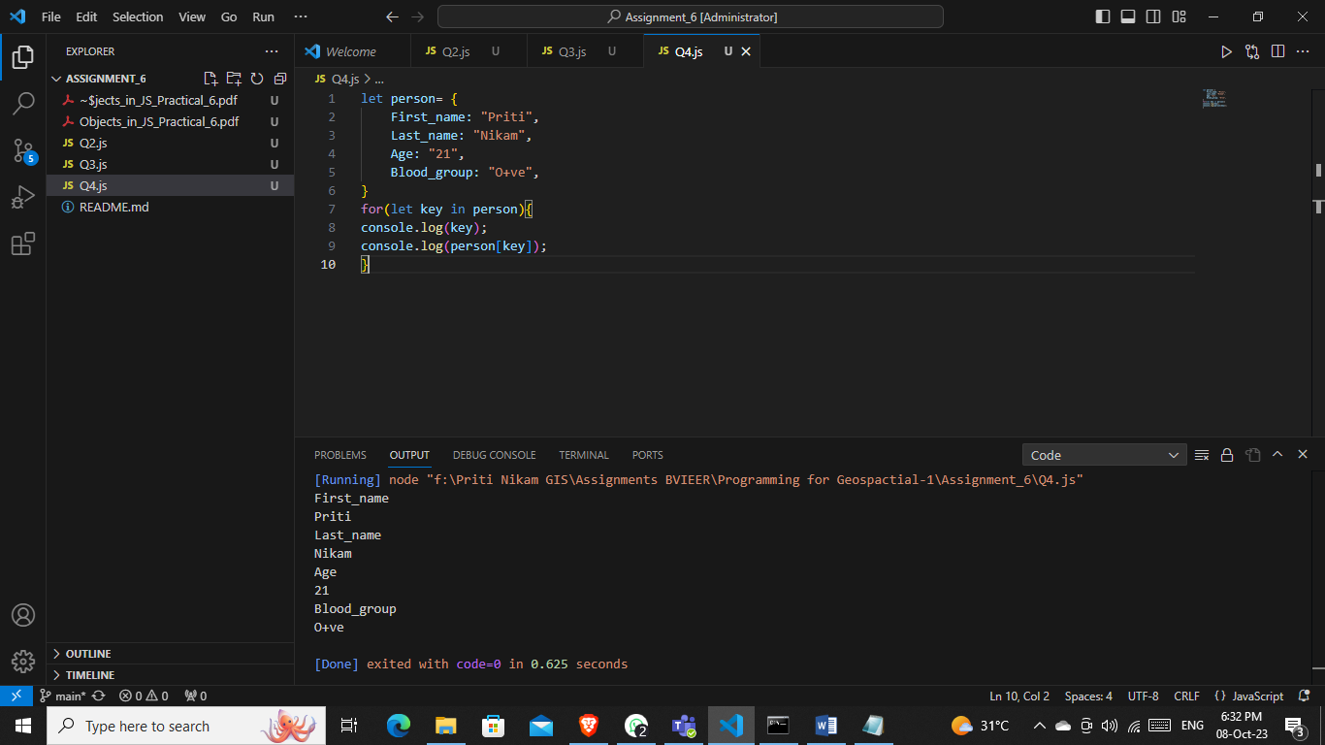

**Q5. Create an object in JavaScript and print the object after deleting one of its properties.**

