Programming in GIS I

Practical 8

# Name: NIKAM PRITI RAJU

Roll No: 05

# Practical 8: Methods, Constructor, and Array in JS

**Note: Create an HTML file for all the below questions.**

Q1. What are methods in JavaScript. Create a method for greeting a user “Hello”?

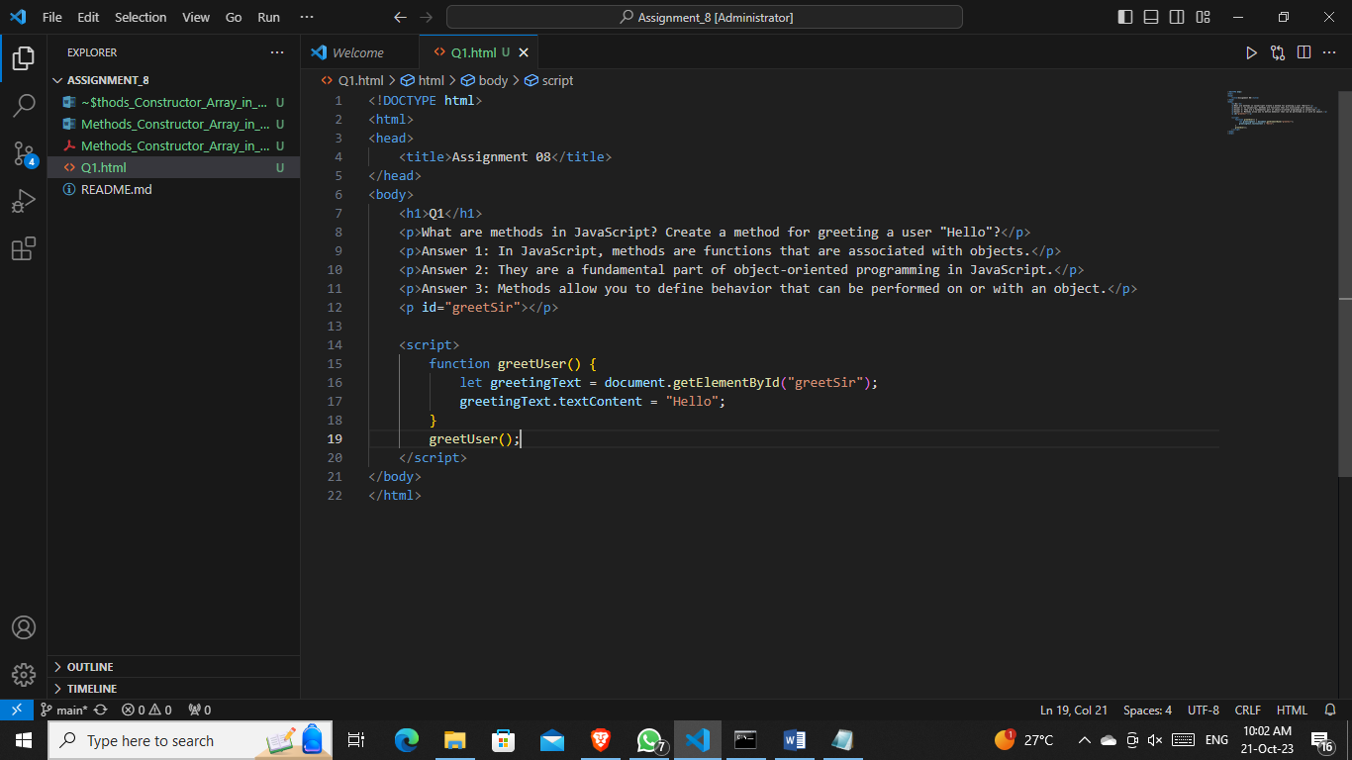

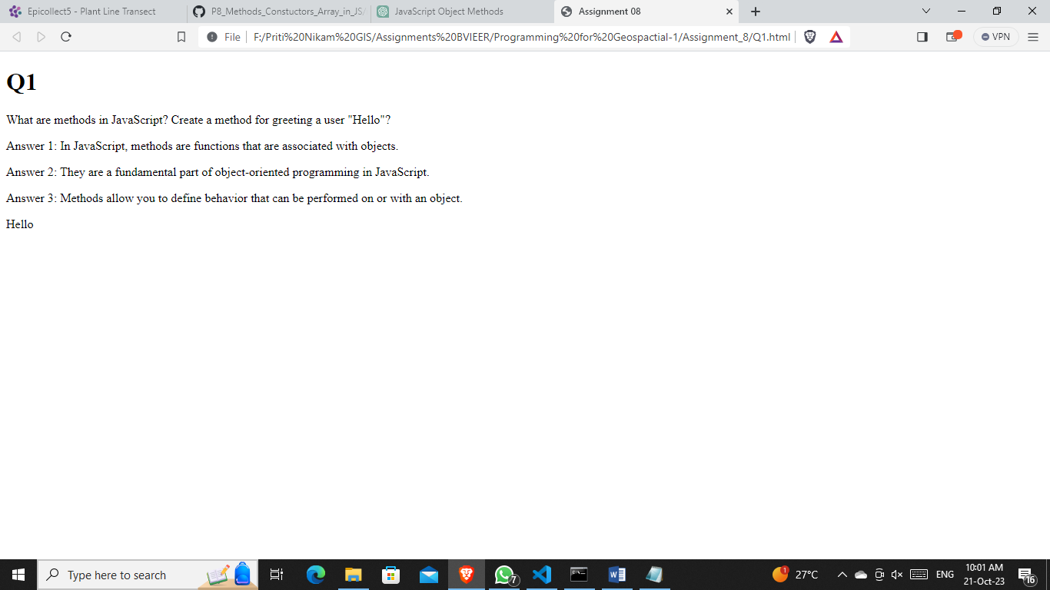

Q2. Create a getConfig method in an object to get details about a laptop.

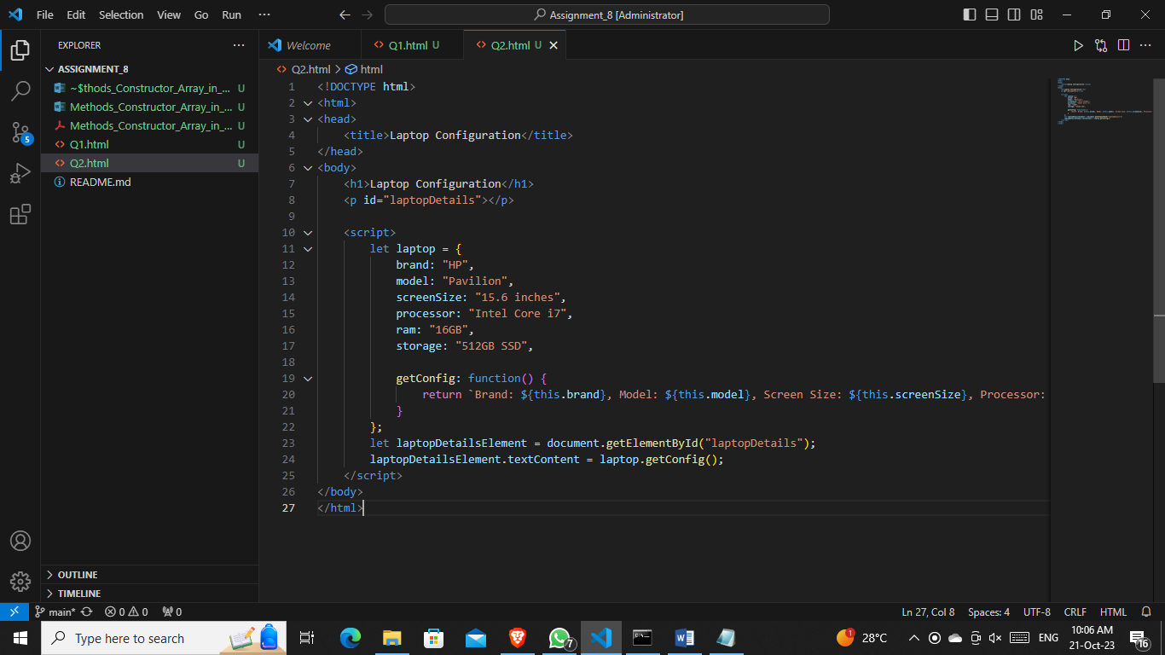

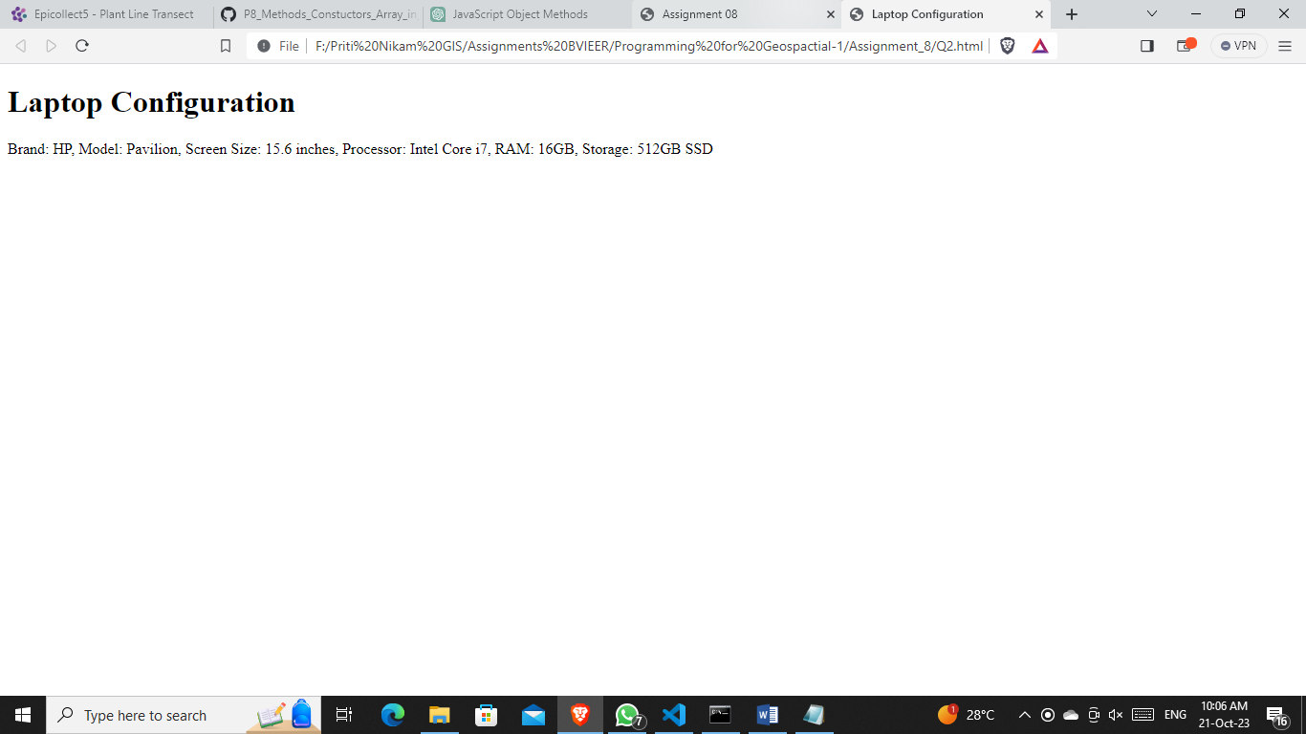

Q3. Create multiple laptop objects, and declare a method to compare the laptop object with another laptop object to get the fastest laptop having more RAM.

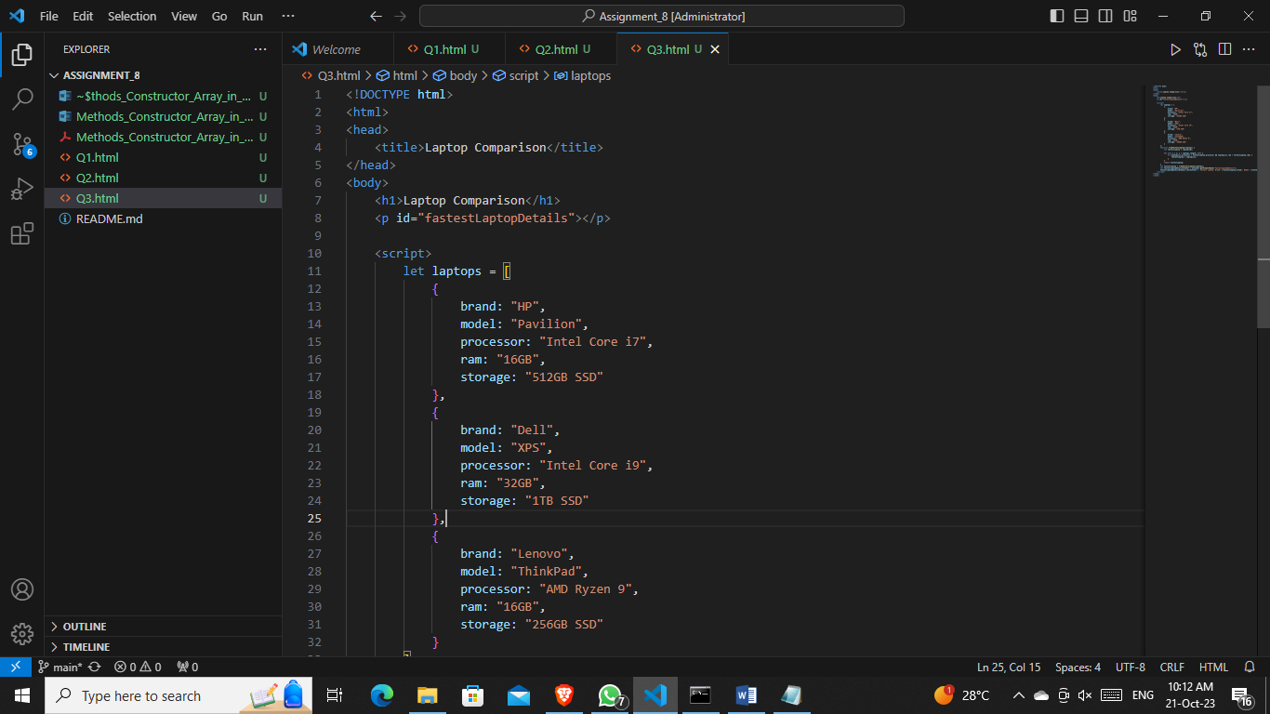

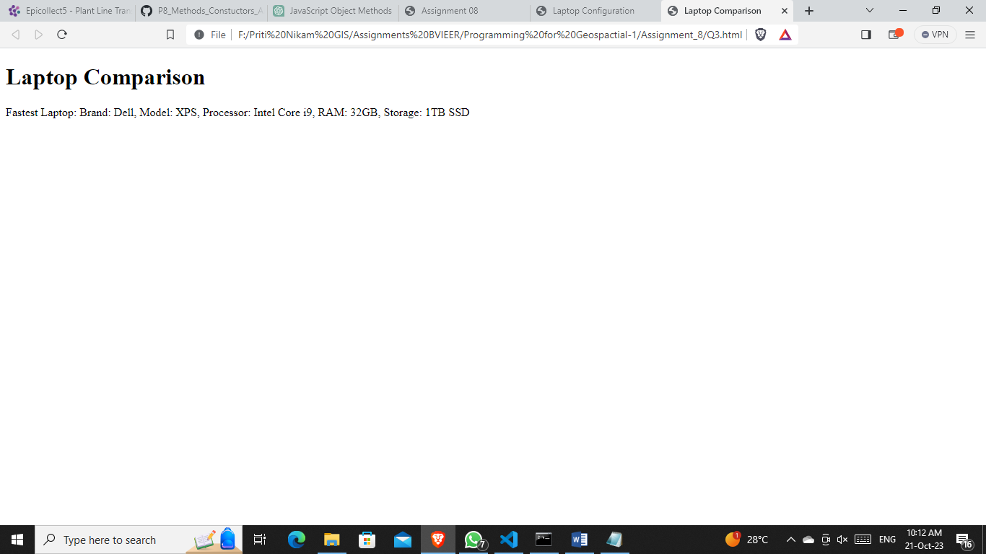

Q4. Create a constructor function called students to create objects having marks for different subjects.

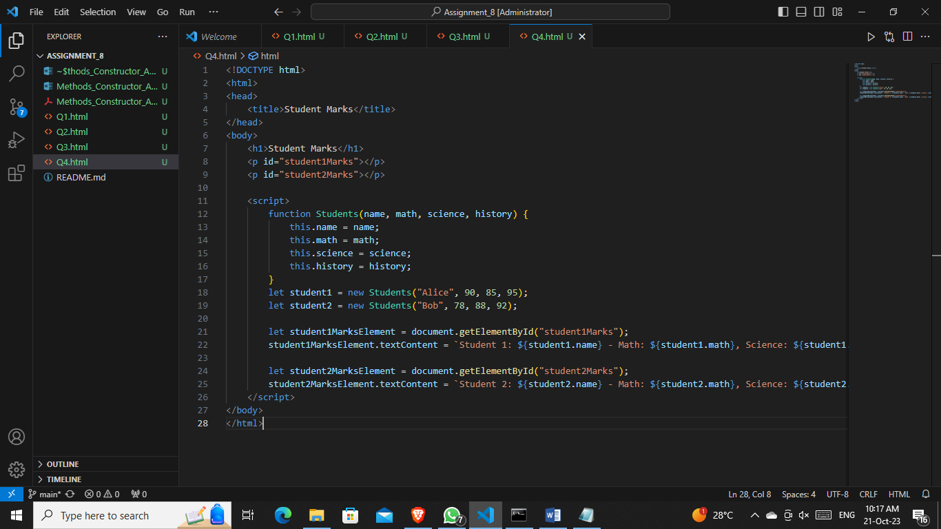

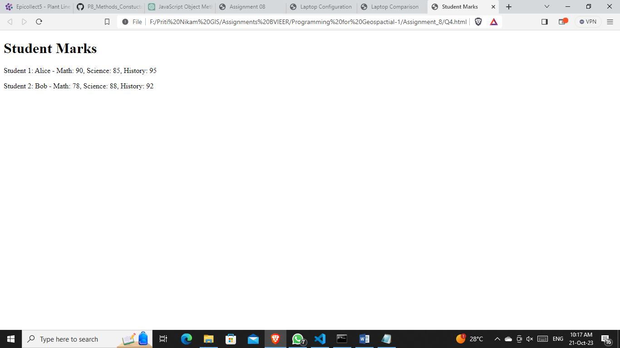

Q5. Create an Array having names of different plants and perform the following operations: a. Add a new plant name to the array

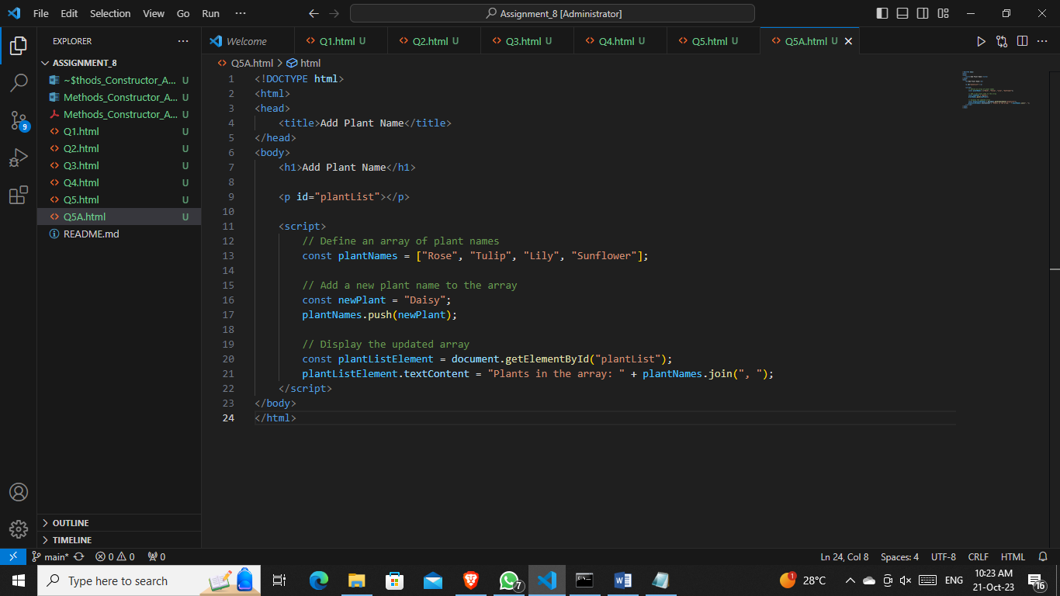

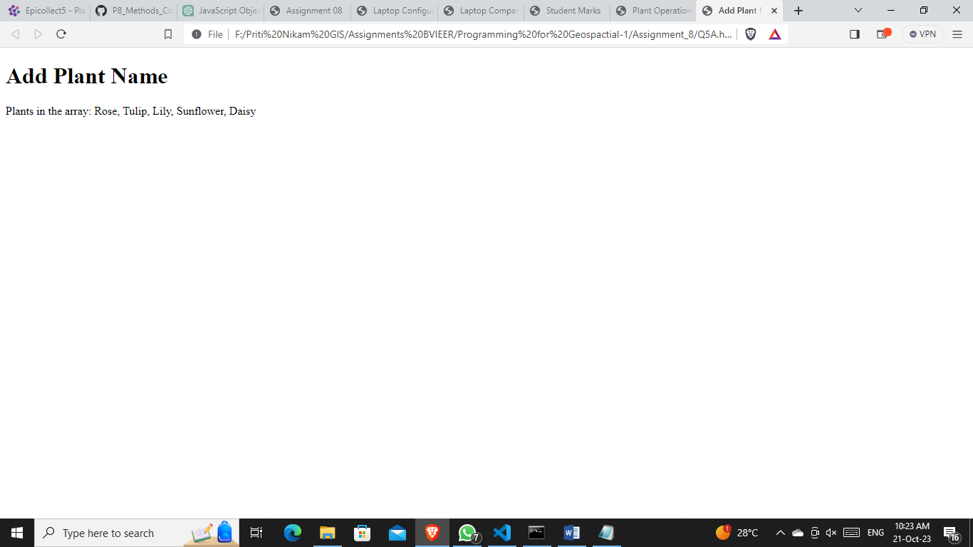

1. Remove the newly added plant name from the array

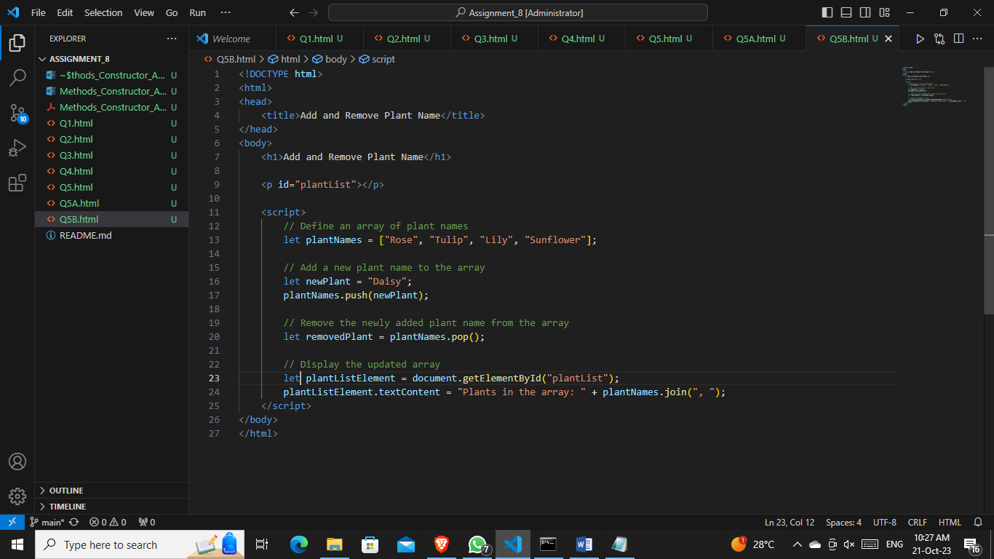

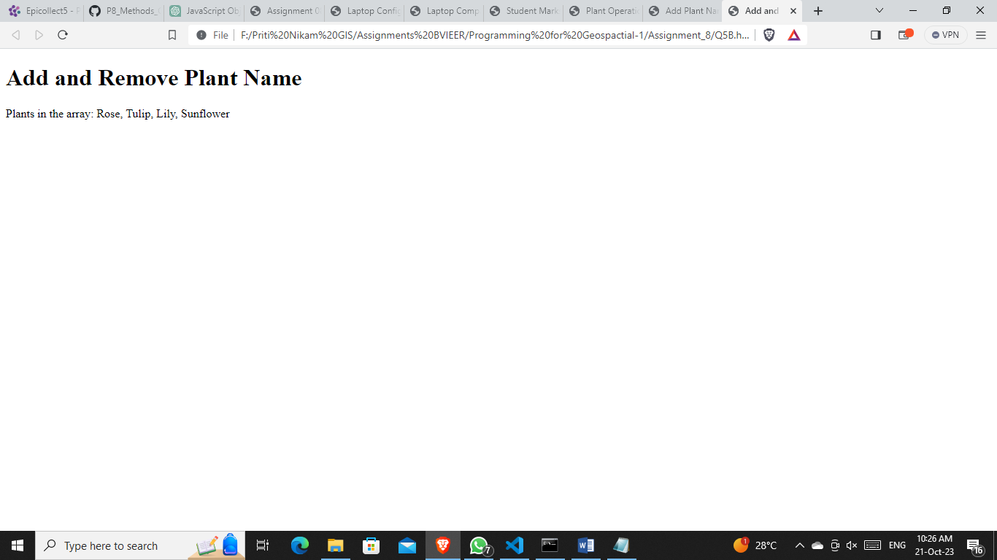

1. Loop through the array and print the name of the plant one by one

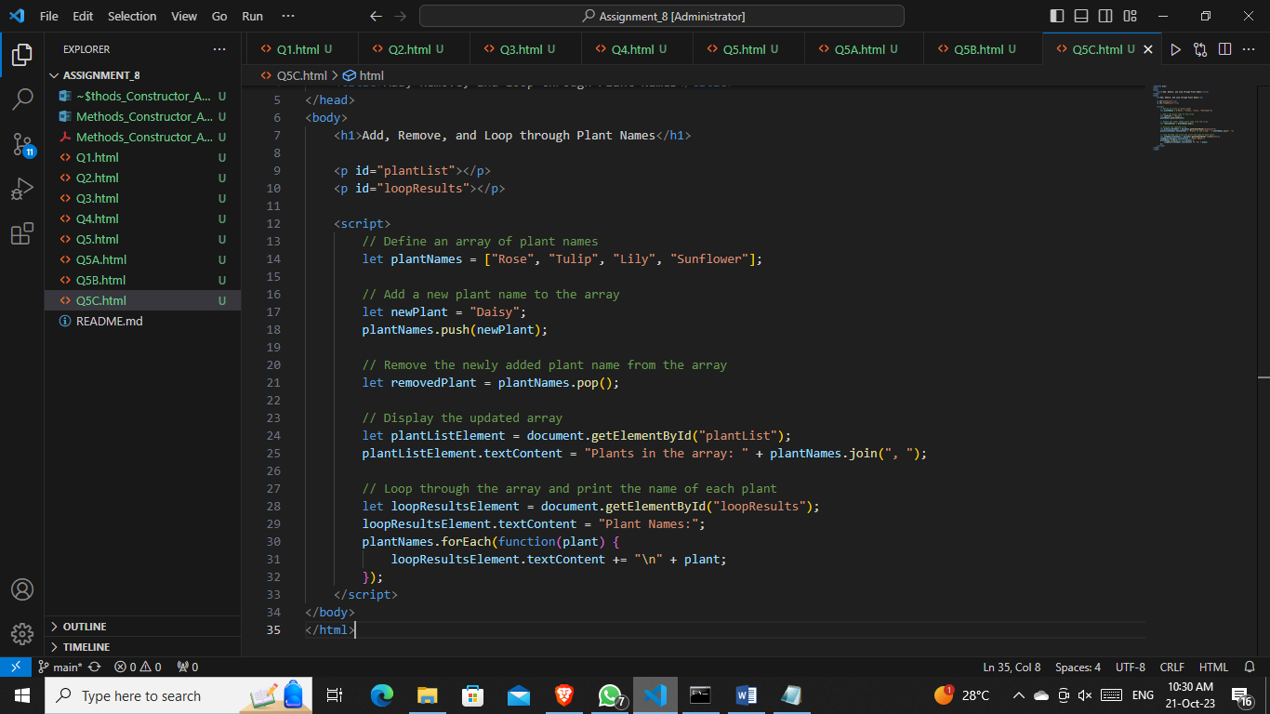

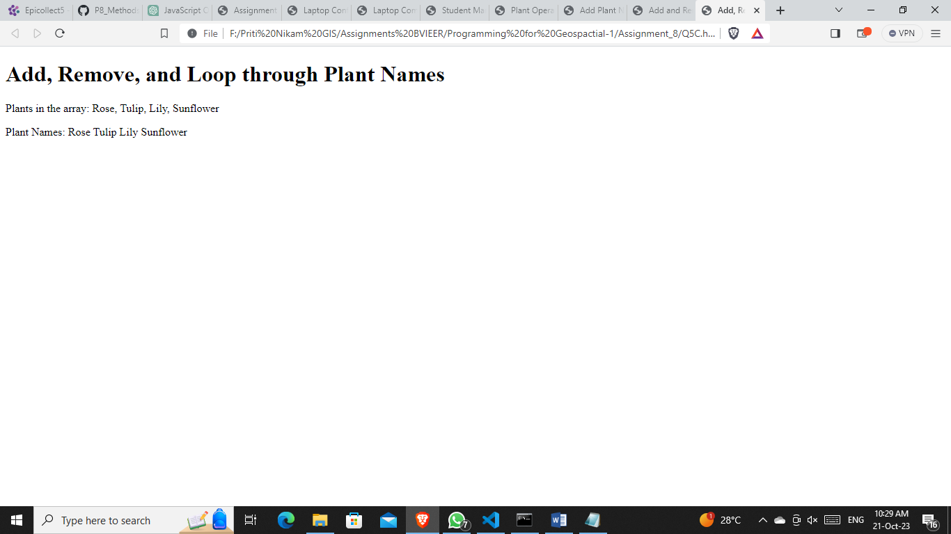

* The whole code together…..

