## Vizualization

1. Scatterplot X and Y
   1. Uniform

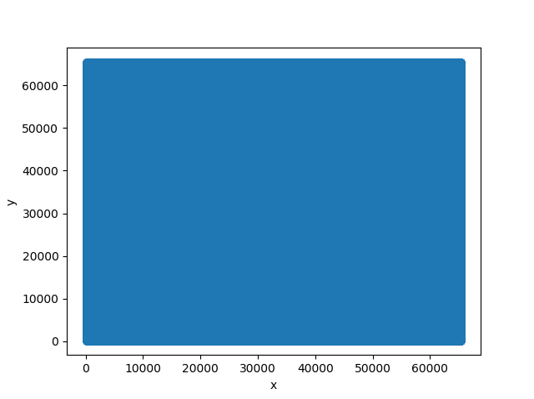

* 1. Gaussian

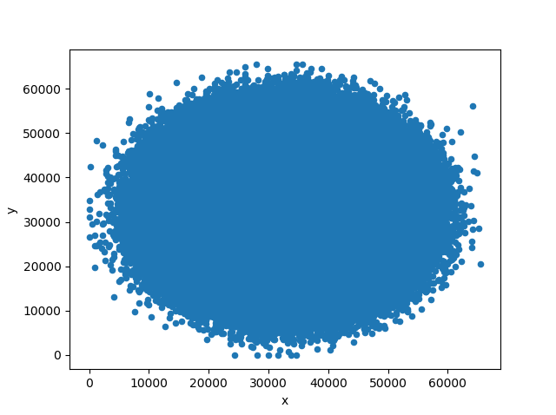

1. Z_Value
   1. Uniform

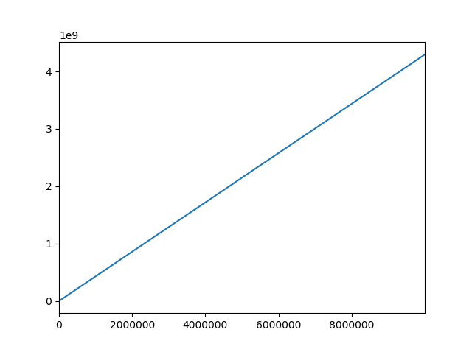

* 1. Gaussian

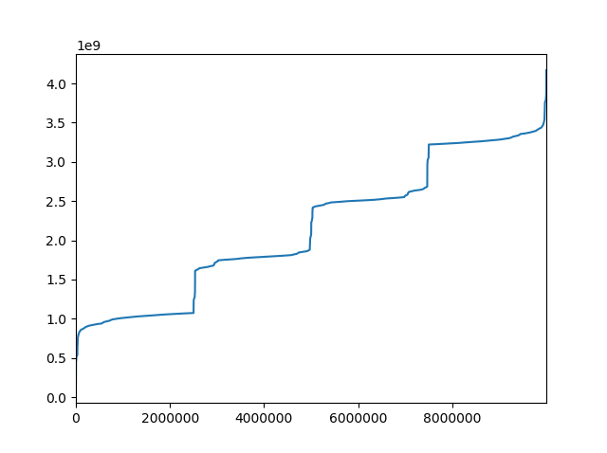

## Simple Linear Regressions

1. Unifrom

**model.coef_ -> 0.00232808 ; MSE -> 533665.9643045 ; R2 -> 0.9999999359618179**

* 1. ID original values

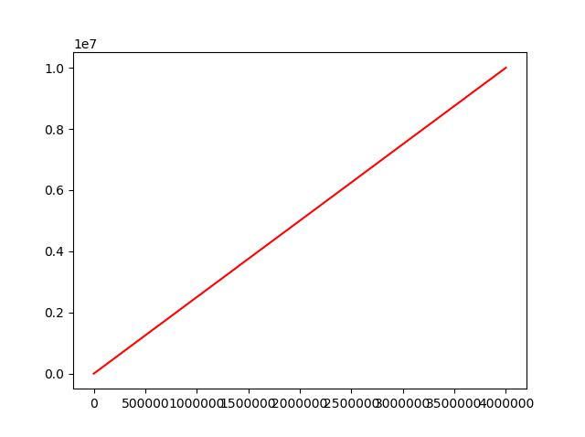

* 1. ID original values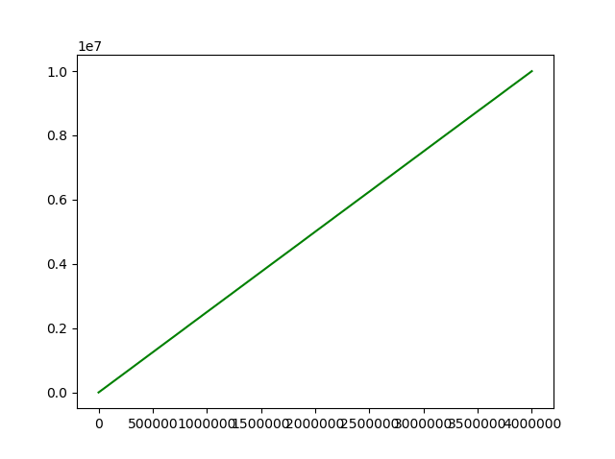

1. Gaussian

**model.coef_ -> 0.00246263; MSE -> 869941866148.4841 ; R2 ->** **0.8956098021656592**

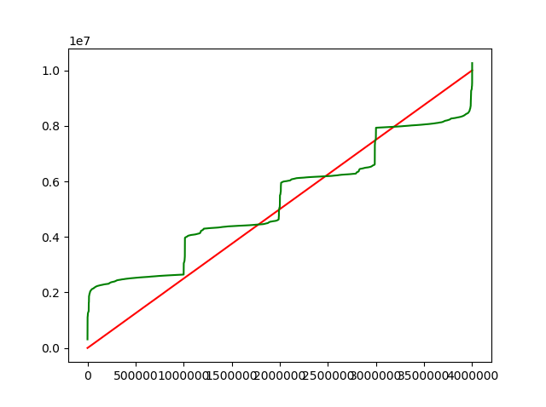ID – Red ; Prediction - Green

## Segmentation

1. Adjacent absolute differences in Gaussian Z values

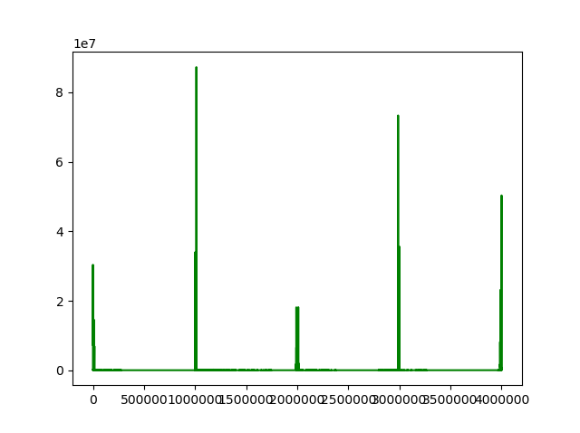

1. Adjacent percent differences in Gaussian Z values

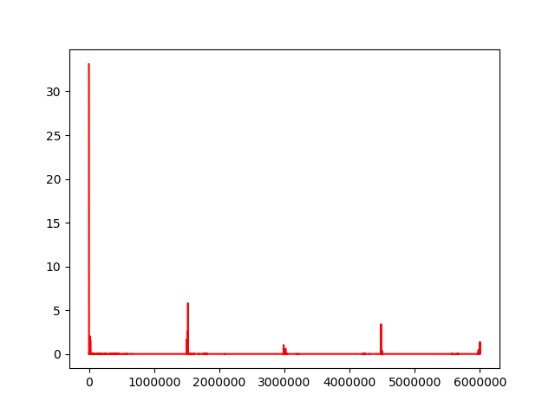

1. List of indexes with Z_value percent change more than 0.5% (62 indexes)

|  |  |  |  |
| --- | --- | --- | --- |
| Index | Z_value Percent change | 1. Percentage change of index on whole scope | 1. Select only index percent change > 1%   (these will be segment boundaries) |
| 1 | 33.10547 | (Indexi – Indexi+1) / number_of_all_indexes = (1-2)/ 6000000 = |  |
| 2 | 0.574678 | 0.000017 |  |
| 5 | 2.626549 | 0.000050 |  |
| 6 | 2.849514 | 0.000017 |  |
| 8 | 0.536153 | 0.000033 |  |
| 9 | 2.108437 | 0.000017 |  |
| 12 | 1.464457 | 0.000050 |  |
| 13 | 1.584904 | 0.000017 |  |
| 17 | 0.932111 | 0.000067 |  |
| 19 | 0.578287 | 0.000033 |  |
| 21 | 0.569848 | 0.000033 |  |
| 27 | 0.585192 | 0.000100 |  |
| 32 | 1.186077 | 0.000083 |  |
| 33 | 1.494027 | 0.000017 |  |
| 42 | 0.50191 | 0.000150 |  |
| 45 | 1.039625 | 0.000050 |  |
| 247 | 10.22249 | 0.003367 |  |
| 248 | 0.804895 | 0.000017 |  |
| 250 | 1.524317 | 0.000033 |  |
| 251 | 0.83828 | 0.000017 |  |
| 252 | 0.823697 | 0.000017 |  |
| 258 | 0.604934 | 0.000100 |  |
| 264 | 0.704705 | 0.000100 |  |
| 268 | 0.537162 | 0.000067 |  |
| 269 | 0.564586 | 0.000017 |  |
| 271 | 0.552668 | 0.000033 |  |
| 297 | 1.627852 | 0.000433 |  |
| 300 | 0.513805 | 0.000050 |  |
| 301 | 0.584873 | 0.000017 |  |
| 303 | 0.975544 | 0.000033 |  |
| 305 | 0.501805 | 0.000033 |  |
| 306 | 0.565261 | 0.000017 |  |
| 308 | 0.990323 | 0.000033 |  |
| 310 | 0.505718 | 0.000033 |  |
| 312 | 0.678678 | 0.000033 |  |
| 317 | 0.598584 | 0.000083 |  |
| 18643 | 2.001437 | 0.305433 |  |
| 18644 | 1.001573 | 0.000017 |  |
| 18661 | 0.895567 | 0.000283 |  |
| 18662 | 1.2231 | 0.000017 |  |
| 18665 | 0.579505 | 0.000050 |  |
| 22410 | 1.58521 | 0.062417 |  |
| 22489 | 0.610738 | 0.001317 |  |
| 22493 | 0.704127 | 0.000067 |  |
| 1501832 | 0.705708 | 24.655650 | 1501832 |
| 1501841 | 0.518724 | 0.000150 |  |
| 1502024 | 0.959678 | 0.003050 |  |
| 1502026 | 1.673193 | 0.000033 |  |
| 1520013 | 2.642497 | 0.299783 |  |
| 1520016 | 5.800192 | 0.000050 |  |
| 1520048 | 0.628984 | 0.000533 |  |
| 1520240 | 2.77004 | 0.003200 |  |
| 1520242 | 1.395735 | 0.000033 |  |
| 2987148 | 1.028309 | 24.448433 | 2987148 |
| 3001910 | 0.512817 | 0.246033 |  |
| 3016774 | 0.613704 | 0.247733 |  |
| 3016812 | 0.51106 | 0.000633 |  |
| 4481810 | 0.832084 | 24.416633 | 4481810 |
| 4481814 | 1.278549 | 0.000067 |  |
| 4482059 | 3.404804 | 0.004083 |  |
| 4482060 | 1.183457 | 0.000017 |  |
| 5999998 | 1.366499 | 25.298967 | 5999998 |

