mSigSDK - browser-native computation of mutation signatures
Aaron Ge^{1,2}*, Tongwu Zhang¹, Yasmmin Côrtes Martins³, Maria Teresa Landi¹, Brian Park¹, Kailing Chen¹, Jeya Balasubramanian¹, Jonas S. Almeida¹
* age1@som.umaryland.edu
1 - Division of Cancer Epidemiology and Genetics, National Cancer Institute, National Institutes of Health, Maryland, USA
2 - University of Maryland, School of Medicine, Maryland, USA
3 - National Laboratory of Scientific Computing, Petrópolis, Brazil

Abstract

Background
Mutational-signature analysis combines reference-catalog access, matrix generation, fitting or extraction, uncertainty assessment, visualization, and reporting. In brief, a sample's pattern of somatic mutations (its mutational spectrum) is compared against a catalog of known signatures to estimate each signature's exposure – the fraction of the sample's mutations attributable to that process. Several mature R and Python packages cover most of this workflow end-to-end, but each requires local installation, each uses its own input format, and recent comparative work has shown that the choice of fitting tool meaningfully affects results. Running multiple tools to triangulate findings is therefore desirable but operationally expensive. There is also, to our knowledge, no standard machine-readable report format that captures parameters, quality-control evidence, and provenance in a way other tools can consume.

Results
mSigSDK is a JavaScript software development kit (SDK) – a programming library that other code or scripts can call, rather than a standalone application – that loads in any modern desktop browser through a single dynamic module import, with no installation and no separate application to download. Its architecture is FAIR-aligned and serverless: public reference resources are fetched through their public APIs, user spectra and mutation annotation format files remain in the client runtime, and computation occurs on the user's device. Within this architecture the SDK provides five integrated capabilities: orchestration of four established mutational-signature tools through a uniform adapter layer (SigProfilerAssignment, MuSiCal, deconstructSigs, and sigminer); a browser-native non-negative matrix factorization implementation for exploratory de novo extraction; a user-configurable quality-control and reporting layer that emits separable evidence fields with configurable thresholds; reproducible reports serialized under a versioned JSON Schema that records method, parameters, evidence fields, warnings, and provenance; and a visualization layer reusing the established mSigPortal mutational-spectrum renderer for portal-consistent figures.
We validated the SDK along five axes. A zero-install reproducibility walk-through took the SDK from browser page-load to a rendered report in 1.89 s. In-browser adapter execution numerically agreed with conventional local execution of each wrapped tool in a Lung-AdenoCA SBS96 benchmark, with exact reproduction for three of the four adapters and floating-point-noise agreement for the fourth. In a separate four-tool comparison, all adapters analyzed the same spectra and catalog under an explicit harmonization contract. On a published known-truth benchmark, mean raw exposure cosine ranged from 0.9983 to 1.0000 at 0% noise, 0.9879 to 0.9996 at 5% noise, and 0.9719 to 0.9926 at 10% noise. On 38 real PCAWG Lung-AdenoCA spectra, pairwise exposure correlations ranged from 0.803 to 0.953 and mean active-signature Jaccard similarity ranged from 0.186 to 0.694, demonstrating that the common adapter layer can identify tool-sensitive conclusions. The SDK's internal solvers agreed numerically with established reference implementations. Runtime benchmarks across Chrome, Edge, and Firefox showed that a 120-sample cohort NNLS exposure refit (fitting only, excluding bootstrap uncertainty) completed in approximately 25 ms, and a 300-sample, 40-signature refit in under 3 s.

Conclusions
mSigSDK is a browser-native, zero-install, FAIR-aligned software development kit for mutational-signature analysis, encompassing multi-tool orchestration, exploratory extraction, configurable quality-controlled review, and schema-based reporting, without requiring sequencing data to leave the user’s device.
Keywords: mutational signatures; JavaScript; browser-native analysis; serverless; FAIR; tool orchestration; WebR; Pyodide; reproducible reporting; cancer genomics.

Background
Mutational signatures summarize somatic mutation patterns associated with endogenous and exogenous mutagenic processes, DNA repair and replication defects, and some therapy-related exposures [1], [2], [3], [4]. In practice, each sample's mutations are tabulated into a spectrum (a count of mutations by context type), which is decomposed into a weighted combination of reference signatures; the weight assigned to each signature, called its exposure, indicates its estimated contribution to that sample. A complete signature analysis combines reference-catalog access, matrix generation, fitting or extraction, uncertainty assessment, visualization, and reporting. Several mature packages cover most of this workflow end-to-end: SigProfilerAssignment for known-signature assignment [5], SigProfilerExtractor for de novo extraction [6], MuSiCal for sparse likelihood-based refitting and discovery [7], deconstructSigs for R-based decomposition [8], MutationalPatterns and musicatk for comprehensive R workflows [9], [10], sigminer for extraction and visualization [11], and mSigPortal for portal-hosted aggregate views [12]. Each package handles its respective scope well.
However, three problems remain. First, all of these packages require local installation in R, Python, or a portal session, which limits reuse and raises privacy concerns when investigators analyze sensitive sequencing data on local devices. Second, the choice of fitting tool has substantive consequences for the resulting exposures, as recent comparative work has documented [13], [14]; running multiple tools to triangulate results is therefore desirable but operationally expensive because each tool brings its own environment and input format, and reconciliation across tools must be done by hand. Third, to our knowledge no standard, machine-readable format currently exists for serializing the parameters, quality-control evidence, warnings, and provenance of a mutational-signature analysis in a way that downstream tools can consume.
We present mSigSDK, a JavaScript software development kit (SDK) – a library of programming functions, as opposed to a standalone application with a graphical interface – that addresses these three problems together. It runs entirely inside the user's web browser (the same program used to view ordinary websites), with no separate installation step, so user data does not need to leave the device and reuse is bounded only by access to a web browser. This is a data-residency guarantee, not a general security guarantee: like any browser-based software, mSigSDK inherits the trust boundary of the browser itself and of the third-party JavaScript it loads, and does not by itself defend against browser vulnerabilities or supply-chain compromise of its dependencies (see Implementation and Discussion for the specific mitigations applied and their limits). It orchestrates multiple established mutational-signature packages through a uniform adapter layer – a wrapper that translates inputs and outputs so each external tool can be run and read from within the SDK – that runs them in-browser using WebR and Pyodide, so comparing tools is reduced to issuing parallel calls on the same input matrix rather than maintaining several local environments. And it serializes results, including parameters, quality-control evidence, warnings, recommended actions, and full provenance, under a published JSON Schema, so that complete analyses can be shared as self-describing records that other tools can read.
The architectural choice that makes this possible is to engage public reference resources through their existing APIs and to keep computation client-side (i.e., on the user's own machine, inside the browser, rather than on a remote server), rather than to aggregate raw data in a single backend. The reusability of data-intensive computational constructs has become a major concern [15], and we argue that modularizing libraries around data-resource APIs offers a more durable foundation for reusable interactive analytics. Wilkinson et al.’s FAIR principles for scientific data stewardship [16] frame the web as a distributed data space served by stateless APIs, and engaging this space through client-side software development kits has previously enabled work in genomic data commons [17], [18], population-scale GWAS analytics [19], and real-time pandemic mortality tracking [15], [20]. mSigSDK applies the same design pattern to mutational-signature analysis.
Because the SDK requires no installation and runs entirely in the browser, it lowers the setup barrier for users working with mutational signatures, including computational analysts running cohort studies, methods developers needing a consistent comparison layer for their own outputs, and educators teaching signature interpretation without provisioning per-student computing environments. For clinical, translational, and wet-lab researchers handling restricted sequencing data, the current SDK is most directly useful through worked notebooks or downstream graphical interfaces rather than as a standalone point-and-click application.

Implementation

Architecture
mSigSDK is distributed as a modular package in the standard ECMAScript module format and loads in any modern desktop browser through a single dynamic import from its public endpoint, with no package manager, conda environment, or container image required (Figure 1). User-supplied spectra and mutation annotation format-derived matrices remain in the client runtime after import; only public-resource queries – to mSigPortal, The Cancer Genome Atlas and the Genomic Data Commons, and the UCSC Genome Browser sequence application programming interface – and externally loaded web assets cross the network. Public catalog and cohort queries request reference data or public derived summaries, not user spectra or MAF rows. Some optional helper paths, such as live reference-context lookup during MAF conversion, may transmit user-derived genomic coordinates to the relevant public endpoint; these paths are documented separately and are disabled in strict-local, no-egress mode. Sample identifiers and complete user-supplied spectra are not included in externally loaded asset URLs. For PCAWG and COSMIC specifically, these queries retrieve only unauthenticated, public derived resources – mutational spectra (sample-by-context count matrices such as SBS96, SBS192, SBS1536, DBS78, and ID83), signature activity summaries, and reference signature profiles – and not raw sequencing files, protected clinical metadata, or controlled-access data governed by GDC, dbGaP, EGA, or ICGC data access agreements. The SDK provides no sign-in or authorization-token mechanism; it cannot access, and does not attempt to access, controlled-access data that a user might separately be authorized to obtain through those upstream repositories.
The SDK keeps two runtime tiers distinct: a native JavaScript tier for core functionality, including its own matrix conversion and non-negative matrix factorization implementations; and an optional Pyodide or WebR tier that runs compatible Python or R packages in a browser worker. Inputs may be precomputed spectra in tab-separated, SigProfiler-style, COSMIC-style, or MuSiCal-compatible formats, or mutation annotation format-like rows that the SDK converts into the standard single-base substitution, double-base substitution, and small insertion or deletion profile types. For MAF-derived profiles, rows are first normalized to the selected sample grouping and then converted through profile-specific trace builders before counts are accumulated; for single-base substitution profiles, an event is counted only when it is a single-nucleotide variant with valid single-base alleles, the resolved reference context agrees with the reported reference allele at the central position, and the standardized substitution maps to a valid, unambiguous COSMIC-style bin. The converter records row-level trace status, skipped-row reasons, and per-sample count reconciliation against the number of convertible input variants, to detect incomplete context lookup or input normalization errors. Full input specifications and conversion options are in the project documentation.
Because browser-based execution depends on third-party JavaScript, R, and Python artifacts whose provenance cannot be fully controlled by the SDK, mSigSDK applies three mitigations. First, the WebR and Pyodide runtimes and all wrapped-package builds are pinned to specific, tested versions rather than resolved dynamically at load time. Second, bundled package artifacts are distributed with accompanying SHA-256 checksums, which are verified at load time before execution; a checksum mismatch aborts the corresponding adapter rather than executing unverified code. Third, the small number of externally loaded ECMAScript modules served from a public content-delivery network are referenced at pinned, versioned URLs. These externally loaded modules are not currently verified via Subresource Integrity (SRI) hashes, so their integrity relies on the content-delivery network rather than on a hash check performed by the SDK itself. Users with stricter requirements may run mSigSDK in a strict-local, no-egress mode, in which all public-resource fetching is disabled and only user-supplied local files and offline-bundled reference catalogs are used; this mode trades access to public reference resources (e.g., mSigPortal-hosted catalogs and cohorts) for the elimination of all outbound network calls during analysis. The resulting trust model is therefore data-residency rather than formal security: users must trust the browser runtime, the selected public-resource endpoints when network helpers are enabled, the content-delivery infrastructure serving runtime assets, and the pinned third-party package artifacts loaded by the SDK. In strict-local mode, the SDK also disables its response-caching layer and suppresses inclusion of sample or user identifiers in any client-side log output, so that no locally cached artifact or diagnostic log line can retain user-derived content even transiently.
The SDK's native JavaScript tier also runs under Node.js (version 18 or later) outside the browser, enabling headless, scriptable execution of fitting, quality-control, and report-generation workflows without a browser or graphical interface; an example headless workflow is included in the project repository.
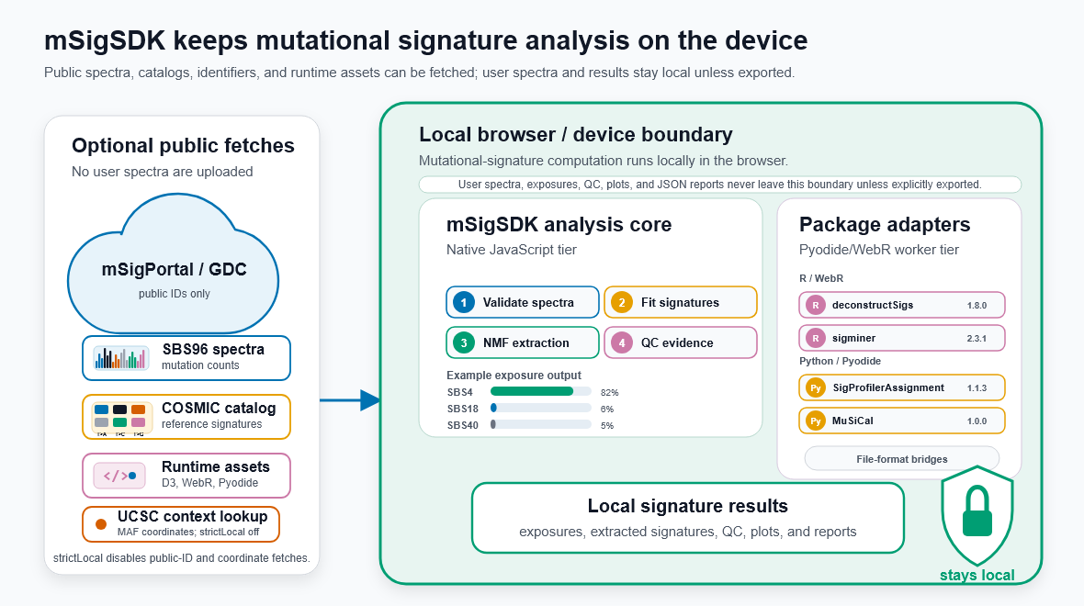
Figure 1. Architecture and data-residency boundary. mSigSDK performs mutational-signature analysis in the browser. Public catalogs, public cohort summaries, reference-context resources, and runtime assets may be fetched from external endpoints, while user spectra, fitted exposures, quality-control outputs, plots, and reports remain in the client runtime unless explicitly exported. Optional coordinate-based helper calls are disabled in strict-local, no-egress mode.

External tool orchestration
The adapter layer lets a single browser session execute and compare multiple established mutational-signature tools on shared spectra. Each adapter follows a uniform three-stage contract: an input-preparation stage produces virtual files and a manifest in the target tool's expected matrix orientation; an execution stage runs the tool in the chosen runtime; and an output-parsing stage reimports the tool's signature and exposure tables into SDK matrix objects through a shared parser. The common parser preserves the same explicit context order and catalog labels, but outputs are not assumed to be semantically comparable merely because they share a matrix shape. Cross-tool comparisons use a separate harmonization contract that records exposure units, complete-catalog membership, filtering order, inactive and omitted signatures, unassigned components, and reconstruction normalization. Each adapter records the targeted package version in provenance, alongside an internal adapter schema version, so downstream consumers can detect schema changes. Four pinned adapter workflows execute in-browser today (Table 1). These adapters expose selected supervised-fitting or refitting interfaces from the upstream packages rather than full browser replicas of each package's complete API.
Table 1. Mutational-signature adapter workflows that execute in-browser through the mSigSDK adapter layer.
Tool | In-browser runtime | Primary role
SigProfilerAssignment 1.1.3 | Pyodide 0.27.4 | cosmic_fit known-signature assignment in matrix mode; plotting and per-mutation probability export are disabled for browser compatibility.
MuSiCal 1.0.0 | Pyodide 0.27.4 | musical.refit.refit browser adapter for sparse refitting; not the full MuSiCal API.
deconstructSigs 1.8.0 | WebR 0.6.0 | whichSignatures known-signature decomposition.
sigminer 2.3.1 | WebR 0.6.0 | sigminer::sig_fit supervised fitting with selected solver methods.

Cross-tool comparison and harmonization
For cross-tool evaluation, all four adapters received the same ordered SBS96 spectra matrix and the same signature catalog. After adapter-specific parsing, output columns were mapped to the complete catalog; package-omitted catalog signatures were retained with zero exposure, non-finite or negative comparison values were set to zero, and package-native unassigned or unexplained components were not relabeled as catalog signatures. Each complete output vector was then converted to relative fractions. Raw exposure accuracy was calculated before filtering. Separately, a common 1% relative-exposure reporting cutoff was applied, values below the cutoff were set to zero, and retained values were renormalized. Active-signature counts, precision, recall, F1, and pairwise Jaccard similarity were calculated from these thresholded vectors. For reconstruction metrics, every catalog signature column was normalized to unit L1 sum before reconstructing the normalized observed spectrum. Pairwise comparisons used flattened-vector Pearson correlation and per-sample L1 distance. Metrics were computed from unrounded fractions; rounding was used only for presentation.
The known-truth analysis used the peer-reviewed synthetic SBS benchmark generated by Islam et al. and distributed with the Diaz-Gay et al. benchmark archive. The archive contains 2,700 spectra generated from 21 reference signatures across nine cancer-type groups and 0%, 5%, and 10% noise conditions. We analyzed one archived spectrum from each cancer-type group at each noise level (nine spectra per noise level; 27 spectra total). The archived 78-signature SBS catalog was supplied unchanged to all four tools. Complete relative-exposure vectors were compared with the published true fractions by cosine similarity, root-mean-square error, and mean absolute error; thresholded active calls were compared with the published true activities by precision, recall, and F1. This high-burden controlled subset was used as an accuracy and noise-sensitivity test, not as a mutation-burden sweep.
The real-world triangulation analysis used the same 38 PCAWG Lung-AdenoCA WGS SBS96 spectra and the same 67-signature COSMIC v3 GRCh37 SBS96 catalog used for adapter-fidelity testing. All tools used the common comparison seed 104729 and the package-specific options recorded in the benchmark provenance. The harmonization layer standardized labels, catalog membership, units, filtering order, and comparison metrics; it did not make the packages' optimization objectives, sparsity behavior, internal normalization, signature-selection logic, or native post-processing equivalent. Because the real cohort has no known exposure truth, this analysis quantifies disagreement and reconstruction behavior rather than biological accuracy or tool superiority.
Native signature fitting
The adapters are not tied to a single dataset, catalog, or tumor type. They accept caller-provided spectra, optional or custom signature matrices, and explicit context ordering, then export these inputs into the SigProfiler-, COSMIC-, or MuSiCal-style matrices required by the selected workflow. At the same time, the adapter layer is deliberately narrower than the full upstream software ecosystem: it exposes supported, pinned workflows that can be executed reproducibly in browser-compatible WebR or Pyodide runtimes, while unsupported upstream functionality remains available through local/server execution or prepared handoff files.
Known-signature refitting is performed independently for each sample by non-negative least squares after aligning the observed spectrum and reference catalog to the same context order. The native fitter precomputes the signature Gram matrix and sample-specific right-hand side, initializes exposures at zero, and updates one exposure at a time from the non-negative normal-equation solution until the maximum coefficient change falls below the scaled convergence tolerance. The default convergence tolerance is 1e-10, and, unless a maximum iteration count is supplied, the iteration limit is the larger of 100 iterations or 100 iterations per candidate signature. Exposures are then filtered using the configured relative-exposure threshold and renormalized when relative exposures are requested.

Exploratory extraction
mSigSDK includes a browser-native implementation of non-negative matrix factorization for exploratory de novo signature extraction. Extraction uses multiplicative-update non-negative matrix factorization of the sample-by-context spectra matrix. Direct extraction defaults to rank 5, 20 restarts from fixed, seeded initializations (base seed 123), a maximum of 1,000 update iterations per restart, and a relative-improvement tolerance of 1e-5. Each update alternates exposure and profile updates, normalizes signature columns, and rescales the corresponding exposure rows to preserve the reconstruction. The selected solution is the restart with the lowest reconstruction error, with average sample cosine similarity and convergence status retained as diagnostic outputs; rank-sweep workflows use the same update rule across candidate ranks, with 10 restarts per rank by default. The user provides a sample-by-context matrix and a candidate rank or rank range; the module returns extracted signature profiles, sample-by-signature exposures, rank-selection diagnostics, and matches between extracted signatures and a reference catalog. The intent is screening and instruction rather than production de novo discovery at large multi-cohort scale, which remains the domain of dedicated extraction tools.

Quality-controlled review
The SDK includes a configurable quality-control layer that converts a panel of evidence fields into a burden-aware reporting mode and recommended actions. Four reporting modes are produced – standard quality-control passed, report with caveats, restricted interpretation, and not assessable – from separable evidence fields covering mutation burden, context coverage, reconstruction quality (cosine similarity, root-mean-square error, mean absolute error, error norms, and maximum residual), residual structure, bootstrap stability from multinomial resampling of the observed spectrum, threshold sensitivity, signature ambiguity from pairwise signature cosine and nearest-neighbor entropy, catalog sufficiency, and panel or whole-exome sequencing evidence. The thresholds that drive each evidence field and the rules that combine them into a reporting mode are user-configurable. The default parameter registry documents each QC evidence field, its default threshold or rule, triggering direction, affected reporting mode, and rationale in the project repository. No community-accepted gold standard exists for these thresholds; the SDK defaults were selected by author judgment and checked for reasonableness against the validation examples and threshold-sensitivity analysis described below, rather than calibrated from a clinical reference standard. These defaults are therefore convenience settings, not community consensus recommendations, and users are expected to recalibrate them for their own catalog, sequencing modality, cohort, and downstream research use. Each evidence field is emitted as a structured object so that a downstream consumer can either accept the assigned reporting mode as a single research-use trust indicator or apply its own combination rule on top of the underlying evidence.
Bootstrap uncertainty is estimated by multinomially resampling each observed spectrum and refitting each resampled spectrum with the same non-negative least-squares settings and post-fit exposure filtering used for the primary fit. The default bootstrap run uses 200 replicates, 95 percent intervals, base seed 123, and the same 1e-10 fitting convergence tolerance; the parameter registry also records 500 replicates as the minimum for stable-interval review and 1,000 as the publication-oriented recommendation. Bootstrap summaries report exposure means, medians, intervals, selection frequencies, and reconstruction diagnostics. Reporting modes are assigned by a rule-based classifier over quality-control warnings: insufficient signal or not-assessable panel evidence yields not assessable; low burden, suspected catalog incompleteness, or high residual structure yields restricted interpretation; bootstrap instability, threshold dependence, signature ambiguity, or flat-signature risk yields report with caveats; and samples without configured review cues are labeled standard quality-control passed.

Reproducible reports and provenance
Results are serialized under a proposed, versioned JSON Schema for mutational-signature analysis reports. The schema is versioned independently of the SDK, with an explicit schema identifier, semantic version, required-field declarations, and field-level descriptions marking each field as required or optional. Minimal and full valid examples, an intentionally invalid example, and validation commands/scripts are provided alongside the schema in the project repository. The compatibility policy is semantic-version based: patch-level schema revisions are intended to preserve backward compatibility, minor revisions may add optional fields, and changes that remove or rename required fields require a major schema-version increment. Each report records the method used (the fitting solver, the adapter and its targeted package version, or the extraction algorithm), the parameters used for fitting and quality control, the validation outcomes, the quality-control evidence fields, the warnings raised, the recommended actions, descriptors for any figures generated, and a provenance block covering the genome build, reference-context source, public-resource endpoints queried, fetch timestamps, and cache status. For resources retrieved through the SDK's mSigPortal, TCGA/GDC, and UCSC live-context helper paths, this block also records HTTP status, payload size, and a SHA-256 checksum of the retrieved payload, enabling post hoc verification against a known-good copy. To our knowledge no community-adopted schema currently exists for mutational-signature reports; the mSigSDK schema is released alongside the source code as a candidate interoperability format that other tools may adopt, critique, or extend. Reports may be emitted as structured JSON or as standalone HTML with the JSON embedded.

Visualization
The plotting layer utilizes mSigPortal [12] mutational-spectrum renderers and D3 [21], Plotly [22], and AMCharts [23] wrappers, producing over thirty interactive views, including mutation burden summaries, clustered cosine similarity heatmaps, similarity trees, uniform manifold approximation projections, exposure heatmaps, bootstrap confidence intervals, threshold sensitivity plots, and non-negative matrix factorization rank-selection diagnostics. A complete catalog of plot functions is in the documentation.

Results
We validated mSigSDK along five axes: that the SDK can be loaded and used without installation; that each in-browser adapter reproduces its matched local package execution; that a harmonized four-tool comparison quantifies known-truth accuracy and real-cohort disagreement; that the SDK's internal solvers reproduce established reference implementations; and that the SDK performs well enough to be used interactively in common cohort-analysis scenarios.

Zero-install browser execution
To demonstrate the zero-install architecture in practice, we walked through a complete analysis session in a fresh browser tab, recording the time from page-load start to a rendered, exportable report (Figure 2). The session began with a dynamic module import on the project-hosted demo page, retrieved a public PCAWG Lung-AdenoCA single-base substitution-96 spectrum from mSigPortal, fitted it against the mSigPortal COSMIC v3 GRCh37 single-base substitution-96 catalog (67 signatures) through an in-browser adapter, and produced the corresponding quality-controlled report, an 8,931-byte JSON packet, in 1.89 s end-to-end. Browser-console imports are therefore presented as API-level examples on supported project pages and notebooks, not as a recommended workflow for arbitrary third-party webpages whose content-security policies may block dynamic imports. Cumulative elapsed time from page-load start was 1.55 s to load the SDK, 1.87 s to retrieve the public spectrum and catalog, and 1.89 s to complete fitting and report generation. No software installation, environment configuration, or data download was required from the user; the SDK, the wrapped tool's runtime, and the public reference resources were fetched on demand from their respective public endpoints.
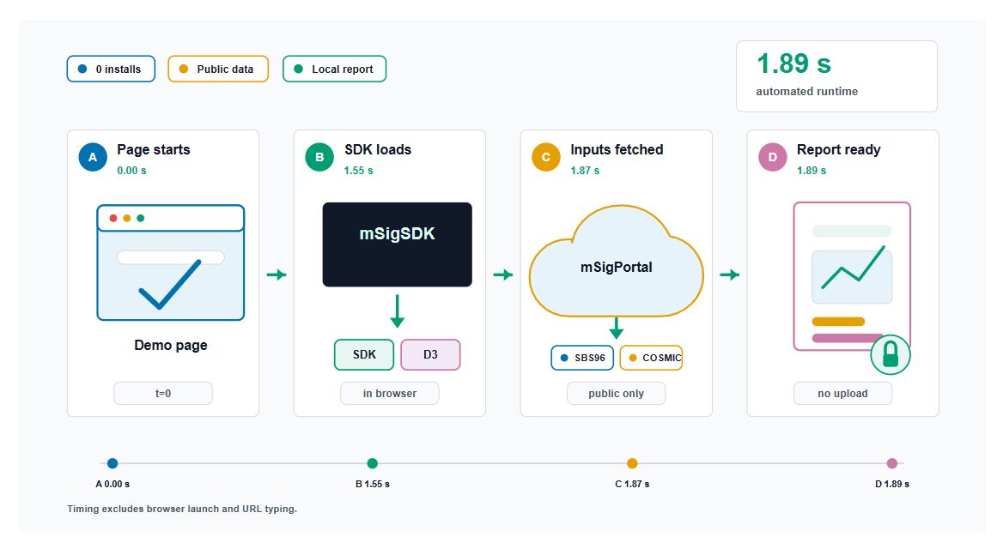Figure 2. Zero-install workflow demonstration. Automated in-page cumulative timing from a fresh browser-profile demo page: after page load begins, the SDK imports, fetches public PCAWG and COSMIC inputs, fits one single-base substitution-96 spectrum against the mSigPortal COSMIC v3 GRCh37 single-base substitution-96 catalog (67 signatures), and renders a local report in 1.89 s. Human time to open a browser or navigate to the page is not included.

Fidelity of the in-browser adapter layer against local execution
To establish that the adapter layer faithfully executes the wrapped tools rather than silently altering their behavior, we ran each in-browser adapter twice on the same inputs: once through the mSigSDK adapter inside a browser session (Chrome 149.0.7827.201, WebR 0.6.0, Pyodide 0.27.4), and once with the same tool at the same pinned package version in a conventional local installation (R 4.6.0 via Rscript for deconstructSigs 1.8.0 and sigminer 2.3.1; Python 3.13.5 in a repo-local virtual environment for SigProfilerAssignment 1.1.3 and MuSiCal 1.0.0). Inputs were 38 PCAWG Lung-AdenoCA single-base substitution-96 spectra fitted against the mSigPortal COSMIC v3 GRCh37 single-base substitution-96 catalog (67 signatures); all four comparisons are deterministic known-signature assignment/refitting paths run with a fixed seed (104729) and matched, deterministic tool options (documented in the project repository) across the browser and local execution. Input spectra, catalog, and metadata are distributed with SHA-256 checksums to support exact reproduction. Numerical agreement was assessed against a pre-specified tolerance: exact agreement (maximum absolute difference of 0) for deconstructSigs, sigminer, and SigProfilerAssignment, and floating-point-noise agreement (tolerance 1×10⁻¹² for both maximum absolute difference and root-mean-square error) for MuSiCal. Although the adapters accept caller-provided spectra, optional or custom signature matrices, and explicit context ordering, these fidelity results validate browser/local numerical agreement only for one benchmark configuration: one tumor type, one profile type, one catalog, and one genome build. We have not evaluated whether browser/local agreement holds equally for other tumor types, low-burden samples, panel or whole-exome settings, MAF-conversion workflows, DBS/ID/SBS1536 profiles, or other genome builds. Separately, exact numerical agreement between browser and local execution demonstrates that the adapter layer does not alter a wrapped tool's behavior; it does not constitute independent evidence that the wrapped tools' outputs are biologically correct, which rests on each tool's own published validation.

Numerical agreement of internal solvers
The non-negative least-squares signature fitting solver matches established Python and R reference implementations to within floating-point tolerance, with a largest absolute exposure difference of 1.65×10⁻⁹. The non-negative matrix factorization extraction algorithm achieves a reconstruction error 0.918× that of the scikit-learn reference and recovers matched components with a high median cosine similarity of 0.967.

Capability demonstration on a public cohort
We demonstrated the SDK on 38 publicly available PCAWG Lung-AdenoCA single-base substitution-96 spectra retrieved through mSigPortal and fitted against the mSigPortal COSMIC v3 GRCh37 single-base substitution-96 catalog (67 signatures), in a single browser session and without server-side computation (Figure 3). This cohort is one slice of the public resources mSigPortal exposes, and is used here as a capability demonstration rather than as validation across all available cancer types or profile representations: as of this writing, mSigPortal's PCAWG whole-genome-sequencing spectrum endpoint alone offers 2,780 public samples across 37 cancer types and five derived profile representations (SBS96, SBS192, SBS1536, DBS78, ID83). SBS4 dominated the cohort, consistent with the known tobacco-associated etiology of lung adenocarcinoma. Fit quality was high across the cohort (median fit cosine 0.997). As an example of the SDK's threshold-sensitivity review, raising the exposure cutoff from 0 to 5% reduced the mean number of active signatures more than six-fold but degraded the mean reconstruction cosine by less than four percentage points, indicating that most low-exposure calls were numerically minor in this cohort. Exploratory non-negative matrix factorization on the same cohort selected rank 6, with the extracted components recovering profiles broadly consistent with the dominant fitted signatures. All panels were generated from the same imported matrix in the same browser session and exported in the SDK's report format with full provenance. A complete walk-through of the workflow – including per-sample evidence cards, bootstrap uncertainty estimation, and the full set of cohort visualizations – is available as a runnable notebook at https://episphere.github.io/msig/notebooks/viewer.html?notebook=msig-sdk-end-to-end-workflow.onb.html.
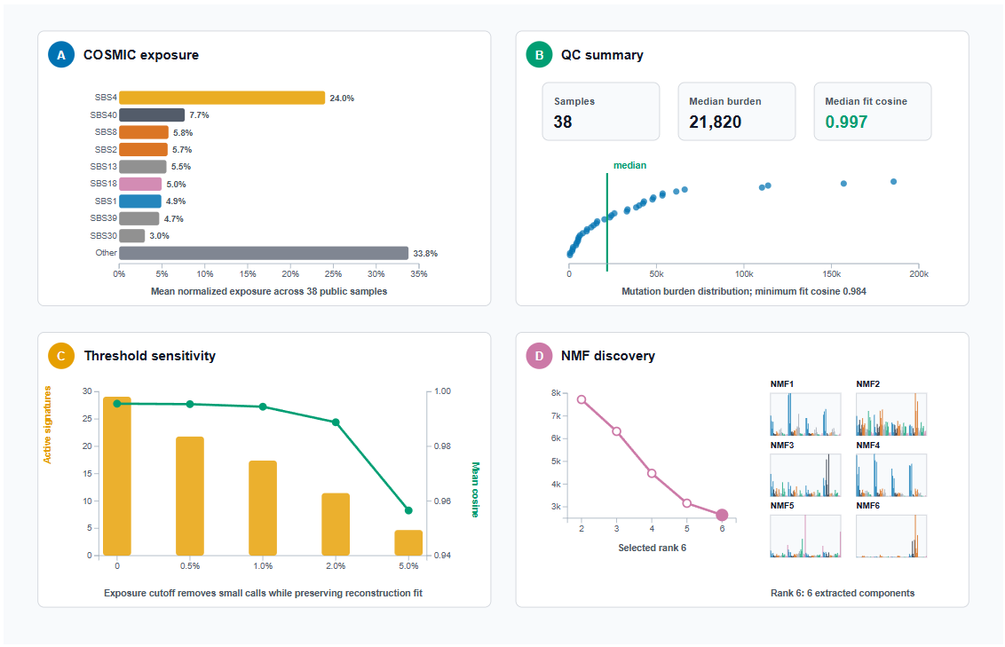
Figure 3. Browser-side public cohort capability summary. Thirty-eight public PCAWG Lung-AdenoCA SBS96 spectra were fetched from mSigPortal, fitted in the browser against the mSigPortal COSMIC v3 GRCh37 SBS96 catalog with 67 signatures, and summarized as manuscript-scale SDK outputs. Panels show (A) mean normalized COSMIC exposure across the cohort for the dominant fitted signatures, with remaining signatures grouped as Other; (B) cohort quality-control metrics and mutation-burden distribution; (C) exposure-threshold sensitivity, comparing active-signature counts with reconstruction fit across cutoffs; and (D) exploratory rank-6 non-negative matrix factorization, including rank diagnostics and the six extracted SBS96 component profiles.

Runtime and desktop browser compatibility
Browser runtime is acceptable for interactive use across single-sample, panel-scale, and cohort-scale computational workflows (Figure 4). On the benchmark host (Windows, 32 CPUs, 31.2 GB RAM), a single-sample single-base substitution-96 non-negative least-squares fitting task completed in 4.1 ms median in Chrome, 3.5 ms in Edge, and 2.3 ms in Firefox. A 120-sample cohort refit completed in around 23 ms median in Chrome and Edge and 28.4 ms in Firefox. A portal-scale 300-sample, 40-signature refit completed in around 1.56 s median in Chrome and Edge and 2.85 s in Firefox. Bootstrap uncertainty with 500 iterations on a single sample completed in around 250 ms across all three browsers. Cohort-scale bootstrap, which estimates uncertainty independently for every sample, uses a Web Worker-backed implementation when workers are available, with a serial fallback otherwise; the executed mode is recorded in the workflow report. Bootstrap remains substantially more expensive than fitting alone at cohort scale and is reported separately from the fitting-only scenarios above. Non-negative matrix factorization rank selection followed by rank-4 extraction completed in 3.18 s median in Chrome, 3.15 s in Edge, and 2.26 s in Firefox. All medians are from five isolated repeats per browser and should be interpreted as scenario-level elapsed times rather than full performance distributions. Plot rendering, quality-control evidence computation, report serialization, and memory profiling are excluded from these Figure 4 measurements. The benchmark harness does not further decompose elapsed time into network fetch, module import, Pyodide/WebR initialization, package import, and pure JavaScript execution components. The full benchmark scenarios and harness are in the project repository. All workflows tested, including module loading, public-resource retrieval, native fitting and report generation, D3 visualization, and the Pyodide and WebR adapters, passed on all three browsers tested (Chrome, Edge, and Firefox on Windows). Because current Microsoft Edge and Google Chrome are both Chromium-based browsers, these two browsers should not be interpreted as independent browser-engine tests. Rather, the benchmark evaluates two production Chromium/Blink-family browsers and one Gecko-family browser, with Safari/WebKit remaining outside the present evaluation.
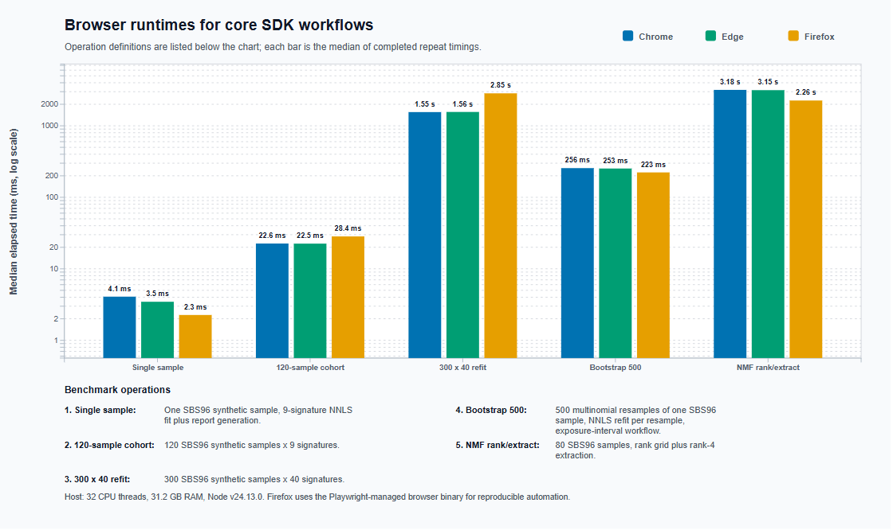
Figure 4. Browser runtime benchmarks. Median elapsed time across five isolated repeats in Chrome, Edge, and Firefox on the benchmark host (Windows, 32 CPUs, 31.2 GB RAM). Scenarios are single-sample non-negative least-squares fit and report; 120-sample cohort NNLS exposure refit (fitting only); 300-sample, 40-signature refit; 500-iteration bootstrap uncertainty on a single sample; and non-negative matrix factorization rank selection plus rank-4 extraction. Log-scale axis keeps fast single-sample operations visible alongside slower workflows. These measurements are scenario-level computational timings rather than full end-to-end workflow timings; plotting, quality-control evidence computation, report serialization, and memory profiling are not included. Medians are reported from five isolated repeats per browser rather than full distributions, and cold-start costs are not decomposed from warm-execution costs.

Known-truth accuracy and real-world tool triangulation
On the published known-truth benchmark, all four tools closely recovered the true exposure fractions, with degradation under the archived noise conditions (Figure 5A-B). Mean raw exposure cosine at 0% noise was 0.9983 for deconstructSigs, 1.0000 for sigminer, 1.0000 for SigProfilerAssignment, and 0.9987 for MuSiCal; at 5% noise it was 0.9879, 0.9919, 0.9996, and 0.9984; and at 10% noise it was 0.9719, 0.9804, 0.9894, and 0.9926, respectively. After the common 1% reporting cutoff, mean active-call F1 at 10% noise was 0.5711, 0.5644, 0.9568, and 0.9167, respectively. At that noise level, mean precision/recall was 0.4459/0.8635 for deconstructSigs, 0.4474/0.8646 for sigminer, 1.0000/0.9238 for SigProfilerAssignment, and 0.9286/0.9175 for MuSiCal. Thus, high reconstruction agreement did not eliminate meaningful differences in false-positive and missed active-signature calls.
The real PCAWG comparison showed materially larger tool-to-tool differences after the same harmonization steps (Figure 5C-F; Table 2). Flattened exposure correlations ranged from 0.803 for sigminer versus SigProfilerAssignment to 0.953 for deconstructSigs versus sigminer. Mean per-sample L1 disagreement ranged from 0.350 to 0.907, and mean active-signature Jaccard similarity ranged from 0.186 to 0.694. Mean active-signature counts were 15.87 for deconstructSigs, 17.39 for sigminer, 4.13 for SigProfilerAssignment, and 11.21 for MuSiCal. Mean reconstruction cosine remained high for all four tools (0.982-0.995), showing that similar reconstruction quality can coexist with different exposure allocations and active-signature sets. The largest mean across-tool exposure ranges were concentrated in SBS5, SBS40, SBS8, SBS4, SBS39, and SBS18.
The synthetic and real-cohort analyses answer different questions. The synthetic benchmark supports known-truth accuracy and active-call sensitivity under its archived noise conditions, but its high-burden mixtures were generated from the same catalog used for fitting and do not demonstrate that the tools are interchangeable. The PCAWG analysis has no known exposure truth and therefore cannot identify a biologically superior tool. Instead, it demonstrates the practical value of the common adapter layer: investigators can distinguish findings that are stable across fitting implementations from findings that are tool-sensitive and require cautious interpretation.
Table 2. Active-signature counts and reconstruction quality for the real PCAWG four-tool comparison after the common 1% reporting cutoff.
Tool | Mean active signatures | Mean reconstruction cosine | Minimum reconstruction cosine
deconstructSigs | 15.87 | 0.9941 | 0.9811
sigminer | 17.39 | 0.9945 | 0.9831
SigProfilerAssignment | 4.13 | 0.9815 | 0.9430
MuSiCal | 11.21 | 0.9931 | 0.9823
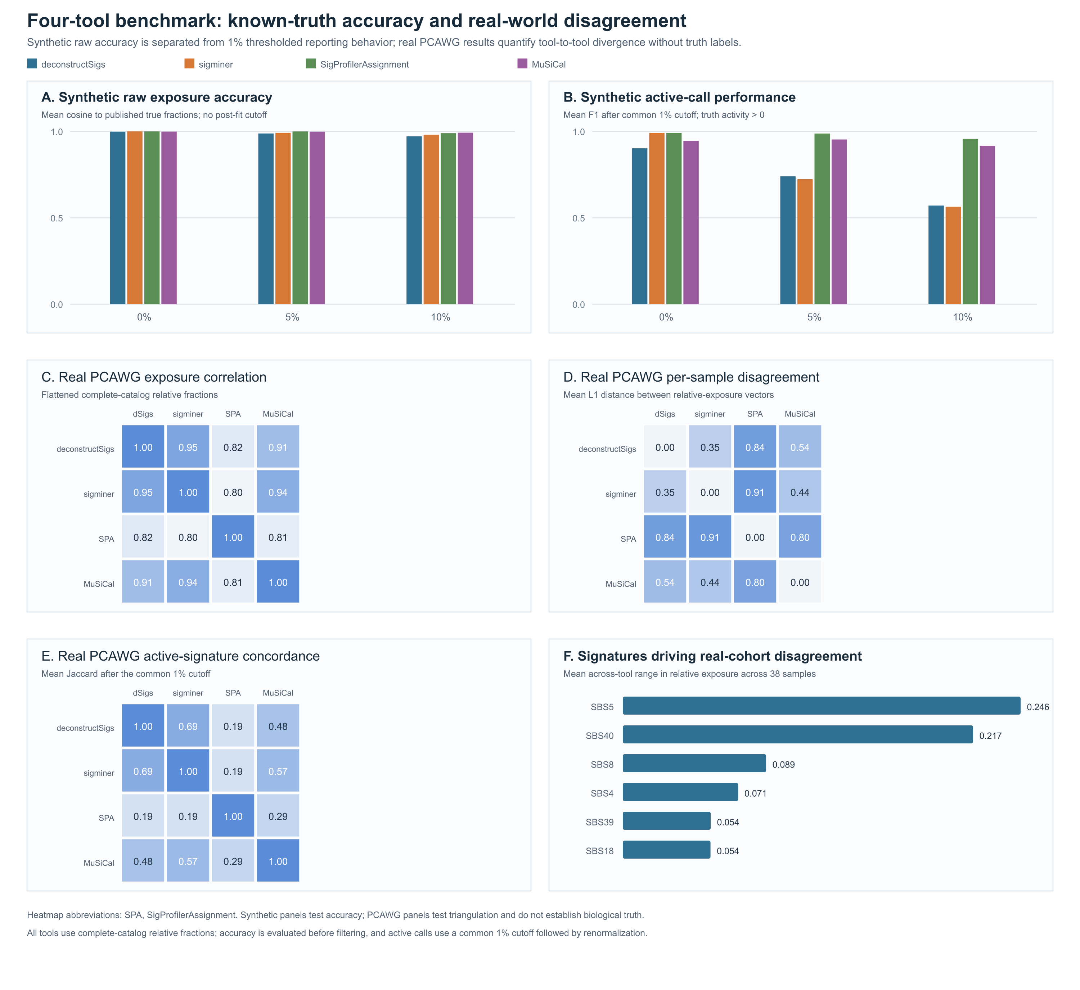
Figure 5. Known-truth accuracy and real-world tool triangulation after explicit harmonization. Panels A-B use one archived spectrum from each of nine cancer-type groups at 0%, 5%, and 10% noise. (A) Mean cosine between the complete raw relative-exposure vector and the published true fractions, evaluated before filtering. (B) Mean active-signature F1 after a common 1% relative-exposure cutoff and renormalization. Panels C-F use 38 PCAWG Lung-AdenoCA WGS SBS96 spectra fitted against the 67-signature COSMIC v3 GRCh37 catalog. (C) Pairwise Pearson correlation of flattened complete-catalog relative fractions. (D) Mean per-sample L1 distance between relative-exposure vectors. (E) Mean active-signature Jaccard similarity after the common 1% cutoff. (F) The six signatures with the largest mean across-tool exposure range. Package-omitted catalog columns were zero-filled; non-finite or negative comparison values were set to zero; unassigned components were not relabeled as catalog signatures; and catalog columns were normalized to unit sum for reconstruction metrics. The synthetic panels evaluate accuracy under the tested archived conditions. The PCAWG panels quantify disagreement without known truth and do not establish biological superiority.

Discussion
The four-tool benchmark supports a narrower and more useful scientific value proposition than orchestration alone. On the published synthetic benchmark, all four tools closely recovered the known fractions, although raw exposure accuracy and active-call performance degraded under increasing archived noise. On the real PCAWG cohort, explicit harmonization did not eliminate substantial differences in exposure allocation, active-signature counts, or active-signature concordance, even when reconstruction cosine remained high. The common adapter layer therefore enables investigators to identify conclusions that are stable across fitting implementations and conclusions that are tool-sensitive; because the real cohort has no known exposure truth, the comparison does not establish that one package is biologically superior. The browser-versus-local fidelity experiment answers a separate question: it shows that the adapters reproduce their wrapped tools rather than silently altering them. Fidelity does not itself validate the biological correctness of a tool's output. This numerical result also does not establish security. Browsers are complex, frequently patched attack surfaces, and JavaScript dependency chains are a documented vector for supply-chain compromise; mSigSDK's pinned-version, checksum-verified execution and optional no-egress mode reduce but do not eliminate this exposure. Users handling regulated or sensitive data should weigh these residual risks rather than treat data residency alone as a privacy control.
Second, on runtime: browser fitting is fast at the scales most analysts encounter – a 120-sample cohort refit completes in roughly 25 ms, comparable to or faster than a local Python session once interpreter startup is included. This figure isolates the fitting step. It should therefore not be read as an end-to-end notebook runtime that includes resource loading, plotting, quality-control evidence generation, report serialization, or memory overhead. A full interactive review that also requests per-sample bootstrap uncertainty takes substantially longer, since bootstrap is estimated independently per sample and, even with Web Worker parallelization where available, remains the dominant cost of an end-to-end cohort review. At larger scales, in-browser non-negative matrix factorization grows noticeably more expensive (about three seconds for rank selection over 80 samples), marking the practical boundary at which in-browser exploration begins to displace, rather than complement, server-side or local analysis. We see this as a useful design signal rather than a limitation: the architecture suits interactive review and screening, and hands off naturally to heavier extraction tools when production-scale de novo discovery is the goal. Because all computation occurs client-side, scale is bounded by the user's own device memory and CPU rather than by any server-side quota; public-API calls contribute only initial spectrum and catalog retrieval and are not part of the per-sample computational cost characterized above.
Third, on shareable provenance: the published JSON Schema lets a complete analysis result – method, parameters, fitted exposures, quality-control evidence, warnings, and the public-resource endpoints queried – travel as a self-contained record that other schema-aware tools can consume and re-render. This is a different kind of reproducibility than a scripted pipeline: not a recipe for re-running the analysis, but a self-describing record of what was done. Combined with the data-residency boundary of browser-native execution, this suits settings where sequencing data cannot leave the device but signature-level results must travel. Reliance on public APIs for reference data is itself a trade-off: unlike locally vendored data, a public endpoint can return erroneous results or become unavailable, and the checksum, endpoint, and timestamp recorded in each report's provenance block are intended to surface such discrepancies after the fact rather than prevent them. We judge this an acceptable trade-off for the reuse and always-current-catalog benefits it provides.
Several limitations warrant consideration. mSigSDK does not replace production-scale de novo extraction or disease-specific validation, for which local package execution is recommended. Similarly, the browser adapter layer should be interpreted as a set of supported, pinned workflows rather than a complete browser clone of each upstream package API. The present validation separates browser/local numerical fidelity for one Lung-AdenoCA SBS96 configuration, known-truth accuracy for 27 published high-burden synthetic spectra across three archived noise conditions, and tool disagreement for 38 real Lung-AdenoCA spectra without exposure truth. The synthetic subset is not a mutation-burden sweep, and the real-cohort comparison cannot determine biological superiority. Performance across additional tumor types, low-burden or panel/WES inputs, MAF-conversion workflows, DBS/ID/SBS1536 profiles, and alternate genome builds remains untested. Quality-control thresholds are heuristically determined rather than based on community standards, requiring user calibration for specific catalogs and cohorts. The adapter layer relies on third-party WebR and Pyodide builds, which evolve independently. Mutation annotation format conversion requires precise genome builds and reference contexts; offline deployments must provide project-specific lookup tables. While the data-residency model reduces data exposure, it is not a substitute for formal security certification; users requiring strict compliance should implement additional measures. Evaluation is currently limited to Chrome, Edge, and Firefox on a Windows benchmark host. Because mSigSDK executes through browser JavaScript/WebAssembly runtimes rather than host-operating-system-specific native code, we expect operating-system effects to be secondary to browser-engine effects for the workflows evaluated here. Current Chrome and Microsoft Edge are both Chromium/Blink-family browsers, so they should not be interpreted as independent browser-engine tests; Firefox provides Gecko-family coverage, while Safari/WebKit remains untested. Mobile and tablet environments are also untested and are outside the current SDK's intended target for desktop-class computational analysis. Finally, while cohort-scale bootstrap is parallelized via Web Workers where supported, it remains computationally intensive compared to fitting-only workflows. The SDK also does not currently persist project workspaces across browser sessions; users must export JSON or HTML reports explicitly before closing the browser tab. We have not pursued desktop packaging because it would reintroduce the installation burden the SDK is designed to avoid.
Future development will extend browser-engine compatibility testing to Safari/WebKit, expand the adapter layer to additional tools as compatible WebR and Pyodide builds become available, submit the JSON Schema for external community review as a candidate interoperability format, revisit and empirically calibrate the quality-control default thresholds as the SDK is applied to additional cancer types, sequencing panels, and known-mixture validation sets, add optional browser-native session persistence for local project workspaces, and add a lightweight graphical front-end notebook template that complements the runnable examples already provided. This interface will be designed for users who prefer guided workflows over direct API calls, with built-in demonstration datasets, preflight input checks, clearer diagnostic messages when genome build or mutation-context assumptions are inconsistent, and a short introductory workflow, while preserving the SDK's zero-install, data-residency guarantees.

Conclusions
mSigSDK is a browser-native, zero-install, FAIR-aligned JavaScript software development kit for mutational-signature analysis. It orchestrates four established mutational-signature packages - SigProfilerAssignment, MuSiCal, deconstructSigs, and sigminer - through a uniform adapter layer; provides exploratory non-negative matrix factorization in the browser; scores fits against a configurable, burden-aware quality-control evidence panel; and serializes results under a proposed, versioned JSON Schema with full provenance. In an explicitly harmonized four-tool benchmark, all four tools showed high known-truth exposure accuracy under the tested published synthetic conditions, while the real PCAWG cohort showed material differences in exposure allocation and active-signature calls. These results support multi-tool triangulation as a way to identify stable and tool-sensitive conclusions, not as a method for selecting a biologically superior tool without truth data. The SDK loads without installation, runs entirely on the client for the workflows that should be local, completes a full single-sample analysis against a 67-signature COSMIC catalog in under two seconds from a cold browser load, and reproduces the behavior of the wrapped tools to numerical precision. It is accessible to anyone working with mutational signatures - including computational analysts, clinical and translational researchers, methods developers, and educators - without the configuration overhead of conventional installations.

Availability and requirements
Project name: mSigSDK
Project home page: https://episphere.github.io/msig/
Documentation: https://episphere.github.io/msig/docs/
Example notebooks and worked demonstrations: https://episphere.github.io/msig/notebooks/viewer.html
Operating system(s): Platform independent (tested on Windows with Chrome, Edge, and Firefox)
Programming language: JavaScript (ECMAScript modules)
Current version: 0.3.0
Other requirements: A modern desktop browser with ECMAScript module support, or Node.js version 18 or later for local execution; WebR for the in-browser deconstructSigs and sigminer adapters; Pyodide for the in-browser SigProfilerAssignment and MuSiCal adapters; internet access for queries to mSigPortal, The Cancer Genome Atlas, the Genomic Data Commons, and the UCSC Genome Browser when those public resources are used
License: MIT
Any restrictions to use by non-academics: None

List of abbreviations
API: application programming interface. COSMIC: Catalogue of Somatic Mutations in Cancer. DBS: double-base substitution. GDC: Genomic Data Commons. ID: insertion or deletion. JSON: JavaScript Object Notation. MAF: mutation annotation format. NMF: non-negative matrix factorization. NNLS: non-negative least squares. PCAWG: Pan-Cancer Analysis of Whole Genomes. QC: quality control. SBS: single-base substitution. SDK: software development kit. TCGA: The Cancer Genome Atlas. WES: whole-exome sequencing. WGS: whole-genome sequencing.

Declarations

Ethics approval and consent to participate
Not applicable.

Consent for publication
Not applicable.

Availability of data and materials
The mSigSDK source code and example workflows are publicly available at https://github.com/episphere/msig. The data supporting the findings of this study are available from mSigPortal at https://analysistools.cancer.gov/mutational-signatures/#/. Notebooks demonstrating example use of the SDK are available at https://episphere.github.io/msig/notebooks/viewer.html.
A preprint of an earlier version of this work is available at Research Square (DOI: 10.21203/rs.3.rs-6536730/v1). The present manuscript reflects substantial development beyond that preprint: the adapter layer orchestrating external tools (SigProfilerAssignment, MuSiCal, deconstructSigs, and sigminer) has been added; browser-native non-negative matrix factorization for exploratory de novo extraction has been added; the quality-control and reporting layer, including its evidence fields and four-mode reporting classifier, has been added; the provenance and reproducible-report system, including the published JSON Schema, checksum verification, and version pinning, has been added; and the runnable example notebooks referenced throughout this manuscript have been published to the project website. The title and privacy framing have also been revised to a precisely scoped data-residency description, consistent with the architecture described here.

Competing interests
A.G., T.Z., Y.C.M., M.T.L., B.P., K.C., J.B., and J.S.A. declare no competing interests.

Funding
This work was funded by the National Cancer Institute Intramural Research Program (DCEG/Episphere number 10901). The funder had no role in the design of the study; in the collection, analysis, or interpretation of the data; or in the writing of the manuscript.

Authors' contributions
A.G. and J.S.A. conceived and designed the study. A.G. developed the mSigSDK, conducted the implementation and testing, created the figures, and wrote the manuscript. J.S.A. provided project direction and technical guidance. T.Z., Y.C.M., M.T.L., B.P., K.C., and J.B. provided feedback, advice, and reviewed the software and manuscript drafts. All authors reviewed and approved the final manuscript.

Acknowledgements
Not applicable.

References
[1] L. B. Alexandrov et al., “The repertoire of mutational signatures in human cancer,” Nature, vol. 578, no. 7793, pp. 94–101, Feb. 2020, doi: 10.1038/s41586-020-1943-3.
[2] M. T. Landi et al., “Tracing Lung Cancer Risk Factors Through Mutational Signatures in Never-Smokers : The Sherlock-Lung Study,” Am. J. Epidemiol., vol. 190, no. 6, pp. 962–976, Jun. 2021, doi: 10.1093/aje/kwaa234.
[3] O. Pich, F. Muiños, M. P. Lolkema, N. Steeghs, A. Gonzalez-Perez, and N. Lopez-Bigas, “The mutational footprints of cancer therapies,” Nat. Genet., vol. 51, no. 12, pp. 1732–1740, Dec. 2019, doi: 10.1038/s41588-019-0525-5.
[4] G. Koh, A. Degasperi, X. Zou, S. Momen, and S. Nik-Zainal, “Mutational signatures: emerging concepts, caveats and clinical applications,” Nat. Rev. Cancer, vol. 21, no. 10, pp. 619–637, Oct. 2021, doi: 10.1038/s41568-021-00377-7.
[5] M. Díaz-Gay et al., “Assigning mutational signatures to individual samples and individual somatic mutations with SigProfilerAssignment,” Bioinformatics, vol. 39, no. 12, p. btad756, Dec. 2023, doi: 10.1093/bioinformatics/btad756.
[6] S. M. A. Islam et al., “Uncovering novel mutational signatures by de novo extraction with SigProfilerExtractor,” Cell Genomics, vol. 2, no. 11, p. 100179, Nov. 2022, doi: 10.1016/j.xgen.2022.100179.
[7] H. Jin et al., “Accurate and sensitive mutational signature analysis with MuSiCal,” Nat. Genet., vol. 56, no. 3, pp. 541–552, Mar. 2024, doi: 10.1038/s41588-024-01659-0.
[8] R. Rosenthal, N. McGranahan, J. Herrero, B. S. Taylor, and C. Swanton, “deconstructSigs: delineating mutational processes in single tumors distinguishes DNA repair deficiencies and patterns of carcinoma evolution,” Genome Biol., vol. 17, no. 1, p. 31, Feb. 2016, doi: 10.1186/s13059-016-0893-4.
[9] F. Blokzijl, R. Janssen, R. van Boxtel, and E. Cuppen, “MutationalPatterns: comprehensive genome-wide analysis of mutational processes,” Genome Med., vol. 10, no. 1, p. 33, Apr. 2018, doi: 10.1186/s13073-018-0539-0.
[10] A. Chevalier et al., “The Mutational Signature Comprehensive Analysis Toolkit (musicatk) for the Discovery, Prediction, and Exploration of Mutational Signatures,” Cancer Res., vol. 81, no. 23, pp. 5813–5817, Dec. 2021, doi: 10.1158/0008-5472.CAN-21-0899.
[11] S. Wang et al., “Copy number signature analysis tool and its application in prostate cancer reveals distinct mutational processes and clinical outcomes,” PLOS Genet., vol. 17, no. 5, p. e1009557, May 2021, doi: 10.1371/journal.pgen.1009557.
[12] T. Zhang, J. Sang, P. Cho, K. Jiang, and M. T. Landi, “Abstract 211: Integrative mutational signature portal (mSigPortal) for cancer genomic study,” Cancer Res., vol. 81, no. 13_Supplement, p. 211, Jul. 2021, doi: 10.1158/1538-7445.AM2021-211.
[13] M. Medo, C. K. Y. Ng, and M. Medová, “A comprehensive comparison of tools for fitting mutational signatures,” Nat. Commun., vol. 15, no. 1, p. 9467, Nov. 2024, doi: 10.1038/s41467-024-53711-6.
[14] A. J. Wu, A. Perera, L. Kularatnarajah, A. Korsakova, and J. J. Pitt, “Mutational signature assignment heterogeneity is widespread and can be addressed by ensemble approaches,” Brief. Bioinform., vol. 24, no. 6, p. bbad331, Sep. 2023, doi: 10.1093/bib/bbad331.
[15] J. S. Almeida, J. Hajagos, J. Saltz, and M. Saltz, “Serverless OpenHealth at data commons scale–traversing the 20 million patient records of New York’s SPARCS dataset in real-time,” PeerJ, vol. 7, p. e6230, Jan. 2019, doi: 10.7717/peerj.6230.
[16] M. D. Wilkinson et al., “The FAIR Guiding Principles for scientific data management and stewardship,” Sci. Data, vol. 3, no. 1, p. 160018, Mar. 2016, doi: 10.1038/sdata.2016.18.
[17] R. L. Grossman, “Data Lakes, Clouds, and Commons: A Review of Platforms for Analyzing and Sharing Genomic Data,” Trends Genet. TIG, vol. 35, no. 3, pp. 223–234, Mar. 2019, doi: 10.1016/j.tig.2018.12.006.
[18] M. A. Jensen, V. Ferretti, R. L. Grossman, and L. M. Staudt, “The NCI Genomic Data Commons as an engine for precision medicine,” Blood, vol. 130, no. 4, pp. 453–459, Jul. 2017, doi: 10.1182/blood-2017-03-735654.
[19] E. Ruan et al., “PLCOjs, a FAIR GWAS web SDK for the NCI Prostate, Lung, Colorectal and Ovarian Cancer Genetic Atlas project,” Bioinformatics, vol. 38, no. 18, pp. 4434–4436, Sep. 2022, doi: 10.1093/bioinformatics/btac531.
[20] J. S. Almeida et al., “Mortality Tracker: the COVID-19 case for real time web APIs as epidemiology commons,” Bioinformatics, vol. 37, no. 14, pp. 2073–2074, Aug. 2021, doi: 10.1093/bioinformatics/btaa933.
[21] D3 by Observable | The JavaScript library for bespoke data visualization. Accessed: May 23, 2026. [Online]. Available: https://d3js.org/
[22] Interactive Data Visualization & Data Apps | Plotly. Accessed: May 23, 2026. [Online]. Available: https://plotly.com/
[23] amCharts. Accessed: May 23, 2026. [Online]. Available: https://www.amcharts.com/accessibility/

