Reviewer 4 - Major Comment 1 manuscript edit kit
Exact changes for the central four-tool value proposition

What to do
FIGURE DECISION
Do not replace Figures 1-4 and do not reuse the adapter-fidelity figure. Add the new benchmark as Figure 5 after current Figure 4, immediately before the Discussion. The adapter-fidelity experiment remains in place because it answers browser-versus-local fidelity, not cross-tool scientific triangulation.
- Replace three existing overview paragraphs: Abstract Results, External tool orchestration, and the opening Results overview.
- Insert one Methods subsection after Table 1 and before Native signature fitting.
- Insert one Results subsection, Table 2, Figure 5, and its caption after current Figure 4.
- Replace the first Discussion implication and narrowly update the limitations and Conclusions.

Exact replacements

1. Abstract - Results paragraph
ORIGINAL
We validated the SDK along four axes. A zero-install reproducibility walk-through took the SDK from browser page-load to a rendered report in 1.89 s. In-browser adapter execution numerically agreed with conventional local execution of each wrapped tool in a Lung-AdenoCA SBS96 benchmark, with exact reproduction for three of the four adapters and floating-point-noise agreement for the fourth. The SDK's internal solvers agreed numerically with established reference implementations. And runtime benchmarks across Chrome, Edge, and Firefox showed that a 120-sample cohort NNLS exposure refit (fitting only, excluding bootstrap uncertainty) completed in approximately 25 ms, and a 300-sample, 40-signature refit in under 3 s.
REPLACE WITH
We validated the SDK along five axes. A zero-install reproducibility walk-through took the SDK from browser page-load to a rendered report in 1.89 s. In-browser adapter execution numerically agreed with conventional local execution of each wrapped tool in a Lung-AdenoCA SBS96 benchmark, with exact reproduction for three of the four adapters and floating-point-noise agreement for the fourth. In a separate four-tool comparison, all adapters analyzed the same spectra and catalog under an explicit harmonization contract. On a published known-truth benchmark, mean raw exposure cosine ranged from 0.9983 to 1.0000 at 0% noise, 0.9879 to 0.9996 at 5% noise, and 0.9719 to 0.9926 at 10% noise. On 38 real PCAWG Lung-AdenoCA spectra, pairwise exposure correlations ranged from 0.803 to 0.953 and mean active-signature Jaccard similarity ranged from 0.186 to 0.694, demonstrating that the common adapter layer can identify tool-sensitive conclusions. The SDK's internal solvers agreed numerically with established reference implementations. Runtime benchmarks across Chrome, Edge, and Firefox showed that a 120-sample cohort NNLS exposure refit (fitting only, excluding bootstrap uncertainty) completed in approximately 25 ms, and a 300-sample, 40-signature refit in under 3 s.

2. Implementation - External tool orchestration
ORIGINAL
The adapter layer lets a single browser session execute and compare multiple established mutational-signature tools on shared spectra. Each adapter follows a uniform three-stage contract: an input-preparation stage produces virtual files and a manifest in the target tool's expected matrix orientation; an execution stage runs the tool in the chosen runtime; and an output-parsing stage reimports the tool's signature and exposure tables into SDK matrix objects through a shared parser. All tools therefore see the same context order, and their outputs are directly comparable without post-hoc reconciliation. Each adapter records the targeted package version in provenance, alongside an internal adapter schema version, so downstream consumers can detect schema changes. Four pinned adapter workflows execute in-browser today (Table 1). These adapters expose selected supervised-fitting or refitting interfaces from the upstream packages rather than full browser replicas of each package's complete API.
REPLACE WITH
The adapter layer lets a single browser session execute and compare multiple established mutational-signature tools on shared spectra. Each adapter follows a uniform three-stage contract: an input-preparation stage produces virtual files and a manifest in the target tool's expected matrix orientation; an execution stage runs the tool in the chosen runtime; and an output-parsing stage reimports the tool's signature and exposure tables into SDK matrix objects through a shared parser. The common parser preserves the same explicit context order and catalog labels, but outputs are not assumed to be semantically comparable merely because they share a matrix shape. Cross-tool comparisons use a separate harmonization contract that records exposure units, complete-catalog membership, filtering order, inactive and omitted signatures, unassigned components, and reconstruction normalization. Each adapter records the targeted package version in provenance, alongside an internal adapter schema version, so downstream consumers can detect schema changes. Four pinned adapter workflows execute in-browser today (Table 1). These adapters expose selected supervised-fitting or refitting interfaces from the upstream packages rather than full browser replicas of each package's complete API.

3. Results - validation overview
ORIGINAL
We validated mSigSDK along four axes: that the SDK can be loaded and used without installation, that the in-browser adapter layer reproduces the behavior of the wrapped tools, that the SDK's internal solvers reproduce established reference implementations, and that the SDK performs well enough to be used interactively in common cohort-analysis scenarios.
REPLACE WITH
We validated mSigSDK along five axes: that the SDK can be loaded and used without installation; that each in-browser adapter reproduces its matched local package execution; that a harmonized four-tool comparison quantifies known-truth accuracy and real-cohort disagreement; that the SDK's internal solvers reproduce established reference implementations; and that the SDK performs well enough to be used interactively in common cohort-analysis scenarios.

Exact Methods insertion
Placement: after Table 1 and before the heading Native signature fitting.

Cross-tool comparison and harmonization
For cross-tool evaluation, all four adapters received the same ordered SBS96 spectra matrix and the same signature catalog. After adapter-specific parsing, output columns were mapped to the complete catalog; package-omitted catalog signatures were retained with zero exposure, non-finite or negative comparison values were set to zero, and package-native unassigned or unexplained components were not relabeled as catalog signatures. Each complete output vector was then converted to relative fractions. Raw exposure accuracy was calculated before filtering. Separately, a common 1% relative-exposure reporting cutoff was applied, values below the cutoff were set to zero, and retained values were renormalized. Active-signature counts, precision, recall, F1, and pairwise Jaccard similarity were calculated from these thresholded vectors. For reconstruction metrics, every catalog signature column was normalized to unit L1 sum before reconstructing the normalized observed spectrum. Pairwise comparisons used flattened-vector Pearson correlation and per-sample L1 distance. Metrics were computed from unrounded fractions; rounding was used only for presentation.
The known-truth analysis used the peer-reviewed synthetic SBS benchmark generated by Islam et al. and distributed with the Diaz-Gay et al. benchmark archive. The archive contains 2,700 spectra generated from 21 reference signatures across nine cancer-type groups and 0%, 5%, and 10% noise conditions. We analyzed one archived spectrum from each cancer-type group at each noise level (nine spectra per noise level; 27 spectra total). The archived 78-signature SBS catalog was supplied unchanged to all four tools. Complete relative-exposure vectors were compared with the published true fractions by cosine similarity, root-mean-square error, and mean absolute error; thresholded active calls were compared with the published true activities by precision, recall, and F1. This high-burden controlled subset was used as an accuracy and noise-sensitivity test, not as a mutation-burden sweep.
The real-world triangulation analysis used the same 38 PCAWG Lung-AdenoCA WGS SBS96 spectra and the same 67-signature COSMIC v3 GRCh37 SBS96 catalog used for adapter-fidelity testing. All tools used the common comparison seed 104729 and the package-specific options recorded in the benchmark provenance. The harmonization layer standardized labels, catalog membership, units, filtering order, and comparison metrics; it did not make the packages' optimization objectives, sparsity behavior, internal normalization, signature-selection logic, or native post-processing equivalent. Because the real cohort has no known exposure truth, this analysis quantifies disagreement and reconstruction behavior rather than biological accuracy or tool superiority.
WHY THIS SATISFIES THE REVIEWER
This insertion explicitly defines absolute-to-relative conversion, complete-catalog zero filling, inactive and unassigned components, the 1% cutoff and renormalization order, catalog normalization, numerical handling, active-call metrics, reconstruction quality, pairwise exposure correlation, per-sample L1 disagreement, and the boundary between harmonized reporting semantics and package-specific algorithms.

Exact Results insertion
Placement: after current Figure 4 and before Discussion. This preserves existing figure numbering and makes the new benchmark Figure 5.

Known-truth accuracy and real-world tool triangulation
On the published known-truth benchmark, all four tools closely recovered the true exposure fractions, with degradation under the archived noise conditions (Figure 5A-B). Mean raw exposure cosine at 0% noise was 0.9983 for deconstructSigs, 1.0000 for sigminer, 1.0000 for SigProfilerAssignment, and 0.9987 for MuSiCal; at 5% noise it was 0.9879, 0.9919, 0.9996, and 0.9984; and at 10% noise it was 0.9719, 0.9804, 0.9894, and 0.9926, respectively. After the common 1% reporting cutoff, mean active-call F1 at 10% noise was 0.5711, 0.5644, 0.9568, and 0.9167, respectively. At that noise level, mean precision/recall was 0.4459/0.8635 for deconstructSigs, 0.4474/0.8646 for sigminer, 1.0000/0.9238 for SigProfilerAssignment, and 0.9286/0.9175 for MuSiCal. Thus, high reconstruction agreement did not eliminate meaningful differences in false-positive and missed active-signature calls.
The real PCAWG comparison showed materially larger tool-to-tool differences after the same harmonization steps (Figure 5C-F; Table 2). Flattened exposure correlations ranged from 0.803 for sigminer versus SigProfilerAssignment to 0.953 for deconstructSigs versus sigminer. Mean per-sample L1 disagreement ranged from 0.350 to 0.907, and mean active-signature Jaccard similarity ranged from 0.186 to 0.694. Mean active-signature counts were 15.87 for deconstructSigs, 17.39 for sigminer, 4.13 for SigProfilerAssignment, and 11.21 for MuSiCal. Mean reconstruction cosine remained high for all four tools (0.982-0.995), showing that similar reconstruction quality can coexist with different exposure allocations and active-signature sets. The largest mean across-tool exposure ranges were concentrated in SBS5, SBS40, SBS8, SBS4, SBS39, and SBS18.
The synthetic and real-cohort analyses answer different questions. The synthetic benchmark supports known-truth accuracy and active-call sensitivity under its archived noise conditions, but its high-burden mixtures were generated from the same catalog used for fitting and do not demonstrate that the tools are interchangeable. The PCAWG analysis has no known exposure truth and therefore cannot identify a biologically superior tool. Instead, it demonstrates the practical value of the common adapter layer: investigators can distinguish findings that are stable across fitting implementations from findings that are tool-sensitive and require cautious interpretation.
Table 2. Active-signature counts and reconstruction quality for the real PCAWG four-tool comparison after the common 1% reporting cutoff.
Tool | Mean active signatures | Mean reconstruction cosine | Minimum reconstruction cosine
deconstructSigs | 15.87 | 0.9941 | 0.9811
sigminer | 17.39 | 0.9945 | 0.9831
SigProfilerAssignment | 4.13 | 0.9815 | 0.9430
MuSiCal | 11.21 | 0.9931 | 0.9823

New Figure 5 - add; do not replace an existing figure
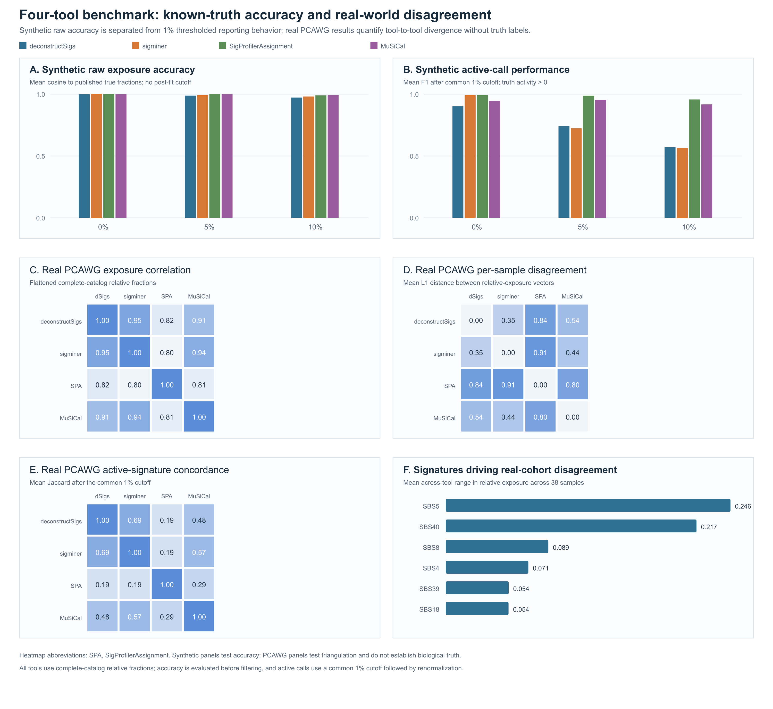
FIGURE 5 CAPTION
Figure 5. Known-truth accuracy and real-world tool triangulation after explicit harmonization. Panels A-B use one archived spectrum from each of nine cancer-type groups at 0%, 5%, and 10% noise. (A) Mean cosine between the complete raw relative-exposure vector and the published true fractions, evaluated before filtering. (B) Mean active-signature F1 after a common 1% relative-exposure cutoff and renormalization. Panels C-F use 38 PCAWG Lung-AdenoCA WGS SBS96 spectra fitted against the 67-signature COSMIC v3 GRCh37 catalog. (C) Pairwise Pearson correlation of flattened complete-catalog relative fractions. (D) Mean per-sample L1 distance between relative-exposure vectors. (E) Mean active-signature Jaccard similarity after the common 1% cutoff. (F) The six signatures with the largest mean across-tool exposure range. Package-omitted catalog columns were zero-filled; non-finite or negative comparison values were set to zero; unassigned components were not relabeled as catalog signatures; and catalog columns were normalized to unit sum for reconstruction metrics. The synthetic panels evaluate accuracy under the tested archived conditions. The PCAWG panels quantify disagreement without known truth and do not establish biological superiority.

Discussion, limitations, and Conclusions

Discussion - first implication
ORIGINAL
The validation results carry three substantive implications. First, on the cost of trust in browser-based scientific software: a common objection to browser-native tools is that a sandboxed WebAssembly or JavaScript environment may silently alter computational behavior relative to a conventional installation. Our adapter-fidelity results do not bear this out. Three of the four adapters reproduced their local references exactly (maximum absolute exposure difference of zero across 38 samples and a 67-signature catalog), and the fourth differed only at the limit of floating-point precision. This fidelity result, however, concerns numerical correctness, not security. Browsers are complex, frequently patched attack surfaces, and JavaScript dependency chains are a documented vector for supply-chain compromise; mSigSDK's pinned-version, checksum-verified execution and optional no-egress mode reduce but do not eliminate this exposure. Users handling regulated or sensitive data should weigh these residual risks rather than treat data-residency alone as a privacy control.
REPLACE WITH
The four-tool benchmark supports a narrower and more useful scientific value proposition than orchestration alone. On the published synthetic benchmark, all four tools closely recovered the known fractions, although raw exposure accuracy and active-call performance degraded under increasing archived noise. On the real PCAWG cohort, explicit harmonization did not eliminate substantial differences in exposure allocation, active-signature counts, or active-signature concordance, even when reconstruction cosine remained high. The common adapter layer therefore enables investigators to identify conclusions that are stable across fitting implementations and conclusions that are tool-sensitive; because the real cohort has no known exposure truth, the comparison does not establish that one package is biologically superior. The browser-versus-local fidelity experiment answers a separate question: it shows that the adapters reproduce their wrapped tools rather than silently altering them. Fidelity does not itself validate the biological correctness of a tool's output. This numerical result also does not establish security. Browsers are complex, frequently patched attack surfaces, and JavaScript dependency chains are a documented vector for supply-chain compromise; mSigSDK's pinned-version, checksum-verified execution and optional no-egress mode reduce but do not eliminate this exposure. Users handling regulated or sensitive data should weigh these residual risks rather than treat data residency alone as a privacy control.

Limitations - replace only the quoted sentence
ORIGINAL
The present validation establishes browser/local numerical fidelity for a Lung-AdenoCA SBS96 fitting benchmark, but does not yet validate performance across additional tumor types, low-burden or panel/WES inputs, MAF-conversion workflows, DBS/ID/SBS1536 profiles, or alternate genome builds.
REPLACE WITH
The present validation separates browser/local numerical fidelity for one Lung-AdenoCA SBS96 configuration, known-truth accuracy for 27 published high-burden synthetic spectra across three archived noise conditions, and tool disagreement for 38 real Lung-AdenoCA spectra without exposure truth. The synthetic subset is not a mutation-burden sweep, and the real-cohort comparison cannot determine biological superiority. Performance across additional tumor types, low-burden or panel/WES inputs, MAF-conversion workflows, DBS/ID/SBS1536 profiles, and alternate genome builds remains untested.

Conclusions
ORIGINAL
mSigSDK is a browser-native, zero-install, FAIR-aligned JavaScript software development kit for mutational-signature analysis. It orchestrates four established mutational-signature packages – SigProfilerAssignment, MuSiCal, deconstructSigs, and sigminer – through a uniform adapter layer; provides exploratory non-negative matrix factorization in the browser; scores fits against a configurable, burden-aware quality-control evidence panel; and serializes results under a proposed, versioned JSON Schema with full provenance. The SDK loads without installation, runs entirely on the client for the workflows that should be local, completes a full single-sample analysis against a 67-signature COSMIC catalog in under two seconds from a cold browser load, and reproduces the behavior of the wrapped tools to numerical precision. It is accessible to anyone working with mutational signatures – including computational analysts, clinical and translational researchers, methods developers, and educators – without the configuration overhead of conventional installations.
REPLACE WITH
mSigSDK is a browser-native, zero-install, FAIR-aligned JavaScript software development kit for mutational-signature analysis. It orchestrates four established mutational-signature packages - SigProfilerAssignment, MuSiCal, deconstructSigs, and sigminer - through a uniform adapter layer; provides exploratory non-negative matrix factorization in the browser; scores fits against a configurable, burden-aware quality-control evidence panel; and serializes results under a proposed, versioned JSON Schema with full provenance. In an explicitly harmonized four-tool benchmark, all four tools showed high known-truth exposure accuracy under the tested published synthetic conditions, while the real PCAWG cohort showed material differences in exposure allocation and active-signature calls. These results support multi-tool triangulation as a way to identify stable and tool-sensitive conclusions, not as a method for selecting a biologically superior tool without truth data. The SDK loads without installation, runs entirely on the client for the workflows that should be local, completes a full single-sample analysis against a 67-signature COSMIC catalog in under two seconds from a cold browser load, and reproduces the behavior of the wrapped tools to numerical precision. It is accessible to anyone working with mutational signatures - including computational analysts, clinical and translational researchers, methods developers, and educators - without the configuration overhead of conventional installations.

Final consistency check
- The manuscript now separates adapter fidelity, known-truth accuracy, and real-world triangulation.
- Raw accuracy is evaluated before the reporting cutoff; active calls are evaluated after the common 1% cutoff and renormalization.
- The synthetic benchmark is not described as a mutation-burden sweep or evidence that tools are interchangeable.
- The real PCAWG comparison is not described as accuracy or evidence that one tool is biologically superior.
- Figure 5 contains all four real-world displays requested by the reviewer: exposure correlation, per-sample disagreement, active-signature concordance, and discrepancy-driving signatures.
- Table 2 reports active-signature counts and reconstruction quality explicitly.

