Worksheet size: 100000 cells

MTB > chis c1-c3

Chi-Square Test

Expected counts are printed below observed counts

None 1 to 15 16 or mo Total
1 105 7 11 123
82.73 17.69 22.59

2 58 5 13 76
51.12 10.93 13.96

3 84 37 42 163
109.63 23.44 29.93

4 57 16 17 90
60.53 12.94 16.53

Total 304 65 83 452

Chi-Sq = 5.997 + 6.458 + 5.944 +
0.927 + 3.217 + 0.065 +
5.991 + 7.844 + 4.866 +
0.206 + 0.722 + 0.014 = 42.252

DF = 6, P-Value = 0.000

-------------------------------------------------

MTB > POne 452 105;
SUBC> Confidence 95.0;
SUBC> Test 0.5;
SUBC> Alternative 0.

Test and Confidence Interval for One Proportion

Test of p = 0.5 vs p not = 0.5
Exact
Sample X N Sample p 95.0 % CI P-Value
1 105 452 0.232301 (0.194124, 0.274022) 0.000

--------------------------------------------------------------

MTB > let k1 = 105/452
MTB > let k2 = 1-k1
MTB > print k1 k2

Data Display

K1 0.232301
K2 0.767699

MTB > name k1 'p^'
MTB > name k2 '1-p^'

MTB > let k3 = (k1*k2)/452
MTB > let k4 = sqrt(k3)
MTB > print k3 k4

Data Display

K3 0.000394551
K4 0.0198633

MTB > invcdf 0.975

Inverse Cumulative Distribution Function

Normal with mean = 0 and standard deviation = 1.00000

P( X <= x) x
0.9750 1.9600

MTB > let k5 = k4 * 1.96
MTB > print k5

Data Display

K5 0.0389321

MTB > let k6 = k1 - k5
MTB > let k7 = k1 + k5
MTB > print k6 k7

Data Display

K6 0.193369
K7 0.271233

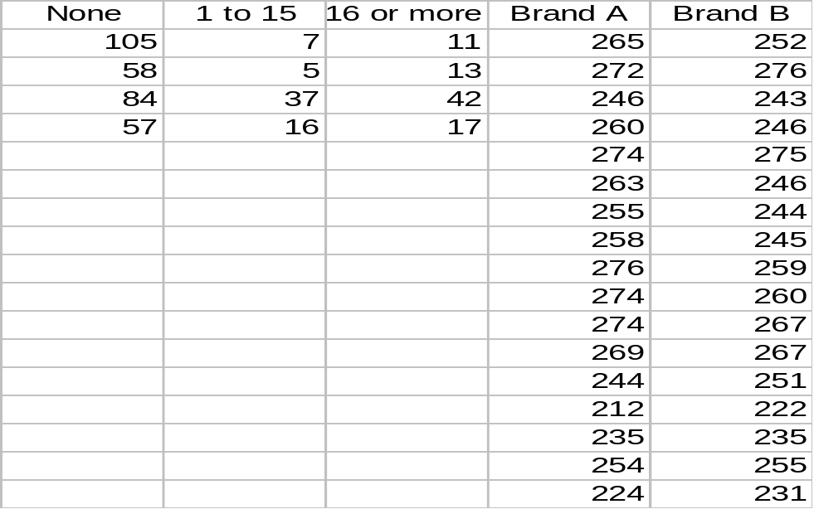

MTB > Paired 'Brand A' 'Brand B';
SUBC> Confidence 95.0;
SUBC> Test 0.0;
SUBC> Alternative 1;
SUBC> GHistogram.

Paired T-Test and Confidence Interval

Paired T for Brand A - Brand B

N Mean StDev SE Mean
Brand A 17 256.18 18.70 4.54
Brand B 17 251.41 14.93 3.62
Difference 17 4.76 9.09 2.20

95% CI for mean difference: (0.09, 9.44)
T-Test of mean difference = 0 (vs > 0): T-Value = 2.16 P-Value = 0.023

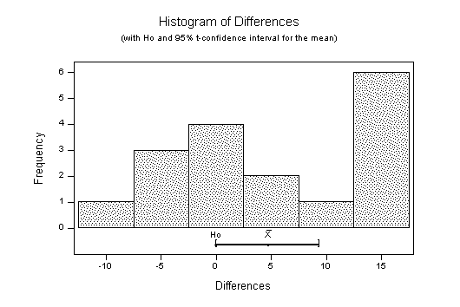

MTB > cdf 3;
SUBC> t 15.

Cumulative Distribution Function

Student's t distribution with 15 DF

x P( X <= x)
3.0000 0.9955

-----------------------------------------

MTB > cdf 0.699;
SUBC> t 10.

Cumulative Distribution Function

Student's t distribution with 10 DF

x P( X <= x)
0.6990 0.7498

-----------------------------------------

MTB > cdf 4.104;
SUBC> chis 10.

Cumulative Distribution Function

Chi-Square with 10 DF

x P( X <= x)
4.1040 0.0575

