Worksheet size: 100000 cells
Q 1.

Lemon Yellow | White | Green | Blue | Value | Index | Residual | Low | Middle | High
45 | 21 | 37 | 16 | 45 | 1 | -2.16667 | 7 | 4 | 4
59 | 12 | 32 | 11 | 59 | 1 | 11.83333 | 3 | 6 | 6
48 | 14 | 15 | 20 | 48 | 1 | 0.833333
46 | 17 | 25 | 21 | 46 | 1 | -1.16667
38 | 13 | 39 | 14 | 38 | 1 | -9.16667
47 | 17 | 41 | 7 | 47 | 1 | -0.16667
 |  |  |  | 21 | 2 | 5.333333
 |  |  |  | 12 | 2 | -3.66667
 |  |  |  | 14 | 2 | -1.66667
 |  |  |  | 17 | 2 | 1.333333
 |  |  |  | 13 | 2 | -2.66667
 |  |  |  | 17 | 2 | 1.333333
 |  |  |  | 37 | 3 | 5.5
 |  |  |  | 32 | 3 | 0.5
 |  |  |  | 15 | 3 | -16.5
 |  |  |  | 25 | 3 | -6.5
 |  |  |  | 39 | 3 | 7.5
 |  |  |  | 41 | 3 | 9.5
 |  |  |  | 16 | 4 | 1.166667
 |  |  |  | 11 | 4 | -3.83333
 |  |  |  | 20 | 4 | 5.166667
 |  |  |  | 21 | 4 | 6.166667
 |  |  |  | 14 | 4 | -0.83333
 |  |  |  | 7 | 4 | -7.83333

MTB > desc c1-c4
Descriptive Statistics

Variable N Mean Median TrMean StDev SE Mean
Lemon Yellow 6 47.17 46.50 47.17 6.79 2.77
White 6 15.67 15.50 15.67 3.33 1.36
Green 6 31.50 34.50 31.50 9.91 4.05
Blue 6 14.83 15.00 14.83 5.34 2.18

Variable Minimum Maximum Q1 Q3
Lemon Yellow 38.00 59.00 43.25 50.75
White 12.00 21.00 12.75 18.00
Green 15.00 41.00 22.50 39.50
Blue 7.00 21.00 10.00 20.25

MTB > help oneway
MTB > oneway c5 c6 c7

One-way Analysis of Variance

Analysis of Variance for C5

Source DF SS MS F P
C6 3 4218.5 1406.2 30.55 0.000
Error 20 920.5 46.0
Total 23 5139.0
Individual 95% CIs For Mean
Based on Pooled StDev
Level N Mean StDev ---+---------+---------+---------+---
1 6 47.167 6.795 (----*----)
2 6 15.667 3.327 (----*----)
3 6 31.500 9.915 (----*----)
4 6 14.833 5.345 (---*----)
---+---------+---------+---------+---
Pooled StDev = 6.784 12 24 36 48

MTB > %NormPlot C7;
SUBC> Title "Q.1 residuals".
Executing from file: G:\WINDOWS\MTBWIN\MACROS\NormPlot.MAC
Macro is running ... please wait

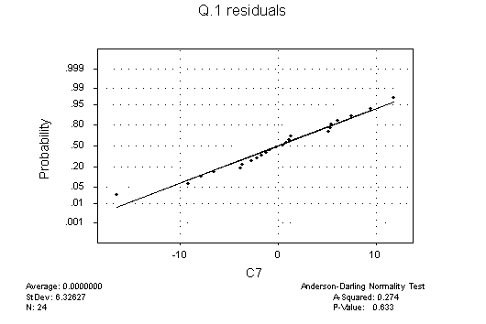MTB > cdf 30.55;
SUBC> f 3 20.

Cumulative Distribution Function
F distribution with 3 DF in numerator and 20 DF in denominator

x P( X <= x)
30.5500 1.0000

MTB > invcdf .95;
SUBC> f 3 20.

Inverse Cumulative Distribution Function
F distribution with 3 DF in numerator and 20 DF in denominator

P( X <= x) x
0.9500 3.0984

Q 7.6.3

MTB > help chis
MTB > chis c9-c11

Chi-Square Test

Expected counts are printed below observed counts

Low Middle High Total
1 7 4 4 15
5.00 5.00 5.00

2 3 6 6 15
5.00 5.00 5.00

Total 10 10 10 30

Chi-Sq = 0.800 + 0.200 + 0.200 +
0.800 + 0.200 + 0.200 = 2.400
DF = 2, P-Value = 0.301

MTB > cdf 2.4;
SUBC> chis 2.

Cumulative Distribution Function
Chi-Square with 2 DF

x P( X <= x)
2.4000 0.6988

MTB > invcdf 0.95;
SUBC> chis 2.

Inverse Cumulative Distribution Function
Chi-Square with 2 DF

P( X <= x) x
0.9500 5.9915

