Value | Row Index | Col Index | Residual | Fitted |  | Data | Row Ind | Col Ind | Res 8.2.8 | Fitted 8.2.8
90.4 | 1 | 1 | 0.1 | 90.3 |  | 14.552 | 1 | 1 | -0.11975 | 14.67175
90.2 | 1 | 1 | -0.1 | 90.3 |  | 17.024 | 1 | 1 | 2.35225 | 14.67175
90.7 | 1 | 2 | 0.05 | 90.65 |  | 10.132 | 1 | 1 | -4.53975 | 14.67175
90.6 | 1 | 2 | -0.05 | 90.65 |  | 16.979 | 1 | 1 | 2.30725 | 14.67175
90.2 | 1 | 3 | -0.1 | 90.3 |  | 13.98 | 1 | 2 | 4.109 | 9.871
90.4 | 1 | 3 | 0.1 | 90.3 |  | 5.777 | 1 | 2 | -4.094 | 9.871
90.1 | 2 | 1 | -0.1 | 90.2 |  | 7.638 | 1 | 2 | -2.233 | 9.871
90.3 | 2 | 1 | 0.1 | 90.2 |  | 12.089 | 1 | 2 | 2.218 | 9.871
90.5 | 2 | 2 | -0.05 | 90.55 |  | 11.378 | 2 | 1 | -1.7975 | 13.1755
90.6 | 2 | 2 | 0.05 | 90.55 |  | 12.578 | 2 | 1 | -0.5975 | 13.1755
90.4 | 2 | 3 | 0.15 | 90.25 |  | 17.709 | 2 | 1 | 4.5335 | 13.1755
90.1 | 2 | 3 | -0.15 | 90.25 |  | 11.037 | 2 | 1 | -2.1385 | 13.1755
90.5 | 3 | 1 | -0.1 | 90.6 |  | 20.825 | 2 | 2 | -0.116 | 20.941
90.7 | 3 | 1 | 0.1 | 90.6 |  | 17.333 | 2 | 2 | -3.608 | 20.941
90.8 | 3 | 2 | -0.05 | 90.85 |  | 20.329 | 2 | 2 | -0.612 | 20.941
90.9 | 3 | 2 | 0.05 | 90.85 |  | 25.277 | 2 | 2 | 4.336 | 20.941
90.4 | 3 | 3 | 0.15 | 90.25 |  | 12.345 | 3 | 1 | 0.09425 | 12.25075
90.1 | 3 | 3 | -0.15 | 90.25 |  | 11.044 | 3 | 1 | -1.20675 | 12.25075
 |  |  |  |  |  | 9.458 | 3 | 1 | -2.79275 | 12.25075
 |  |  |  |  |  | 16.156 | 3 | 1 | 3.90525 | 12.25075
 |  |  |  |  |  | 22.223 | 3 | 2 | 2.67575 | 19.54725
 |  |  |  |  |  | 21.844 | 3 | 2 | 2.29675 | 19.54725
 |  |  |  |  |  | 16.176 | 3 | 2 | -3.37125 | 19.54725
 |  |  |  |  |  | 17.946 | 3 | 2 | -1.60125 | 19.54725
Worksheet size: 100000 cells

Q 1.

(a)

MTB > twoway c8 c9 c10 c11 c12

Two-way Analysis of Variance
Analysis of Variance for Value

Source DF SS MS F P
Row Index 2 0.1678 0.0839 4.08 0.055
Col Index 2 0.5678 0.2839 13.81 0.002
Interaction 4 0.1022 0.0256 1.24 0.359
Error 9 0.1850 0.0206
Total 17 1.0228

(b)
From the p-values, we accept the null hypothesis for interaction effects, i.e. there is no evidence of interaction between pressure and temperature with these data. Also, we can reject the null hypothesis for column effects at alpha of 0.05 or 0.01 -- the p-value is 0.002 so the data definitely indicates that the different pressures affect the chemical process. However, for the effects of temperature, the results are not clear cut. With a p-value of 0.055, we would accept the null hypothesis at an alpha level of 0.05, but reject if we used an alpha of 0.10, so these data indicate that perhaps more study needs to be done to determine the extent that different temperatures affect the process.
(c)

MTB > %NormPlot 'Residual';
SUBC> Title "Residuals Normality".
Executing from file: G:\WINDOWS\MTBWIN\MACROS\NormPlot.MAC
Macro is running ... please wait
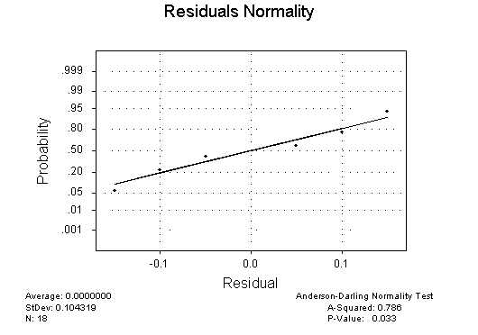
With a p-value of 0.033, the normality of the residuals would be rejected at our usual alpha level of 0.05, so the two-way ANOVA model we have used to test these data is probably not appropriate in this situation.

(d)
The standard deviation of the residuals is sigma = 0.104319, so we can estimate the variance component from this as sigma² = 0.010882.

Q 8.2.8

MTB > twoway c15 c16 c17 c18 c19

Two-way Analysis of Variance
Analysis of Variance for Data

Source DF SS MS F P
Row Ind 2 99.8 49.9 4.81 0.021
Col Ind 1 70.2 70.2 6.76 0.018
Interaction 2 203.0 101.5 9.78 0.001
Error 18 186.8 10.4
Total 23 559.8

MTB > %NormPlot 'Res8.2.8';
SUBC> Title "8.2.8Res Normality".
Executing from file: G:\WINDOWS\MTBWIN\MACROS\NormPlot.MAC
Macro is running ... please wait

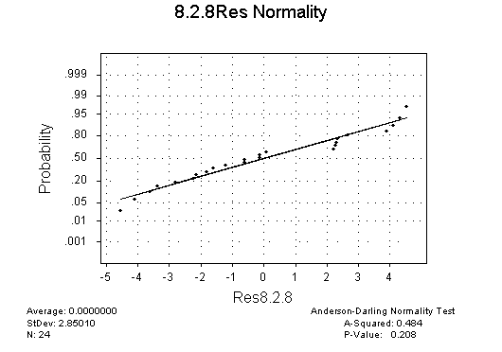

The residuals are acceptably normal with a p-value of 0.208. From the
p-values for row effects, column effects, and row-column interaction, we will reject the null hypothesis for each of these at the 0.05 alpha level. The evidence of row-column interaction is particularly strong with a p-value of 0.001. Both row effects and column effects are clearly indicated at alpha of 0.05, but the null hypothesis for each of these would have been accepted if we had decided to use a more stringent alpha level of 0.01.

MTB >

