Assumptions and Justifications for Screen Sequences and State Transition Diagrams

This is an introductory document giving screen shots and state transition diagrams of a primary scenario and 3 secondary scenarios for a Use case of the video rental project. The screen shots will give the client an idea of how the system will work, i.e. these will be a type of graphic prototype that will enable the client to validate the way the system looks for a number of important scenarios. After this initial consultation, and once client approval had been obtained for the general ‘look’ of the screens, all the remaining screen shots could be filled in to function as part of a comprehensive specifications document if necessary.
The state transition diagrams are not for the client but for the design team, and will serve to guide this team as to required functionalities needed when filling in the methods and other areas of the Class analysis documents. These initial diagrams serve to describe some of the important functions present in these scenarios, and would be extended and completed once client input had been obtained on the other materials present in this deliverable.
The distribution machine will incorporate a touchscreen technology because this provides for quick and effective customer service. Basic instructions concerning how to use touchscreens will be provided right on the cover of the distribution machine. For many items, customers can simply press a choice on the screen to indicate their preferences. When customer input is needed in the form of new information, this will be done by means of the keyboard provided by the distribution machine. Acceptance of the entered information will be conveyed by the customer by choosing an ‘OK’ box on touchscreen, or the input can be cleared by pressing a ‘Clear’ box - functions which would be disabled until the customer had entered some of the required input. Having ‘OK’ and ‘Clear’ options is a common function on machines of this type and customers will expect such a service. Similarly, having screen options which allow customers to cancel the current transaction and return to the main menu, or end the session completely, must be available from many places in the system.
To aid customers in using the machine, there will also be a very prominently displayed ‘help’ button on the keyboard, which the customer may press at any time to obtain help with using the system. Instead of crowding each individual screen with an extra ‘help’ box, it seems more practical to have this function available any time from a dedicated key on the keyboard. Choosing ‘help’ in this way would let the customer access a detailed series of help tutorials which can explain any aspect of using the cassette rental machine. This help tutorial could be terminated any time by pressing a “back to system” touchscreen box on screen.
A number of common functions for each screen have not been included in these analyses for reasons of efficiency and convenience. For example, each screen requiring customer input will have to incorporate a timeout function which will produce some notice/warning screen if input does not occur within a reasonable time period (this period to be determined by industry standards and client consultation) . Similarly, the customer not retrieving her card or cassette would have to produce a notifier screen and this would be present in many different scenarios. Unless these states play a role in the actual sequence followed by a particular scenario, they have not been inserted in the state transition diagrams. Inserting each of these possible states would have turned the existing diagram, which is already almost too complex even though it details only a small part of the overall system, into a very confusing and unusable document.
Another necessary task in designing this system is ensuring that there are functions in place to deal with cases of inappropriate keyboard input from the customer when only touchscreen information is required and vice versa. Again, describing all these possible states is well beyond the scope of this introductory document, but could be done once initial client approval had been obtained and additional software personnel had been acquired. The resulting state transition diagram could then serve as a complete template for producing the design documents required by the project.

5 Screen sequences

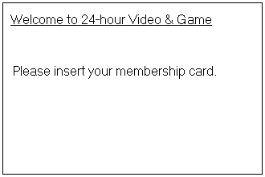
5.1 Primary scenario

1.

User inserts a valid card.

2.
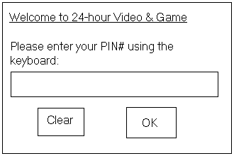

User enters a valid PIN # and presses OK.

3.

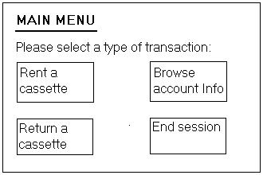

User selects ‘Rent a cassette’

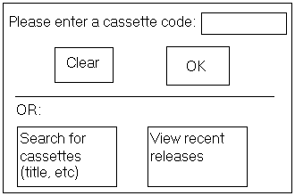
4.

User selects ‘Search for cassettes (title, etc)’

5.

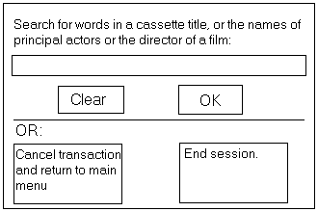

User enters a title that is in stock and presses OK.

6.

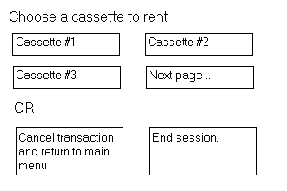

User chooses Cassette #1.

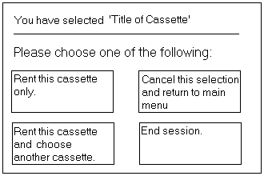
7.

User chooses ‘Rent this cassette only’

8.

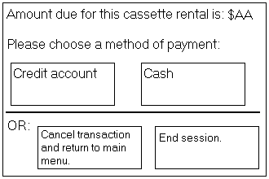

User chooses ‘Credit account’

9.

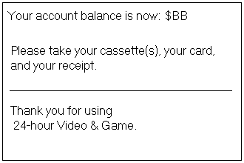

End primary scenario screens.

5.2.1 Secondary scenario #1

1.

User inserts a valid card.

2.

User enters an invalid PIN # and presses OK.

3.

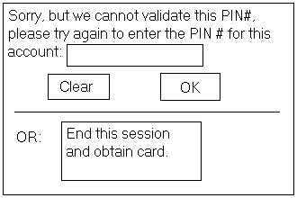

User enters an invalid PIN # and presses OK.

4.

User chooses to end the session.

5.

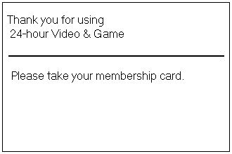

End secondary scenario #1 screens.

5.2.2 Secondary scenario #2

1.

User inserts a valid card.

2.

User enters a valid PIN # and presses OK.

3.

User chooses ‘Rent a cassette’.

4.

User enters a cassette code and presses OK.

5.

User chooses ‘Rent this cassette only’

6.

User chooses to pay by Cash.

7.

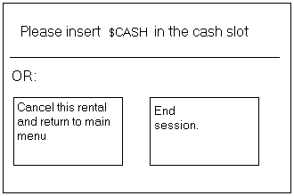

User inserts insufficient cash into the machine.
Screen eventually times out.

8.

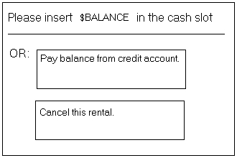

User still does not insert more cash.
Screen eventually times out and starts flashing while machine begins to emit warning ‘beeps’ to alert the customer.

9.

User still does not enter more cash.
Screen eventually times out again and this time the transaction is cancelled.
Deposited cash is credited to the customer’s account and the membership card is returned to the customer.

10.

End Secondary scenario #2 screens.

5.2.3 Secondary scenario #3

1.

User inserts a valid card.

2.

User enters a valid PIN # and presses OK.

3.

User chooses to rent a cassette.

4.

User enters a code for a cassette that is not in stock and presses OK.

5.

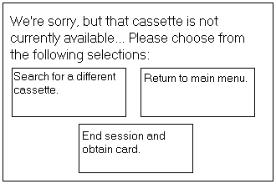

User chooses to end the session.

6.

End Secondary scenario #3 screens.

6 State Transition Diagrams

6.1 Entities (interacting with the distribution machine)

c = customer
R = remote system

6.2 States

W(1..n, s): distribution machine is waiting for customer 1..n while displaying screen s.

S(c, s): distribution machine is serving customer c while displaying screen s.

C(r, a, b): distribution machine is communicating with device r, sending information a and receiving information b

6.3 Events

A(c, a) = customer c performs action(s) a

D(o, c) = distribution machine performs operation(s) o for customer c

M = A(c, main) = customer c chooses to return to distribution machine main menu

C = A(c, cancel) = customer c chooses to cancel the current transaction

E = A(c, end): customer c chooses to end the current session

$G = A(c, $g): customer inserts greater amount of cash than required for the transaction

$E = A(c, $e): customer enters exact amount of cash required for the transaction

$L = A(c, $l): customer enters less cash than required for the transaction

timeout = current screen times out

6.4 Screens (displayed by rental machine)

WELCOME - welcomes customer to the video machine and asks to insert membership card
PIN - asks customer to enter PIN number
xPIN – asks customer to re-enter PIN number as the previous entry could not be validated

MAIN = main menu - asks customer if she wants to rent or return a cassette, or browse credit account information

RENT - asks customer to enter a cassette code, or search cassette information
SEARCH - asks customer to enter information to use for searching the cassette database

CHOOS - asks customer to choose a cassette from among those displayed
NUM – asks customer to rent selected cassette only or rent selected cassette and choose another cassette also

PAY – displays cassette rental price and asks customer to choose a payment method
FINAL - informs customer of new account balance and reminds to take cassette, receipt, and card

END - no rental, thanks customer and reminds to take card
OUT - informs the customer that the selected cassette is out of stock and asks to select another function

CASH - asks customer to insert enough cash to cover the current transaction
TKBAL - asks customer to take the balance of cash owed
BAL - asks customer how she wishes to pay the balance of the amount owed to distribution machine

MORE - reminds customer that she has not yet inserted sufficient cash to cover the current transaction

!MORE! – flashing MORE screen, with warning ‘beeps’

6.5 Actions (done by customer)

PIN - customer enters valid PIN # and presses OK touchscreen box
xPIN(n) - customer enters an invalid PIN # for the nth time and presses OK
rent - customer chooses to rent a cassette
search - customer chooses to search for cassettes with keyboard entry
info - customer enters information via the keyboard and presses OK
chx - customer chooses a cassette displayed by the distribution machine
code – customer enters a cassette code in the appropriate box and presses OK
cnfm - customer confirms the rental of the displayed cassette
again – customer chooses to rent the current selection and also choose another cassette

acct – customer chooses the credit account option
cash - customer chooses the cash option
clear – customer presses the ‘Clear’ touchscreen box to clear the existing keyboard input

m - customer chooses to return to main menu
c - customer chooses to cancel the current transaction
e - customer chooses to end current session
$g - customer inserts more cash than required for the transaction
$e - customer enters exact amount of cash required for the transaction
$l - customer enters less cash than required for the transaction
$$ - customer takes cash output by distribution machine
CRC – customer takes rented cassette, transaction receipt, and membership card
card – customer takes membership card

6.6 Information (exchanged between distribution machine and remote system)

CI - customer info (age group, status, encrypted PIN #, list of cassettes, etc.)
CASSINFO - cassette information (titles, prices, etc.)
ACCTINFO – account information (current balance, etc.)
INFO - information submitted by customer as search criteria
TRX - transaction information (amount, customer, confirmation, etc.) and current transaction end signal

TRSF – amount of funds to transfer to customer’s account and current transaction end signal

ACK – acknowledgement of information received
CLOSE – current transaction information and end signal, and instructions to close customer account

CODE - cassette code
in – selected cassette is in stock for this machine
out – selected cassette is out of stock for this machine

6.7 Operations (performed by distribution machine)

CRC – distribution machine outputs rented cassette, transaction receipt, and customer card

card – distribution machine returns card to customer
rec – distribution machine records information received and acknowledges reception
$$ - distribution machine outputs required amount of cash

6.8 State Transition Diagram
