Question 3

- Pseudo-code (or Java or C++ code) of at least 3 methods identified in 2 (the selected methods should include branches and loops), with documentation describing pre-conditions and post-conditions, explanation of the steps, and an annotated listing of any expected exceptions, how these will be dealt with, and justification.

GUYS……Please let me know if there are things that you don’t agree with. I will include the Visio file that you can take a look at and see if all is well. Other than this, I don’t have Visio at home, so I will have to make the changes at school.

rentCassette method for Machine Class

Preconditions and Postconditions

- I have proposed that the rentCassette method returns an integer to the main program that called it. A return value of 0 will correspond to successful completion of the program while a return value of 1 will indicate an unsuccessful completion of the program
- As we only have one customer using the machine at a time, we can also assume that the Customer object has been previously allocated statically
- I have also assumed that our objects are correctly initialized with the required data in the private instance variables ie. (the instantiation of Customer objects initializes the private instance variables with the correct information as well as that of the super class). In other words, we will be sure to make sure that the constructor of our base class properly calls the constructor for the super class
- It is worth noting that I have made the cassetteDB objects allocated at runtime. Conceivably, we could have instantiated this object statically. The appropriate choice really will depend also on the hardware that we have selected.
- I have assumed that the Cassette objects referenced in the cassette array field of the cassetteDB object will be instantiated before my method is called (perhaps dynamically to maximize the flexibility of our database
- One should also note that my particular implementation also returns pointers to objects in my various database objects, rather than just copies of it. This was done to ensure that the object that my method references is always current. For example, if another method modifies parameters in the Customer or Cassette object, I want to be sure that my method references an object containing these changes.
- As my rentCassette method accepts parameters, it does not include the methods for our central GUI. In this case, we will simply return a 0 to indicate that a rental was successfully completed and a 1 to indicate an unsuccessful transaction. Because of the extensive redisplay of menu options, this option is preferable to looping the program until valid input is entered into the method.
- The Transaction, Cassette, database objects and machine objects have been instantiated previously

General Assumptions and Annotation for Error Types

- Due to the nature of this system, I have proposed that it should be coded in C++. C++ is object oriented and will allow us to access the low level architecture of our system. I feel that this gives us the most control over our system. (ie. can interact with various types of hardware)
- We can also assume that those objects that will be created at run-time will be allocated dynamically while those objects that do not need to be allocated at run-time will be allocated statically. For example, the users will be dynamically created at run-time by our system. Most of our methods will be able to access the customer information and account information in the database objects through the interface that is provided by the Customer abstract data type.
- I have also proposed that each product has a separate PUID number, as opposed to similar inventories of the same product having the same PUID number. This will simplify the organization and reference of our cassette object data fields.
- I would also like to note that my exception handling calls error handling objects that must be separately written. These classes of objects are, in turn, inherited from standard libraries. The exceptions detailed in our code will execute any instructions in the catch block before calling the exception object that will be written for this case
- The premature_termination_exception class will detect whether the user has cancelled the transaction (by pressing a “Cancel This Rental and Return to Main Screen” option on the touch screen or by pressing an END session option on the main menu). In addition to the program’s output being printed to the error stream in an appropriate fashion, the error handler will deal with freeing up any of the dynamically allocated memory, and will reset the system
- A time_out_exception class will detect whether the user has been inactive for an established period of time. In such a case, the program’s output will be printed to the error stream in an appropriate fashion, the error handler will free up any dynamically allocated memory and the system will be reset. Additionally, timing out during the pay method should insure that any money that was entered into the cash slot has been transferred to the customer’s account.
- My cout method will be overloaded to write to the output buffer of the machine
- My cin method will be overloaded to accept input from the touch screen. This input will be overloaded so that a character is passed to our method.
int machine::rentCassette(int CustomerIDNum, int PUID) {

try{
char paymentMethod;
//initializations for customer object
double custBalance = curCustomer.getBalance();
bool validAdult = curCustomer.getAdultStatus();
int numRentals = curCustomer.getCurrentRentals();
double custBalance = curCustomer.getBalance();

// we now want to be able to return a pointer to the Cassette object so that we can reference certain
// properties and then reference the appropriate fields in the Cassette object with the interface
// provided.
Cassette * curCassette = cassetteDB.getCassetteByIndex(PUID);

// here we will return a pointer to our date abstract data type…presumably some sort of object like
//a CString object type.
Date * int curCassetteDueDate=*curCassette.getDueDateNumCassette();
double curCassetteCost = *curCassette.getCost();
bool curCassetteAdult = *curCassette.getType();
char * curCassetteTitle = *curCassette.getTitle();
bool curCassetteIsRented = *curCassette.isRented();

// instantiation of rental object below must also instantiate a Transaction object with the customer
// private instance variable (we will dynamically allocate an object for the rental transaction here)
// the CustomerIDNum parameter will be needed to instantiate its super class with the appropriate
// parameters.

NB if we do not use multiple machines for our implementation, we do not need the MachineNum parameter

Rental * CustRent = new Rental(CustomerIDNum, int machineNum);

// query the database to see if there is anything in the cassette object
// corresponding to our cassette object. The following method will return a pointer
// to a Cassette object which can then be referenced to find out whether or not
// there is inventory available. This method may have to reference our machine
// number in the instance of multiple machines and will need to search

//the exception below will print an error message to the buffer which will then be sent to the screen
if (curCassetteIsRented) {
throw “There is no inventory available for this selection. Please make another choice”;
return 1; //indicates the rental process was unsuccessful
}
else{
if ((curCustomer.getAdultStatus()==true) && curCustomer.getType()==false)) {
throw “I am sorry. This product is only available to people of the age of
majority. Please make another selection.”;
return 1; // indicates that the rental process was unsuccessful
}
else {
double custBal = curCustomer.getBalance();

//consistent with the object oriented paradigm, the cout and cin methods can be
// overloaded to write to our hardware screen (perhaps a memory location
// corresponding to our output buffer
cout << “Please Enter a payment method.\n”;
cin >> paymentMethod;

switch (paymentMethod){
case ‘C’ : case ‘c’: //label for cash entry

// Here the payment classes and
Payment * curPayment = new cashPayment(amount);
// this method will accept the pointer to our current
// cassette as a parameter so that relevant fields can
// be referenced
*curPayment.pay(CustRent);

// Here worry about updating the information in our objects
RemoteSystem.rentalUpdate();
CurrentAccount.rentalUpdate();
CurCustomer.rentalUpdate();
return 0; //indicates successful rental procedure
break;
case ‘E’ : case ‘e’ //label for cheque payment
if (curCustomer.gtBalance() < *CustCassette.getCost())
{
throw “You have inadequate funds for this transaction.”
return 1; //indicates unsuccessful rental
}
else{
Payment * curPayment = new creditPayment;
// this method will accept the pointer to our current
// cassette as a parameter so that relevant fields can
// be referenced
*curPayment.pay(CustRent);

// Here worry about updating the information in our objects
RemoteSystem.rentalUpdate();
CurrentAccount.rentalUpdate();
CurCustomer.rentalUpdate();
return 0; //indicates successful rental
}
break;
default:
throw “You have made an invalid selection. Please try again”;
return 1; //indicates unsuccessful rental
break;

}catch (premature_termination_exception& e) //catch block for premature
cerr << “Thank You For Using 24 Hour Video and Game/n”; //termination of the
cerr << “Please Take Your Membership Card”; //program
throw e;
}catch(time_out_exception& e) //catch block for time out of
cerr << “Thank You For Using 24 Hour Video and Game/n”; //program
cerr << “Please Take Your Membership Card”;
throw e;

}
}
}

pay method for cashPayment Class

Preconditions and Postconditions

- I have proposed that the pay method returns an integer to the main program that called it. A return value of 0 will correspond to successful completion of the program while a return value of 1 will indicate an unsuccessful completion of the program
- It will be assumed that the Rental Object has been instantiated before the pay method has been called. In this case, the Rental object will contain the methods to calculate the amount of money owed by the customer for the cassette rental.
- I have also assumed that the system has already statically allocated our current customer and assigned the CurCustomer variable to this object. Due to inheritance, the methods of this object can then be accessed by our method above.
- I have also assumed that the accountDB and RemoteSystem objects have already been statically allocated when the system initializes. Once again, the decision as to whether these objects will be statically or dynamically allocated will depend on the particular hardware that we are using. As there is only ever one RemoteSystem object allocated at a given time, I felt it was prudent to allocate the RemoteSystem object statically. This object will be named curRemoteSystem.

.

General Assumptions and Annotation for Error Types

- As the GUI for presenting the menu options is fairly complex and generic, other methods are used to present these menu options. These menus can be called and accessed with the overloaded cout and cin methods for our OSStream class
- I would also like to note that my exception handling calls error handling objects that must be separately written. These classes of objects are, in turn, inherited from standard libraries. When an exception is produced, any instructions in the catch block are executed before the exception object is called.
- A time_out_exception class will detect whether the user has been inactive for an established period of time. In such a case, the program’s will output a message to the error stream in an appropriate fashion, the error handler will free up any dynamically allocated memory and the system will be reset. Additionally, timing out during the pay method should insure that any money that was entered into the cash slot has been transferred to the customer’s account.
- A premature_termination_exception class will detect whether the user has cancelled the transaction (by pressing a “Cancel This Rental and Return to Main Screen” option on the touch screen or by pressing an “END session” option on the main menu). In addition to the program sending a message to the error stream, the error handler will deal with freeing up any of the dynamically allocated memory, and will reset the system
- The user is also given the choice of paying the remainder of the balance to his/her credit account. In this case, I have chosen to handle the situation as an exception. This situation will invoke the appropriate error handler and will be handled by the cash. Specifically, the invalid_money_exception class will handle this error along with the exception encountered if the money entered into the system is invalid.
- I have also assumed that the RemoteSystem class possesses methods to query the database for the account balance for a given user. Presumably such a method would need to be passed a Customer object so that the relevant information can be referenced. This class will also possess a rentalUpdate method which will accept a Customer object and integer value as parameters and update the entries in all pertinent databases

int cashPayment::pay(Rental * CustRental ) {
double moneyValue; // this is the variable that the card reader will enter the values into
boolean choice; // this is a variable used to determine whether the user wants
// the difference to be credited to their account
try{
bool enough = false;

// a pointer to the rental object will need to be dereferenced to obtain any information in the private
// instance fields. As our Payment class does not inherit from the Rental class, this is a necessary evil.

double curTotalCost = *CustRental.payment();
// Here I have assumed that the curRemoteSystem object possesses all of the methods to query the database
// for the releveant information

double curCustBalance = curRemoteSystem.getBalance(curCustomer);
cout << “Please Insert Cash in the Cash Slot\n”;

// In this case, the cin method will be overloaded to accept input from the card reader. Likely, the
// card reader would write to a memory location in our system which can then be referenced by our
// program. Additionally, the cout method is overloaded to print up the appropriate menu and dialogue
// boxes

do{
// it is assumed that the menus will prompt the user to enter any money in the appropriate slot and manner
try{
cout << “Your balance is now ” << curBalance;
cin >> moneyValue;

//method will update all of the pertinent databases
curRemoteSystem .rentalUpdate(moneyValue, CustomerID);
curBalance = curRemoteSystem.getBalance(curCustomer);

//now test to see if there is enough paid to terminate the transaction
if (curBalance>=curTotalCost){
enough=true;
}
}while(!enough);

// now have to deal with giving the customer change
cout << “Would you Like to Credit Your Account With the Difference?”;
cin >> choice;
if (choice==true)
// invocation of this method will credit the current customer with the difference
curCustomer.setBalance(curBalance-curTotalCost);

else
// invocation of this method will deliver money to the customer through the cash slot
curMachine.giveMoney(curBalance-curTotalCost);

return 0; //indicates successful termination of the method

}catch(invalid_money_exception& e) // catch block in case the money
cerr << “READ ERROR. Please try again\n” // entered in invalid
throw e;
}catch (premature_termination_exception& e) //catch block for premature
cerr << “Thank You For Using 24 Hour Video and Game/n”; //termination of the
cerr << “Please Take Your Membership Card”; //program
throw e;
}catch(time_out_exception& e) //catch block for time out of
cerr << “Thank You For Using 24 Hour Video and Game/n”; //program
cerr << “Please Take Your Membership Card”;
// depending on our implementation, it may be required to update the customer’s account with the value of
// money that was entered into the cash slot before throwing the exception. I have assumed that the
// rentalUpdate method has already taken care of this situation.
throw e;

}
checkPIN method for cashPayment Class

Preconditions and Postconditions

- I have proposed that the checkPIN method returns an integer to the main program that called it. A return value of 0 will correspond to successful completion of the program while a return value of 1 will indicate an unsuccessful completion of the program
- I have assumed that the RemoteSystem has already been statically allocated when the system initializes the client. See previous method discussions regarding the justification for this decision.
- It is also assumed that the checkPIN method will be called with a string parameter. This will allow the PIN that is entered by the user to be compared with that recorded in the database
- It will also be assumed that the curMachine object has already been instantiated before a call to its checkPIN method. As only one machine object is required, it is conceivable that this object will be statically allocated (depending on the constraints of my hardware, I may be required to change my implementations and insure that this object can be allocated at run-time).
- As the GUI for presenting the menu options is fairly complex and generic, other methods are used to present these menu options. These menus can be called with the overloaded cout and cin method for our OSStream class

General Assumptions and Annotation for Error Types

- In my particular methods I have called various error classes that will detect whether an error has occurred or not. These error classes are derived from standard libraries and will detect the following factors:
- A premature_termination_exception class will detect whether the user has cancelled the transaction (by pressing a “Cancel This Rental and Return to Main Screen option” on the touch screen or by pressing an “END session” option on the main menu). In addition to the program sending a message to the error stream in an appropriate fashion, the error handler will deal with freeing up any of the dynamically allocated memory, and will reset the system.
- A time_out_exception class will detect whether the user has been inactive for an established period of time. In such a case, the program will send a message to the error stream in an appropriate fashion, the error handler will free up any dynamically allocated memory and the system will be reset. Additionally, timing out during the pay method should insure that any money that was entered into the cash slot has been transferred to the customer’s account.
- I have also assumed that the RemoteSystem class possesses methods to query the database for the PIN number in our Customer account. The various levels of access will be transparent with this method
- It is assumed that any exception handling regarding entering an invalid card will be caught by methods that are calling the checkPIN method. In turn, this other method will throw an exception if the card entered into our machine is invalid.

int Machine::checkPIN(string TestPin) {
// in my implementation, I have proposed a method that will return an integer value. According to standard
// conventions, a return value of 0 will correspond to successful termination and a return value of 1 will
// correspond to an unsuccessful termination of the method.

int count=0;
int returnValue=1;
bool found=false;
try{
do{
if (testpin==curMachine.checkPIN(TestPin){
valid=true;
returnValue=0;
}
else{
count++; //variable that is used to count the number of failed attempts
// these cout and cin methods from the OSStream classes will be overloaded to display
// appropriate message boxes and dialog boxes as required.
cout << “Sorry but we cannot validate this PIN. Please Try Again to Enter the PIN
number for this account”;
cin >> TestPin

}
}while((!valid)&&(count<=5));
return returnValue;

}catch (premature_termination_exception& e) //catch block for premature
cerr << “Thank You For Using 24 Hour Video and Game/n”; //termination of the
cerr << “Please Take Your Membership Card”; //program
throw e;
}catch(time_out_exception& e) //catch block for time out of
cerr << “Thank You For Using 24 Hour Video and Game/n”; //program
cerr << “Please Take Your Membership Card”;
throw e;
}

4) Choose one of the methods in 3), and give a white-box test strategy to exercise all branches by design inspections. If possible, choose the first inspection scenario to correspond to a primary scenario from the previous deliverables. Indicate clearly which branches and loops in the method have not yet been exercised. Select additional inspection scenarios to cover the unexercised branches and loops, and indicate for each scenario which loops and branches are covered by that scenario.

Mark: For this question, for some reason, I am unable to reproduce the entire image. It is a complete image but the paste and insert picture from file options both produce the same effect…it is clipped on the bottom. The best I can suggest at this point is to pen in the changes.

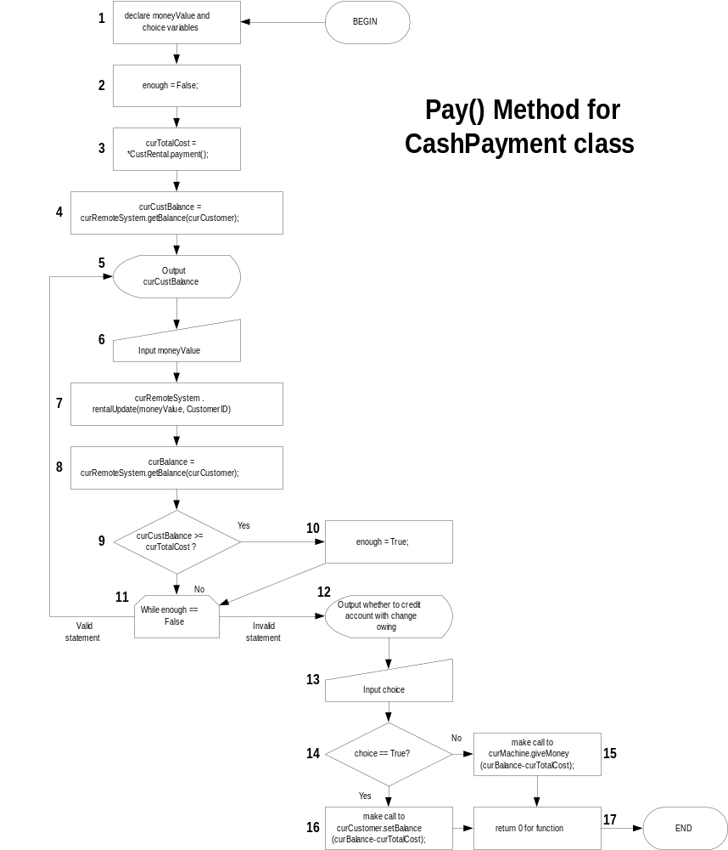
Branch Testing for Pay() Method

White box testing will be employed to verify that the appropriate branches in the algorithm for my pay method are being covered. I would suggest inserting pieces of code in the original code to verify whether the appropriate branches are being covered (effectively force the branches to be executed). The numeric steps summarized in the path tests below are referenced in the previous figure. It is worth noting that there are tools currently available that can assist in developing these test cases. Specifically, Rational offers a tool that will develop code for white box testing in tandem with the original builds.

The Pay() method is an integral component of a primary scenario in which the user decides to pay by cash. As this method affords the fundamental functionality one would expect in a dispensing machine, this method will be examined in our test cases. It is worth noting that, collectively, these test cases will examine all of the branches in our method.

Test Case 3 is an integral component of Secondary Scenario II. In this scenario, the user enters an inadequate amount of money and the system should loop back from statement 11 to statement 5

Test Case 1

Statement Testing: IF CONDITIONAL -test case to verify that when curCustBalance>=CurTotalCost, the conditional in statement 9 will evaluate to TRUE and statement 10 will be subsequently executed. The path tested will be 1-2-3-4-5-6-7-8-9-10.

Purpose: To verify that the system appropriately sets the flag value for the “enough” variable when the curCustBalance value exceeds or is equal to the curTotalCost value. We wish to test the YES branch of statement 9

Test Set Up: set the curCustBalance variable to a particular value and then the moneyValue variable to a value higher than the curCustBalance value. (these values can be set with inserted code)

Test Steps: Execute the method with this set up data

Verdict: Verify that the “enough” flag has been set to TRUE (inspect value with inserted code)

Test Reset: Not Required

Test Case 2

Statement Testing: IF CONDITIONAL -test case to verify that when curCustBalance<CurTotalCost, the conditional in statement 9 will evaluate to FALSE and statement 11 will be subsequently executed. The path tested will be 1-2-3-4-5-6-7-8-9-11.

Purpose: To verify that the system will not set the flag value for the “enough” variable when the curCustBalance value does not exceed the curTotalCost value. We wish to test the NO branch of statement 9.

Test Set Up: set the curCustBalance variable to a particular value and then the moneyValue variable to a value less than the curCustBalance value. (these values can be set with inserted code)

Test Steps: Execute the method with this set up data

Verdict: Verify that the “enough” flag has not been set to TRUE and is indeed still FALSE (inspect value with inserted code)

Test Reset: Not Required

Test Case 3

Statement Testing: WHILE LOOP - test case to verify that when curCustBalance<curTotalCost and the “enough” variable is set to FALSE,the postcondition in the loop (statement 11) will succeed and statement 5 will be subsequently executed. The path tested will be 1-2-3-4-5-6-7-8-9-11-5

Purpose: To verify that the system will loop back and output the curCustBalance when the value for the “enough” variable is set to FALSE. We wish to test the VALID STATEMENT branch of statement 11.

Test Set Up: set the value for the “enough” variable to FALSE. (this value can be set with inserted code)

Test Steps: Execute the method with this set up data

Verdict: Verify that the curCustBalance has been output (that statement 5 has been executed)

Test Reset: Not Required

Test Case 4

Statement Testing: WHILE LOOP –test case to verify that when curCustBalance >=curTotalCost and the enough variable is set to TRUE, the postcondition in the loop (statement 11) will fail and statement 12 will be executed. The path tested will be 1-2-3-4-5-6-7-8-9-10-11-12

Purpose: To verify that the system will not loop back to 5 and output the curCustBalance when the value for the “enough” variable is set to TRUE. We wish to test the INVALID STATEMENT branch of statement 11.

Test Set Up: set the value for the “enough” variable to TRUE (this value can be set with inserted code)

Test Steps: Execute the method with this set up data

Verdict: Verify that step 12 has been output and that the user is being prompted to credit their account with the money that is owing.

Test Reset: Not Required

Test Case 5

Statement Testing: IF CONDITIONAL -test case to verify that when curCustBalance >=curTotalCost, the “enough” variable is set to TRUE, and the “choice” variable == TRUE, the conditional causes statement 16 to be executed. The path tested will be: 1-2-3-4-5-6-7-8-9-10-11-12-13-14-16-17

Purpose: To verify that the system will branch to 15 when the “choice” variable input is TRUE. In this case, the system should make a call to curMachine.giveMoney(curBalance-curTotalCost); We wish to test the NO branch of statement 14.

Test Set Up: set the value for the “choice” variable to TRUE (this value can be set with inserted code)

Test Steps: Execute the method with this set up data

Verdict: Verify that step 16 has been executed and that the system has called the method: curMachine.giveMoney(curBalance-curTotalCost);

Test Reset: Not Required

Test Case 6

Statement Testing: IF CONDITIONAL -test case to verify that when curCustBalance >=curTotalCost, the “enough” variable is set to TRUE, and the “choice” variable == FALSE, the conditional causes statement 15 to be executed. The path tested will be: 1-2-3-4-5-6-7-8-9-10-11-12-13-14-16-17

Purpose: To verify that the system will branch to 16 when the “choice” variable input is FALSE. In this case, the system should make a call to curCustomer.setBalance(curBalance-curTotalCost); We wish to test the YES branch of statement 14.

Test Set Up: set the value for the “choice” variable to FALSE (this value can be set with inserted code)

Test Steps: Execute the method with this set up data

Verdict: Verify that step 15 has been executed and that the system has called the method: curCustomer.setBalance(curBalance-curTotalCost);

Test Reset: Not Required

