System Design – designing the future.

24-hour Video & Game


April 6, 2001

Course: SEG3300
for: Prof. R. Probert

by:
Patrick Hunter #1392178
Tu Nguyen #555104
Mark Sattolo #428500

Title: Project Deliverable #3
Due: Apr.6, 2001, 20h EDT.

EXECUTIVE SUMMARY

- This deliverable contains a number of sections that are for the development team and not primarily the Client, although perhaps Client personnel familiar with software design may want to check the Detailed Class Diagram of Section 2 or especially the Collaboration diagrams of Section 1 to verify that the implementation of the video machine is proceeding according to the Client’s view of the required functionalities.

- Designers and Programmers will want to examine these Sections 1 and 2, as well as the preliminary code in Section 3 to be sure that the planned implementation is properly following the specified design documents. Programmers and SQA personnel will want to confer on the Testing documents in Section 4 to be sure that the outlined test plan is practical and effective within the time frame provided for sub-system and system testing after coding is complete.

- Finally, Section 5 is a key section to note for Management at both the Client and the Developer as this estimate for LOC will be a good indication as to the final effort required for the project as a whole. This will allow an updated estimate to be made as to whether the initial projections of the project cost are still valid or need to be amended.

TABLE OF CONTENTS

1 Collaboration Diagrams 5
1.1 Assumptions & Justifications 5
1.2 Primary Scenario 6
1.3 Secondary Scenario #1 7
1.4 Secondary Scenario #2 8
1.5 Secondary Scenario #3 9
2 Detailed Class Diagram 10
3 Description of 3 Methods from the Detailed Class Diagram 11
3.1 Assumptions and Justifications 11
3.2 Machine : :rentCassette() 11
3.2.1 Pre-conditions & Post-conditions 11
3.2.2 Method body 11
3.2.3 Exceptions 13
3.3 cashPayment : :pay() 14
3.3.1 Pre-conditions & Post-conditions 14
3.3.2 Method body 14
3.3.3 Exceptions 15
3.4 Machine : :checkPIN() 16
3.4.1 Pre-conditions & Post-conditions 16
3.4.2 Method body 16
3.4.3 Exceptions 17
4 White-Box Test Strategies 18
4.1 Assumptions & Justifications 18
4.2 Flow-chart for Method 19
4.3 First Inspection Scenario 20
4.4 Additional Inspection Scenarios 20
4.4.1 Test Case 2 20
4.4.2 Test Case 3 20
4.4.3 Test Case 4 21
4.4.4 Test Case 5 21
4.4.5 Test Case 6 21
5 Estimate for LOC in the Detailed Class Diagram 23
Appendix A – Sequence diagrams from Deliverable #2 25
Appendix B – Categorization of Methods by Complexity Type 29
Appendix C – e-mail for Seg3300 30
Appendix D – Statement of Participation 33

List Of Figures

1.2 Primary Scenario Collaboration Diagram ……………..………………………………... 6
1.3 Secondary Scenario #1 Collaboration Diagram ………………………………………… 7
1.4 Secondary Scenario #2 Collaboration Diagram ………………………………………… 8
1.5 Secondary Scenario #3 Collaboration Diagram ………………………………………… 9
- Detailed Class Diagram ………………………..………….……………………….….… 10
4.2 Flow-chart for cashPayment::pay() method …………………………………..……….... 19
Appendix A – Sequence diagrams from Deliverable #2 …………………………………….. 25

List Of Tables

Appendix D – Statement of Participation ……………………………………………………. 33

Glossary of Abbreviations

SA – System Administrator
PIN – Personal Identification Number
UPC – Universal Price Code
LOC – Lines of Code

References

1. Stephen R. Schach; Classical and Object-Oriented Software Engineering with UML and Java, 4th ed.; WCB McGraw-Hill; Boston; 1999.

2. Grady Booch; Object-Oriented Analysis and Design with Applications, 2nd ed.; Addison-Wesley; Menlo Park, Calif.; 1994.

3. Grady Booch, James Rumbaugh, Ivar Jacobson; The Unified Modeling Language User Guide; Addison-Wesley; Reading, Mass.; 1999.

4. Notes for Seg3300, available at http://www.site.uottawa.ca/~bob/seg3300/index.html

5. e-mail for Seg3300, see appendix C.

List of Appendices

A) Sequence diagrams from Deliverable #2 – pages 25 to 28.

B) Categorization of Methods by Complexity Type – page 29.

- e-mail for Seg3300 – pages 30 to 32.

D) Statement of Participation – page 33.

1 Collaboration Diagrams

1.1 Assumptions & Justifications

These collaboration diagrams correspond to the same scenarios used with the sequence diagrams produced for Deliverable #2. However, the current diagrams are now at a much higher degree of complexity and detail given that they encompass all we have learned from the further design process that has taken place since the previous deliverable. The sequence diagrams provided before were created when the level of detail of the project had not gone past that of the principal actors involved in the scenarios. Now, though, we have some knowledge of the actual objects that will be needed to fulfill the video machine design. Also, all the work we have put into implementing the actual classes, attributes, and methods has provided invaluable guidance to us in seeing where our initial scenarios have had to be supplemented and altered. This is only natural as the project process proceeds to further levels. Therefore, there cannot be a one-to-one correspondence between the initial diagrams and later diagrams in terms of exact details, even though they do represent the same sequences of actions in terms of use-cases.

1.2 Primary Scenario

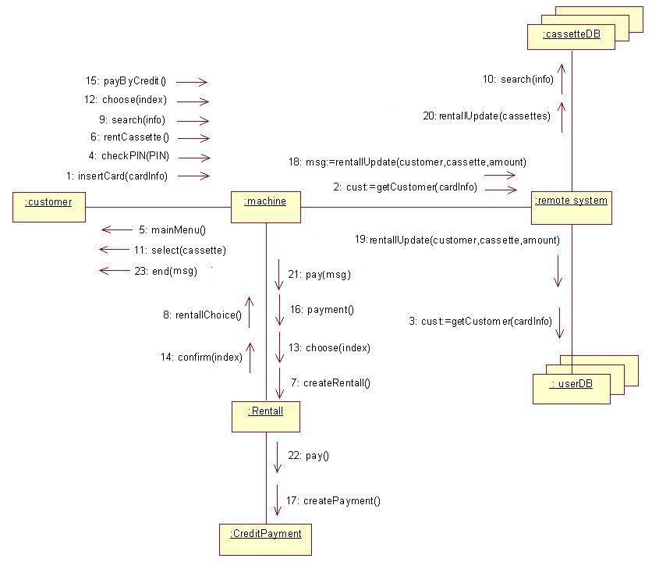

1.3 Secondary Scenario #1

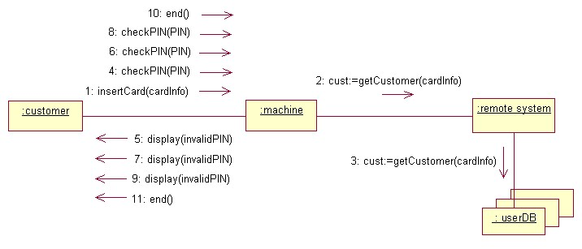

1.4 Secondary Scenario #2

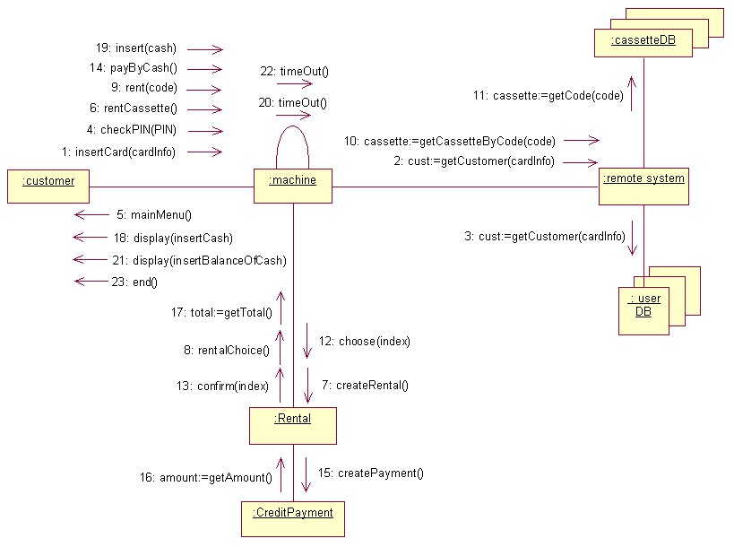

1.5 Secondary Scenario #3

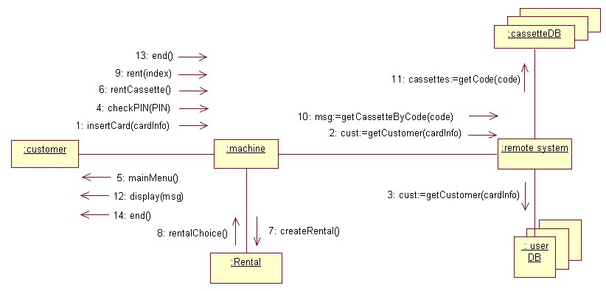

2 Detailed Class Diagram

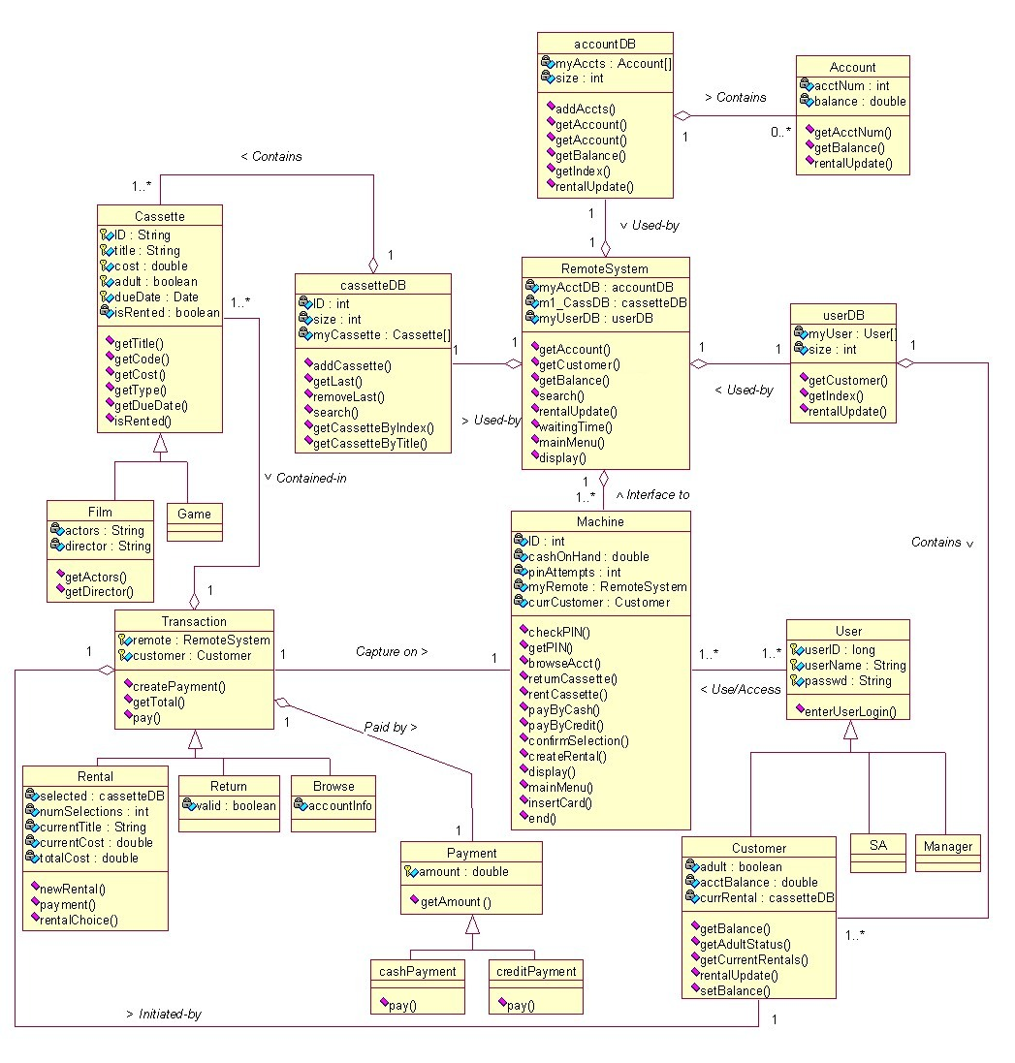

3 Description of 3 Methods from the Detailed Class Diagram

3.1 Assumptions and Justifications

- Due to the nature of this system, we have proposed that it should be coded in C++. C++ is object-oriented and will allow us to access the low level architecture of our system. We feel that this gives us the most control over our system. (i.e. can interact with various types of hardware)
- We can also assume that those objects that will be created at run-time will be allocated dynamically while those objects that do not need to be allocated at run-time will be allocated statically. For example, the users will be dynamically created at run-time by our system. Most of our methods will be able to access the customer information and account information in the database objects through the interface that is provided by the Customer abstract data type.
- We have also proposed that each product has a separate PUID number, as opposed to similar inventories of the same product having the same PUID number. This will simplify the organization and reference of our cassette object data fields.

3.2 Machine : :rentCassette()

3.2.1 Pre-conditions & Post-conditions

- We have proposed that the rentCassette method returns an integer to the main program that called it. A return value of 0 will correspond to successful completion of the program while a return value of 1 will indicate an unsuccessful completion of the program
- As we only have one customer using the machine at a time, we can also assume that the Customer object has been previously allocated statically
- We have also assumed that our objects are correctly initialized with the required data in the private instance variables i.e. (the instantiation of Customer objects initializes the private instance variables with the correct information as well as that of the super class). In other words, we will be sure to make sure that the constructor of our base class properly calls the constructor for the super class
- It is worth noting that we have made the cassetteDB objects allocated at runtime. Conceivably, we could have instantiated this object statically. The appropriate choice really will depend also on the hardware that we have selected.
- We have assumed that the Cassette objects referenced in the cassette array field of the cassetteDB object will be instantiated before our method is called (perhaps dynamically to maximize the flexibility of our database
- One should also note that our particular implementation also returns pointers to objects in our various database objects, rather than just copies of it. This was done to ensure that the object that our method references is always current. For example, if another method modifies parameters in the Customer or Cassette object, we want to be sure that our method references an object containing these changes.
- As our rentCassette method accepts parameters, it does not include the methods for our central GUI. In this case, we will simply return a 0 to indicate that a rental was successfully completed and a 1 to indicate an unsuccessful transaction. Because of the extensive redisplay of menu options, this option is preferable to looping the program until valid input is entered into the method.
- The Transaction, Cassette, database objects and machine objects have been instantiated previously.

3.2.2 Method body

int machine::rentCassette(int CustomerIDNum, int PUID) {
try{
char paymentMethod;
//initializations for customer object
double custBalance = curCustomer.getBalance();
bool validAdult = curCustomer.getAdultStatus();
int numRentals = curCustomer.getCurrentRentals();
double custBalance = curCustomer.getBalance();

// we now want to be able to return a pointer to the Cassette object so that we can reference certain
// properties and then reference the appropriate fields in the Cassette object with the interface
// provided.
Cassette * curCassette = cassetteDB.getCassetteByIndex(PUID);

// here we will return a pointer to our date abstract data type…presumably some sort of object like
//a CString object type.
Date * int curCassetteDueDate=*curCassette.getDueDateNumCassette();
double curCassetteCost = *curCassette.getCost();
bool curCassetteAdult = *curCassette.getType();
char * curCassetteTitle = *curCassette.getTitle();
bool curCassetteIsRented = *curCassette.isRented();

// instantiation of rental object below must also instantiate a Transaction object with the customer
// private instance variable (we will dynamically allocate an object for the rental transaction here)
// the CustomerIDNum parameter will be needed to instantiate its super class with the appropriate
// parameters.

NB if we do not use multiple machines for our implementation, we do not need the MachineNum parameter

Rental * CustRent = new Rental(CustomerIDNum, int machineNum);

// query the database to see if there is anything in the cassette object
// corresponding to our cassette object. The following method will return a pointer
// to a Cassette object which can then be referenced to find out whether or not
// there is inventory available. This method may have to reference our machine
// number in the instance of multiple machines and will need to search

//the exception below will print an error message to the buffer which will then be sent to the screen
if (curCassetteIsRented) {
throw “There is no inventory available for this selection. Please make another choice”;
return 1; //indicates the rental process was unsuccessful
}
else{
if ((curCustomer.getAdultStatus()==true) && curCustomer.getType()==false)) {
throw “I am sorry. This product is only available to people of the age of
majority. Please make another selection.”;
return 1; // indicates that the rental process was unsuccessful
}
else {
double custBal = curCustomer.getBalance();

//consistent with the object oriented paradigm, the cout and cin methods can be
// overloaded to write to our hardware screen (perhaps a memory location
// corresponding to our output buffer
cout << “Please Enter a payment method.\n”;
cin >> paymentMethod;

switch (paymentMethod){
case ‘C’ : case ‘c’: //label for cash entry

// Here the payment classes and
Payment * curPayment = new cashPayment(amount);
// this method will accept the pointer to our current
// cassette as a parameter so that relevant fields can
// be referenced
*curPayment.pay(CustRent);

// Here worry about updating the information in our objects
RemoteSystem.rentalUpdate();
CurrentAccount.rentalUpdate();
CurCustomer.rentalUpdate();
return 0; //indicates successful rental procedure
break;
case ‘E’ : case ‘e’ //label for cheque payment
if (curCustomer.gtBalance() < *CustCassette.getCost())
{
throw “You have inadequate funds for this transaction.”
return 1; //indicates unsuccessful rental
}
else{
Payment * curPayment = new creditPayment;
// this method will accept the pointer to our current
// cassette as a parameter so that relevant fields can
// be referenced
*curPayment.pay(CustRent);

// Here worry about updating the information in our objects
RemoteSystem.rentalUpdate();
CurrentAccount.rentalUpdate();
CurCustomer.rentalUpdate();
return 0; //indicates successful rental
}
break;
default:
throw “You have made an invalid selection. Please try again”;
return 1; //indicates unsuccessful rental
break;

}catch (premature_termination_exception& e) //catch block for premature termination of the program
cerr << “Thank You For Using 24 Hour Video and Game/n”;
cerr << “Please Take Your Membership Card”;
throw e;
}catch(time_out_exception& e) //catch block for time out of program
cerr << “Thank You For Using 24 Hour Video and Game/n”;
cerr << “Please Take Your Membership Card”;
throw e;
}
}
}

3.2.3 Exceptions

We would like to note that our exception handling would probably be coded in a different manner than we have proposed here. It is conceivable to have an exception object type and invalid transactions would simply throw an appropriate exception. However, in order to include some of the loops and condition tests used with these error handlers, we have incorporated error handling into our methods.

As our rentCassette method accepts parameters, it does not include the methods for our central GUI. In this case, we will return a 0 to indicate that a rental was successfully completed and a 1 to indicate an unsuccessful transaction. Because of the extensive redisplay of menu options, this option is preferable to looping the program until valid input is entered into the method.

One should also note that our particular implementation also returns pointers to objects in our various database objects, rather than just copies of it. This was done to ensure that the object that our method references is always current. For example, if another method modifies parameters in the Customer or Cassette object, we want to be sure that our method references an object containing these changes.

Our cout method will be overloaded to write to the output buffer of the machine. Our cin method will be overloaded to accept input from the touch screen a return a character if a particular selection is made.

cashPayment : :pay()

3.3.1 Pre-conditions & Post-conditions

- We have proposed that the pay method returns an integer to the main program that called it. A return value of 0 will correspond to successful completion of the program while a return value of 1 will indicate an unsuccessful completion of the program
- It will be assumed that the Rental Object has been instantiated before the pay method has been called. In this case, the Rental object will contain the methods to calculate the amount of money owed by the customer for the cassette rental.
- We have also assumed that the system has already statically allocated our current customer and assigned the CurCustomer variable to this object. Due to inheritance, the methods of this object can then be accessed by our method above.
- We have also assumed that the accountDB and RemoteSystem objects have already been statically allocated when the system initializes. Once again, the decision as to whether these objects will be statically or dynamically allocated will depend on the particular hardware that we are using. As there is only ever one RemoteSystem object allocated at a given time, we felt it was prudent to allocate the RemoteSystem object statically. This object will be named curRemoteSystem.

3.3.2 Method body

int cashPayment::pay(Rental * CustRental ) {
double moneyValue; // this is the variable that the card reader will enter the values into
boolean choice; // this is a variable used to determine whether the user wants
// the difference to be credited to their account
try{
bool enough = false;

// a pointer to the rental object will need to be dereferenced to obtain any information in the private
// instance fields. As our Payment class does not inherit from the Rental class, this is a necessary evil.

double curTotalCost = *CustRental.payment();
// Here we have assumed that the curRemoteSystem object possesses all of the methods to query the database
// for the relevant information

double curCustBalance = curRemoteSystem.getBalance(curCustomer);
cout << “Please Insert Cash in the Cash Slot\n”;

// In this case, the cin method will be overloaded to accept input from the card reader. Likely, the
// card reader would write to a memory location in our system which can then be referenced by our
// program. Additionally, the cout method is overloaded to print up the appropriate menu and dialogue
// boxes

do{
// it is assumed that the menus will prompt the user to enter any money in the appropriate slot and manner
try{
cout << “Your balance is now ” << curBalance;
cin >> moneyValue;

//method will update all of the pertinent databases
curRemoteSystem .rentalUpdate(moneyValue, CustomerID);
curBalance = curRemoteSystem.getBalance(curCustomer);

//now test to see if there is enough paid to terminate the transaction
if (curBalance>=curTotalCost){
enough=true;
}
}while(!enough);

// now have to deal with giving the customer change
cout << “Would you Like to Credit Your Account With the Difference?”;
cin >> choice;
if (choice==true)
// invocation of this method will credit the current customer with the difference
curCustomer.setBalance(curBalance-curTotalCost);

else
// invocation of this method will deliver money to the customer through the cash slot
curMachine.giveMoney(curBalance-curTotalCost);
return 0; //indicates successful termination of the method

}catch(invalid_money_exception& e) // catch block in case the money entered is invalid
cerr << “READ ERROR. Please try again\n”
throw e;
}catch (premature_termination_exception& e) //catch block for premature termination of the program
cerr << “Thank You For Using 24 Hour Video and Game/n”;
cerr << “Please Take Your Membership Card”;
throw e;
}catch(time_out_exception& e) //catch block for time out of program
cerr << “Thank You For Using 24 Hour Video and Game/n”;
cerr << “Please Take Your Membership Card”;
// depending on our implementation, it may be required to update the customer’s account with the value of
// money that was entered into the cash slot before throwing the exception. We have assumed that the
// rentalUpdate method has already taken care of this situation.
throw e;
}

3.3.3 Exceptions

- As the GUI for presenting the menu options is fairly complex and generic, other methods are used to present these menu options. These menus can be called and accessed with the overloaded cout and cin methods for our OSStream class
- We would also like to note that our exception handling calls error handling objects that must be separately written. These classes of objects are, in turn, inherited from standard libraries. When an exception is produced, any instructions in the catch block are executed before the exception object is called.
- A time_out_exception class will detect whether the user has been inactive for an established period of time. In such a case, the program’s will output a message to the error stream in an appropriate fashion, the error handler will free up any dynamically allocated memory and the system will be reset. Additionally, timing out during the pay method should insure that any money that was entered into the cash slot has been transferred to the customer’s account.
- A premature_termination_exception class will detect whether the user has cancelled the transaction (by pressing a “Cancel This Rental and Return to Main Screen” option on the touch screen or by pressing an “END session” option on the main menu). In addition to the program sending a message to the error stream, the error handler will deal with freeing up any of the dynamically allocated memory, and will reset the system
- The user is also given the choice of paying the remainder of the balance to his/her credit account. In this case, we have chosen to handle the situation as an exception. This situation will invoke the appropriate error handler and will be handled by the cash. Specifically, the invalid_money_exception class will handle this error along with the exception encountered if the money entered into the system is invalid.
- We have also assumed that the RemoteSystem class possesses methods to query the database for the account balance for a given user. Presumably such a method would need to be passed a Customer object so that the relevant information can be referenced. This class will also possess a rentalUpdate method which will accept a Customer object and integer value as parameters and update the entries in all pertinent databases

3.4 Machine : :checkPIN()

3.4.1 Pre-conditions & Post-conditions

- We have proposed that the checkPIN method returns an integer to the main program that called it. A return value of 0 will correspond to successful completion of the program while a return value of 1 will indicate an unsuccessful completion of the program
- We have assumed that the RemoteSystem has already been statically allocated when the system initializes the client. See previous method discussions regarding the justification for this decision.
- It is also assumed that the checkPIN method will be called with a string parameter. This will allow the PIN that is entered by the user to be compared with that recorded in the database
- It will also be assumed that the curMachine object has already been instantiated before a call to its checkPIN method. As only one machine object is required, it is conceivable that this object will be statically allocated (depending on the constraints of our hardware, we may be required to change our implementations and insure that this object can be allocated at run-time).
- As the GUI for presenting the menu options is fairly complex and generic, other methods are used to present these menu options. These menus can be called with the overloaded cout and cin method for our OSStream class

3.4.2 Method body

int Machine::checkPIN(string TestPin) {
// in our implementation, we have proposed a method that will return an integer value. According to standard
// conventions, a return value of 0 will correspond to successful termination and a return value of 1 will
// correspond to an unsuccessful termination of the method.

int count=0;
int returnValue=1;
bool found=false;
try{
do{
if (testpin==curMachine.checkPIN(TestPin){
valid=true;
returnValue=0;
}
else{
count++; //variable that is used to count the number of failed attempts
// these cout and cin methods from the OSStream classes will be overloaded to display
// appropriate message boxes and dialog boxes as required.
cout << “Sorry but we cannot validate this PIN. Please Try Again to Enter the PIN
number for this account”;
cin >> TestPin

}
}while((!valid)&&(count<=5));
return returnValue;

}catch (premature_termination_exception& e) //catch block for premature
cerr << “Thank You For Using 24 Hour Video and Game/n”; //termination of the program
cerr << “Please Take Your Membership Card”;
throw e;
}catch(time_out_exception& e) //catch block for time out of
cerr << “Thank You For Using 24 Hour Video and Game/n”; //program
cerr << “Please Take Your Membership Card”;
throw e;
}

3.4.3 Exceptions

- In our particular methods we have called various error classes that will detect whether an error has occurred or not. These error classes are derived from standard libraries and will detect the following factors:
- A premature_termination_exception class will detect whether the user has cancelled the transaction (by pressing a “Cancel This Rental and Return to Main Screen option” on the touch screen or by pressing an “END session” option on the main menu). In addition to the program sending a message to the error stream in an appropriate fashion, the error handler will deal with freeing up any of the dynamically allocated memory, and will reset the system.
- A time_out_exception class will detect whether the user has been inactive for an established period of time. In such a case, the program will send a message to the error stream in an appropriate fashion, the error handler will free up any dynamically allocated memory and the system will be reset. Additionally, timing out during the pay method should insure that any money that was entered into the cash slot has been transferred to the customer’s account.
- We have also assumed that the RemoteSystem class possesses methods to query the database for the PIN number in our Customer account. The various levels of access will be transparent with this method
- It is assumed that any exception handling regarding entering an invalid card will be caught by methods that are calling the checkPIN method. In turn, this other method will throw an exception if the card entered into our machine is invalid.

4 White-Box Test Strategies

Assumptions & Justifications

White box testing will be employed to verify that the appropriate branches in the algorithm for my pay method are being covered. I would suggest inserting pieces of code in the original code to verify whether the appropriate branches are being covered (effectively force the branches to be executed). The numeric steps summarized in the path tests below are referenced in the following chart. It is worth noting that there are tools currently available that can assist in developing these test cases. Specifically, Rational offers a tool that will develop code for white box testing in tandem with the original builds.

The Pay() method is an integral component of a primary scenario in which the user decides to pay by cash. As this method affords the fundamental functionality one would expect in a dispensing machine, this method will be examined in our test cases. It is worth noting that, collectively, these test cases will examine all of the branches in our method.

Test Case 3 is an integral component of Secondary Scenario 2. In this scenario, the user enters an inadequate amount of money and the system should loop back from statement 11 to statement 5.

4.2 Flow-chart for Method

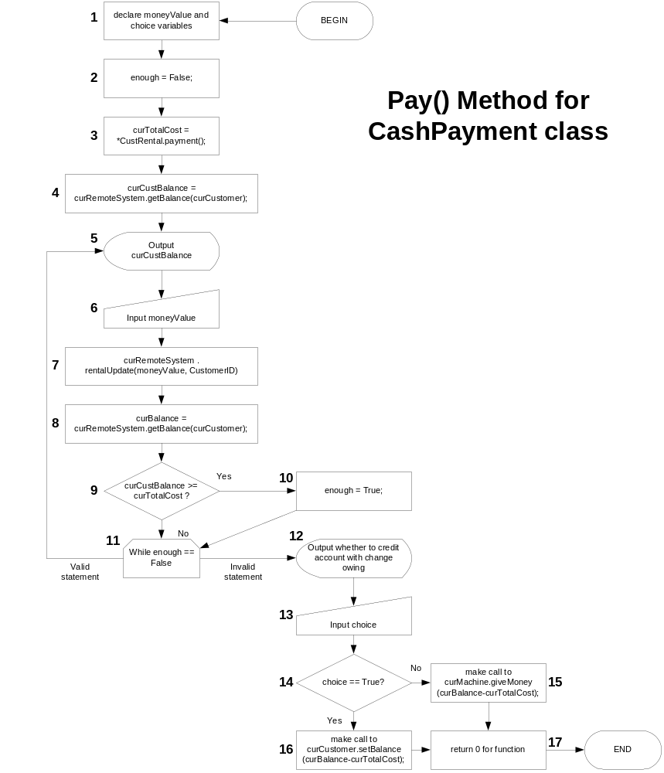

4.3 First Inspection Scenario

Statement Testing: The statements tested will be 1-2-3-4-5-6-7-8-9-10.

Branch Testing: IF CONDITIONAL -test case to verify that when curCustBalance>=CurTotalCost, the conditional in statement 9 will evaluate to TRUE and statement 10 will be subsequently executed.

Purpose: To verify that the system appropriately sets the flag value for the “enough” variable when the curCustBalance value exceeds or is equal to the curTotalCost value. We wish to test the YES branch of statement 9

Test Set Up: set the curCustBalance variable to a particular value and then the moneyValue variable to a value higher than the curCustBalance value. (these values can be set with inserted code)

Test Steps: Execute the method with this set up data

Verdict: Verify that the “enough” flag has been set to TRUE (inspect value with inserted code)

Test Reset: Not Required

Branch Coverage: This test case covers the primary scenario for the pay() method and exercises the TRUE branch of conditional #9 in the flow-chart. The other branches and loops seen in Fig.4.1 above will be tested verified for correctness with the subsequent test cases.

4.4 Additional Inspection Scenarios

4.4.1 Test Case 2

Statement Testing: The statements tested will be 1-2-3-4-5-6-7-8-9-11.

Branch Testing: IF CONDITIONAL -test case to verify that when curCustBalance<CurTotalCost, the conditional in statement 9 will evaluate to FALSE and statement 11 will be subsequently executed.

Purpose: To verify that the system will not set the flag value for the “enough” variable when the curCustBalance value does not exceed the curTotalCost value. We wish to test the NO branch of statement 9.

Test Set Up: set the curCustBalance variable to a particular value and then the moneyValue variable to a value less than the curCustBalance value. (these values can be set with inserted code)

Test Steps: Execute the method with this set up data

Verdict: Verify that the “enough” flag has not been set to TRUE and is indeed still FALSE (inspect value with inserted code)

Test Reset: Not Required

4.4.2 Test Case 3

Statement Testing: The statements tested will be 1-2-3-4-5-6-7-8-9-11-5

Branch Testing: WHILE LOOP - test case to verify that when curCustBalance<curTotalCost and the “enough” variable is set to FALSE,the postcondition in the loop (statement 11) will succeed and statement 5 will be subsequently executed.

Purpose: To verify that the system will loop back and output the curCustBalance when the value for the “enough” variable is set to FALSE. We wish to test the VALID STATEMENT branch of statement 11.

Test Set Up: set the value for the “enough” variable to FALSE. (this value can be set with inserted code)

Test Steps: Execute the method with this set up data

Verdict: Verify that the curCustBalance has been output (that statement 5 has been executed)

Test Reset: Not Required

4.4.3 Test Case 4

Statement Testing: The statements tested will be 1-2-3-4-5-6-7-8-9-10-11-12

Branch Testing: WHILE LOOP –test case to verify that when curCustBalance >=curTotalCost and the enough variable is set to TRUE, the postcondition in the loop (statement 11) will fail and statement 12 will be executed.

Purpose: To verify that the system will not loop back to 5 and output the curCustBalance when the value for the “enough” variable is set to TRUE. We wish to test the INVALID STATEMENT branch of statement 11.

Test Set Up: set the value for the “enough” variable to TRUE (this value can be set with inserted code)

Test Steps: Execute the method with this set up data

Verdict: Verify that step 12 has been output and that the user is being prompted to credit their account with the money that is owing.

Test Reset: Not Required

4.4.4 Test Case 5

Statement Testing: The statements tested will be: 1-2-3-4-5-6-7-8-9-10-11-12-13-14-16-17

Branch Testing: IF CONDITIONAL -test case to verify that when curCustBalance >=curTotalCost, the “enough” variable is set to TRUE, and the “choice” variable == TRUE, the conditional causes statement 16 to be executed.

Purpose: To verify that the system will branch to 15 when the “choice” variable input is TRUE. In this case, the system should make a call to curMachine.giveMoney(curBalance-curTotalCost); We wish to test the NO branch of statement 14.

Test Set Up: set the value for the “choice” variable to TRUE (this value can be set with inserted code)

Test Steps: Execute the method with this set up data

Verdict: Verify that step 16 has been executed and that the system has called the method: curMachine.giveMoney(curBalance-curTotalCost);

Test Reset: Not Required

4.4.5 Test Case 6

Statement Testing: The statements tested will be: 1-2-3-4-5-6-7-8-9-10-11-12-13-14-16-17

Branch Testing: IF CONDITIONAL -test case to verify that when curCustBalance >=curTotalCost, the “enough” variable is set to TRUE, and the “choice” variable == FALSE, the conditional causes statement 15 to be executed.

Purpose: To verify that the system will branch to 16 when the “choice” variable input is FALSE. In this case, the system should make a call to curCustomer.setBalance(curBalance-curTotalCost); We wish to test the YES branch of statement 14.

Test Set Up: set the value for the “choice” variable to FALSE (this value can be set with inserted code)

Test Steps: Execute the method with this set up data

Verdict: Verify that step 15 has been executed and that the system has called the method: curCustomer.setBalance(curBalance-curTotalCost);

Test Reset: Not Required

5 Estimate for LOC in the Detailed Class Diagram

For the purpose of this estimate, the number of lines of code in a method will be considered equivalent to the number of lines of text. Most comments in the code are in-line and do not take up lines independently of the code that they complement. This allows us to get a quick but fairly robust estimate of the lines of code in the implemented methods. As long as this way of calculating LOC is followed consistently, then there is no problem with having included some comment lines as LOC, when they may not be strictly considered “code” according to some. There then remains the job of extrapolating from these coded methods to the remaining methods in the class diagram. For this, we can divide up methods into three types: highly-complex, intermediate, and low-level, depending on the estimated level of complexity of the code.

This level of complexity will mainly be a factor of the number of branches and loops in the method in question. And, in the same way that we were able to identify that the 3 methods described in this deliverable have many branches and loops, we can estimate which other methods have many, or a moderate amount, or few branches and loops. This is done mainly by focussing on the state transition diagrams submitted in Deliverable #2 and the interaction diagrams submitted in Deliverables 2 and 3. Examining these designs gives us a good idea of the functions of the methods involved in the detailed class diagram, and knowledge of these functions and the different cases they must deal with gives us a good idea of the expected number of branches and loops which will be necessary. And then, as already mentioned, this gives us a good picture of the complexity of the individual methods.

In this deliverable, there are two complex methods with many conditions, i.e. rentCassette() and pay(), and the third method, checkPIN(), is not quite as involved, and is only an intermediate level method. From these then, we can obtain direct estimates for the actual LOC in two of the three method types, but these are the most important types of methods as it is in these methods that most of the ‘work’ of the project is done. As the project requirements necessitated picking methods for coding that “include branches and loops”, and we tried to pick fairly involved methods for implementation and testing so as to be able to show clearly the various steps involved in these processes, thus we do not have an implementation of a low-level method.

Hence, we cannot get a direct estimate of the number of LOC in one of these methods. In this case then, getting the value for the number of LOC in a low-level method just involves estimating the average (perhaps slightly lower due to a number of low-level methods which simply return the value in an attribute) of the number of LOC of an intermediate method and 0 LOC. This gives us a simple and efficient procedure, and there does not as yet seem to be any justification for producing a weighted average of these values as opposed to a simple average. But if we were to continue with coding a number of different methods, we may find out that a different estimate would be more appropriate.

For now, though, we can count the number of LOC for intermediate and highly-complex methods.
The values for our three implemented methods are as follows:

rentCassette() <highly-complex> : 109
pay() <highly-complex> : 65
checkPIN() <intermediate> : 35

These values perhaps indicate that rentCassette() is a kind of method even more complex than ‘highly-complex’, maybe a type that should be called ‘extremely-complex’ and handled on its own. After all, rentCassette() is the main method in the key class of the project, and the number of LOC clearly reflect its importance. But for now, we will just continue with the standard practice of using a hierarchy of three different method types of complexity, while keeping in mind for the future that perhaps this practice needs to be revised. This would be something to follow up on as further coding and estimation of the project length proceeded.

Thus, we obtain estimates for our three types of methods as follows:

highly-complex : 87 LOC < average of values for rentCassette() and pay() >
intermediate : 35 LOC < value from checkPIN >
low-level : 17 LOC < rounded-down value between intermediate and zero >

Then, based on the analysis done in the interaction and state transition diagrams, we can come up with numbers of each type of method as follows:

highly-complex : 18
intermediate : 25
low-level : 19

There are 62 methods represented in the class diagram with a distribution between the various complexity types as outlined above. See appendix B for a list of the methods included in each type. This does not of course include any of the methods that are not involved in the core Use Case (Renting a Cassette) that is the subject of this Deliverable. Thus, classes like ‘Return’ are not included in the estimate for this class diagram – they are contained as stubs only in the detailed class diagram in Section 2, and do not have any methods implemented.

Given these values, we can now do multiplication and come up with the total LOC estimate for the detailed class diagram:

highly-complex : 18 methods x 87 LOC/method = 1566 LOC

intermediate : 25 methods x 35 LOC/method = 875 LOC

low-level : 19 methods x 17 LOC/method = 323 LOC
----------------
METHODS TOTAL = 2764 LOC

The estimated total for the methods is 2764 LOC. The only other step necessary for estimating the total LOC for the class diagram is to estimate the number of LOC needed to define and/or declare the member variables for each class. This should only take one line per variable, including any comments, and we can count in the class diagram itself (p.) that there are 39 member variables listed for the non-stub classes, thus we will have to include another 39 LOC in the total. We are assuming here also that there are no comments for the individual classes apart from the comments contained within their methods themselves.

Our overall estimate for the number of LOC in the detailed class diagram of Section 2 is :

2764 LOC (methods) + 39 LOC (member variable initialization) = 2803 LOC.

Again, it must be kept in mind that we have considered that comments are an integral part of the coding process and so must be included in any estimate of LOC. Any estimates of effort based on our estimates of LOC will reflect that comments in the code are essential and do take up a significant amount of effort, perhaps more even than writing the code itself. Therefore, we include comments as lines of code. However, any other estimates that try to exclude comments from the number of LOC would have produced different numbers than ours, and estimates like that based on different assumptions cannot be directly compared with our estimates.

Appendix A – Sequence diagrams from Deliverable #2

Primary Scenario

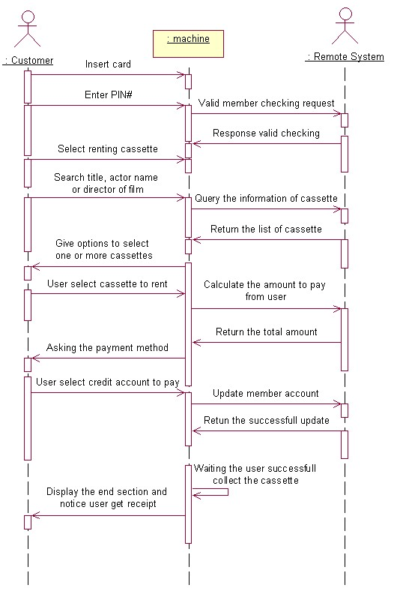
Secondary Scenario #1

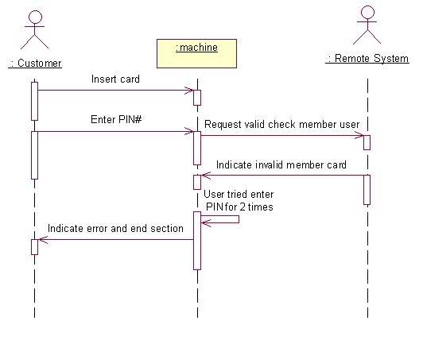
Secondary Scenario #2

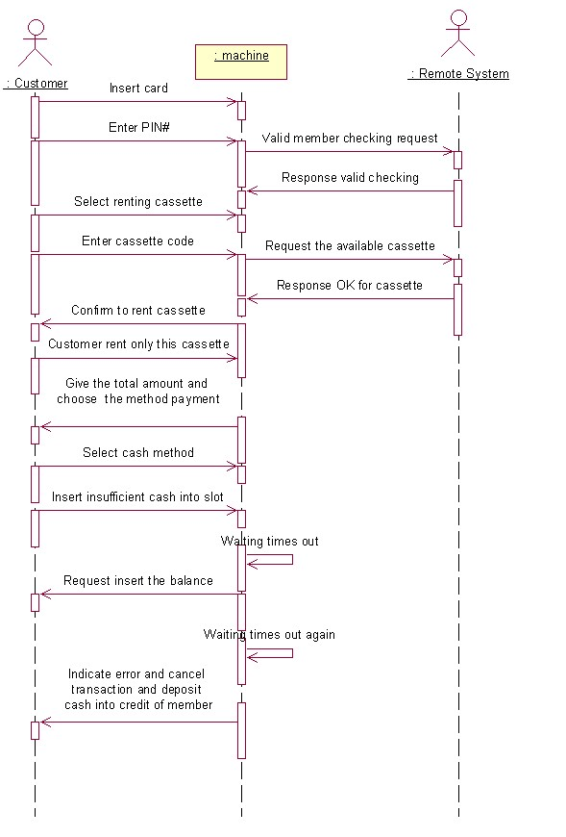
Secondary Scenario #3

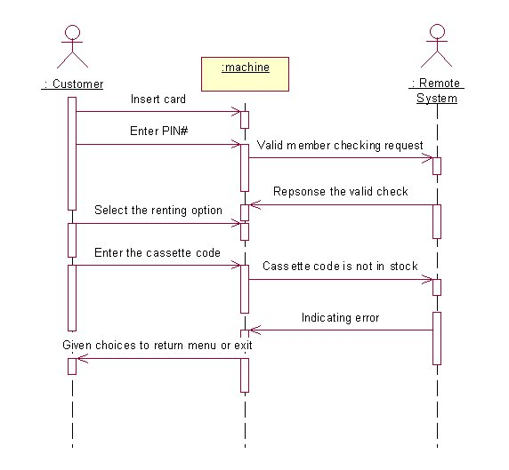

Appendix B – Categorization of Methods by Complexity Type

As explained in Section 5, the judgment as to which complexity category each method would belong to was based on the information obtained from our detailed class diagrams and interaction diagrams, our implementation, and on our estimate of how much ‘work’ would be done in each method. Specifically, the number of branches and/or loops that would be needed was the primary consideration.

Highly-complex Methods

cassetteDB::search
accountDB::rentalUpdate
Account::rentalUpdate
userDB::rentalUpdate
RemoteSystem::search
RemoteSystem::rentalUpdate
RemoteSystem::mainMenu
Machine::browseAcct
Machine::returnCassette
Machine::rentCassette
Machine::confirmSelection
Machine::mainMenu
Customer::rentalUpdate
cashPayment::pay
creditPayment::pay
Rental::payment
Film::getActors
Film::getDirector

Intermediate Methods

cassetteDB::addCassette
cassetteDB::getLast
cassetteDB::removeLast
accountDB::addAccts
accountDB::getAccount
accountDB::getBalance
accountDB::getAccount
userDB::getCustomer
User::enterUserLogin
RemoteSystem::getAccount
RemoteSystem::getCustomer
RemoteSystem::getBalance
RemoteSystem::display
Machine::checkPIN
Machine::payByCash
Machine::payByCredit
Machine::createRental
Machine::display
Machine::insertCard
Customer::getCurrentRentals
Rental::newRental
Rental::rentalChoice
Transaction::createPayment
Transaction::getTotal
Transaction::pay

Low-level Methods

cassetteDB::getCassetteByIndex
cassetteDB::getCassetteByTitle
accountDB::getIndex
Account::getAcctNum
Account::getBalance
userDB::getIndex
RemoteSystem::waitingTime
Machine::getPIN
Machine::end
Customer::getBalance
Customer::getAdultStatus
Customer::setBalance
Payment::getAmount
Cassette::getTitle
Cassette::getCode
Cassette::getCost
Cassette::getType
Cassette::getDueDate
Cassette::isRented

Appendix C – e-mail for Seg3300

From: <bob@site.uottawa.ca>
To: u1907299 <u1907299@site.uottawa.ca>
Cc: <seg3300A@site.uottawa.ca>; <seg3300B@site.uottawa.ca>; <ssome@site.uottawa.ca>
Subject: Helpful Hint
Date: Thursday, April 05, 2001 11:54 AM

Dear Student u1907299:

1) First of all, keep it simple. You did (pseudo-) code for 3 methods in
part 3) of Deliverable 3. All you do is to rank these 3 methods in terms
of complexity, e.g., SIMPLE, AVERAGE, COMPLEX. Calculate a value for
Estimated Lines of Cide (ELOC) for each type you have. For example,
suppose methods M1, M2, M3 have 16, 36, and 40 LOC respectively. You
judge that M1 is SIMPLE, M2 and M3 are AVERAGE, and COMPLEX would take
about the same number of LOC MORE than AVERAGE as AVERAGE has MORE LOC
than SIMPLE.

So you estimate:

SIMPLE = 16 LOC

AVERAGE = (36 + 40)/2 = 38 LOC

COMPLEX = 38 + (38-16)
= 38 + 22
= 60 LOC

Now you look at every method in your class diagram and estimate whether it
will be SIMPLE, AVERAGE, or COMPLEX. Give the reasons for your estimate.
Then, sum up all the LOC based on the complexities of ALL methods in the
class diagram of part 2) to yield your overall LOC estimate. Try to
indicate what percentage will be declarative code, what percentage will
probably be reusing definitions from class librariies (if any), and what
percentage will likely be executable code.

2) Remember to follow the boiler plate standard for deliverable hand-ins.

3) Remember to include the old (from deliverable 2) scenarios you derived
the collaboration diagrams from in part 1. as an Appendix, or if your
scenarios have changed radically since Deliverable 2, please include the
new scenarios (4 of them) in Appendix 1 for reference for the markers.

Sincerely,
Prof. Probert
******************************

On Wed, 4 Apr 2001, u1907299 wrote:

> Dear Pro.:
> I still have no idea how to write the 5th item in deliverable 3. Because
> the number of lines of code is not a reliable metric in estimating of
> software engineering,there are no detail discussion about how to estimate
> the number of lines of code corresponding to class diagram? So,would you
> like to give me some hints about it?
>
> Thanks your time!
>
======================================================================
From: <bob@site.uottawa.ca>
To: <seg3300A@site.uottawa.ca>; <seg3300B@site.uottawa.ca>
Subject: Reminder about Statement of Participation
Date: Wednesday, April 04, 2001 3:53 PM

Dear Students,

Please remember that as part of Deliverable #3, you are to hand in a
description signed by all members of the team of the degree of
contribution of effort that each of you made to each deliverable.
This is required so that the allocation of marks can be fairly assigned.

A very simple table would suffice, for example,

THE EXAMPLE TEAM

Student | D1 | D2 | D3
---------------------------------
Bob Brown | more | avg | more
---------------------------------
Julie Jones | avg | avg | more
---------------------------------
Trudy Taylor| less | avg | less
---------------------------------
Ted White | avg | avg | avg

The rows are the names of the students, and the columns are D1, D2, and D3
for Deliverable 1, 2, and 3 respectively.

In each entry in the table, the students are to indicate whether their
contribution was average, more than average (between the members of the
team), or less than average (between the members of the team).

Please make sure that each member of the team signs next to his/her name.

Thank you for your assistance in arriving at a fair allocation of the
grades.

Reminder: Please check the Web next week. All assignments, deliverables,
and mid-term marks will be posted. Please verify that your grades are as
posted to the best of your knowledge. If there are any problems, please
send me an email before the exam date.

The final exam is at 2:00 p.m. on Tuesday, April 24, 2001 in GYM B.

Have an enjoyable Easter break and all the best on all of your
assignments.

Professor Probert

=================================================

From: <bob@site.uottawa.ca>
To: Sara Gaudreault <saragaudreault@hotmail.com>
Cc: <seg3300A@site.uottawa.ca>; <seg3300B@site.uottawa.ca>; <ssome@site.uottawa.ca>
Subject: Re: Deliverable 3 seg3300
Date: Monday, April 02, 2001 2:45 PM

Dear Sara,

As I mentioned in class, the expresion "collaboration diagrams" in
question 1 implies scenarios, i.e., more than one scenario. Therefore,
we wish you to hand 4 collaboration diagrams, 1 for a primary scenario,
and 3 secondary scenarios. The scenarios should be included in an
appendix. You can simplify your secondary scenarios collaboration
diagrams by not repeating initial or final message interactions from the
primary scenario. Indicate clearly where you left the primary
scenario and where you retun to it (if you do).

Sincerely,
Prof. Probert
***********************
>
> for number 1:
> do you want a collaboration diagram for primary scenario only (as stated in
> the question) ?
> or
> Primary + 3 secondary scenarios like you seems to say in your e-mail
> below?
>

>
>
> >From: <bob@site.uottawa.ca>
> >To: seg3300A@site.uottawa.ca, seg3300B@site.uottawa.ca
> >CC: tyang@site.uottawa.ca, xjin@site.uottawa.ca, ssome@site.uottawa.ca
> >Subject: Helpful Hint for Deliverable 3
> >Date: Thu, 29 Mar 2001 15:37:15 -0500 (est)
> >
> >Dear Students,
> >
> >For Question 1 to assist the markers, please hand in the primary scenarios
> >and three secondary scenarios from Deliverable 2 which you had chosen to
> >make collaboration diagrams from. The best place to include these
> >scenarios is as an Appendix.
> >
> >Sincerely,
> >Prof. Probert
> >
>
>
> Sara Gaudreault
> saragaudreault@hotmail.com
>
============================================

From: <bob@site.uottawa.ca>
To: <seg3300A@site.uottawa.ca>; <seg3300B@site.uottawa.ca>
Cc: <tyang@site.uottawa.ca>; <xjin@site.uottawa.ca>; <ssome@site.uottawa.ca>
Subject: Helpful Hint for Deliverable 3
Date: Thursday, March 29, 2001 4:37 PM

Dear Students,

For Question 1 to assist the markers, please hand in the primary scenarios
and three secondary scenarios from Deliverable 2 which you had chosen to
make collaboration diagrams from. The best place to include these
scenarios is as an Appendix.

Sincerely,
Prof. Probert

Appendix D – Statement of Participation

 | Deliverable 1 | Deliverable 2 | Deliverable 3
Patrick Hunter | average | average | average
Tu Nguyen | average | average | average
Mark Sattolo | average | average | average

Note: Due to time constraints imposed by our various differing school and employment schedules, we were not able to meet at any time within the past few days to have this document personally signed by each member. We had previously arranged enough overlap in our areas of responsibility so that each member of the team could have an equal share of the work at each phase of the project and no person would be unduly burdened for a particular deliverable.

