February 13, 2001

Seg3300B

for: Prof. R.Probert

by: Mark Sattolo 428500

Assignment #1

due: Feb.13, 2001

Q1&2 Assumptions & Justifications

- Deadline for changes to the requirements for this assignment was Feb.9 at 12pm EST. These questions could never be completed if all the continual revisions had to be incorporated.

- Customers earn bonus air miles if they are members of a special privileges club. The airlines do this to encourage customer loyalty. The customer name is submitted to the membership database in order to earn the bonus. Details are not specified in this document.

- This document specifies what happens when customers are valid and do have a reservation within the next two hours after their arrival. Actions that would take place in other scenarios are not detailed here as this would take too much time. Most alternate scenarios would just involve specifying message screens informing the customer that there is no current information, or asking the customer to see a ticket agent, or something similar.

- The reservation database holds all information about flight arrivals and departures, passengers booked on flights, etc. Some or all of this info can be returned to the check-in system when requested. Thus, there is no need for separate databases for flight information and reservation (sometimes abbreviated as Res) information.

- Customers that need special flight arrangements, e.g. who may want a new reservation beyond the next available flight, will have to proceed to a ticket agent to make changes. A check-in system like this cannot be too complicated or it will require specifications much more involved than given here. Original or changed reservation information processed at the card system will be sent to the reservation database with a special flag indicating that this reservation has been confirmed.

- This card-based system interacts with customers and external entities such as databases and printers. Printers are considered to be external as they can be accessed by many independent systems. The check-in system itself is comprised of a card reader, the touchscreen, and all other hardware and software needed to process customer responses and communicate with the external entities, etc. The system does have access to the current time which it can submit to the reservation database as customers arrive.

- All the information necessary to find future flights for a customer are the destination and departure time of the current reservation. The next suitable flight for the customer can be found in the reservation database given these.

Q1

- Some data delivered to the customer consists of messages conveyed via the touchscreen which is part of the check-in system. Particular message screens are indicated by means of placing the key word or words for that screen in single quotation marks, e.g. ‘Confirm/Cancel’ corresponds to the screen message “Please confirm this change to your reservation or press Cancel to reject this change” or something similar. These messages will usually be displayed with some other information such as the details of a customer’s reservation, e.g. airline, departure gate and time, etc.

- Customer responses to the system, e.g. selecting the operation “Cancel” via the touchscreen, are similarly indicated by data in single quotation marks – as in ‘Cancel’.

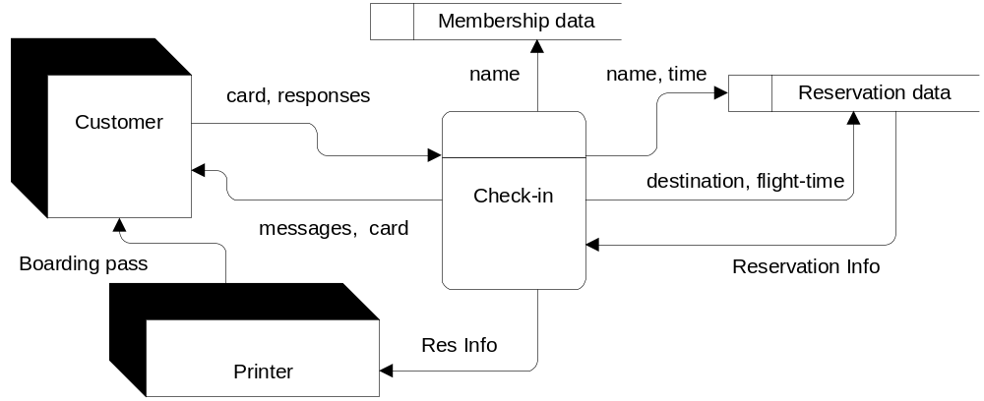Level 0 Diagram

[ Diagram 1 ]

Q2

States

W(1..n, s): System is waiting for customer 1..n while displaying screen s.

S(c, r, s): System is serving customer c with reservation r and displaying screen s.

C(d, a, b): System is communicating with device d, sending information a and receiving information b.

Events

I(c, v): Customer c inserts valid card v into the system’s card-reader.

G(v, c): System gives valid card v back to customer c.

R(f, c): System records reservation information f concerning customer c.

M(m, c): System receives message m from customer c.

U(r, q, c): System updates reservation r to reservation q for customer c.

Screens

WELCOME = Screen welcoming customers to the system and requesting to enter their membership, credit, or other card.

RCC = Reservation Confirm/Change? – screen asking customers to confirm or change the current reservation information.

CRCC = Changed Reservation Confirm/Cancel? – screen asking customers to confirm or cancel a changed reservation.

BAG = Baggage Yes/No? – screen asking customers to indicate if they have any baggage to check.

AGT = Proceed to Agent – screen asking customers to take their card and bring their bags to a check-in agent.

TBP = Take Boarding Pass – screen asking customers to take their card and boarding pass and proceed to the departure gate.

Messages (Customer to system)

CHANGE = Change reservation – customer has chosen to change the current reservation.

CANCEL = Cancel changed reservation – customer has rejected the new reservation suggested by the system.

CONFIRM = Confirm reservation – customer has accepted the original or modified reservation information.

YES = Yes, there is baggage – customer indicates that she does have bags to be checked in.

NO = No baggage – customer has indicated that she does not have any bags to be checked in.

External Entities

P = Printer – used to print the boarding passes for customers and perhaps other information.

MD = Membership database – stores information on customers who are members of a special privileges club.

RD = Reservation database – stores information on scheduled flights, passengers, departure times and gates, etc.

Reservations and other Information

RI = Reservation information – information about a customer’s current reservation.

NFI = Next flight information – information about the next available flight for a customer.

NAME = Name of customer – obtained from customer’s card and used for membership and reservation information.

NCT = Name of customer and Current time – information passed to the Reservation database.

DFT = Destination and Flight time of the current reservation – used to find the next suitable flight for a customer.

X = No information passed – or perhaps just a brief acknowledgement to the system if necessary.

Transitions

Transitions can be determined directly from the State Transition Diagram, but are presented here as well. Most transitions are specified without predicates, as using predicates (e.g. s = WELCOME) would have made most of the transitions much more difficult to follow. An example of this is the first transition. Thus, most of the necessary conditions for transitions are inserted directly into the State or Event specification. Also, as this system cycles through a series of menus for many different customers, the initial and final state are the same – the W(1..n, WELCOME) state.

W(1..n, s) & I(c, v) & s = welcome → C(d, a, b), d = md, a = name, b = x .
C(MD, NAME, X) → C(RD, NCT, RI) .
C(RD, NCT, RI) & R(RI, c) → S(c, RI, RCC) .
S(c, RI, RCC) & M(CHANGE, c) → C(RD, DFT, NFI) .
S(c, RI, RCC) & M(CONFIRM, c) → S(c, RI, BAG) .
C(RD, DFT, NFI) & R(NFI, c) → S(c, NFI, CRCC) .
S(c, NFI, CRCC) & M(CANCEL, c) → S(c, RI, RCC) .
S(c, NFI, CRCC) & M(CONFIRM, c) → C(RD, NFI, X).
C(RD, NFI, X) & U(RI, NFI, c) → S(c, RI, BAG) .
S(c, RI, BAG) & M(NO, c) → C(P, RI, X).
S(c, RI, BAG) & M(YES, c) → S(c, RI, AGT) .
C(P, RI, X) → S(c, RI, TBP) .
( S(c, RI, AGT) v S(c, RI, TBP) ) & G(v, c) → W(1..n, welcome).

[ Diagram 2 ]

Q3

The initial state for this machine is “Ready for Input”. The final state can be either “Valid” or “Not Valid”, depending on the binary number submitted to the machine. The state transition diagram could be expressed using either bits or bitstrings. I did the diagram using bits as the input is a string of characters and using bits gave a better picture of the state of the machine after each subsequent character is read.

