SOLUTION TO FINAL EXAMINATION

CSI 3150 Computational Method for Numerical Problems

July, 1996

Duration: 3 hours
Type: Open Book (Nonprogrammable calculators allowed)
Total: 100 Marks
Professor: Weixuan Li

1. (12 marks) Suppose an equation f(x) = 0 is to be solved, and an approximation of the root is found x₀ ≈ 1.7052. Evaluating the direvatives of the function f(x) at x = x₀, we find f(x₀) = 0.0018, f '(x₀) = 1.5283, f "(x₀) = 2.2176. What is the best approximation of this root you can get from these values? (Use at least 5 digits after the decimal point in your calculation.)

Solution. Let x* be the root of this equation. Let h = x* − x₀. Then, by Taylor's formula,

f(x*) = f(x₀) + f '(x₀)h / 1! + f "(x₀)h² / 2! = 0.0018 + 1.5283h + 2.2176h² / 2 = 0.

Therefore, h ≈ − 0.0012. The approximation obtained from these values is

x₀ + h = 1.7052 − 0.00118 = 1.7040.

2. (10 marks) Assume the following values are known for an unknown function f(x):

x f(x)
1 3
2 8
4 6

(i) Find an approximation of f(1.8).

(ii) Find an approximation of f '(1.2).

Solution. You may use a number of different methods to find an approximation of f(1.8). To solve these two questions together, we may find a polynomial to approximate the unknown function first. The Lagrange polynomial of this function is

P(x) = 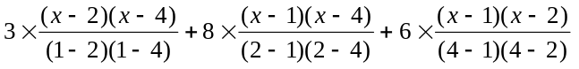
= (x − 2)(x − 4) − 4(x − 1)(x − 4) + (x − 1)(x − 2)
= − 2x² + 11x − 6.

When x = 1.8, f(1.8) ≈ P(1.8) = 7.32. f '(1.2) ≈ P '(1.2) = − 4 × 1.2 + 11 = 6.2.

3. (12 marks) Suppose the following values are known for a function f(x):

x f(x)

2 4
4 6
6 9
8 15

Use Nowton's backward difference formula to find an approximation of f(7). (Make sure you are using the right formula!)

Solution. The difference table is as follows:

2 4
2
4 6 1
3 2
6 9 3
6
8 15

Now h = 2. Newton's backward difference formula gives

f(x) ≈ P(2 + 2s) = 15 − 6s / 2 + 3s(s − 1) / 6 − 2s(s − 1)(s − 2).

Since 7 = 8 − 2s, s = (8 − 7) / 2 = 0.5. Then

f(7) ≈ P(2 + 2 × 2.5) = 15 − 6 × 0.5 + 3 × 0.5 × (−0.5) / 2 − 2 × 0.5 × (−0.5) × (−1.5) / 6 = 11.5.

4. (14 marks) The following values are given for a function f(x):

x f(x)

0.0 0
0.2 0.587785
0.4 0.951057
0.5 1.000000
0.7 0.809017
0.9 0.309017
1.0 0

Use whatever method that you think approriate to find an approximation of the integral of the function over the interval [0, 1]. (I do not expect you to find a polynomial or polynomials to approximate this function - this is too time consuming.)

Solution. The best way to approximate this integral can be obtained by using Simpson's rule on intervals [0, 0.4] and [0.5, 0.9], and trapezoidal rule on intervals [0.4, 0.5] and [0.9, 1].

Simpson's rule gives I[0, 0.4] ≈ 0.2201465, I[0.5, 0.9] ≈ 0.3030057.

The trapezoidal rule gives I[0.4, 0.5] ≈ 0.0975529, I[0.9, 1] ≈ 0.0154509.

The approximation of the integral is 0.636156.

If you use trapezoidal rule on all subintervals, you will get a worse approximation: 0.618372.
5. (12 marks) Assume an integral I = 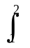f(x)dx is approximated by the composite Simpson's rule. When [1, 2] is subdivided into 4 subintervals, I ≈ I₁ = 0.693254; when [1, 2] is subdivided into 10 subintervals, I ≈ I₂ = 0.693150. Find a better approximation of I from these values by considering the error term of the formula. (Use at least 6 digits after the decimal point in your calculation.)

Solution. When the interval [1, 2] is subdivided into 2m subintervals, h = 1 / (2m). Then

I = 0.693254 + (1 / 180)(0.25)⁴f⁽⁴⁾(ξ₁),

I = 0.693150 + (1 / 180)(0.1)⁴f⁽⁴⁾(ξ₂).

Assume f⁽⁴⁾(ξ₁) ≈ f⁽⁴⁾(ξ₂). Eliminate the error term in these expressions: Multiply the second expression by 2.5⁴ = 39.0625, and subtract the first expression. We have

38.0625I = 39.0625 × 0.693150 − 0.693254 ≈ 26.38292.

I = 0.693147.

6. Suppose the Runge-Kutta method of order 4 is used to solve the initial value problem

y' = t + y, y(0) = 1.

With stepsize h = 0.2, it has been found that y(0.2) ≈ 1.242800, y(0.4) ≈ 1.583636, y(0.6) ≈ 2.044213.

(i) (8 marks) Continue to use Runge-Kutta method to find an approximation of y(0.8).

(ii) (8 marks) Use the predictor and corrector method to find an approximation of y(1.0).

(iii) (2 marks) Estimate the local truncation error of the result y(1.0) that you found in (ii).

(iv) (2 marks) If the local truncation error must be less than ε = 0.0001, what is the stepsize should be used?

Solution. (i) An approximation of y(0.8) by Runge-Kutta method is obtained by the following calculation:

K₁ = 0.528843, K₂ = 0.601727, K₃ = 0.609015, K₄ = 0.690646, y(0.8) ≈ 2.651042.

(ii) Note that the predictor-corrector method uses approximations y(0.2), y(0.4), y(0.6), and y(0.8) to find the predictor, and it uses y(0.4), y(0.6), y(0.8), and the predictor to find the corrector. The predictor = 3.436109, corrector = 3.436520. y(1.0) ≈ 3.436520.

(iii) Local truncation error σ = 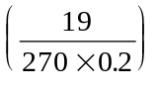|corrector - predictor| ≈ 0.00014451.

(iv) The adjusted step size = (0.0001 / 2σ)^{1/4} ≈ 0.1534.

7. (i) (12 points) Write the Jacobi's iteration formula and the Gauss-Seidel iteration formula of the following system in the matrix form:

2x + y + z = 4,
x + 2y + z = 4,
x + y + 2z = 4.

(ii) (8 marks) Suppose a system of linear equations with 3 unknowns is solved by the iteration formula

x^{(k+1)} = Tx^{(k)} + c,

where T = 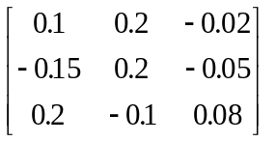.

Assume x⁽³⁾ = (x', y', z'), x⁽⁴⁾ = (x", y", z") and the accurate solution is x* = (x*, y*, z*) . If

max { |x* − x"|, |y* − y"|, |z* − z"| } = 0.0015,

Estimate max { |x* − x"|, |y* − y"|, |z* − z"| }.

Solution. (i) D = 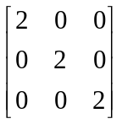, U = 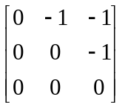, L = 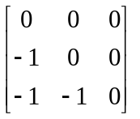.

D⁻¹(L + U) = 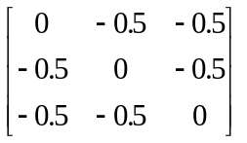.

The Jacobi's iteration fomula is

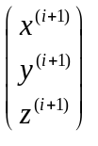= 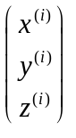+ 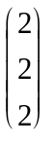.

(D − L)⁻¹U = 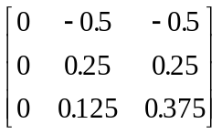.

The Gauss-Seidel's iteration formula is

= 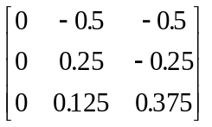+ 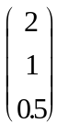.

(ii) By the given conditions, || T ||∞ = 0.4 and || x⁽⁴⁾ − x⁽³⁾ ||∞ = 0.0015.

max { |x* − x"|, |y* − y"|, |z* − z"| } = || x* − x⁽⁴⁾ ||∞ ≤ [|| T ||∞ / (1 − || T ||∞)] || x⁽⁴⁾ − x⁽³⁾ ||∞
= (0.4 / 0.6) × 0.0015 = 0.001.

