SOLUTION TO FINAL EXAMINATION
CSI 3150
Summer 1998

Duration: 3 hours
Type: Closed book, formulas attached, non-programmable calculators allowed.
Total marks: 80
Professor: Weixuan Li

1. (5 marks) It is known that the equation x⁴ + 2x² − x − 3 = 0 has a root between 1 and 1.5. Use the bisection method to locate the root in an interval with length less then 0.05.

positive negative difference middle f(middle)
1.5 1.0 0.5 1.25 +
1.25 1.0 0.25 1.125 +
1.125 1.0 0.125 1.0625 −
1.125 1.0625 0.0625 1.09375 −
1.125 1.09375

The root is between 1.09375 and 1.125.

2. (8 marks) Find a polynomial P(x) that has the following properties: P(0) = 0, P(1) = 2, P'(0) = 0, P"(0) = 0, P'(1) = 0.5, P"(1) = 0.

P(x) = ax⁵ + bx⁴ + cx³ + dx² + ex + f.

P'(x) = 5ax⁴ + 4bx³ + 3cx² + 2dx + e,

P"(x) = 20ax³ + 12bx² + 6cx + 2d.

P(0) = f = 0, P'(0) = e = 2, P"(0) = 2d = 0.
P(1) = a + b + c + d + e + f = a + b + c = 2,
P'(1) = 5a + 4b + 3c + 2d + e = 5a + 4b + 3c = 0.5,
P"(1) = 20a + 12b + 6c + 2d = 20a + 12b + 6c = 0.

2a + b = −5.5,
14a + 6b = −12.

2a = 21, a = 10.5, b = −26.5, c = 18.

This polynomial is P(x) = 10.5x⁵ − 26.5x⁴ + 18x³.

3. (10 marks) Suppose f (0) = x, f (h) = y, f (3h) = z. Find an approximation of f ' (0) in terms of x, y and z.

y = f(h) ≈ x + f'(0)h + f"(0)h² / 2,
z = f(3h) ≈ x + 3f'(0)h + 9f"(0)h² / 2.

9y − z ≈ 8x + 6f'(0)h.

f'(0) ≈ (9y − z − 8x) / (6h).

4. (10 marks) Suppose it is known that f (a) = 3, f (c) = 5, f (b) = 9, where a < c < b. Find an approximation of the integral 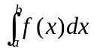.

By the Lagrange polynomial,

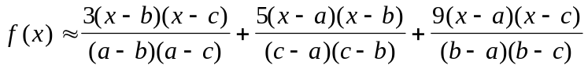.

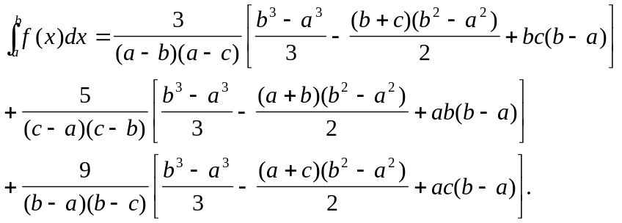

5. (10 marks) Suppose an integral I = is to be estimated. Using Simpson's rule, we get an approximation 2.1876. Using Simpson's three eighth rule, we get an approximation 2.2394. Find a better approximation of the integral from these results.

I = 2.1876 − (1 / 90)K[(b − a) / 2]⁵ = 2.1876 − (1 / 2880)K(b − a)⁵,

I = 2.2394 − (3 / 80)K[((b − a) / 3]⁵ = 2.2394 − (1 / 6480)K(b − a)⁵.

2880I = 6300.288 − K(b − a)⁵,

6480I = 14511.312 − K(b − a)⁵.

3600I = 8211.024. I = 2.28084.

6. (10 marks) Use Taylor's method of order two to find an approximation of y(0.1) with step-size h = 0.05, where y(t) is the solution to the following initial value problem:

y' = t² + y², y(0) = 1.

y' = f(t , y) = t² + y²,

y" = df / dt = 2y(t² + y²) + 2t.

y_{i+1} = y_{i} + (t_{i}² + y_{i}²)h + [y_{i}(t_{i}² + y_{i}²) + t_{i}]h².

y₀ = 1,

y₁ = y(0.5) ≈ 1 + 0.05 + 0.05² = 1.0525,

y₂ = y(1.0) ≈ 1.0525 + (0.5² + 1.0525²) × 0.05 + [1.0525 × (0.5² + 1.0525²) + 0.5] × 0.05² = 1.12521.

7. (i) (10 marks) y' = y² + e^{t}, y(0) = 1.

Suppose it is known that y(0) = 1, y(0.1) = 1.2286, y(0.2) = 1.5343, y(0.3) = 1.9658. Use the predictor-corrector method to find an approximation of y(0.4).

(ii) (2 marks) Estimate the local truncation error of your result in Part (i).

w₄' = w₃ + (0.1 / 24)[55f(t₃, w₃) − 59f(t₂, w₂) + 37f(t₁, w₁) − 9f(t₀, w₀)]

= 1.9658 + (0.1 / 24)(55 × 5.2142 − 59 × 3.5755 + 37 × 2.6146 − 9 × 2) ≈ 2.6098.

w₄" = w₃ + (0.1 / 24)[9f(t₄, w₄') + 19f(t₃, w₃) − 5f(t₂, w₂) + f(t₁, w₁)]

= 1.9658 + (0.1 / 24)(9 × 8.3029 + 19 × 5.2142 − 5 × 3.5755 + 2.6146) ≈ 2.6264.

y(0.4) ≈ 2.6264.

The local truncation error is (19 / 27)|2.6264 − 2.6098| ≈ 0.0117.

8. (i) (10 marks) Do two iterations to solve the following system of linear equations using the Gauss-Seidel method, starting with the approximation x⁽⁰⁾ = 1, y⁽⁰⁾ = 1, z⁽⁰⁾ = 1:

4x + 2y + z = 14,
x + 5y − z = 10,
x + y + 8z = 20.

(ii) (5 marks) Suppose the result you obtained in part (i) is (x⁽²⁾, y⁽²⁾, z⁽²⁾) and the accurate solution of the system of equations is (x*, y*, z*).
Estimate max { |x⁽²⁾ − x*|, |y⁽²⁾ − y*|, |z⁽²⁾ − z*| }.

x = 3.5 − 0.5y − 0.25z,
y = 2 − 0.2x + 0.2z,
z = 2.5 − 0.125x − 0.125y.

x⁽⁰⁾ = 1, y⁽⁰⁾ = 1, z⁽⁰⁾ = 1,

x⁽¹⁾ = 3.5 − 0.5 − 0.25 = 2.75,
y⁽¹⁾ = 2 − 0.2 × 2.75 + 0.2 = 1.65,
z⁽¹⁾ = 2.5 − 0.125 × 2.75 − 0.125 × 1.65 = 1.95.

x⁽²⁾ = 3.5 − 0.5 × 1.65 − 0.25 × 1.95 = 2.1875,
y⁽²⁾ = 2 − 0.2 × 2.1875 + 0.2 × 1.95 = 1.9525,
z⁽²⁾ = 2.5 − 0.125 × 2.1875 − 0.125 × 1.9525 = 1.9825.

T = (D − L)⁻¹U =

=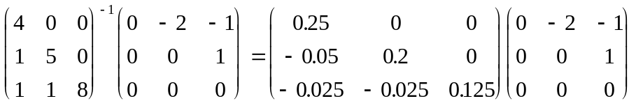

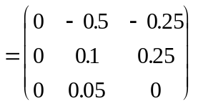.

||T||∞ = 0.75.

||x* − x⁽²⁾|| ≤ (0.75 / 0.25)max{0.5625, 0.3025, 0.0325} ≈ 1.7.

