University of Ottawa
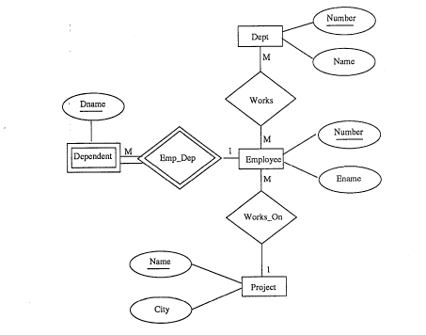
School of Information Technology and Engineering
CSI 3317 - 2000F
Class Project
Instructor: Dr. Cory Butz
Due: Friday, November 24, 2000 at noon
Hand in: to the CS13317 box on 3rd floor MCD.

Title of Project: Database Scheme Design using Entity Relationship Diagrams.

Objective: To learn independently how to design a database scheme from a given entity-relationship diagram.

Reference: In addition to the class text, I also suggest that you take a look at Date’s text.

Consider the entity-relationship diagram illustrated below. Provide the SQL data definitions for it including primary and foreign keys as needed. The key properties are underlined.

If you make any assumptions, they must be explicitly stated in your project you turn in.

