Sudoku Puzzle Generator

Project Team Members
Jonas Kety
Eric Pitts
Connor Waits

Project Summary
Our project creates a sudoku puzzle with a GUI interface that the user can solve the puzzle on. It features three different difficulties, which change the number of original hints the player gets (the harder the difficulty, the less hints), and gives the user a popup window if he/she wins.

Goals and Objectives
The main goals of the project are:
- To implement an algorithm that creates a 9x9 matrix that is filled out according to the rules of sudoku
- To create a puzzle out of the matrix by removing certain entities in the matrix
- To display the puzzle on the screen using a Tkinter generated GUI
- To implement a way for the user to enter his/her solution to the puzzle
- To check if the user’s solution is the correct answers
The game is playable on the user’s Raspberry Pi (or any touchscreen environment, just optimized for the Pi), allowing for a simple puzzle in bed or at the user’s desk.

Github Repository
This project's Github repository is located at: https://github.com/epitts1013/RPiFinalProjectGroup9
There are three branches (master, GUI-Testing, and Changing-Size) that were used. All final and working products were pushed to master when they were fully completed, and all testing was done in the GUI-Testing branch. Almost 40 commits were to the testing branch, which was a lot of trial and error work from the group. The final Changing-Size branch was made for when we had to change the interface from our laptops to the Pi.

Bill of Materials
The items required are: Raspberry Pi B v3, and Raspberri Pi 7” touchscreen display. The software required is: Python v2.7.9.

GPIO and GUI

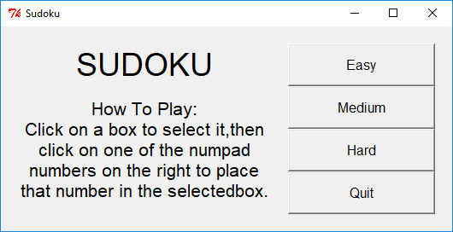
GPIO was not used in this project. The GUI was created using the Tkinter module in Python v2.7.9. The program first creates a window that allows the user to select a difficulty using buttons from the Tkinter library. The window then takes the newly-changed sudoku puzzle and crafts a window consisting of nine rows of nine buttons. The hints are buttons that are disabled. The user can tap on any button to select it, which will then highlight the button in green. The user can then tap any of the number buttons on the side of the window to change the number of the selected button. After the user has completed the puzzle, he or she can tap the “check puzzle” button located in the top right to check and see if the puzzle is correct. If it is not fully completed, text will popup telling the user that the puzzle is not fully filled out yet. If the puzzle is not correct, the GUI will tell the user “Incorrect solution.” Finally, if the puzzle is correct, a new window will pop up with the text “You win!” 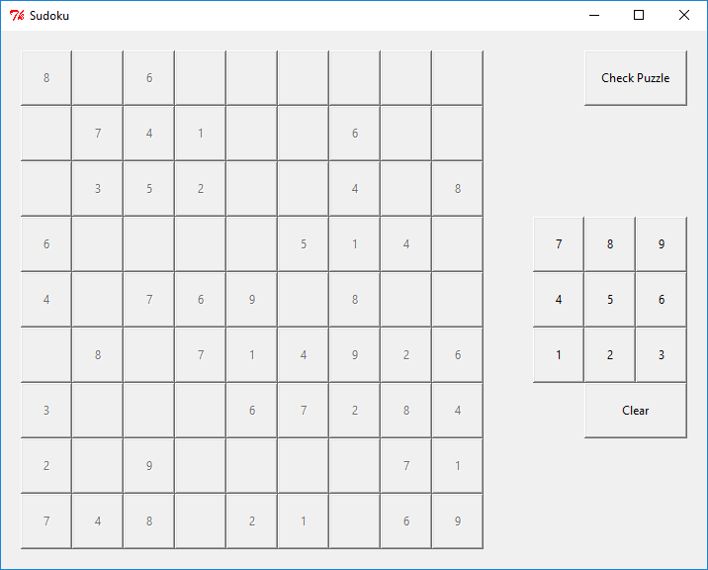

Gantt Chart
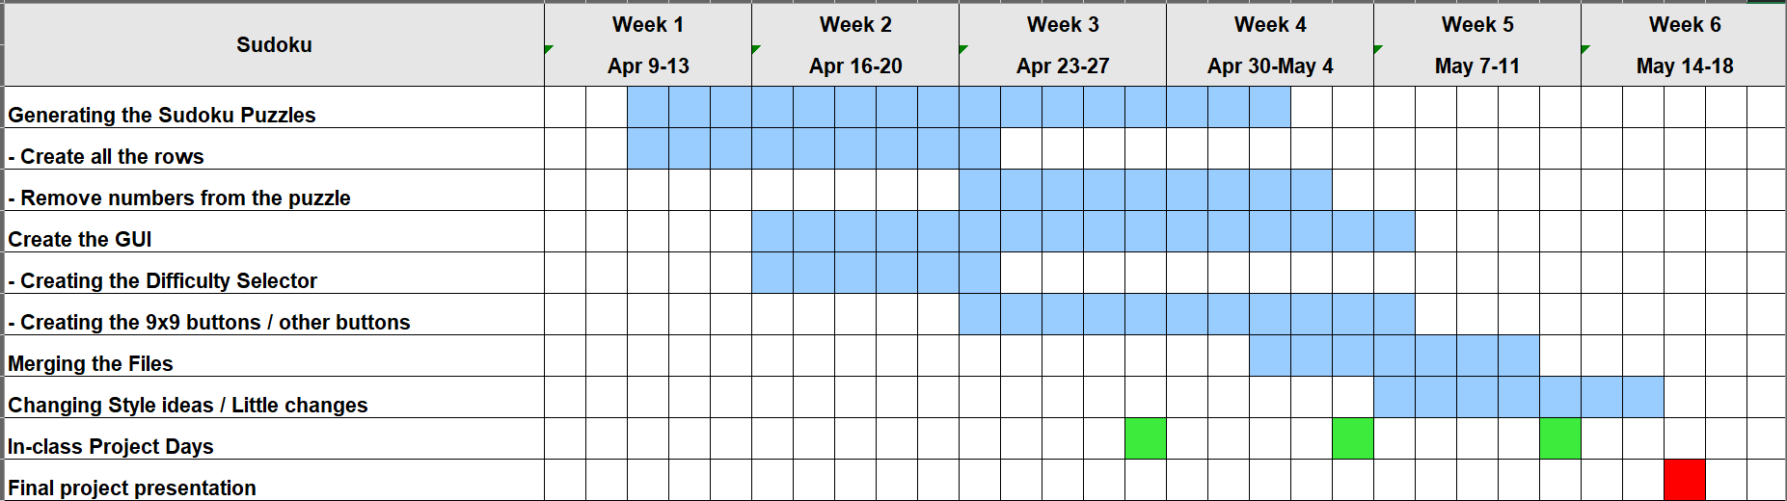

Our original schedule was changed because creating the actual sudoku generator took two weeks longer than expected. We decided to change the way the user could input a number by just adding a base numpad instead of a window popup. The GUI took about s long as expected, along with the merge taking about as long as expected.

Future Development Plans
Future development plans to continue working on the sudoku puzzle would be to implement an algorithm to find all solutions to the puzzle that is outputted to the user. Currently, the solution to the puzzle may not be unique, so it is possible, but not likely, that the user could submit a valid solution to the puzzle, but the program finds it to be incorrect. Implementing this feature would be involve extremely mathematically rigorous logic unless a brute-force method would be used, which be terribly inefficient. Another improvement that could be made would be adding a feature that allowed you to write “guesses” or notes in the margin of a square before putting in an answer. We could add more quality of life changes to the interface, so the user can tell each 3x3 matrix within the 9x9 apart. A tries system could be implemented to add more difficulty to the puzzles, and possibly a score based on a timer could be added.

Lessons Learned
The main lessons that were learned while working on this project was how to work in depth with lists of lists in Python, more advanced techniques in Tkinter, and how to merge the code created by different team members into one seamless program. Learning to communicate and updating team members regularly, as well as how to break a problem down and solve it one component at a time were vital skills developed during this project.

