Sudoku Puzzle Generator

Project Team Members
Connor Waits
Jonas Kety
Eric Pitts

Project Summary
Our project will generate a sudoku puzzle with a GUI interface that the user can solve the puzzle on.

Goals and Objectives
The main goals of our project are:
- To implement an algorithm to create a 9x9 matrix that is filled out according to the rules of sudoku
- To create a puzzle out of that matrix by removing entries in the matrix
- To display the puzzle to the screen
- To implement a way for the user to enter their solution to the puzzle
- And to check if the user’s solution is the correct one

GPIO
We will not be using any external circuits for this project.

GUI
The GUI will make use of the Raspberry Pi’s LCD touchscreen. The display to the user will look exactly like a sudoku puzzle, with entry boxes where blank spaces are. The user will be able to select a box and enter their guess for the number in it.

Github Repository
This project's Github repository is located at: https://github.com/epitts1013/RPiFinalProjectGroup9

Gantt Chart
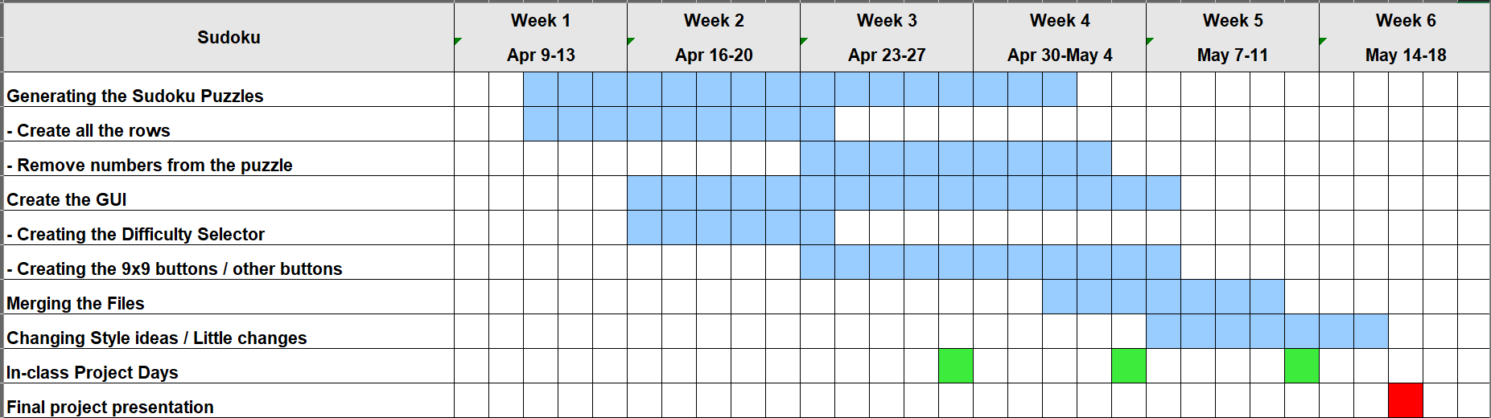

Future Development Plans
Future plans to continue working on the sudoku puzzle would be to implement an algorithm to find all solutions to the puzzle that is outputted to the user. Currently, the solution to the puzzle may not be unique, so it is possible, but not likely, that the user could submit a valid solution to the puzzle, but the program finds it to be incorrect. Implementing this feature would be involve extremely mathematically rigorous logic unless a brute-force method would be used, which be terribly inefficient. Another improvement that could be made would be adding a feature that allowed you to write “guesses” or notes in the margin of a square before putting in an answer.

Lessons Learned
The main lessons that were learned while working on this project was how to work in depth with lists of lists in Python, more advanced techniques in tkinter, and how to merge the code created by different team-members into one seamless program. Learning to communicate and updating team members regularly, as well as how to break a problem down and solve it one component at a time were vital skills developed during this project.

