Subject : CLOUD COMPUTING
Attempt all Questions
MCQ (5*1 =5)

1. Which of the following is an online backup and storage system?
a) Amazon Elastic Compute Cloud
b) Amazon Simple Queue Service
c) Amazon Simple Notification Service
d) Amazon Simple Storage System

2. Which of the following allows you to create instances of the MySQL database to support your Web sites?
a) Amazon Elastic Compute Cloud
b) Amazon Simple Queue Service
c) Amazon Relational Database Service
d) Amazon Simple Storage System

3. Which type of Hypervisor is shown in the following figure?
a) Type 1
b) Type 2
c) Type 3
d) All of the mentioned

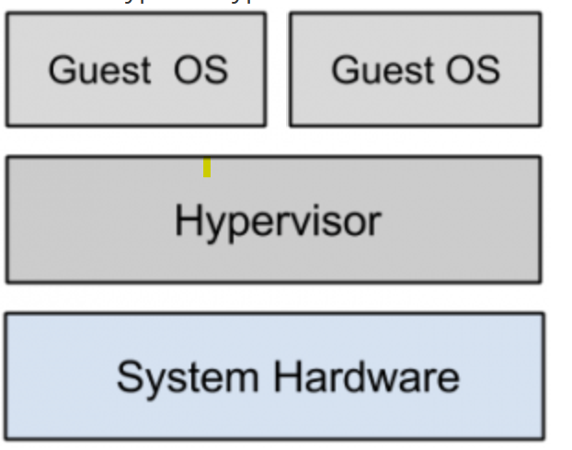

4. Who is the father of cloud computing?
a) Sharon B. Codd
b) Edgar Frank Codd
c) J.C.R. Licklider
d) Charles Bachman

- Which of the following is a key benefit of utility computing?
- Users must purchase hardware to access services
- Computing resources are available on a pay-as-you-go basis
- Services require long-term contracts and fixed pricing
- Only large enterprises can use utility computing

SHORT QUESTIONS (3*5 =15)

- What is cloud computing? Describe its key characteristics and compare it with traditional IT infrastructure.

7. Explain cloud service models (IaaS, PaaS, SaaS) with examples and their common usage.

8. Describe cloud deployment models (Public, Private, Hybrid, Community) with examples and typical use cases.

