A
LAB REPORT
ON
object-oriented programming with c++

By
Jenesh Kumar Rawal
Exam Roll No: 8229011
TU Regd. No: 9-2-29-11-2025


Submitted to:
PIYUSH PANT
Mahendra Ratna Campus

In partial fulfillment of the requirements for the Course
Object-Oriented Programming with C++

Tahachal, Kathmandu
Sept 2026
Table of Content
1. Write a C++ program to input a number and check whether it is a prime number or not. 1
1.1. Source Code 1
1.2. Output 1
2. Write a C++ program to find the sum of numbers from 1 to n. 2
2.1. Source code 2
2.2. Output 2
3. Write a C++ program to find the factorial of a number using recursion. 3
3.1. Source Code 3
3.2. Output 3
4. Write a C++ program to calculate the area of a circle, rectangle, and square using method overloading. 4
4.1. Source Code 4
4.2. Output 4
5. Write a C++ program to swap two numbers using pass by value. 5
5.1. Source code 5
5.2. Output 5
6. Write a C++ program to swap two numbers using pass by reference. 6
6.1. Source Code 6
6.2. Ouput 6
7. Write a C++ program to swap two numbers without using a third variable. 7
7.1. Source Code 7
7.2. Output 7
8. Write a C++ program to input a number and print its reverse. 8
8.1. Source Code 8
8.2. Output 8
9. Write a C++ program to demonstrate constructor overloading. 9
9.1. Source Code 9
9.2. Output 9
10. Write a C++ program to demonstrate encapsulation. 10
10.1. Source Code 10
10.2. Output 10
11. Write a C++ program to demonstrate a friend function. 11
11.1. Source Code 11
11.2. Output 11
12. Write a C++ program to demonstrate a static data member. 12
12.1. Source Code 12
12.2. Output 12
13. Write a C++ program to demonstrate the execution sequence of constructors in base and derived classes. 13
13.1. Source Code 13
13.2. Output 13
14. Write a C++ program to demonstrate different modes of inheritance. 14
14.1. Source Code 14
14.2. Output 14
15. Write a C++ program to demonstrate method overriding. 15
15.1. Source Code 15
15.2. Output 15
16. Write a C++ program to demonstrate arithmetic operator overloading. 16
16.1. Source Code 16
16.2. Output 16
17. Write a C++ program to demonstrate relational operator overloading. 17
17.1. Source Code 17
17.2. Output 17
18. Write a C++ program to demonstrate unary operator overloading. 18
18.1. Source Code 18
18.2. Output 18
19. Write a C++ program to demonstrate the use of namespaces. 19
19.1. Source Code 19
19.2. Output 19
20. Write a C++ program to perform addition using a function template. 20
20.1. Source Code 20
20.2. Output 20
21. Write a C++ program to find the maximum of two values using a function template. 21
21.1. Source Code 21
21.2. Output 21
22. Write a C++ program to open a file in read mode and display its contents. 22
22.1. Source Code 22
22.2. Output 22
23. Write a C++ program to open a file in write mode and write data into it. 23
23.1. Source Code 23
23.2. Output 23
24. Write a C++ program to demonstrate random access file handling and explain how it differs from sequential access. 24
24.1. Source Code 24
24.2. Output 24
25. Write a C++ program to demonstrate exception handling using try, throw, and catch. 25
25.1. Source Code 25
25.2. Output 25

Write a C++ program to input a number and check whether it is a prime number or not.

Source Code
#include <iostream>
using namespace std;

int main(){
int n, i;
bool prime = true;
cout << "Enter a number: ";
cin >> n;

if(n <= 1){
prime = false;
}else {
for (i = 2; i <= n/2; i++){
if(n%i == 0){
prime = false;
break;
}
}
}
if(prime)
cout << n << " is a prime number.";
else
cout << n << " is not a prime number.";

return 0;
}

Output
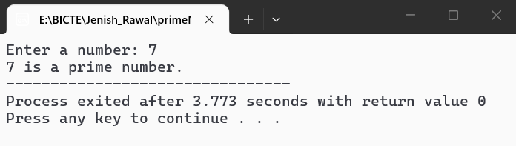

Write a C++ program to find the sum of numbers from 1 to n.

Source code
#include<iostream>
using namespace std;
int main(){
int n,i;
int sum = 0;

cout <<"Enter the value of n: ";
cin >> n;

for(i = 1; i <= n; i++){
sum = sum + i;
}

cout << "Sum of numbers from 1 to " << n << " = " << sum;

return 0;
}

Output
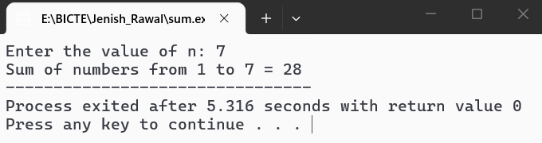

Write a C++ program to find the factorial of a number using recursion.

Source Code
#include <iostream>
using namespace std;

// Recursive function
int factorial(int n){
if(n == 0 || n == 1)
return 1;
else
return n * factorial(n - 1);
}
int main(){
int n;
cout << "Enter a number: ";
cin >> n;

cout << "Factorial of " << n << " = " << factorial(n);

return 0;
}

Output
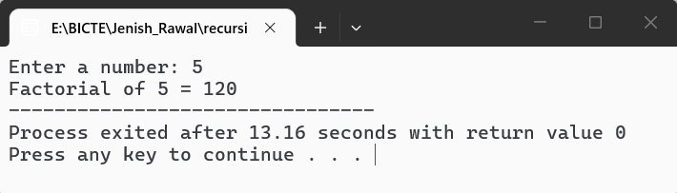

Write a C++ program to calculate the area of a circle, rectangle, and square using method overloading.

Source Code
#include <iostream>
using namespace std;
class Area{
public:
// Area of circle
float calculate(float radius){
return 3.14 * radius * radius;
}
// Area of rectangle
float calculate(float length, float breath){
return length * breath;
}
// Area of square
int calculate(int side){
return side * side;
}
};
int main(){
Area a;
float radius, length, breadth;
int side;
cout <<"Enter radius of circle: ";
cin >> radius;
cout << "Area of circle = " << a.calculate(radius) << endl;

cout << "Enter length and breath of rectangle: ";
cin >> length >> breadth;
cout <<"Area of rectangle = "<<a.calculate(length, breadth)<< endl;
cout << "Enter side of square: ";
cin >> side;
cout <<"Area of square = " << a.calculate(side) << endl;
return 0;
}

Output
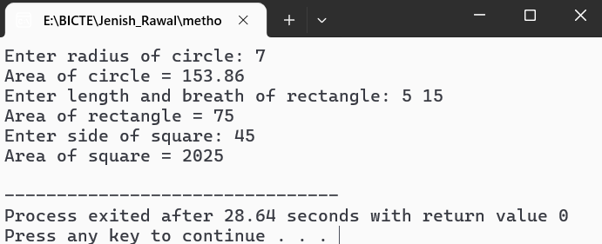

Write a C++ program to swap two numbers using pass by value.

Source code
#include <iostream>
using namespace std;

void swapNumber(int a, int b){
int temp;
temp = a;
a = b;
b = temp;
cout << "After swapping inside funtion: " << endl;
cout << "a = " << a << endl;
cout << "b = " << b << endl;
}
int main(){
int a, b;

cout << "Enter two number: ";
cin >> a >> b;

cout << "Before swapping: " << endl;
cout << "a = " << a << endl;
cout << "b = " << b << endl;

swapNumber(a, b);

cout << "After function call: " << endl;
cout << "a = " << a << endl;
cout << "b = " << b << endl;

return 0;
}

Output
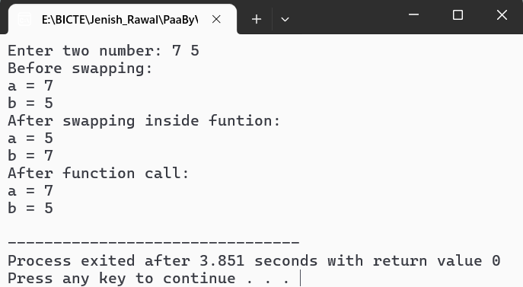

Write a C++ program to swap two numbers using pass by reference.

Source Code
#include <iostream>
using namespace std;

void swapNumbers(int &a, int &b){
int temp;
temp = a;
a = b;
b = temp;
}
int main(){
int a, b;

cout << "Enter two numbers: ";
cin >> a >> b;

cout << "Before swapping: " << endl;
cout << "a = " << a << endl;
cout << "b = " << b << endl;

swapNumbers(a, b);

cout << "After swapping: " << endl;
cout << "a = " << a << endl;
cout << "b = " << b << endl;

return 0;
}

Ouput
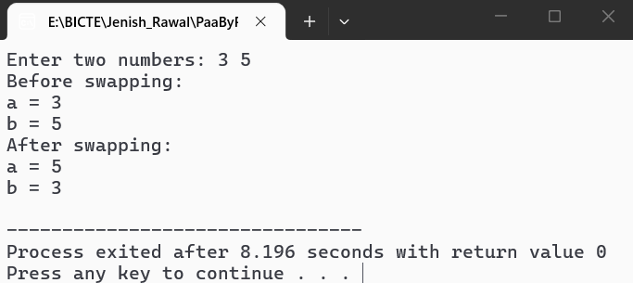

Write a C++ program to swap two numbers without using a third variable.

Source Code
#include <iostream>
using namespace std;

int main(){
int a, b;

cout << "Enter two numbers: ";
cin >> a >> b;

cout << "Before swapping: " <<endl;
cout << "a = " << a << endl;
cout << "b = " << b << endl;

// Swapping without third variable
a = a + b;
b = a - b;
a = a - b;

cout <<"After swapping: " <<endl;
cout <<"a = " << a << endl;
cout <<"b = " << b << endl;

return 0;
}

Output
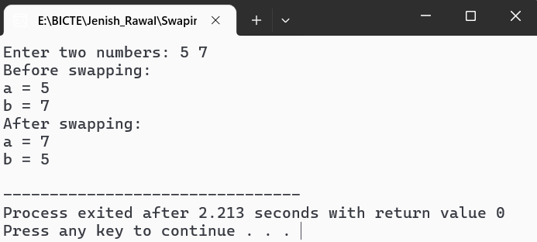

Write a C++ program to input a number and print its reverse.

Source Code
#include <iostream>
using namespace std;

int main(){
int n, reverse = 0, digit;

cout << "Enter a number: ";
cin >> n;

while(n != 0){
digit = n % 10;
reverse = reverse * 10 + digit;
n = n / 10;
}

cout << "Reverse of the number = " << reverse;

return 0;
}

Output
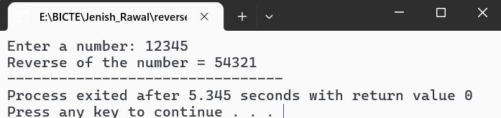

Write a C++ program to demonstrate constructor overloading.

Source Code
#include<iostream>
using namespace std;

class Student {
int id;
string name;
public:
//Default constructor
Student(){
id = 0;
name = "Unknown";
}
// Parameterized constructor with one parameter
Student(int i ){
id = i;
name = "Unknown";
}
// Parameterrized constructor with two parameters
Student(int i, string n){
id = i;
name = n;
}
void display(){
cout << "ID: " << id << ", Name: " << name << endl;
}
};
int main(){
Student s1;
Student s2(101);
Student s3(102,"Jenish");

s1.display();
s2.display();
s3.display();

return 0;
}

Output
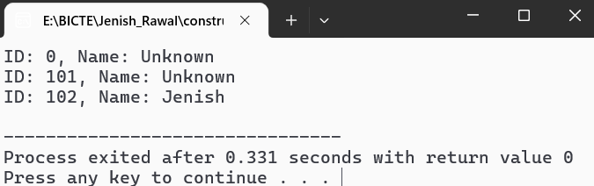

Write a C++ program to demonstrate encapsulation.

Source Code
#include <iostream>
using namespace std;

class Student{
private:
int marks;
public:
// Setter function
void setMarks(int m){
marks = m;
}
// Getter function
int getMarks(){
return marks;
}
};
int main(){
Student s;

s.setMarks(75);

cout << "Student Marks = " << s.getMarks();

return 0;

}

Output
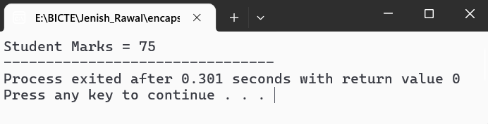

Write a C++ program to demonstrate a friend function.

Source Code
#include <iostream>
using namespace std;

class Student {
private:
int marks;
public:
Student(){
marks = 85;
}
// Friend Function declaration
friend void display(Student s);
};
// Friend function definition
void display(Student s){
cout << "Student Marks = " << s.marks;
}
int main(){
Student s;

display(s);

return 0;
}

Output
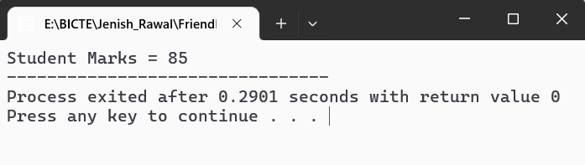

Write a C++ program to demonstrate a static data member.

Source Code
#include <iostream>
using namespace std;

class Student {
private:
int id;
static int count;
public:
Student(int i){
id = i;
count++;
}
void display(){
cout <<"Student ID: " << id << endl;
}
static void displayCount(){
cout << "Total Students: " << count << endl;
}
};
// Definition of static data member
int Student::count = 0;

int main(){
Student s1(101);
Student s2(102);
Student s3(103);

s1.display();
s2.display();
s3.display();

return 0;
}

Output
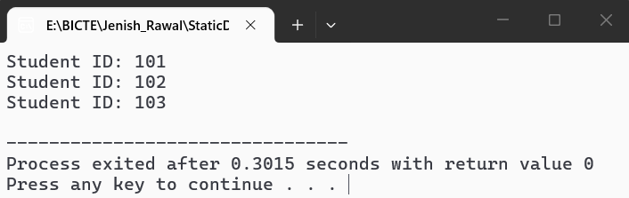

Write a C++ program to demonstrate the execution sequence of constructors in base and derived classes.

Source Code
#include <iostream>
using namespace std;

class Base{
public:
Base(){
cout << "Base class constructor executed." << endl;
}
};
class Derived : public Base{
public:
Derived(){
cout <<"Derived clas constructor executed." << endl;
}
};

int main(){
Derived d;

return 0;
}

Output
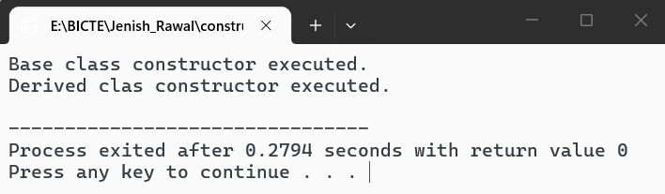

Write a C++ program to demonstrate different modes of inheritance.

Source Code

#include<iostream>
using namespace std;

class Base{
public:
int publicData = 11;
protected:
int protectedData = 21;
private:
int privatedData = 31;
};
// Public inheritance
class PublicDerived : public Base {
public:
void display(){
cout << "Public Inheritance: " << endl;
cout << "Public Data = " << publicData << endl;
cout << "Protected Data = " << protectedData << endl;
}
};
// Protected inheritance
class ProtectedDerived : protected Base{
public:
void display(){
cout << "Protected Inheritance: "<< endl;
cout << "Public Data = " << publicData << endl;
cout << "Protected Data = " << protectedData << endl;
}
};

// Private inheritance
class PrivatedDerived : private Base{
public:
void display(){
cout <<"Private Inheritance: " <<endl;
cout <<"Public Data = " <<publicData << endl;
cout <<"Protected Data = " <<protectedData << endl;
}
};
int main(){
PublicDerived p1;
ProtectedDerived p2;
PrivatedDerived p3;

p1.display();
p2.display();
p3.display();

return 0;
}

Output
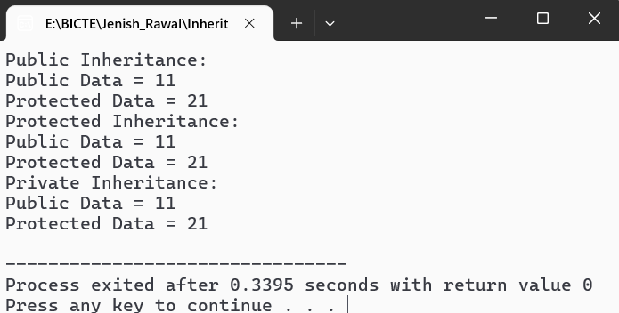

Write a C++ program to demonstrate method overriding.

Source Code
#include<iostream>
using namespace std;

class Animal{
public:
virtual void sound(){
cout << "Animal Makes Sound." << endl;
}
};
class Dog : public Animal {
public:
void sound(){
cout <<"Dog Barks. " <<endl;
}
};

int main(){
Animal* a;
Dog d;
a = &d;
a ->sound();

return 0;
}

Output
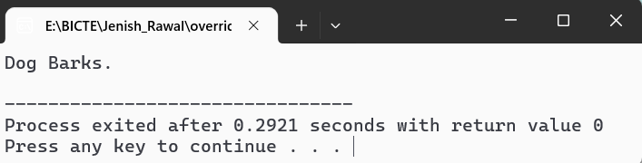

Write a C++ program to demonstrate arithmetic operator overloading.

Source Code
#include <iostream>
using namespace std;

class Number{
private:
int value;
public:
Number(int v){
value = v;
}
// Overloading + operator
Number operator + (Number n){
return Number(value + n.value);
}
void display(){
cout << "Sum = " << value << endl;
}
};
int main(){
Number n1(10);
Number n2(20);

Number n3 = n1 + n2;

n3.display();

return 0;
}

Output
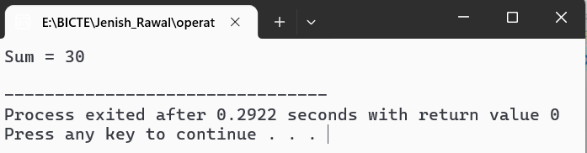

Write a C++ program to demonstrate relational operator overloading.

Source Code
#include <iostream>
using namespace std;

class Number{
private:
int value;
public:
Number(int v){
value = v;
}
// Overloading > operator
bool operator > (const Number& n) {
return value > n.value;
}
};
int main(){
Number n1(50);
Number n2(30);

if(n1 > n2)
cout <<"n1 is greater than n2.";
else
cout <<"n1 is not greater than n2.";

return 0;
}

Output
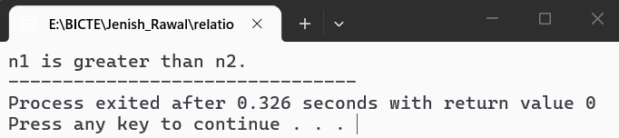

Write a C++ program to demonstrate unary operator overloading.

Source Code
#include <iostream>
using namespace std;

class Number {
private:
int value;
public:
Number(int v){
value = v;
}
// Overloading unary -- operator
void operator --(){
value = --value;
}
void display(){
cout <<"value = " << value <<endl;
}
};

int main(){
Number n(10);
--n;
cout << "Before applying unary --(n-1) operator: "<<endl;
n.display();

return 0;
}

Output
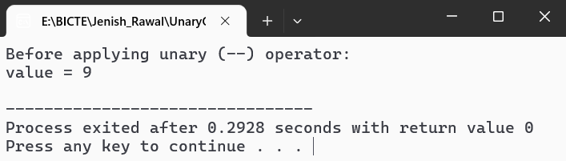

Write a C++ program to demonstrate the use of namespaces.

Source Code
#include <iostream>
using namespace std;

//First namespace
namespace First {
void display(){
cout << "This is First namespace." <<endl;
}
}
// Second namespace
namespace Second {
void display(){
cout << "This is Second namespace." <<endl;
}
}
int main(){
First::display();
Second::display();

return 0;
}

Output
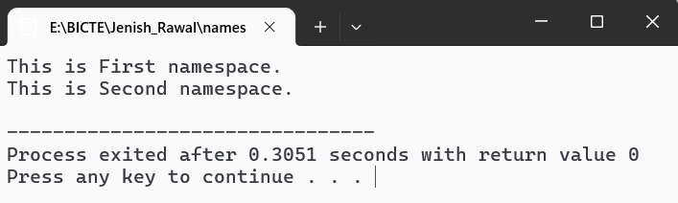

Write a C++ program to perform addition using a function template.

Source Code
#include <iostream>
using namespace std;

// Function template
template <class T>
T add(T a, T b){
return a + b;
}

int main(){
int a, b;
float x, y;

cout <<"Enter two integer: ";
cin >> a >> b;
cout <<"Sum = " << add(a, b) << endl;

cout <<"Enter two decimal numbers: ";
cin >> x >> y;
cout << "Sum = " << add(x,y) << endl;

return 0;
}

Output
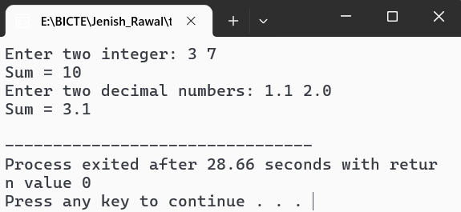

Write a C++ program to find the maximum of two values using a function template.

Source Code
#include <iostream>
using namespace std;

// Function template
template <class T>
T maximum(T a, T b) {
if (a > b)
return a;
else
return b;
}

int main() {
int a, b;
float x, y;

cout << "Enter two integers: ";
cin >> a >> b;
cout << "Maximum = " << maximum(a, b) << endl;

cout << "Enter two decimal numbers: ";
cin >> x >> y;
cout << "Maximum = " << maximum(x, y) << endl;

return 0;
}

Output
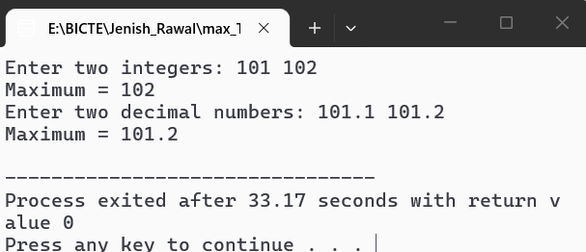

Write a C++ program to open a file in read mode and display its contents.

Source Code
#include <iostream>
#include <fstream>
using namespace std;

int main(){
ifstream file;
string line;

// Open file in read mode
file.open("data.txt");

// Check if file opend successfully
if(!file){
cout << "Unable to open file." << endl;
return 1;
}

// Read and display file contents
while (getline(file, line)){
cout << line << endl;
}

// Close the file
file.close();

return 0;
}

Output
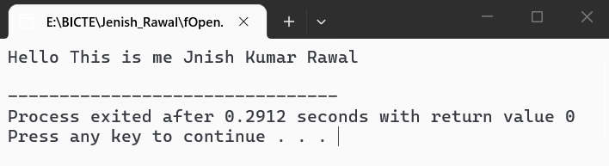

Write a C++ program to open a file in write mode and write data into it.

Source Code
#include <iostream>
#include <fstream>
using namespace std;

int main(){
ofstream file;

// Open file in write mode
file.open("data.txt");

// Check if file opened successfully
if(!file){
cout << "Unable to open file." << endl;
return 1;
}

// Write data into the file
file <<"Name: Jenish" << endl;
file << "Course: BICTE" << endl;
file << "Semester: Second" << endl;

// Close the file
file.close();

cout << "Data written successfully.";

return 0;
}

Output
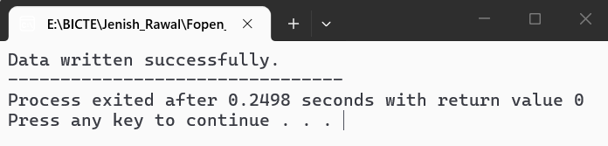

Write a C++ program to demonstrate random access file handling and explain how it differs from sequential access.

Source Code
#include <iostream>
#include <fstream>
using namespace std;

int main(){
fstream file;

// Open file for reading and writing
file.open("data.txt", ios::in | ios::out | ios::trunc);

if(!file){
cout <<"Unable to open file." << endl;
return 1;
}

// Write data into the file
file << "MAHENDRA_RATNA_CAMPUS";

// Move read pointer to position 5
file.seekg(5);

char ch;
file.get(ch);

cout <<"Character at position 5 = " << ch << endl;

// Close the file
file.close();

return 0;
}

Output
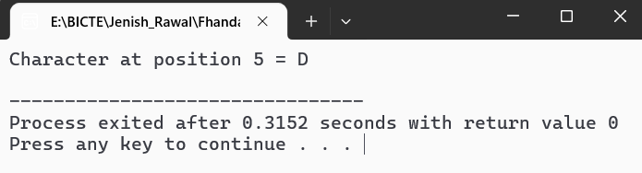

Write a C++ program to demonstrate exception handling using try, throw, and catch.

Source Code
#include <iostream>
using namespace std;

int main(){
int a, b;

cout << "Enter two number: ";
cin >> a >> b;

try{
if(b == 0){
throw "Division by zero is not allowed.";
}
cout << "Result = " << a / b << endl;
}
catch (const char* message){
cout << "Exception: " << message << endl;
}

return 0;
}

Output
