FINAL REPORT
ON
VISUAL PROGRAMMING WITH C#
By
RAM SEWAK RAUT
Exam Roll No:7829012
TU Regd:3-1-6-136 -2011

Submitted to:
PIYUSH PANT
Mahendra Ratna Campus
In partial fulfillment of the requirements for the Visual programming with C#
Tahachal, Kathmandu
19th Dec 2025

Final Report: Visual Programming with C#

Table of Contents
Introduction
Chapter One: Basic Programming Concepts
Chapter Two: Strings and Lambda Expressions
Chapter Three: LINQ Queries
Chapter Four: Database and ADO.NET
Final Project: CRUD Application with Login
Conclusion

Introduction
The field of software development demands a strong foundation in programming logic, language syntax, and application architecture. The C# programming language, developed by Microsoft, stands as a powerful, versatile, and modern tool for building a wide array of applications, from simple console utilities to complex, enterprise-level systems. This report is submitted in fulfilment of the final assignment requirements for the Visual Programming with C# course.
The primary objective of this document is to systematically present the solutions to a series of programming challenges and a final project, as outlined in the course materials [1]. The structure of this report mirrors the provided assignment, which is divided into four distinct chapters, each focusing on a specific area of C# programming, followed by a capstone project. The chapters cover:
- Basic Programming Concepts: Algorithmic problem-solving involving numbers, arrays, and strings.
- Strings and Lambda Expressions: Advanced string manipulation and the introduction of functional programming concepts with lambda expressions.
- LINQ Queries: Data querying and manipulation using the powerful Language-Integrated Query framework.
- Database and ADO.NET: Interaction with a SQL database, including table creation, stored procedures, and data access using ADO.NET.
The report culminates with a detailed overview of a final project—an Employee Management System. This project integrates the skills learned throughout the course into a practical application featuring user authentication and full CRUD functionality. As per the instructions [1], each problem is documented with the question, a complete code snippet, and a sample of the program's output, providing a clear and thorough record of the work completed.

Chapter One: Basic Programming Concepts
This chapter addresses fundamental programming problems designed to build a strong foundation in C# syntax, control structures, and basic algorithms.

1.1 Swap Two Numbers (Using a Third Variable)
Write a C# program to swap two numbers using a third variable.

Code Snippet:
using System;
public class Swapper
{
public static void Main(string[] args)
{
int a = 5, b = 10;
Console.WriteLine("Before swap: a = {a}, b = {b}");
int temp = a;
a = b;
b = temp;
Console.WriteLine("After swap: a = {a}, b = {b}");
}
}

Output:
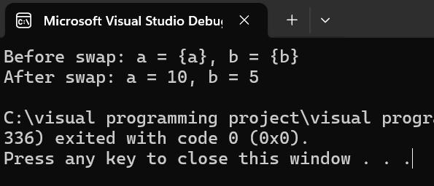

1.2 Swap Two Numbers (Without a Third Variable)
Write a C# program to swap two numbers without using a third variable.

Code Snippet:
using System;
public class SwapperNoTemp
{
public static void Main(string[] args)
{
int a = 15, b = 20;
Console.WriteLine($"Before swap: a = {a}, b = {b}");
a = a + b; // a = 35
b = a - b; // b = 35 - 20 = 15
a = a - b; // a = 35 - 15 = 20
Console.WriteLine("After swap: a = {a}, b = {b}");
}
}

Output:
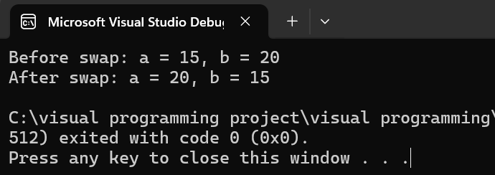

1.3 Prime Number Check
Write a C# program to input a number from the user and check if it is a prime number.

Code Snippet:
using System;
public class PrimeChecker
{
public static void Main(string[] args)
{
Console.Write("Enter a number: ");
int n = Convert.ToInt32(Console.ReadLine());
bool isPrime = true;
if (n <= 1) isPrime = false;
for (int i = 2; i <= Math.Sqrt(n); i++)
{
if (n % i == 0)
{
isPrime = false;
break;
}
}
if (isPrime)
Console.WriteLine("{n} is a prime number.");
else
Console.WriteLine("{n} is not a prime number.");
}
}

Output (Example):
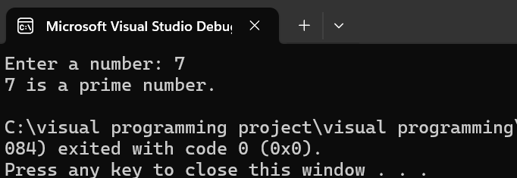

1.4 Palindrome Number Check
Write a C# program that checks whether a number is a palindrome.

Code Snippet:
using System;
public class PalindromeChecker
{
public static void Main(string[] args)
{
Console.Write("Enter a number: ");
int number = Convert.ToInt32(Console.ReadLine());
int originalNumber = number;
int reversedNumber = 0;
while (number > 0)
{
int remainder = number % 10;
reversedNumber = (reversedNumber * 10) + remainder;
number = number / 10;
}
if (originalNumber == reversedNumber)
Console.WriteLine("{originalNumber} is a palindrome.");
else
Console.WriteLine("{originalNumber} is not a palindrome.");
}
}

Output (Example):
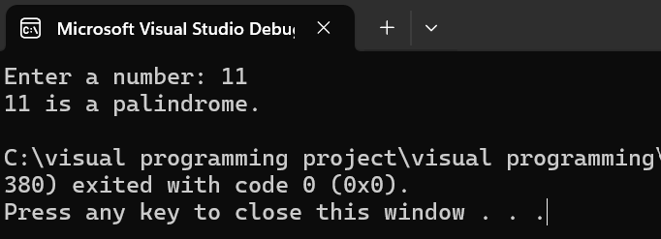

1.5 Reverse a Number
Write a C# program to reverse a number entered from the console.

Code Snippet:
using System;
public class NumberReverser
{
public static void Main(string[] args)
{
Console.Write("Enter a number to reverse: ");
int number = Convert.ToInt32(Console.ReadLine());
int reversedNumber = 0;
while (number != 0)
{
int remainder = number % 10;
reversedNumber = reversedNumber * 10 + remainder;
number /= 10;
}
Console.WriteLine($"Reversed number: {reversedNumber}");
}
}

Output (Example):

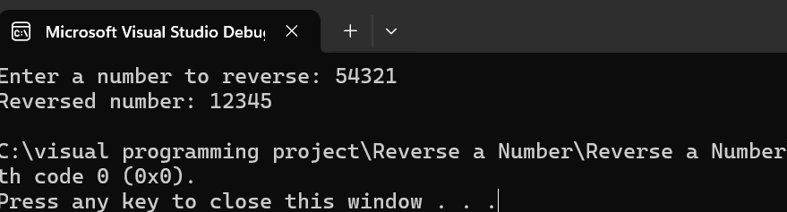

1.6 Armstrong Number Check
Write a C# program to check whether a number is an Armstrong number.

Code Snippet:
using System;
public class ArmstrongChecker
{
public static void Main(string[] args)
{
Console.Write("Enter a number: ");
int number = Convert.ToInt32(Console.ReadLine());
int originalNumber = number;
int sum = 0;
int n = number.ToString().Length;
while (number > 0)
{
int digit = number % 10;
sum += (int)Math.Pow(digit, n);
number /= 10;
}
if (sum == originalNumber)
Console.WriteLine($"{originalNumber} is an Armstrong number.");
else
Console.WriteLine($"{originalNumber} is not an Armstrong number.");
}
}

Output (Example):
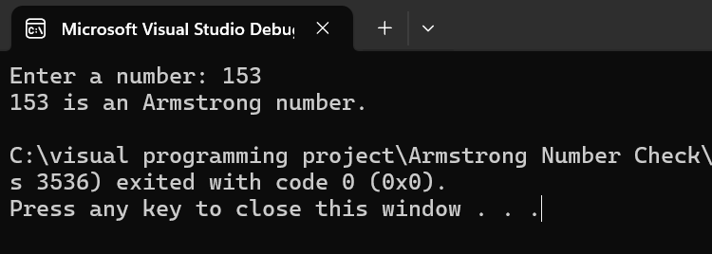

1.7 Fahrenheit to Celsius Conversion
Write a C# program to convert temperature from Fahrenheit to Celsius.

Code Snippet:
using System;
public class TempConverter
{
public static void Main(string[] args)
{
Console.Write("Enter temperature in Fahrenheit: ");
double fahrenheit = Convert.ToDouble(Console.ReadLine());
double celsius = (fahrenheit - 32) * 5 / 9;
Console.WriteLine($"Temperature in Celsius is: {celsius:F2}");
}
}

Output (Example):
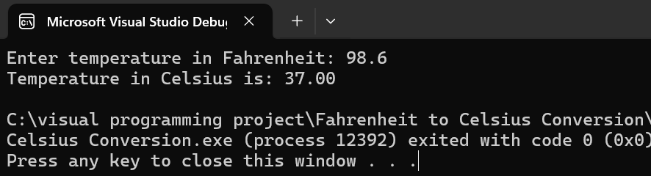

1.8 Fibonacci Series (Recursion)
Write a C# program to print the first N numbers of the Fibonacci series using recursion.

Code Snippet:
using System;
public class FibonacciRecursive
{
public static int Fibonacci(int n)
{
if (n <= 1)
return n;
return Fibonacci(n - 1) + Fibonacci(n - 2);
}
public static void Main(string[] args)
{
Console.Write("Enter the number of Fibonacci terms to print: ");
int count = Convert.ToInt32(Console.ReadLine());
Console.WriteLine("Fibonacci Series:");
for (int i = 0; i < count; i++)
{
Console.Write(Fibonacci(i) + " ");
}
}
}

Output (Example):

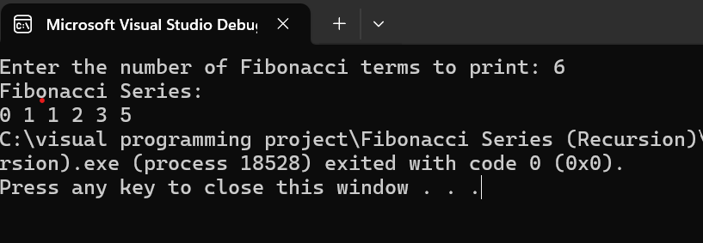

1.9 Second Largest Number in an Array
Write a C# program to find the second largest number in an array.

Code Snippet:
using System;
using System.Linq;
public class SecondLargest
{
public static void Main(string[] args)
{
int[] numbers = { 10, 5, 8, 20, 15, 12 };
if (numbers.Length < 2)
{
Console.WriteLine("Array must contain at least two elements.");
return;
}
int largest = int.MinValue;
int secondLargest = int.MinValue;
foreach (int number in numbers)
{
if (number > largest)
{
secondLargest = largest;
largest = number;
}
else if (number > secondLargest && number != largest)
{
secondLargest = number;
}
}
Console.WriteLine($"The second largest number is: {secondLargest}");
}
}

Output:

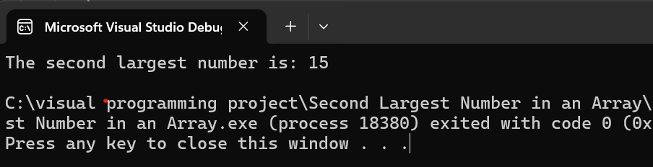

1.10 Count Vowels in a String
Write a C# program to count the number of vowels (a, e, i, o, u) in a given string.

Code Snippet:
using System;
public class VowelCounter
{
public static void Main(string[] args)
{
Console.Write("Enter a string: ");
string input = Console.ReadLine().ToLower();
int vowelCount = 0;
foreach (char c in input)
{
if ("aeiou".Contains(c))
{
vowelCount++;
}
}
Console.WriteLine($"Number of vowels: {vowelCount}");
}
}

Output (Example):
Enter a string: Hello World
Number of vowels: 3

1.11 Find Missing Number in an Array
Write a C# program to find the missing number in an array of integers from 1 to N.

Code Snippet:
using System;
public class MissingNumberFinder
{
public static void Main(string[] args)
{
int[] arr = { 1, 2, 4, 5, 6 }; // Array from 1 to 6 with 3 missing
int n = arr.Length + 1; // Expected length
int totalSum = n * (n + 1) / 2;
int arraySum = 0;
foreach (int num in arr)
{
arraySum += num;
}
int missingNumber = totalSum - arraySum;
Console.WriteLine($"The missing number is: {missingNumber}");
}
}

Output:

