Microsoft SQL Server configuration in brief

System configuration

Host: KKAD
Private IP Address: 192.100.100.185 (Dynamic IP)
Operating System Version: Window server 2012 Standard
Microsoft SQL Server: MS SQL Server 2016 Develop
Visual studio: Visual studio 2015 community

MS SQL Server configuration
Server name : KKAD\DEV
Instance name: DEV
Product: Microsoft SQL Server Developer (64-bit)
SQL Server Version 13.0.4001.0
Authentication: SQL Server Authentication
System Administrator (SA) account: sa / sql@r00t
User account: mssql / mssql@2017
Root Directory C:\Program Files\Microsoft SQL Server\MSSQL13.DEV\MSSQL
Window Service: SQL Server (DEV)
Operating System (OS) account: KKGROUP\mssql / sql@r00t

SSH Server (SFTP) configuration
Product: Cygwin and OpenSSH (64-bit)
SFTP administrator account: administrator / kkwelcomeit@2017
SFTP user account: sftpuser / sftp@2017
Port: 22
Root directory : C:\cygwin64
Home directory : C:\cygwin64\home
Window Service: CYGWIN sshd
Operating System (OS) account: KKGROUP\sftpuser / sftp@2017

Microsoft SQL Server version:
Microsoft SQL Server 2016 (SP1) (KB3182545) - 13.0.4001.0 (X64) Oct 28 2016 18:17:30 Copyright (c) Microsoft Corporation Developer Edition (64-bit) on Windows Server 2012 Standard 6.2 <X64> (Build 9200: ) (Hypervisor)
Visual studio version:
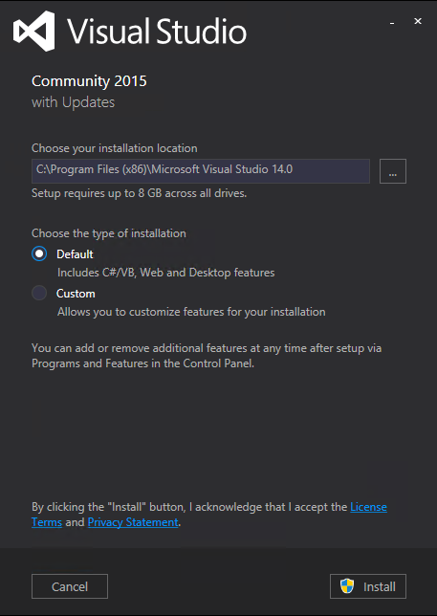
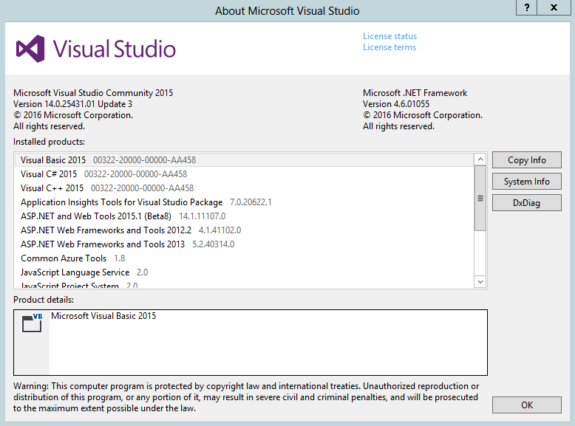
Cygwin (SSH) version:


