BIOL 2321L General Genetics Lab
Section - 2 (6pm – 8:50pm)
November 20, 2018
X-Linked Inheritance in Drosophila melanogaster
Evan Munro

Introduction:
The species used for study in this experiment is Drosophila melanogaster, which is commonly known as the fruit fly. These flies are great test subjects for many reasons. Drosophila melanogaster individuals are very small and have simple diets, so it is easy to keep large numbers of them in a laboratory. Fruit flies also reproduce relatively quickly, which is useful for genetic research because multiple generations of flies can be studied in a matter of weeks. Drosophila melanogaster have been studied by geneticists for over 100 years, so there is a plethora of information available for testing and understanding genetic principles (University of Arkansas 32). Another trait of fruit flies that makes them good for research is the fact that the males and females have morphological differences. These morphological differences make manipulation of mating groups much easier. Male flies are smaller than females, have darker abdomens, and have sex combs on their forelegs while females do not (University of Arkansas 32). The morphological differences can be viewed in Figure 1 below.

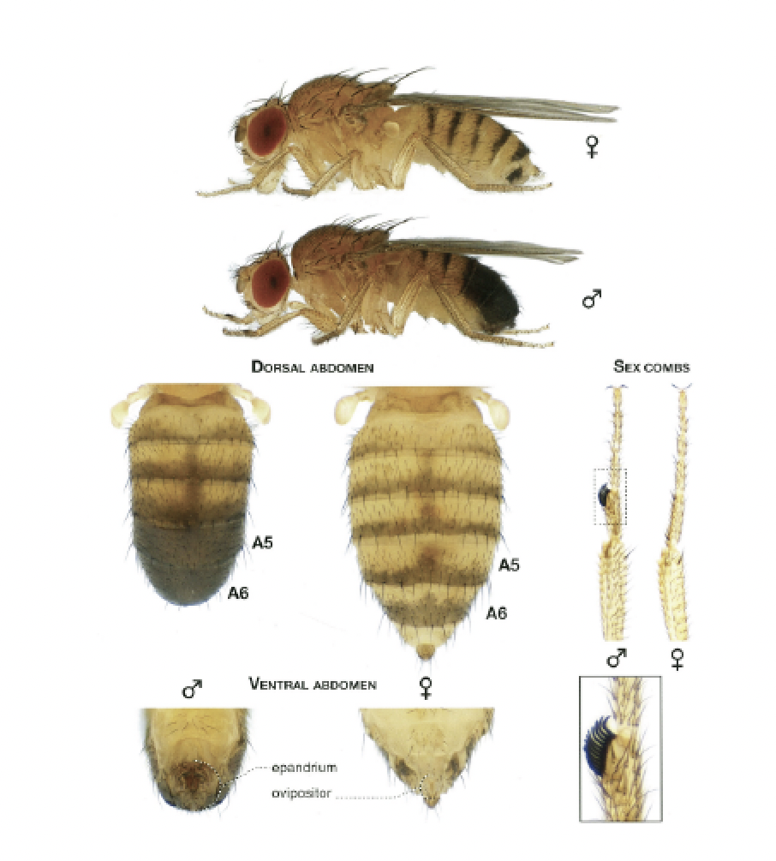
Figure 1. Morphological differences between male and female Drosophila melanogaster (University of Arkansas 33).

The chromosomal composition of flies is similar to that of humans, but they differ in a few ways. Humans possess 22 pairs of autosomes and 1 pair of sex chromosomes, while Drosophila melanogaster possess 3 pairs of autosomes and 1 pair of sex chromosomes. Both humans and fruit flies have X and Y sex chromosomes, but the presence of a Y chromosome in a fruit fly individual does not determine maleness like the presence of a Y chromosome does in a human individual. For fruit flies, sex is determined by the ratio of X chromosomes to sets of autosomes (Arnini). Normal flies have two sets of autosomes, so if a fly has two X chromosomes then it has a ratio of 1:1, and it is a female. If a fly has one X chromosome and one Y chromosome then it has a ratio of 1:2, and it is a male. Even if an individual has XXY sex chromosomes it is still a female because it has a 1:1 ratio of X chromosomes to sets of autosomes (Arnini).
The life span of Drosophila melanogaster is dependent on the environment, and since they are kept at room temperature and in crowded vials for studying, they live about 12-15 days (Arnini). Their life cycle consists of progressing from egg→larva→pupa→adult. The larvae hatch from fertilized eggs one day after being laid, then the larvae eat and grow for four days (Arnini). At the end of the larval stage the larvae crawl up the sides of their container in preparation for the pupal stage. Once in the pupal stage metamorphosis occurs over 4-6 days until the adult flies emerge from the pupal case (Arnini). After eclosure from the pupal case, female flies remain virgins for only 8-10 hours (Geiger). The virginity of female flies is relevant in this experiment because females have the ability to store sperm from any mating encounter, so using virgin flies in a new cross is necessary in order to be certain of the parental male genotype (Geiger). Virgin flies will be used for the first parental cross in this experiment, but the second cross in the experiment will not require virgins because the experimental setup results in the first filial generation of flies being exposed from birth to only members of the opposing sex that already have the intended genotype.
To study X-linked inheritance in this experiment, the white gene, which is located on X chromosomes of flies, is studied. As stated on page 33 of the University of Arkansas General Genetics Laboratory Manual, “In Drosophila genetics, genes are usually named after the phenotype of flies that carry the mutant allele of the gene.” That is why the white gene refers to the mutant allele that produces white eyes in flies. White eye color is the result of expression of the recessive allele, and it is denoted with (w-). Red eye color is the result of expression of the dominant allele, and it is denoted with (w+). There are three generations of flies that are studied in this experiment, and they are the P generation, the F1 generation, and the F2 generation. The P generation is the parent generation that consists of pure-bred homozygous or hemizygous flies. F1 stands for the first filial generation, which is the offspring of the parental cross. F2 stands for the second filial generation, which is the offspring of the F1 cross. Genotypes for the flies will use nomenclature consisting of a fly’s sex chromosomes in capital letters and the allele of the white gene found on the corresponding sex chromosome in superscript. For example, X^{w-}Y denotes a white-eyed male fly that has one X chromosome with the recessive allele of the white gene and one Y chromosome that does not carry the white gene.

Materials and Methods:
The experiment that was performed required the following items.
- 5 Virgin female flies (X^{w+}X^{w+}) for Cross A
- 5 Male flies (X^{w-}Y) for Cross A
- 5 Virgin female flies (X^{w-}X^{w-}) for Cross B
- 5 Male flies (X^{w+}Y) for Cross B
- Brushes
- Food vials (food ingredients: dry yeast, cornmeal, agar, malt, corn syrup, tegospept, propionic acid, and water)
- Dissecting microscopes
- FlyNap (consisting of: 50% triethylamine, fragrances, 22.63% ethanol, 1.25% 2-propanol, and 1.13% methanol)
The goal of week one was to set up the appropriate crosses with the P generation. Four vials containing the four fly genotypes were gathered from the lab TA. The vials filled with flies were combined to achieve the desired crosses. The two desired crosses were labeled “Cross A, P” and Cross B, P.” Cross A was formed by crossing the red-eyed female flies possessing the X^{w+}X^{w+} genotype with the white-eyed male flies possessing the X^{w-}Y genotype. Cross B was formed by crossing the white-eyed female flies possessing the X^{w-}X^{w-} genotype with the red-eyed male flies possessing the X^{w+}Y genotype. After one week the P generation flies were removed from the vials and dumped into the fly morgue. The goal of the third week was to count the F1 generation and select six males and six females from the same cross to produce the F2 generation. Placing the small brush dipped in FlyNap into the vials caused the flies to be anesthetized. Effective anesthetization was determined by a lack of movement from the flies. Once anesthetized, the number of red-eyed and white-eyed males and females were counted with a dissecting microscope and recorded. Six F1 males and females from Cross A were placed in a new food vial labeled “Cross A, F1”, and six F1 males and females from Cross B were placed in a different new food vial labeled “Cross B, F1.” The remaining flies were discarded. A week after creating the F1 crosses, the F1 generation flies from removed from the vials and discarded into the fly morgue. During the fifth week the numbers of red-eyed and white-eyed males and females of the F2 generation of crosses A and B were counted and recorded using the same method as in week three. Once finished with counting flies, the flies were discarded into the fly morgue. Finally, a statistical analysis was performed on the results.
These specific crosses were carried out because they ought to produce specific phenotypic ratios of progeny in the F2 generation that help to verify or challenge the principles of X-linked inheritance. It is necessary to carry out the experiment to the F2 generation because the recessive white allele will not show in the F1 generation. The expected phenotypic ratios for each generation can be deduced from the Punnett squares found below in Tables 1 and 2. The statistical analysis performed in this experiment was a chi-squared test, which is also referenced as a χ² test. The χ² test provides a method to accept or reject a statistical null hypothesis based on the principles of X-linked inheritance. Such a test assesses the probability that an observed distribution of data is due to chance by comparing the observed data to the expected data. The null hypothesis is that there is no statistical difference between the observed and expected values of the distribution. For this experiment that means the null hypothesis is there is no statistical difference between the observed distribution of phenotypic rations and the expected distribution of phenotypic ratios in the F2 generation. To accept the null hypothesis would mean that our observations line up with the principles of X-linked inheritance. To reject the null hypothesis would mean that our observations to not line up with the principles of X-linked inheritance. The decision to accept or reject the null hypothesis is based on where the χ² value lies in the p-value table found below in Table 3. The degrees of freedom (df) are determined by subtracting one from the number of possible populations, or n – 1 = df. Rejecting the null hypothesis only occurs if the probability that the observed data is due to chance (p) is less than 0.05.
The purpose of this lab is to test the principles of X-linked inheritance and verify that genes reside on certain chromosomes. A chi-squared test is used to analyze results and determine whether to accept or reject the null hypothesis that the observed results are consistent with the predicted ratios of genetic inheritance in Drosophila melanogaster progeny based on the principles of X-linked inheritance.

Table 1 - Cross A Punnett squares
P | X^{w+} | X^{w+} | F1 | X^{w-} | X^{w+}
X^{w-} | X^{w-} X^{w+} | X^{w-} X^{w+} | X^{w+} | X^{w+} X^{w-} | X^{w+} X^{w+}
Y | X^{w+}Y | X^{w+}Y | Y | X^{w-}Y | X^{w+}Y

This table shows the genotypes expected in the progeny resulting from the P generation cross A on the left; therefore, the left side shows the expected genotypes of the F1 generation. It also shows the genotypes expected in the progeny resulting from the F1 generation cross A on the right; therefore, the right side shows the expected genotypes of the F2 generation.
Table 2 - Cross B Punnett squares
P | X^{w-} | X^{w-} | F1 | X^{w+} | X^{w-}
X^{w+} | X^{w+} X^{w-} | X^{w+} X^{w-} | X^{w-} | X^{w-} X^{w+} | X^{w-} X^{w-}
Y | X^{w-}Y | X^{w-}Y | Y | X^{w+}Y | X^{w-}Y

This table shows the genotypes expected in the progeny resulting from the P generation cross B on the left; therefore, the left side shows the expected genotypes of the F1 generation. It also shows the genotypes expected in the progeny resulting from the F1 generation cross B on the right; therefore, the right side shows the expected genotypes of the F2 generation.

Table 3 – p-value table (University of Arkansas General Genetics Laboratory Manual 38)
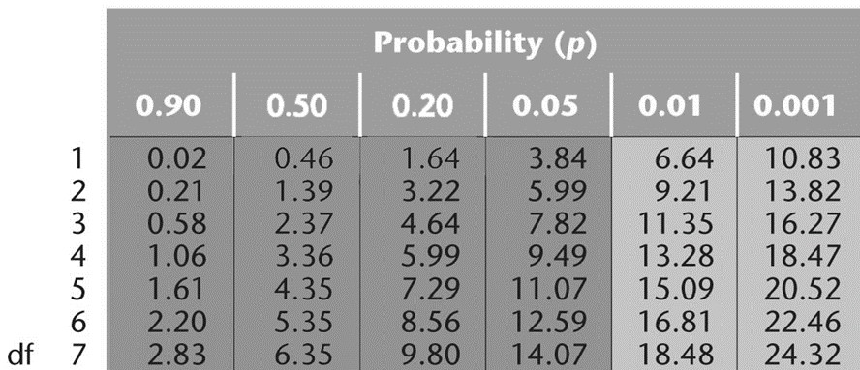

Results:

Week 3: Individual F1 Observations

Table 4 – Individual F1 progeny distribution for both crosses
 | Cross A |  |  |  | Cross B
 | F1 male, n | F1 male, % | F1 female, n | F1 female, % | F1 male, n | F1 male, % | F1 female, n | F1 female, %
Red Eyes | 25 | 40.98 | 36 | 59.01 | 0 | 0 | 18 | 51.43
White Eyes | 0 | 0 | 0 | 0 | 17 | 48.57 | 0 | 0
Total flies | 61 |  |  |  | 35

This table shows the number of red-eyed and white-eyed male and female flies that were observed by me and Shoon Wai in the third week of the experiment for both cross A and B. The flies being observed were members of the F1 generation.

Week 5: F2 Observations and Chi-Squared Tables

Table 5 – Individual F2 progeny distribution for both crosses
 | Cross A |  |  |  | Cross B
 | F2 male, n | F2 male, % | F2 female, n | F2 female, % | F2 male, n | F2 male, % | F2 female, n | F2 female, %
Red Eyes | 47 | 30.72 | 68 | 44.44 | 34 | 23.78 | 39 | 27.27
White Eyes | 38 | 24.84 | 0 | 0 | 43 | 30.07 | 27 | 18.88
Total flies | 153 |  |  |  | 143

This table shows the number of red-eyed and white-eyed male and female flies that were observed by me and Shoon Wai in the fifth week of the experiment for both cross A and B. The flies being observed were members of the F2 generation.

Table 6- Individual Cross A chi-squared test
 | Observed (O) | Expected (E) | $$O-E$$ | $${(O-E)}^{2}$$ | $$\frac{{(O-E)}^{2}}{E}$$
Red-eyed females | 68 | 76.5 | -8.5 | 72.25 | 0.94
Red-eyed males | 47 | 38.25 | 8.75 | 76.56 | 2.00
White-eyed males | 38 | 38.25 | -0.25 | 0.0625 | 0.00
df |  |  |  |  | 2
$$χ^{2}$$ |  |  |  |  | 2.94
p-value |  |  |  |  | 0.20 < p < 0.50

This table contains the chi-squared test data for our individual Cross A results. The observed column numbers came from Table 5. The expected values were calculated by multiplying the total flies in the Cross A F2 generation by 0.5 for red-eyed females and by 0.25 for the red-eyed males and white-eyed males. The χ² value was calculated by finding the sum of the $\frac{{(O-E)}^{2}}{E}$ values from the three populations of flies. The χ² value of 2.94 with two degrees of freedom fell between the columns for p = 0.20 and p = 0.50 in Table 3; therefore, 0.20 < p < 0.50 for our individual Cross A distribution.

Table 7- Individual Cross B chi-squared test
 | Observed (O) | Expected (E) | $$O-E$$ | $${(O-E)}^{2}$$ | $$\frac{{(O-E)}^{2}}{E}$$
Red-eyed females | 39 | 35.75 | 3.25 | 10.56 | 0.30
White-eyed females | 27 | 35.75 | -8.75 | 76.56 | 2.14
Red-eyed males | 34 | 35.75 | -1.75 | 3.06 | 0.09
White-eyed males | 43 | 35.75 | 7.25 | 52.56 | 1.47
df |  |  |  |  | 3
$$χ^{2}$$ |  |  |  |  | 4.00
p-value |  |  |  |  | 0.20 < p < 0.50

This table contains the chi-squared test data for our individual Cross B results. The observed column numbers came from Table 5. The expected values were calculated by multiplying the total flies in the Cross B F2 generation by 0.25 for all four populations of flies. The χ² value was calculated by finding the sum of the $\frac{{(O-E)}^{2}}{E}$ values from the four populations of flies. The χ² value of 4.00 with three degrees of freedom fell between the columns for p = 0.20 and p = 0.50 in Table 3; therefore, 0.20 < p < 0.50 for our individual Cross B distribution.

Table 8- Classroom Cross A chi-squared test
 | Observed (O) | Expected (E) | $$O-E$$ | $${(O-E)}^{2}$$ | $$\frac{{(O-E)}^{2}}{E}$$
Red-eyed females | 790 | 795 | -5 | 25 | 0.03
Red-eyed males | 418 | 397.5 | 20.5 | 420.25 | 1.06
White-eyed males | 382 | 397.5 | -15.5 | 240.25 | 0.60
df |  |  |  |  | 2
$$χ^{2}$$ |  |  |  |  | 1.69
p-value |  |  |  |  | 0.20 < p < 0.50

This table contains the chi-squared test data for classroom Cross A results. The observed column numbers came from the pooled totals of everyone in lab section 2. The expected values were calculated by multiplying the total flies in the Cross A F2 generation by 0.5 for red-eyed females and by 0.25 for the red-eyed males and white-eyed males. The χ² value was calculated by finding the sum of the $\frac{{(O-E)}^{2}}{E}$ values from the three populations of flies. The χ² value of 1.69 with two degrees of freedom fell between the columns for p = 0.20 and p = 0.50 in Table 3; therefore, 0.20 < p < 0.50 for our classroom Cross A distribution.

Table 9- Classroom Cross B chi-squared test
 | Observed (O) | Expected (E) | $$O-E$$ | $${(O-E)}^{2}$$ | $$\frac{{(O-E)}^{2}}{E}$$
Red-eyed females | 332 | 301.25 | 30.75 | 945.56 | 3.14
White-eyed females | 287 | 301.25 | -14.25 | 203.06 | 0.67
Red-eyed males | 303 | 301.25 | 1.75 | 3.06 | 0.01
White-eyed males | 283 | 301.25 | -18.25 | 333.06 | 1.11
df |  |  |  |  | 3
$$χ^{2}$$ |  |  |  |  | 4.93
p-value |  |  |  |  | 0.05 < p < 0.20

This table contains the chi-squared test data for classroom Cross B results. The observed column numbers came from the pooled totals of everyone in lab section 2. The expected values were calculated by multiplying the total flies in the Cross B F2 generation by 0.25 for all four populations of flies. The χ² value was calculated by finding the sum of the $\frac{{(O-E)}^{2}}{E}$ values from the three populations of flies. The χ² value of 4.93 with two degrees of freedom fell between the columns for p = 0.05 and p = 0.20 in Table 3; therefore, 0.05 < p < 0.20 for our classroom Cross B distribution.

Discussion:
All of the observed results from this experiment were expected and explainable. As shown in the left side of Table 1, the expected genotype percentages for the F1 generation of Cross A were 50% X^{w-}X^{w+} and 50% X^{w+}Y. As shown in the left side of Table 2, the expected genotype percentages for the F1 generation of Cross B were 50% X^{w+}X^{w-} and 50% X^{w-}Y. As shown in the right side of Table 1, the expected genotype percentages for the F2 generation of Cross A were 25% X^{w+}X^{w-}, 25% X^{w+}X^{w+}, 25% X^{w-}Y, and 25% X^{w+}Y. These genotypic percentages for the F2 generation of Cross A can also be interpreted as expected phenotypic percentages of 50% red-eyed females, 25% red-eyed males, and 25% white-eyed males. As shown in the right side of Table 2, the expected genotype percentages for the F2 generation of Cross B were 25% X^{w-}X^{w+}, 25% X^{w-}X^{w-}, 25% X^{w+}Y, and 25% X^{w-}Y. These genotypic percentages for the F2 generation of Cross B can also be interpreted as expected phenotypic percentages of 25% red-eyed females, 25% white-eyed females, 25% red-eyed males, and 25% white-eyed males. When these expected phenotypic percentages were used to calculate the expected values for the F2 populations of crosses A and B, the χ² values calculated with our individual Cross A, individual Cross B, classroom Cross A, and classroom Cross B observations all corresponded to p-values larger than 0.05 as shown in Tables 6, 7, 8, and 9. Such results from the chi-squared tests allow us to accept the null hypothesis in every case. The null hypothesis states there is no statistical difference between the observed distribution of phenotypic rations and the expected distribution of phenotypic ratios in the F2 generation, so our data does reflect X-linked inheritance of the white gene. This conclusion is based on the fact that the null hypothesis was formed on the assumption that the white gene is located on the X chromosome and exhibits X-linked characteristics of inheritance.

Bibliography:

Arnini, Christin. “Using Drosophila to Teach Genetics.” Yale-New Haven Teachers Institute, 2018, teachersinstitute.yale.edu/curriculum/units/1996/5/96.05.01.x.html.

Geiger, Pete. “An Introduction to Fruit Flies.” Drosophila Melanogaster and Mendelian Genetics, University of Washington, 11 July 2017, depts.washington.edu/cberglab/wordpress/outreach/an-introduction-to-fruit-flies/.

University of Arkansas General Genetics Laboratory Manual. 2018. Print.

