R.No : S20190020256 Name: Trisanu Bhar
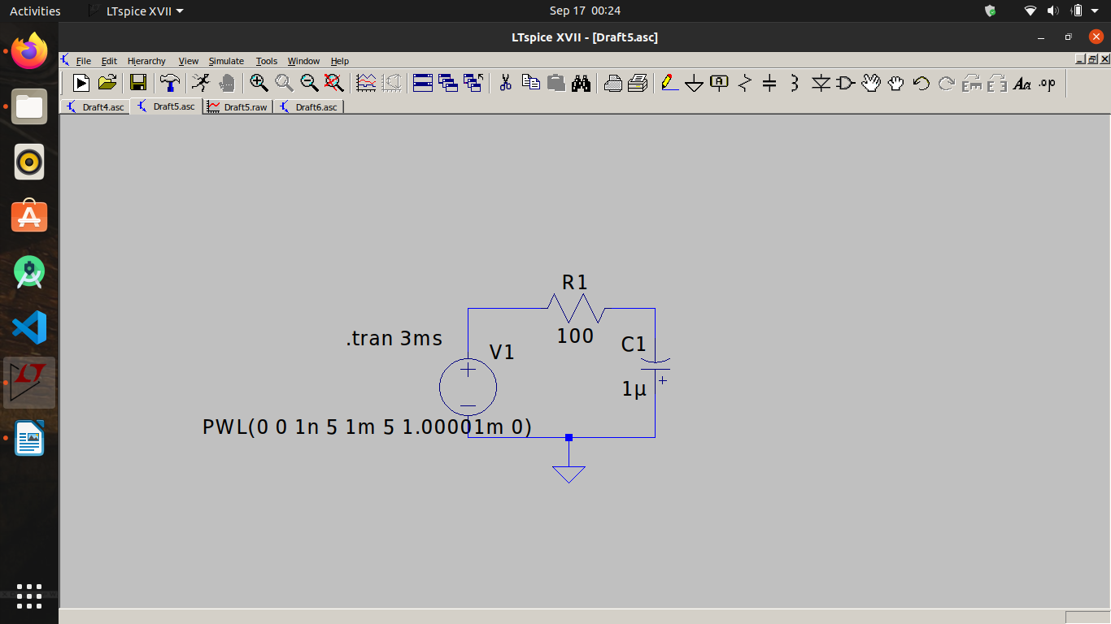
1. Series RC Circuit:-

a. Multiple pulse transient analysis
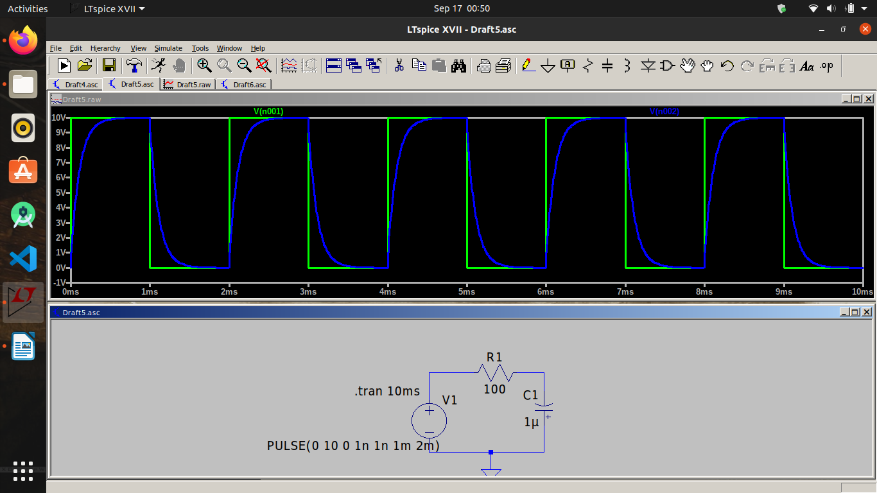

c.Single Pulse transient analysis:-

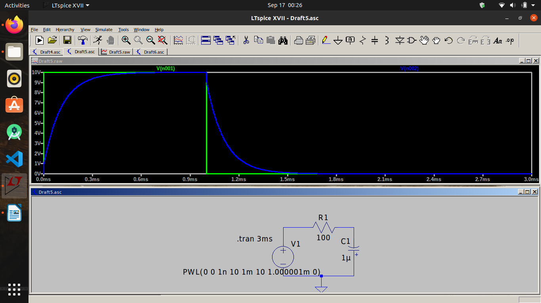
d. Operating point
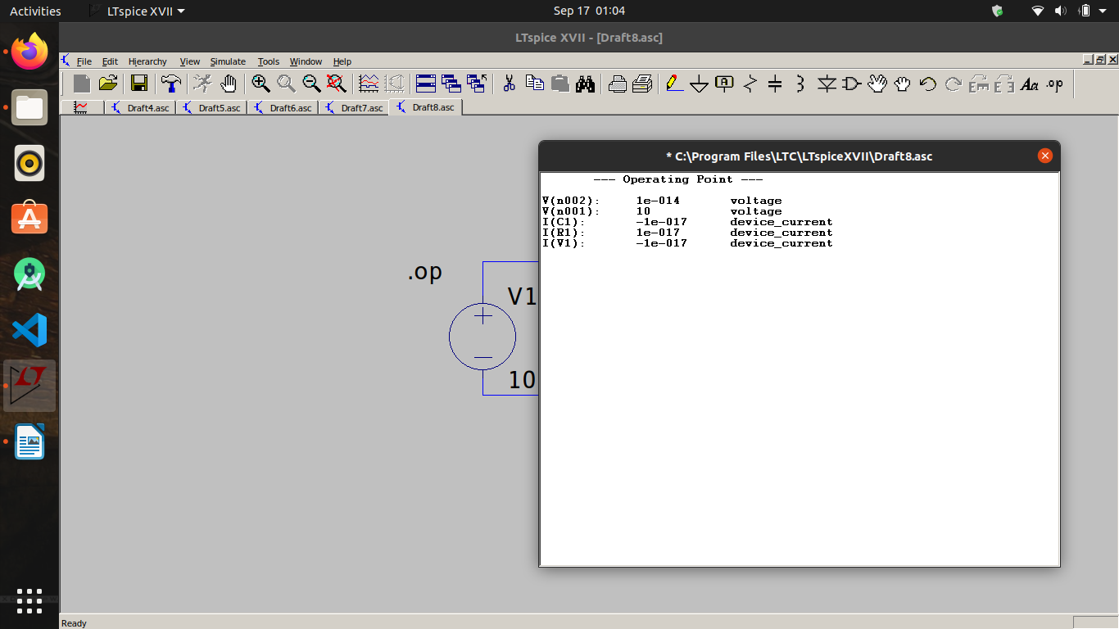

e. DC Sweep

i) Vin

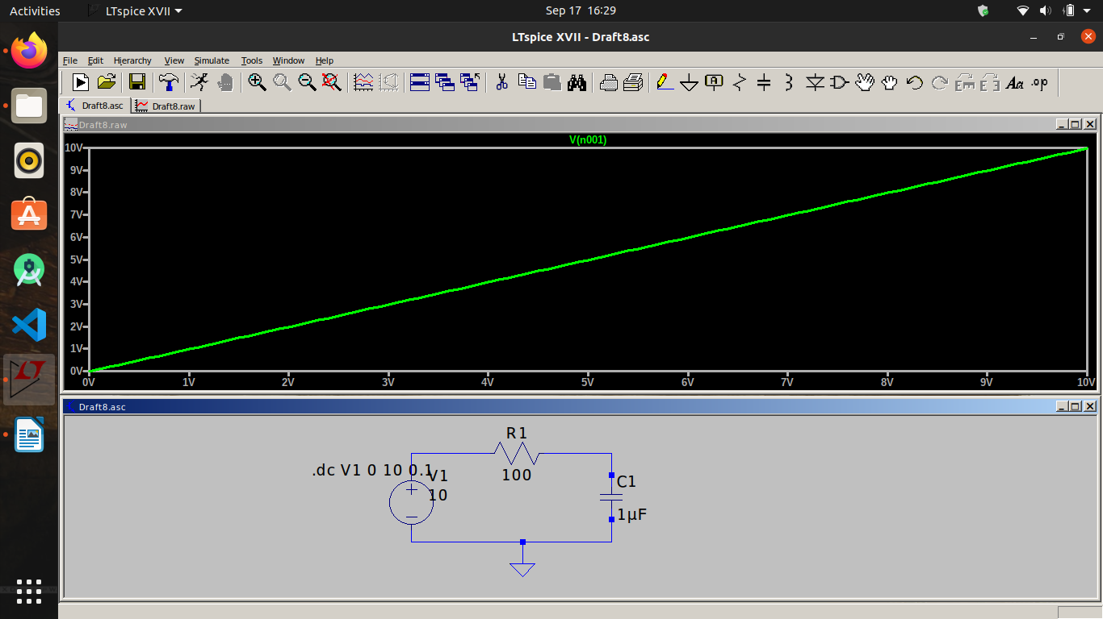
ii) Ic1

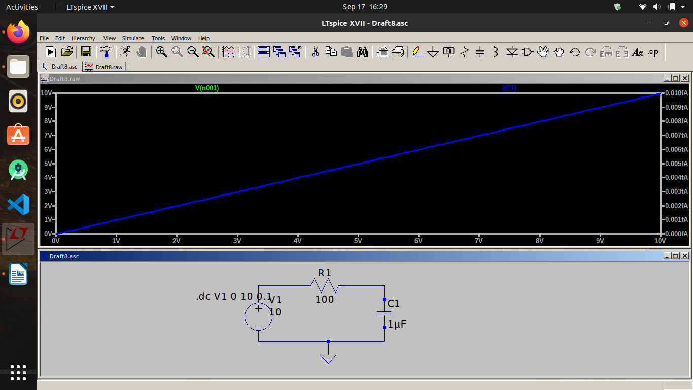

f.Sinosudal analysis

i) Between Vin and Ic

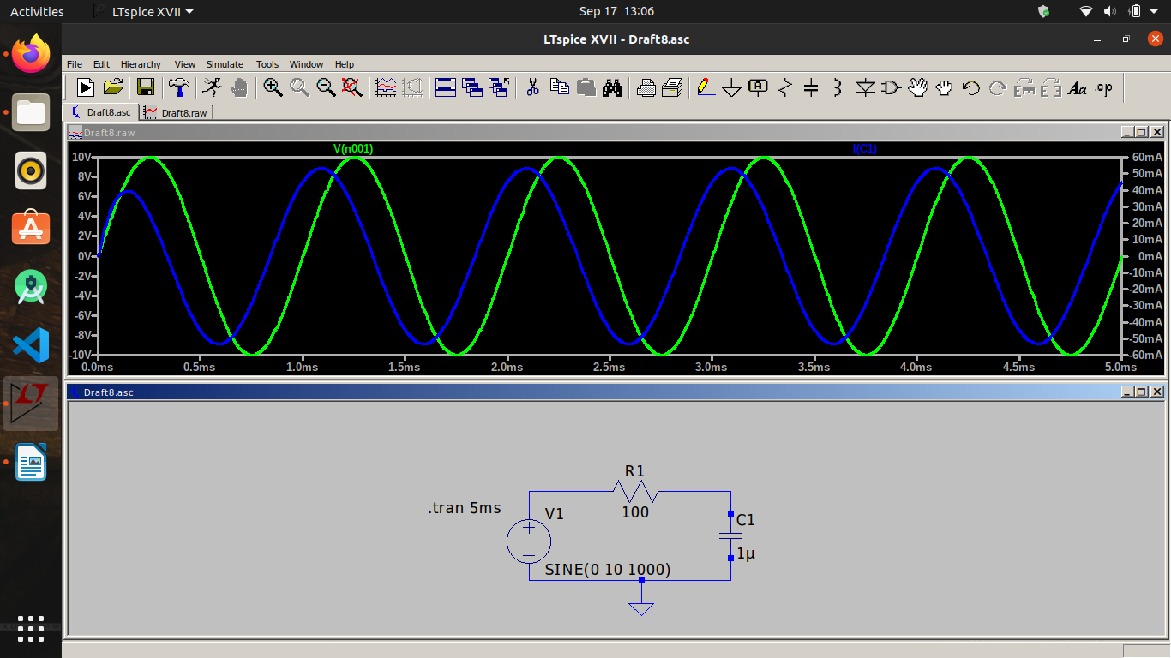
ii) Between Vin and Vc
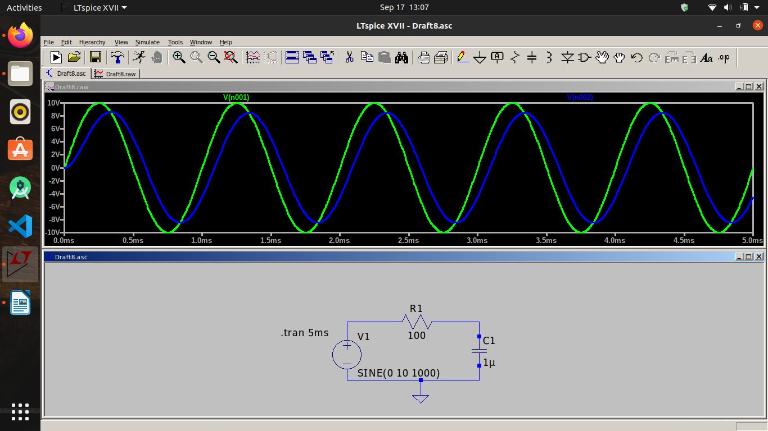

iii) Between Vc and Ic
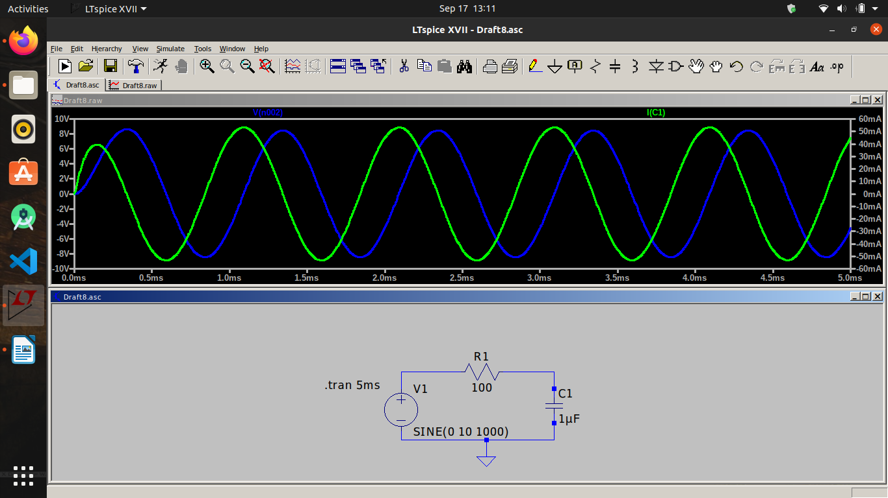
2. Parallel RC Circuit analysis:

a. Transient analysis:

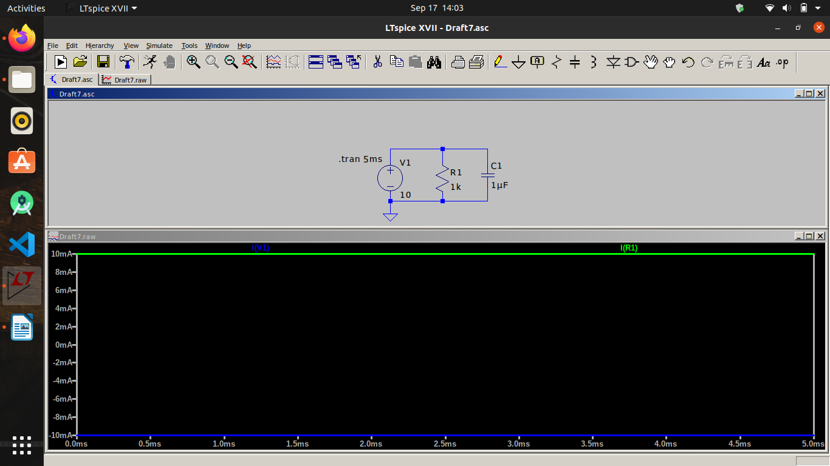
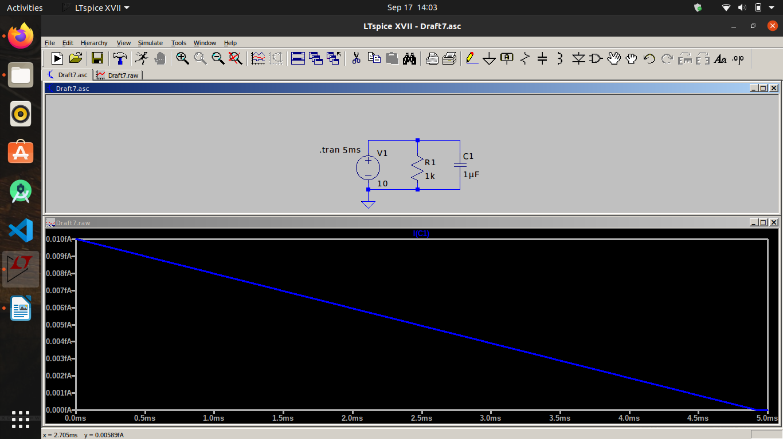
b. Operating point

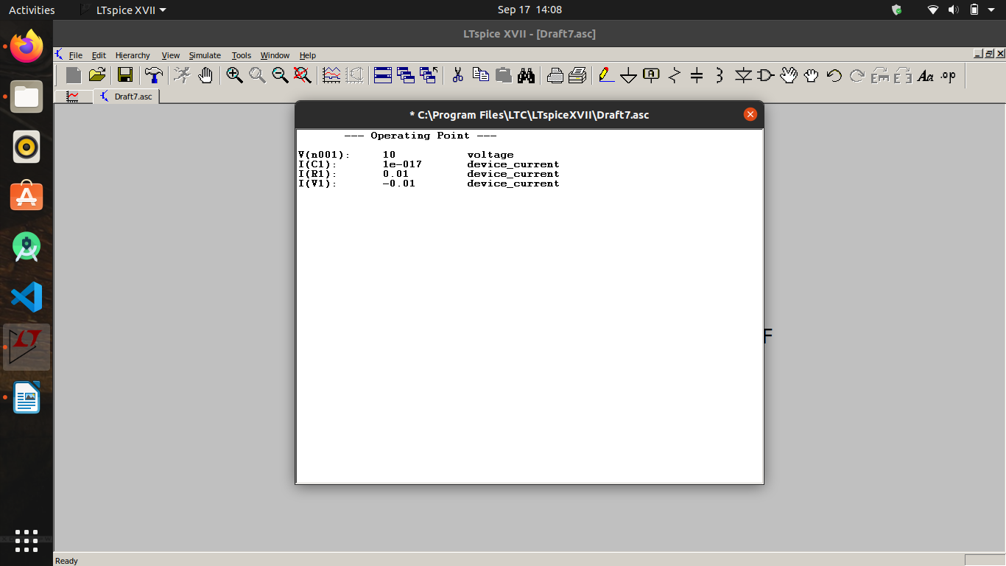

c. DC Sweep

i)Between Iv1 and Ir1
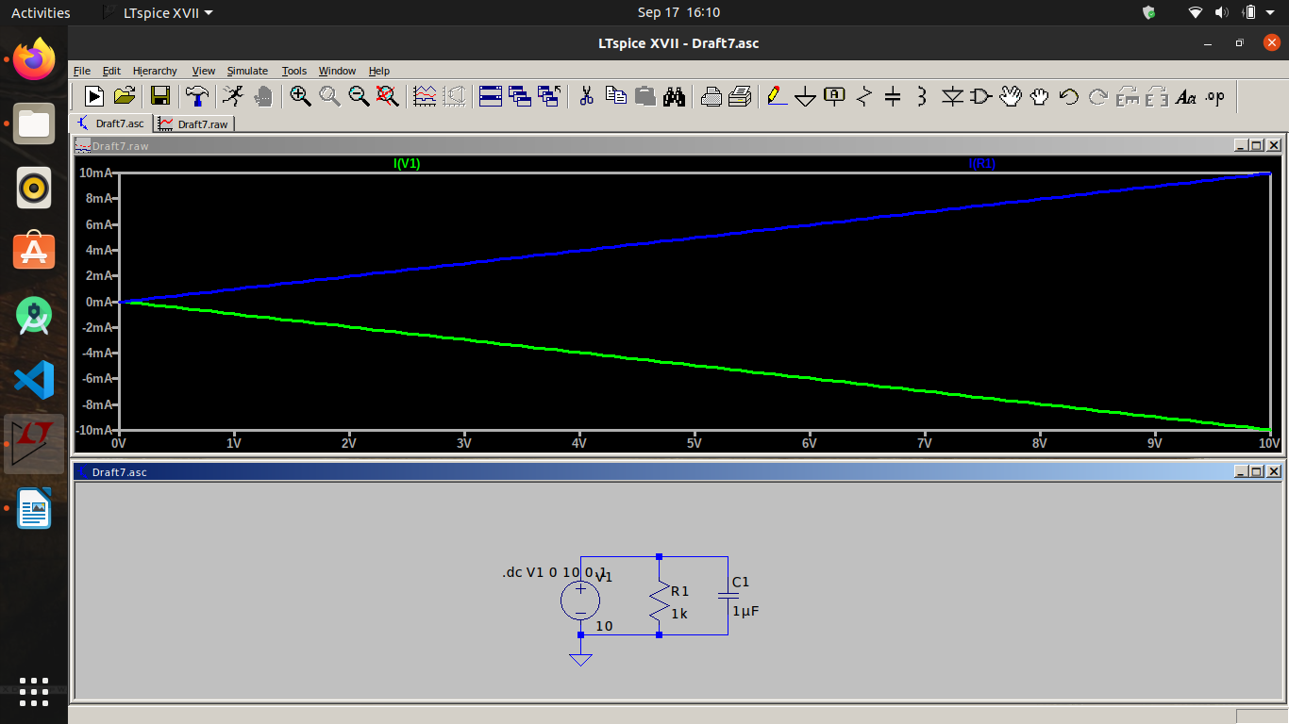
ii) Ic1

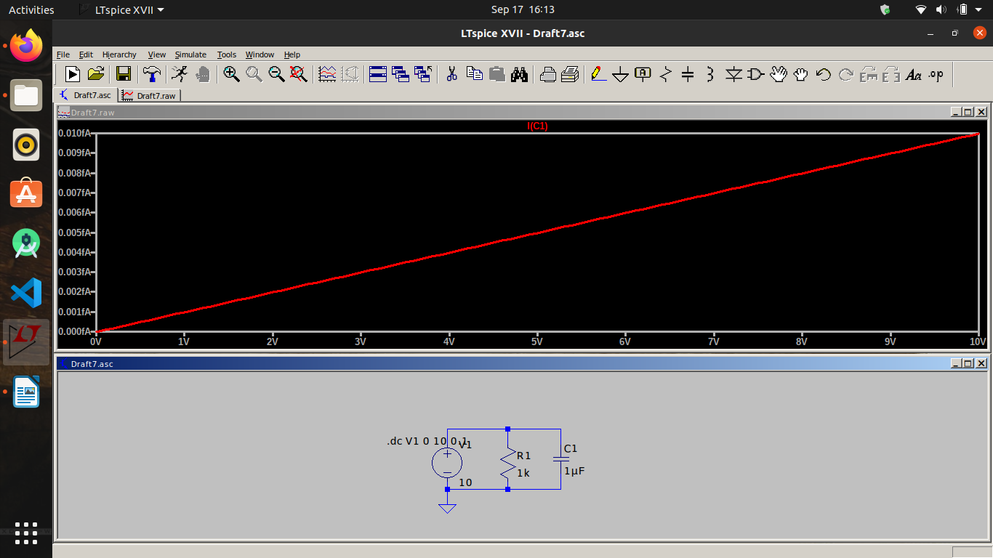

d. Sinosudal wave

i. Between Vin and Ic:
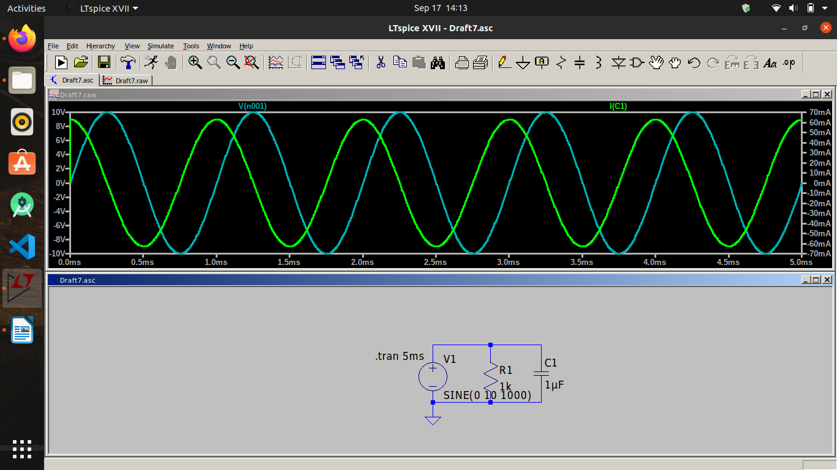
b. Between Iin and Ic and Ir:
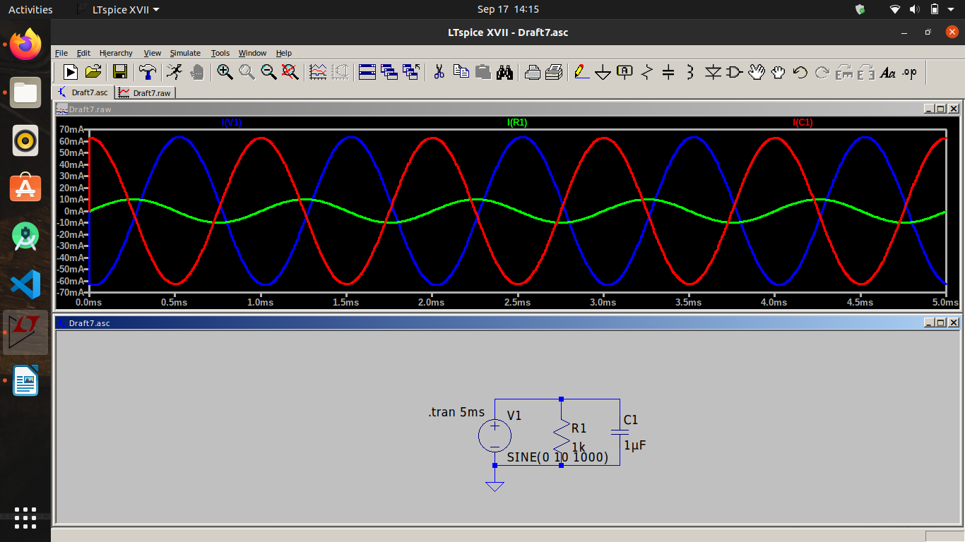

3, Using diode and capacitor:-

a, Transient analysis

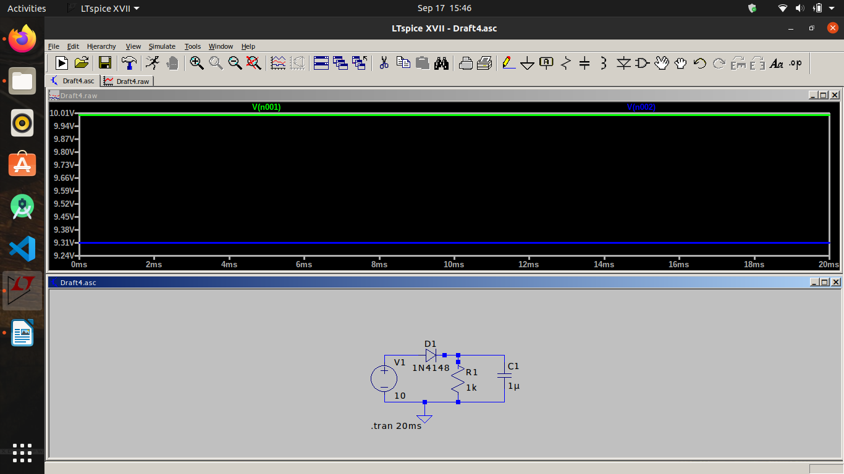

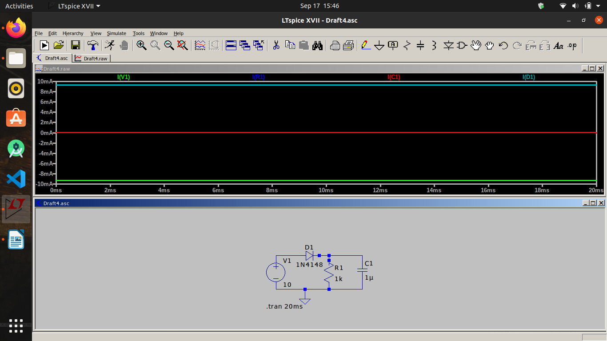

b. Operating point:-

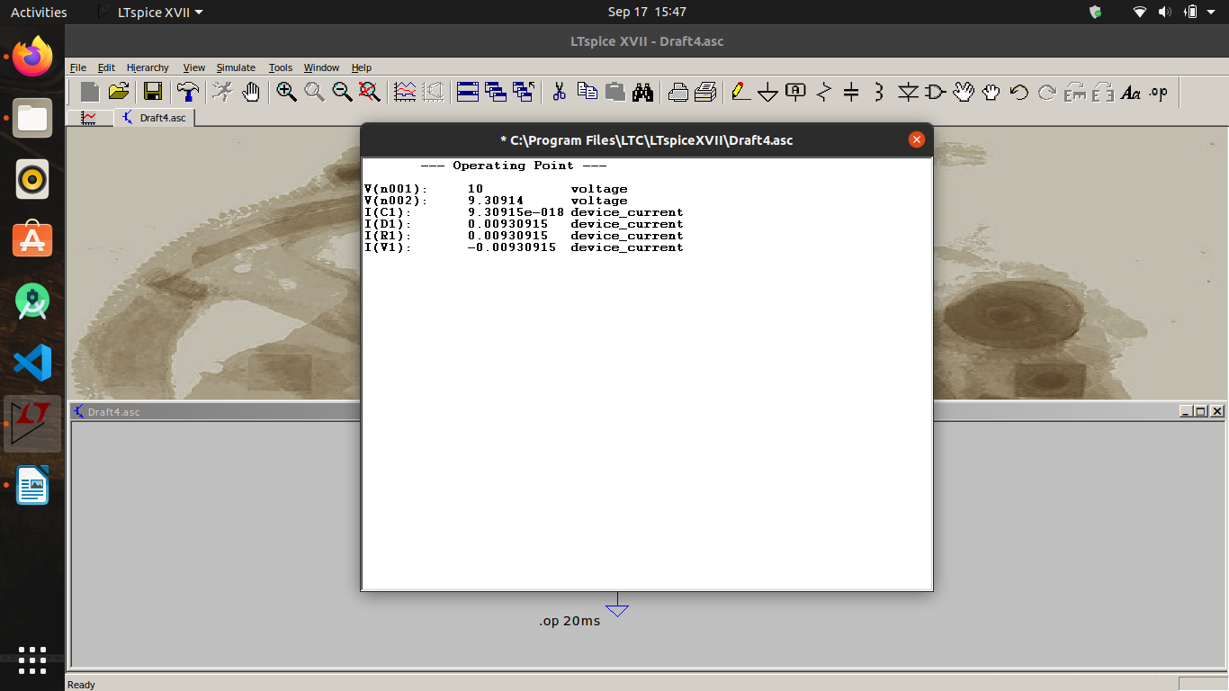
d. Sinosudal Analysis:
i) Between Vout and Vin

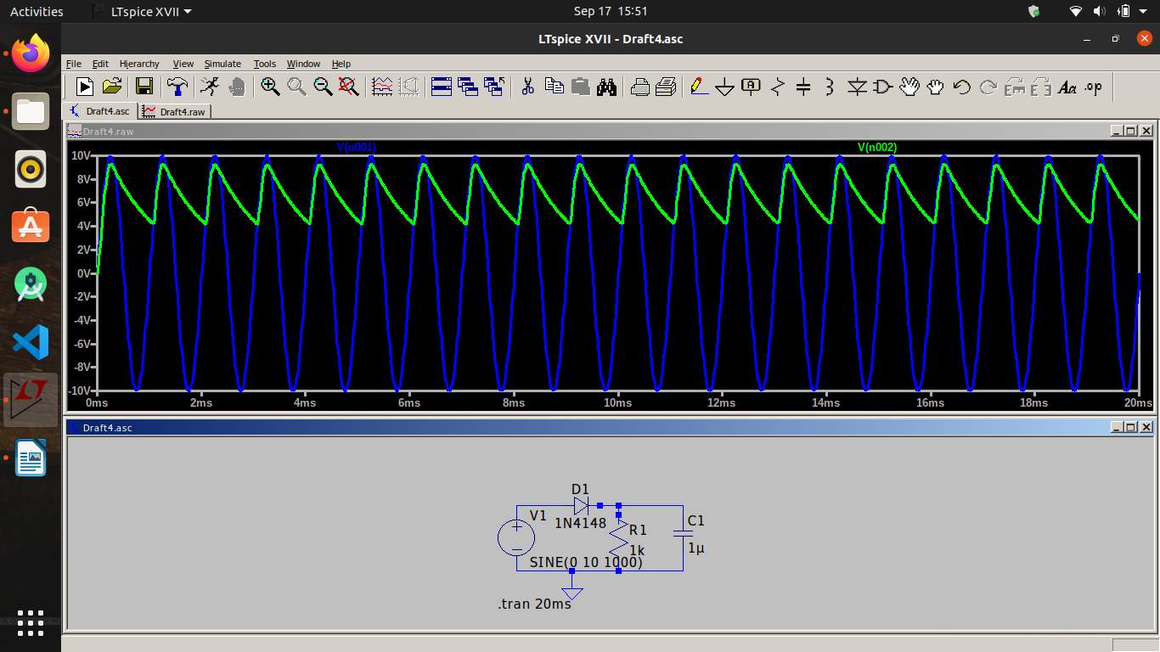

ii) Between Iin and Id :
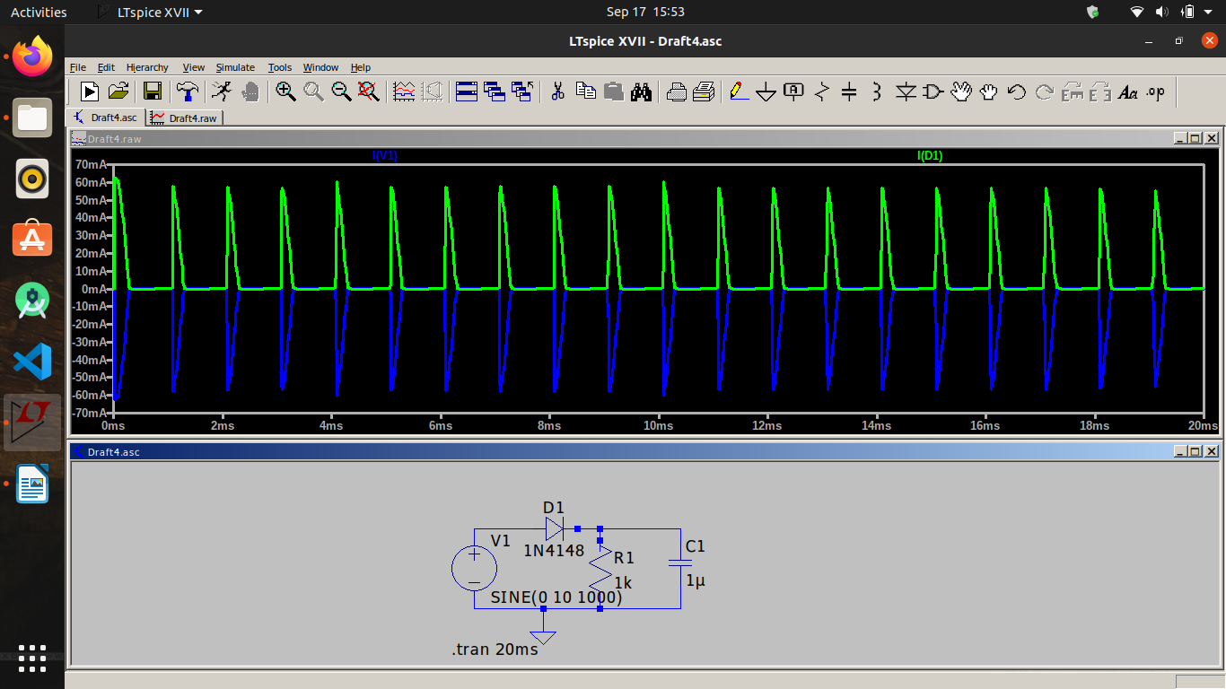
iii) Between Ir1 and Ic1:

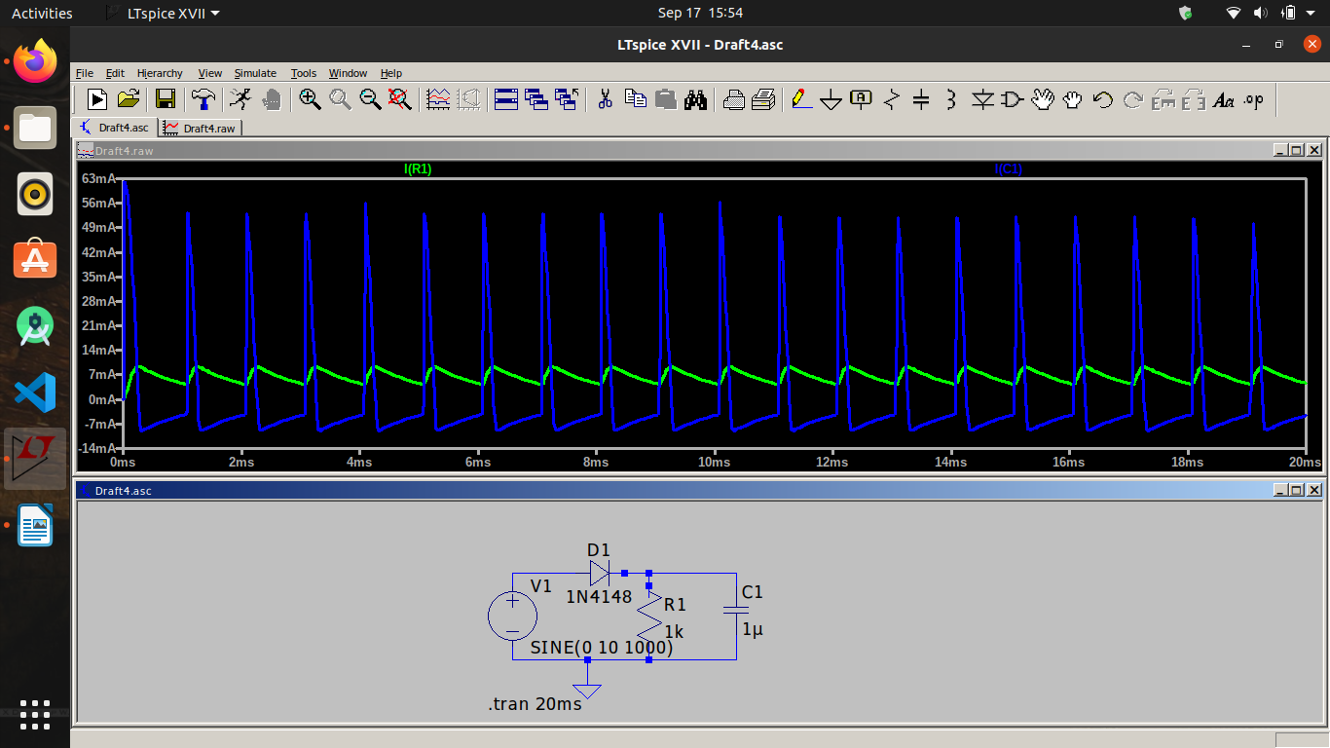

e. DC Sweep:
i) Between Vin and Vr
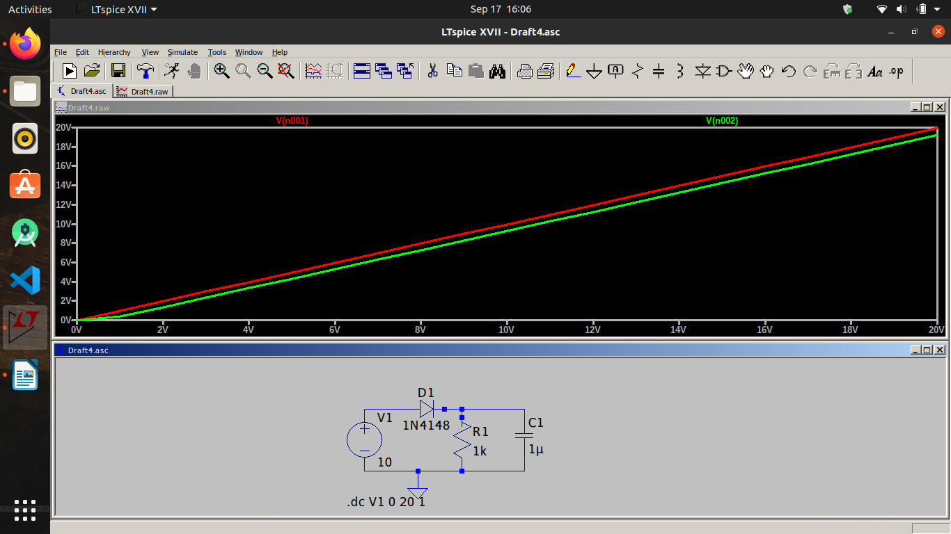
ii)Between Iv1 and Id1:

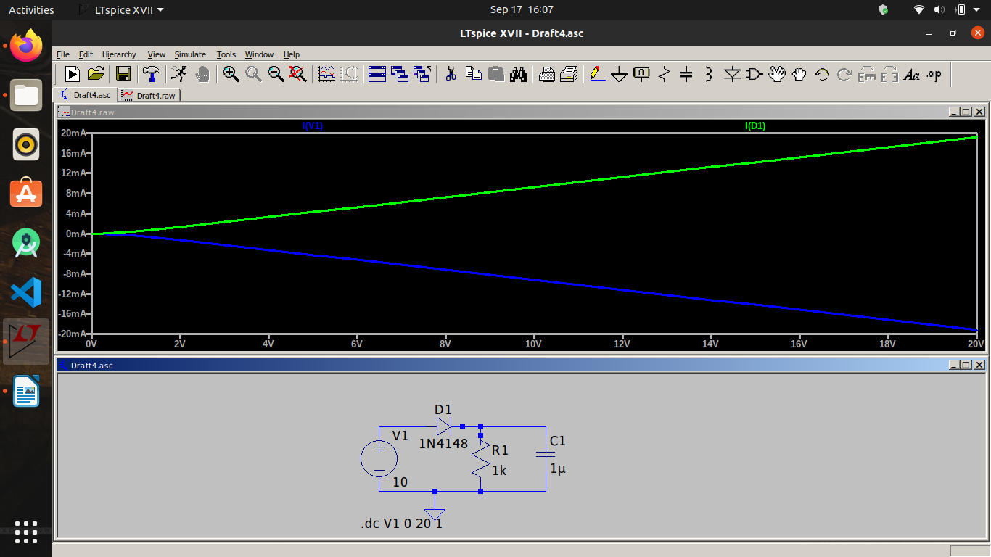

iii) Ic1
