Aquaponics

Mitic, Vladimir

# **Index**

Table of Contents

**Index** 2

Introduction 3

Why Aquaponics? 3

Vegetables 3

Media Filled Beds 3

Nutrient File Technique (NFT) 3

Deep Water Culture (DWC) 3

Introduction

This system is running on Arduino Uno board.

Why Aquaponics?

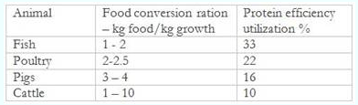

How it works

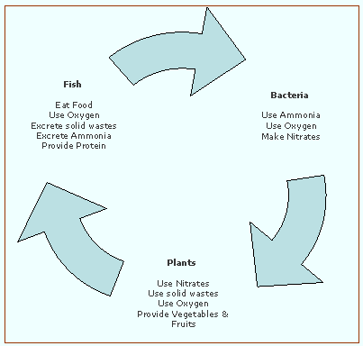

Vegetables

Media Filled Beds

Adasd

Nutrient File Technique (NFT)

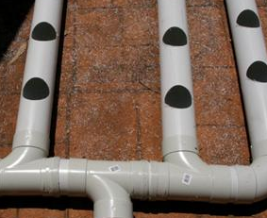 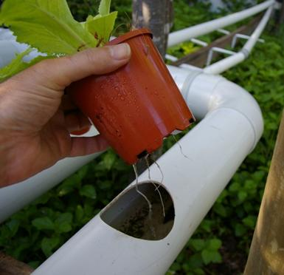

Deep Water Culture (DWC)

Fish

Water

