Vktech Home Appliance DHT22/AM2302 Digital Temperature And Humidity Measurement Sensor  
Temperature Humidity Sensor (ASONG AM2302, 20366 B09D06, Jan 9 2015)  
(Equivalents: )

[**DHT22**](http://www.adafruit.com/products/385) **(DHT lib)**

* 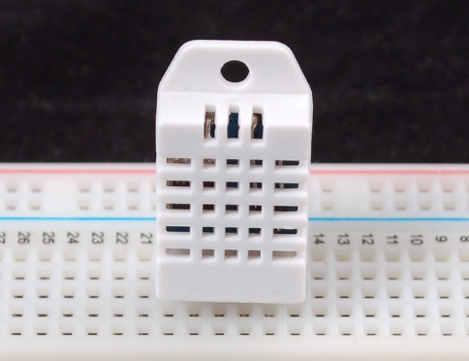Low cost
* 3 to 5V power and I/O
* 2.5mA max current use during conversion (while requesting data)
* Good for 0-100% humidity readings with 2-5% accuracy
* Good for -40 to 125°C temperature readings ±0.5°C accuracy
* No more than 0.5 Hz sampling rate (once every 2 seconds)
* Body size 15.1mm x 25mm x 7.7mm
* 4 pins with 0.1" spacing

Likewise, it is fairly easy to connect up to the DHT sensors. They have four pins

* 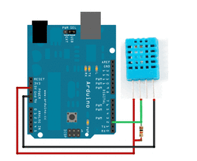VCC (3 to 5V power)
* Data out
* Not connected
* Ground

Simply ignore pin 3, its not used. You will want to place a 10K resistor between VCC and the data pin, to act as a medium-strength pull up on the data line. The Arduino has built in pullups you can turn on but they're very weak, about 100K

This diagram shows how we will connect for the testing sketch. Connect data to pin 2, you can change it later to any pin.

<https://github.com/adafruit/DHT-sensor-library>

SainSmart Tiny RTC I2C DS1307 AT24C32 24C32 memory Real Time Clock Module for Arduino

**DS1307 (RTC lib)**

* 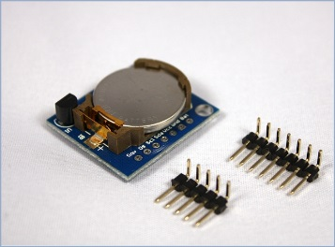**24C32** 32K I2C EEPROM memory.
* **DS1307** based RTC with CR2032 battery (Battery included).
* Fully charged, it can provide the DS1307 timing 1.
* Compact design, 27mm * 28mm * 8.4mm.
* Leads to the a DS1307 clock pin, to provide the clock signal for the microcontroller.

This is a great battery-backed real time clock (RTC) that allows your microcontroller project to keep track of time even if it is reprogrammed, or if the power is lost. Perfect for datalogging, clock-building, time stamping, timers and alarms, etc. The DS1307 is the most popular RTC, and works best with 5V-based chips such as the Arduino.

This breakout board is a kit and requires some light soldering which should only take about 15 minutes.

It can count leap-years and knows how many days are in a month, but it doesn't take care of Daylight Savings Time (because it changes from place to place)

You MUST have a coin cell installed for the RTC to work, if there is no coin cell, you should pull the battery pin low.

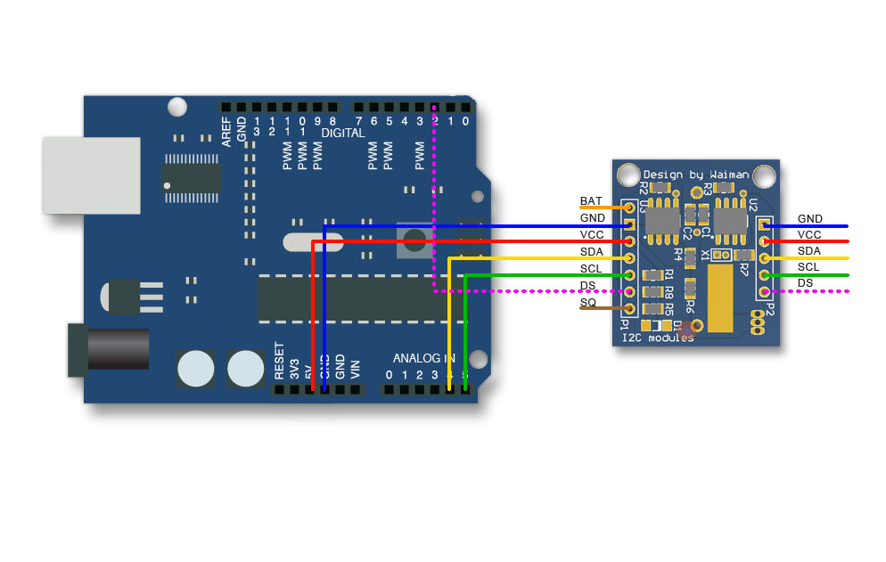**You MUST have a coin cell installed for the RTC to work, if there is no coin cell, it will act strangly and possibly hang the Arduino so ALWAYS make SURE there's a battery installed, even if its a dead battery.**

Uses I2C interface:  
Uses 2 pins for the I2C bus: A4 (SDA) and A5 (SCL)  
Above pins can only be used for another I2C peripherals. (LCD screen for example)  
Needs 4.7 KOhm pull up resistor.

Arduino Tiny RTC I2C Real Time Clock Pinout

|  |  |  |
| --- | --- | --- |
| PIN | Description | Comment |
| BAT | Battery voltage | To monitor the battery voltage, or not connected |
| GND | Ground | Ground |
| VCC | 5V supply | Power the module and charge the battery |
| SDA | I2C data | I2C data for the RTC |
| SCL | I2C clock | I2C clock for the RTC |
| DS | DS18B20 Temp. Sensor output | One wire interface |
| SQ | Square wave output | Normally not used |

The I2C wires "SDA" and "SCL" are the data line and clock line, they should be connected to the corresponding pins depending on the Arduino board.

|  |  |
| --- | --- |
| Board | I2C / TWI pins |
| Uno, Ethernet | A4 (SDA), A5 (SCL) |
| Mega2560 | 20 (SDA), 21 (SCL) |
| Leonardo | 2 (SDA), 3 (SCL) |
| Due | 20 (SDA), 21 (SCL), SDA1, SCL1 |

**Ethernet**

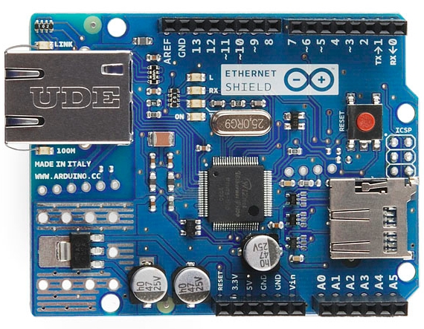  
The Wiznet W5100 provides a network (IP) stack capable of both TCP and UDP, plus SD card.   
It supports up to **four** simultaneous socket connections. 

Arduino communicates with both the W5100 and SD card using the **SPI bus** (through the ICSP header) SPI bus uses 3 pins D11, D12 and D13.  
When working with SD library, SS is on Pin 4 (D4).  
When working with W5100 (Ethernet) library, SS is on Pin 10 (D10).  
All above pins cannot be used for general I/O.

Note that because the W5100 and SD card share the SPI bus, only one can be active at a time.  
If you are using both peripherals in your program, this should be taken care of by the corresponding libraries. If you're not using one of the peripherals in your program, however, you'll need to explicitly deselect it. To disable the SD card, set pin 4 as an output and write a high to it. For disabling the W5100, set digital pin 10 as a high output.

* PWR: indicates that the board and shield are powered
* LINK: indicates the presence of a network link and flashes when the shield transmits or receives data
* FULLD: indicates that the network connection is full duplex
* 100M: indicates the presence of a 100 Mb/s network connection (as opposed to 10 Mb/s)
* RX: flashes when the shield receives data
* TX: flashes when the shield sends data
* COLL: flashes when network collisions are detected

The solder jumper marked "INT" can be connected to allow the Arduino board to receive interrupt-driven notification of events from the W5100, but this is not supported by the Ethernet library. The jumper connects the INT pin of the W5100 to **digital pin 2** of the Arduino.

WiFiShield

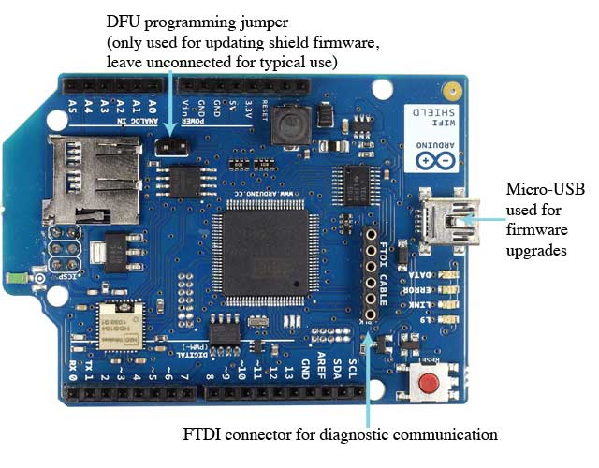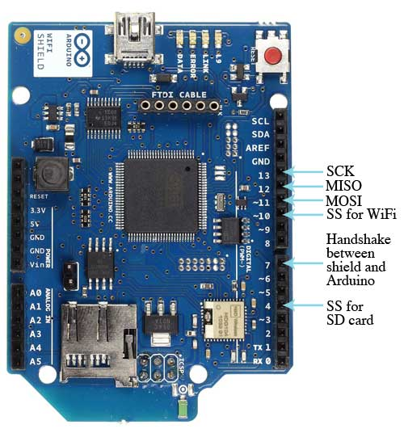

The shield can connect to encrypted networks that use either WPA2 Personal or WEP  
Encryption. It can also connect to open networks.

A network must broadcast its SSID for the shield to be able to connect.

The Arduino WiFi Shield allows an Arduino board to connect to the internet using the 802.11 wireless specification (WiFi). It is based on the [HDG204](http://pub.ucpros.com/download/1451_hdg204_datasheet_pa4.pdf?osCsid=mcrh728ovgeg6ub4ka6mccrso5s) Wireless LAN 802.11b/g System in-Package. An AT32UC3 provides a network (IP) stack capable of both TCP and UDP.

RioRand™ LCD Module for Arduino 20 x 4, White on Blue **HD44780**

|  |  |  |  |  |  |  |  |  |  |  |  |  |  |  |  |  |  |  |  |  |  |  |  |  |  |  |  |  |  |  |  |  |  |  |  |  |  |  |  |  |  |  |  |  |  |  |  |  |  |
| --- | --- | --- | --- | --- | --- | --- | --- | --- | --- | --- | --- | --- | --- | --- | --- | --- | --- | --- | --- | --- | --- | --- | --- | --- | --- | --- | --- | --- | --- | --- | --- | --- | --- | --- | --- | --- | --- | --- | --- | --- | --- | --- | --- | --- | --- | --- | --- | --- | --- |
| |  |  | | --- | --- | | LCD Pin # | Function | | 1 | VSS (Gnd) | | 2 | VDD (+5V) | | 3 | Contrast Adjustment | | 4 | RS Register Select Input | | 5 | R/W Read/Write Signal,  normally at Gnd | | 6 | E Enable | | 7 | DB0 | | 8 | DB1 | | 9 | DB2 | | 10 | DB3 | | 11 | DB4 | | 12 | DB5 | | 13 | DB6 | | 14 | DB7 | | 15 | Back Light Adjustment | | 16 | LED (-) Gnd for back light | | |  |  | | --- | --- | | LCD Pin | Arduino Pin | | RS | D12 | | E | D11 | | DB4 | D5 | | DB5 | D4 | | DB6 | D3 | | DB7 | D2 | |

The Arduino connections are as follows:

#include <LiquidCrystal.h> //Makes available the Arduino environment Liquid Crystal Display  
Liquid Crystal lcd(12,11,5,4,3,2); //Assigns the proper pin connections (as above) between Arduino and the display

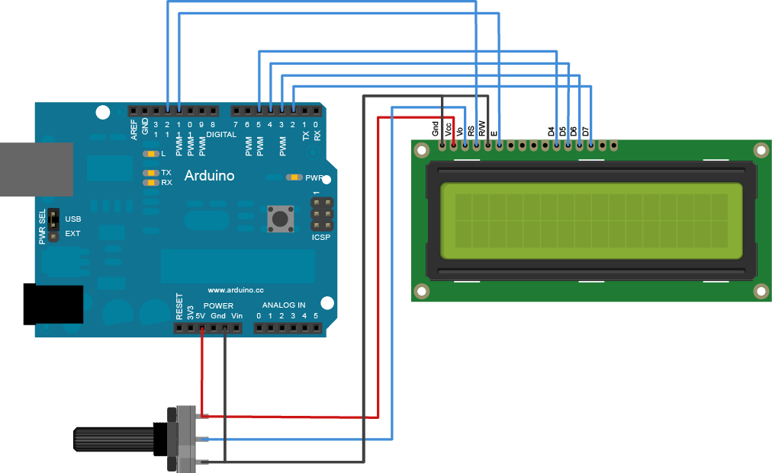Line 1 (top line): Addresses 0 -19  
Line 2: Addresses 64 - 83  
Line 3: Addresses 20 - 39  
Line 4: Addresses 84 - 95

You need 6 digitals pins to do stuff, so if you are planning to control several servo motors either get larger arduino like mega or buy I2C controller.

http://42bots.com/tutorials/arduino-controlled-lcd-using-a-shift-register-and-the-spi-library/   
<http://playground.arduino.cc/Main/LiquidCrystal>

used SS pin D8 instead.(D11 & D13)

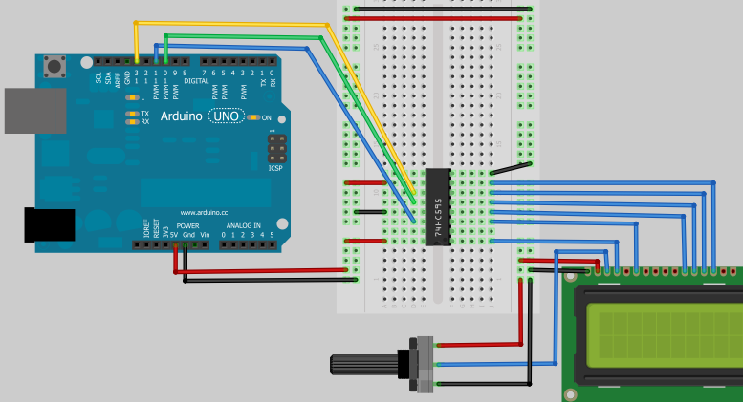

SunFouder 2 pcs Ultrasonic Module HC-SR04 Distance Sensor for Arduino UNO MEGA R3 Mega2560 Due milanove Nano Robot XBee ZigBee

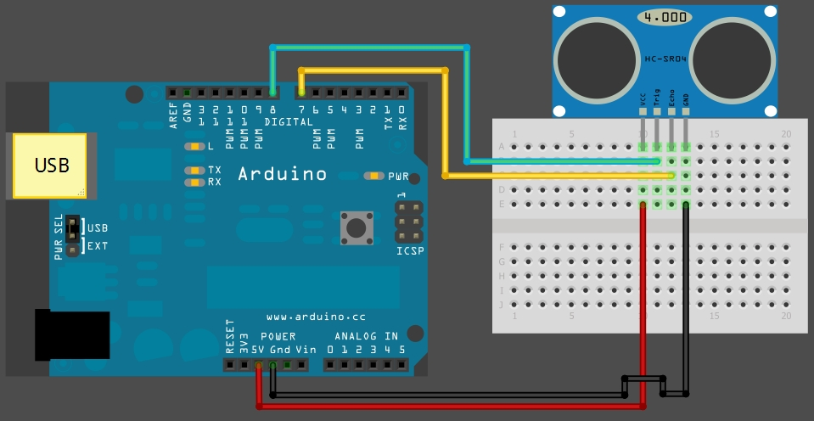

http://arduinobasics.blogspot.com/2012/11/arduinobasics-hc-sr04-ultrasonic-sensor.html

http://www.instructables.com/id/Simple-Arduino-and-HC-SR04-Example/

Vktech 5pcs 2M Waterproof Digital Temperature Temp Sensor Probe DS18b20

The DS18B20 is recommended for any application that requires 9 to 12 bits of temperature resolution. This device offers much more flexibility and is easier to use than the DS18S20

<http://milesburton.com/Main_Page?title=Dallas_Temperature_Control_Library>

<https://github.com/milesburton/Arduino-Temperature-Control-Library>

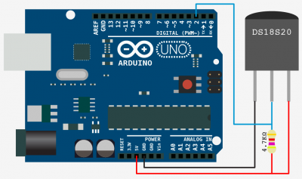

OneWire works ☺  
Dallas Temperature Control Library doesn’t   
(compile errors – remove const from function parameters fixes it!)  
Can use up to 255 sensors on same pin in parallel!!

Used sketch_08_03_OneWire_DS18B20_2   
Save in settings if any sensor was not initialized! Then reboot remotely  
If sensor disconnected it shows value -127, and both 85?

Photo Cell

https://learn.adafruit.com/photocells/using-a-photocell

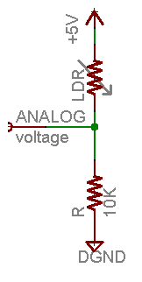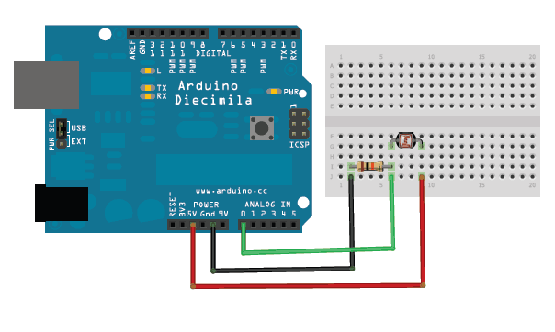

|  |  |  |  |  |  |
| --- | --- | --- | --- | --- | --- |
| **Ambient light like…** | **Ambient light (lux)** | **Photocell resistance (Ω)** | **LDR + R (Ω)** | **Current thru LDR +R** | **Voltage across R** |
| **Dim hallway** | **0.1 lux** | 600KΩ | 610 KΩ | 0.008 mA | 0.1 V |
| **Moonlit night** | **1 lux** | 70 KΩ | 80 KΩ | 0.07 mA | 0.6 V |
| **Dark room** | **10 lux** | 10 KΩ | 20 KΩ | 0.25 mA | 2.5 V |
| **Dark overcast day / Bright room** | **100 lux** | 1.5 KΩ | 11.5 KΩ | 0.43 mA | 4.3 V |
| **Overcast day** | **1000 lux** | 300 Ω | 10.03 KΩ | 0.5 mA | 5V |

**Ph Sensor**

https://www.sparkfun.com/products/10972   
https://github.com/OpenHydroponics/Billie-s-Hydroponic-Controller/blob/master/HydroponicControllerV1.1.0

**Green House Arduino Uno (upgrade to Arduino Mega 2560 R3 for more pins)**

|  |  |  |  |  |  |  |  |  |
| --- | --- | --- | --- | --- | --- | --- | --- | --- |
|  | has to be on that pin | | | | | | | |
|  | can be any other pin | | | | | | | |
| DIGITAL | | D1 | D2 | D3 | D4 | D5 | D6 | D7 | | D8 | D9 | D10 | D11 | D12 | D13 |
| Network  & SD card (3 + 2 pins) | |  | INT? |  | SS2 |  |  |  | |  |  | SS1 | 1 | 2 | 3 |
| Temperature & Humidity | | in |  |  |  |  |  |  | |  |  |  |  |  |  |
| Clock | |  |  |  |  |  |  |  | |  |  |  |  |  |  |
| LCD (with SPI) | |  |  |  |  |  |  |  | | SS3 |  |  | 1 |  | 2 |
| Ultrasonic | |  |  |  |  | out | in |  | |  |  |  |  |  |  |
| Temperature (5) Wire-1 | |  |  | in |  |  |  |  | |  |  |  |  |  |  |
| Photo Cell | |  |  |  |  |  |  |  | |  |  |  |  |  |  |
| Relay | |  |  |  |  |  |  | out | |  |  |  |  |  |  |
| Servo Motor | |  |  |  |  |  |  |  | |  | out |  |  |  |  |

|  |  |  |  |  |  |
| --- | --- | --- | --- | --- | --- |
| ANALOG | A1 | A2 | A3 | A4 | A5 |
| Network & SD card |  |  |  |  |  |
| Temperature & Humidity |  |  |  |  |  |
| Clock (I2C) |  |  |  | SDA | SCL |
| LCD |  |  |  |  |  |
| Ultrasonic |  |  |  |  |  |
| Temperature |  |  |  |  |  |
| Photo Cell |  |  | X |  |  |

|  |  |
| --- | --- |
| Input Sensors | Output |
| Water temperature bottom pool | Relay – start/stop water heater |
| Water temperature top pool |  |
| Air Humidity  Air Temperature | Servo motor – Open/Close roof (separate system?) |
| Pool Water Level | Send Warning (red lightbulb with relay?) |
| Photo Sensor | Warm Light On/Off (separate system?) |
| Clock | Servo Motor - Automatic Fish Feeder |
| SD Card | Logging / settings |
| Ethernet | Web Application – remote control |
| Camera (separate system) |  |
| Ph Sensor (too complicated – not available) | Send Warning |
| Monitor Clock Battery Voltage (enough pins?) | Send Warning |
| Flow Meter | Start backup pump? |
| Counter for sypher for each bed | Send Warning if not working |