Ian Sabey

Unit 2 Submission 1

CS219T – Python Programming

Professor Sean Small

This one I had some tricky issues with when trying to add a retry function to catch failed entries. My issue was with the placement of the function and getting it to pull the retried entry in, as well as not display the retry unless it was needed. The least amount of issue came from the placement now, where regardless it will run at the end of the program. Which kind of acts as a continuous query as well, seeing as how it allows to pull again. Regardless, I had fun with this one as well!

**Code Block With Entry Output:**

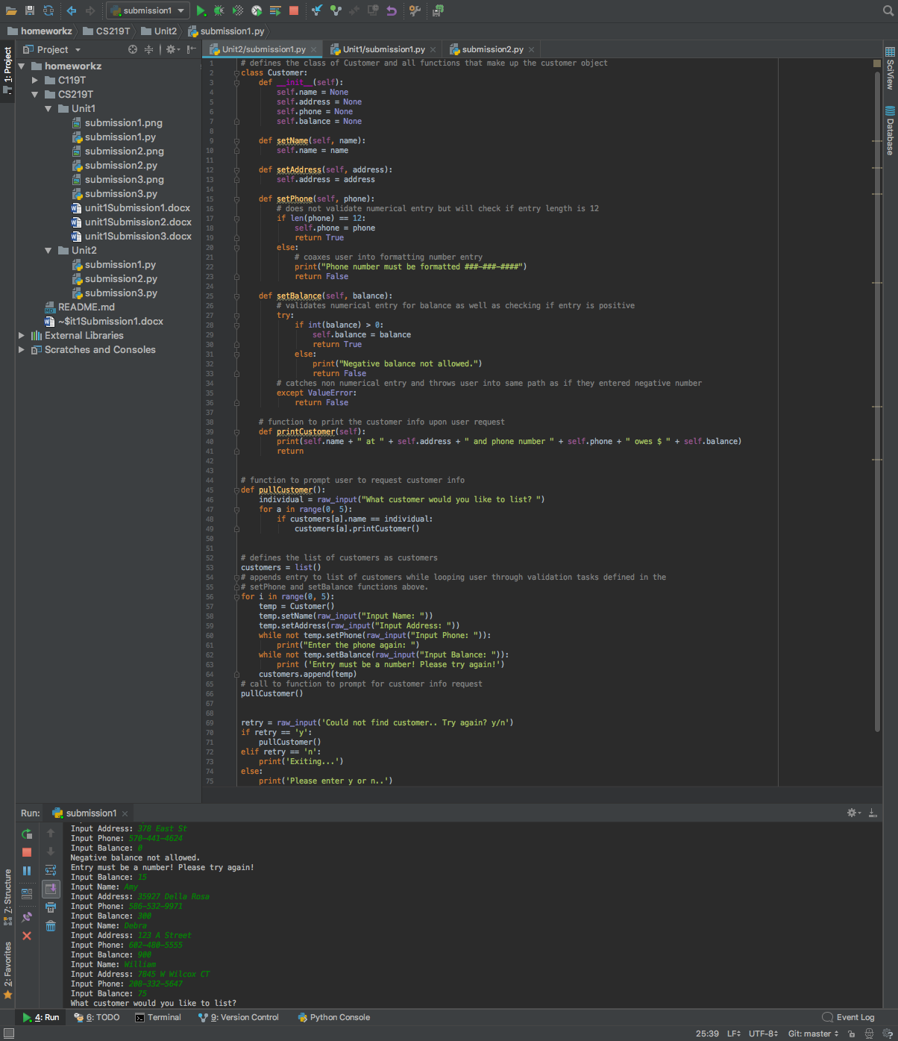

**Query Output:**

I also ran into problems handling if the name entry contained a space (force of habit for me to hit space). If you notice my retry function occurred, this was due to me initially entering Amy with a space at the end but only searching “Amy” with no space. Pointers on that would be amazing!!

