Ian Sabey

Unit 2 Submission 2

CS219T – Python Programming

Professor Sean Small

I think this one was my favorite to play around with. I also had troubles here, but this time was trying to print out the list. I had attempted several implementations but to no avail, was unable to get the items printed out correctly. Only “__main__.Truck()”, for example. Pointers on listing instantiated objects from a class would be awesome as well.

**Code Block:**

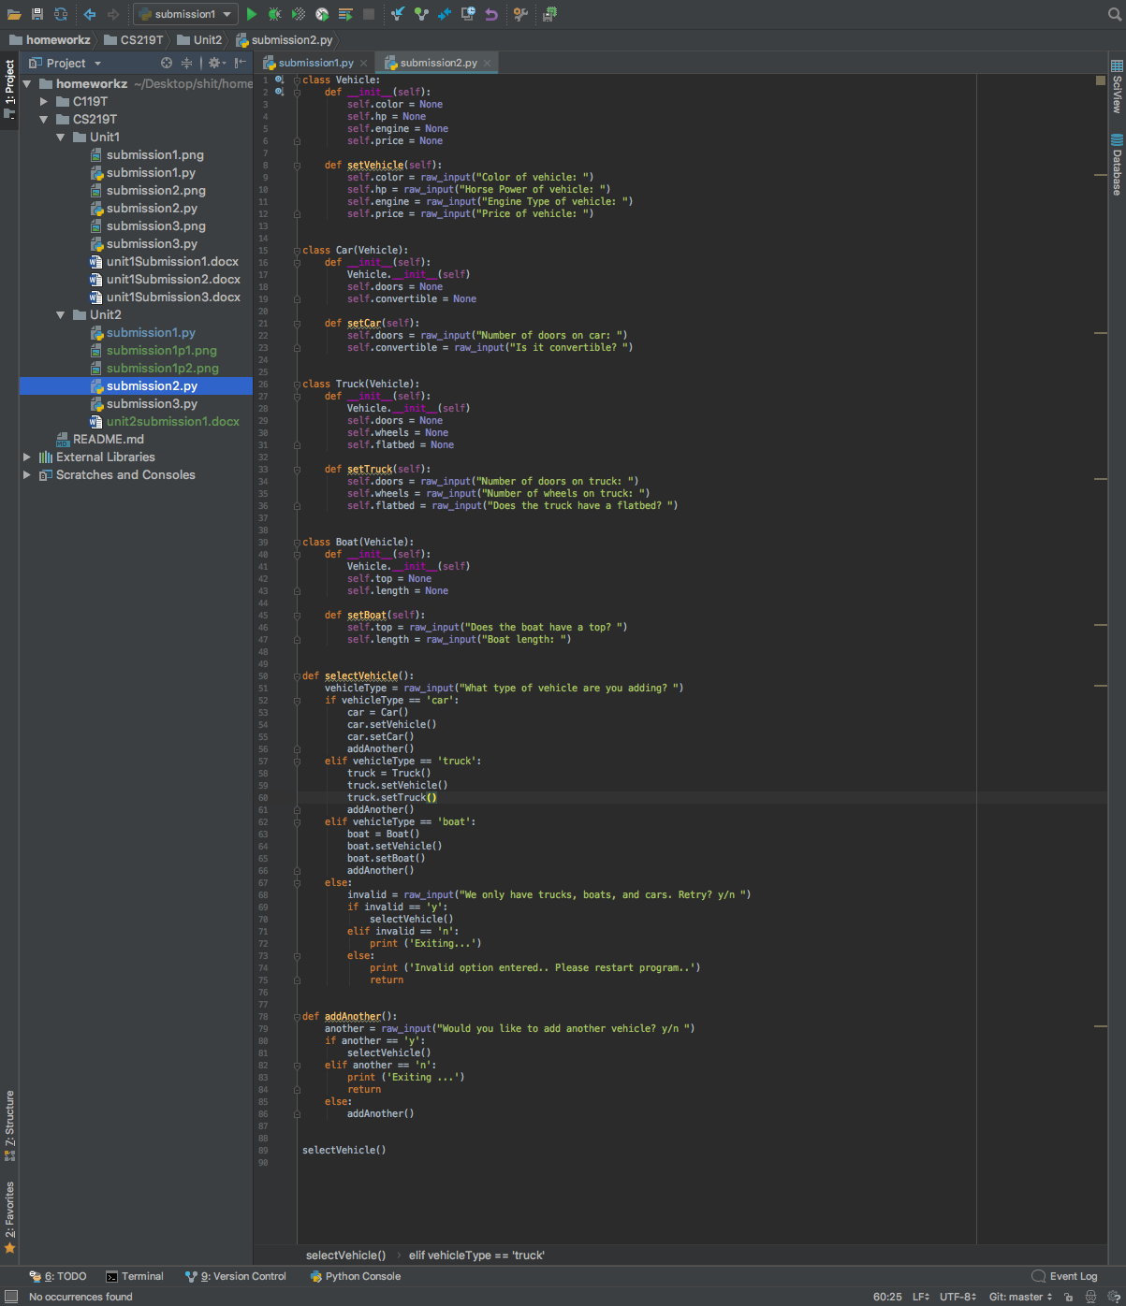

**Output:**

I would have liked to add in another function call to run after ‘addAnother’ which asked if they would like the session displayed (display the cars added during program up time) but that is where I ran into issues.

