Ian Sabey

Unit 2 Submission 3

CS219T – Python Programming

Professor Sean Small

I only had one issue with this one, that was the fact that I use Python 2.7 which required me to string the ‘emp.salary’ value in order to concat in the print function. Other than that this one was rather easy after going through the other two.

**Code Block with Hourly Output:**

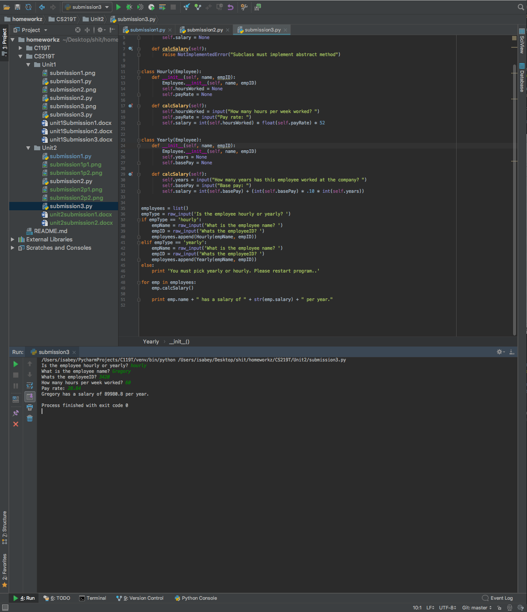

**Code Block with Yearly:**

