Ian Sabey

Unit 3 Submission 1

CS219T Python Programming

Prof. Sean Small

**Problems:**

This one was a challenge for me. I had some issues around TypeError exceptions within the __add__ method and few resources to assist. I discovered the need for further method override/overload within the __str__ method as well as the need to define the __init__ method and __radd__ method.

**Final program:**

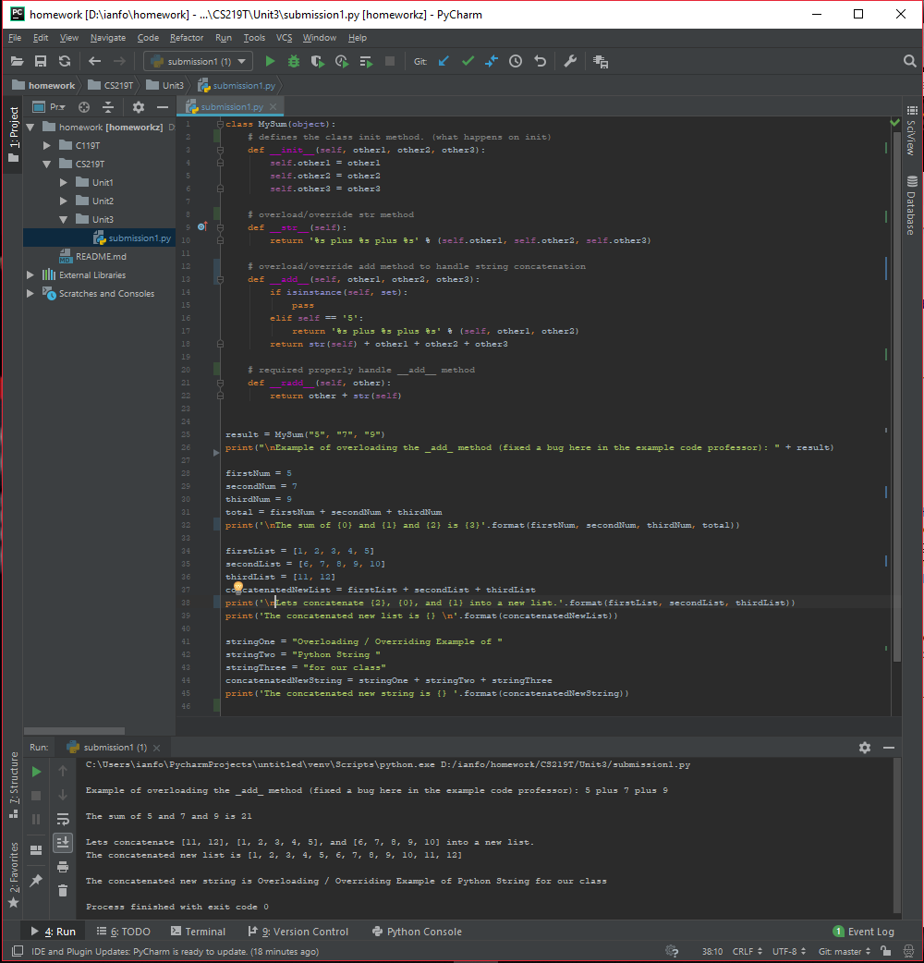

**Original program with error output:**

