Ian Sabey

Unit 4 Submission 2

CS219T – Python Programming

Prof. Sean Small

d

This one was fun. I wish I wasn’t in such a bind with work and everything because I had so many ideas to put into this. I discovered a method in the transaction file that made life a LOT easier when asking for user input for the transaction details. My goal with that was to be able to write that method out one time in an iterative loop and have the ‘t = Transaction()’ become ‘t[i] = Transaction()’ then I could just pass ‘myStatement.insertTransaction(t[i])’. Everything I could find on Stack Overflow strongly suggested against iterating variables. I discovered why when I fell into the rabbit hole and realized how let my assignment was getting.

**Statement start() method with failed attempts to iterate:** 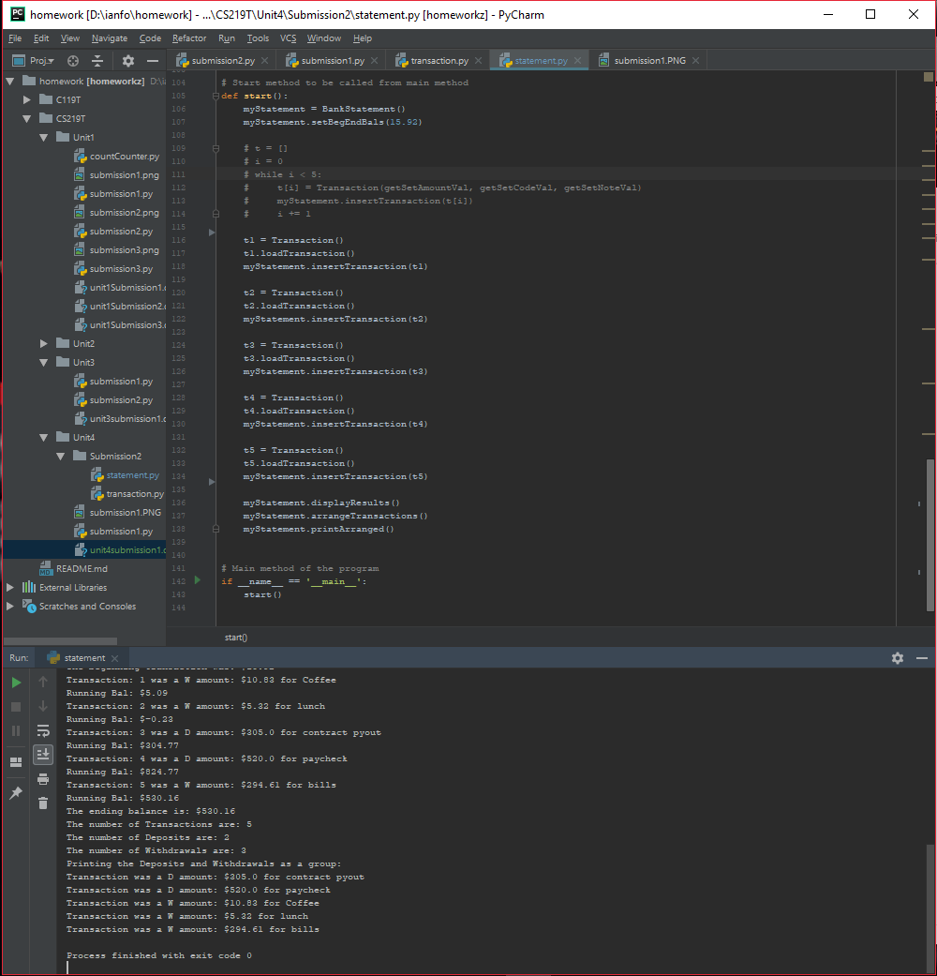

**Statement output:**