Ian Sabey

CS221T – SQL Programming

Unit 1 Submission Node

10/17/2018

Resubmit Due Date: 10/29/2018

**Overview of SQL Language: Submission Question**

This assignment was to create a sample database with tables. In this assignment I worked with MS SQL Server Management Studio (Microsoft Corporation, 2018) in an AWS instance owned by CTU.

There were a few issues I had in completing this assignment that were later to be discovered as network errors on every network I had tried to connect to AWS on. After looking further into packet capture logs from my works network management team, I learned that the port used by the workstation to update the Windows operating system was blocked, I applied the same research into my home network and my hotspot (the three networks I attempted to connect through) and discovered the same result, which was interesting. Prior to this resubmission, after stressing not being able to resolve the issues due to being extremely busy in life, I had attempted a workaround which achieved the end goal of creating the table, though I left out important factors such as a PRIMARY KEY.

After resolving the issues I had with AWS, I copied my SQL file from my IDE, DataGrip, added the PRIMARY KEY to a column that I named ‘id’ and pasted/executed through MS SQL Server Management Studio. I noticed after execution that I had some typos in one of my column names. I created a column named ‘created_by’ and set the value to be CURRENT_DATETIME as you can see in my screenshot below, **Figure 1**. Once I noticed this, I executed an ALTER statement to drop the column, followed by two more ALTER statements to add ‘created_by’ with the correct value CURRENT_USER and to add ‘created_dt’ with the value CURRENT_DATETIME. I then ran two INSERT statements to ensure the table would populate correctly and lastly, ran the SELECT statement to display the data in the table.

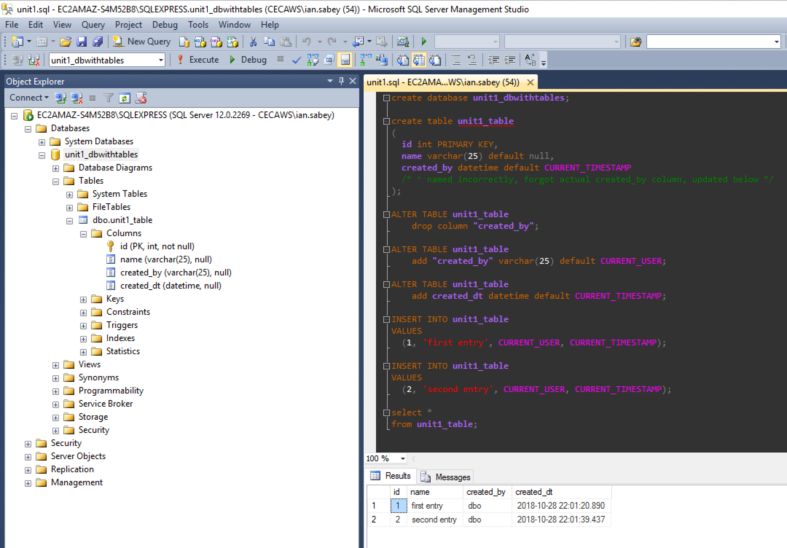

Figure 1: Object Explorer and Code Editor

# Works Cited

Microsoft Corporation. (2018). *MS SQL Server Management Studio 2014*. Retrieved from [computer software]: https://www.microsoft.com/en-US/download/details.aspx?id=42299

w3 Schools. (n.d.). *SQL ALTER Statement*. Retrieved from W3 Schools: https://www.w3schools.com/sql/sql_alter.asp