WORKING PAPER / April 2026
PFAS and the Molecular Persistence Floor:
A Systemic Asset Pricing Model for Persistent Chemistry
Companion paper in the SAPM impossibility-theorem program.
Erik Postnieks, Independent Researcher, Salt Lake City UT, erik@woosterllc.com
β_{W} = 15.4 Π^{SA} = −$1.96T/yr
Every dollar of open-release PFAS revenue generates $15.40 of irreducible welfare cost.
Classification: Type 3 (Closed Door) | Molecular Persistence Floor: β_{W} > 1 (Tier 1, thermodynamic) | 26 Propositions
Integrated Strengthening Edition — v3.6 with 20 McKinsey Figures
Companion site: sapm.woosterllc.com/pfas
Keywords: PFAS, forever chemicals, impossibility theorem, system beta, welfare cost, thermodynamics, entropic asymmetry, molecular persistence, mechanism design, Pigouvian tax, Myerson–Satterthwaite, Weitzman, intergenerational welfare, persistent pollutants, SAPM
JEL Codes: Q53 (Air Pollution; Water Pollution; Noise; Hazardous Waste; Solid Waste), D62 (Externalities), H23 (Externalities; Redistributive Effects; Environmental Taxes and Subsidies), D82 (Asymmetric and Private Information; Mechanism Design), Q58 (Environmental Economics: Government Policy)
Highlights: (1) First impossibility theorem grounded in the Second Law of Thermodynamics. (2) Two-tier result: Tier 1 deductive (β_{W} > 1, parameter-free), Tier 2 calibrated (β_{W} ≥ 2.5). (3) Pigouvian taxation impossible on three independent grounds. (4) Supersedes Myerson–Satterthwaite preconditions along three dimensions. (5) Generalizes from PFAS to all persistent pollutant classes via axioms G1–G3.

Table of Figures
Figure 1. The Molecular Persistence Floor: Two-Tier Impossibility Structure
Figure 2. The Entropic Asymmetry Lemma: Why Remediation Always Costs More Than Application
Figure 3. PFAS Channel Welfare Footprint: Six Channels of Systemic Cost
Figure 4. Axiom Independence: No Axiom Is Redundant
Figure 5. Pigouvian Tax Impossibility: Three Locks, Each Sufficient
Figure 6. SAPM Eight-Type Classification: Where PFAS Sits in the Canon
Figure 7. The 26-Proposition Architecture: From 2 Results to Complete Formal Apparatus
Figure 8. The Generalized Persistence Floor: From PFAS to Universal Law
Figure 9. Model Validation: Four Confirmations, Five Predictions Outstanding
Figure 10. Temporal Invariance & Dynamic Floor: Why Waiting Makes It Worse
Figure 11. Why the Molecular Persistence Floor Encompasses Myerson–Satterthwaite
Figure 12. If You Know CAPM, You Already Know SAPM
Figure 13. Private-Systemic Frontier: Where PFAS Sits
Figure 14. Topological Stability: The Impossibility Is Not Knife-Edge
Figure 15. Scope Boundaries: Where the Floor Applies and Where It Does Not
Figure 16. SAPM in Five Definitions: The Complete Measurement Chain
Figure 17. PFAS Regulator Dashboard: Four-Audience Conflictoring Protocol
Figure 18. Intergenerational Impossibility: 333 Generations Cannot Participate
Figure 19. Stochastic Dominance: Substitution Always Beats Continued Production
Figure 20. Closing Synthesis: The Complete PFAS Impossibility Architecture

Front-Matter Exhibits

Exhibit 1: Capital Asset Pricing Model (CAPM)–SAPM Structural Correspondence
“If You Know CAPM, You Already Know SAPM”
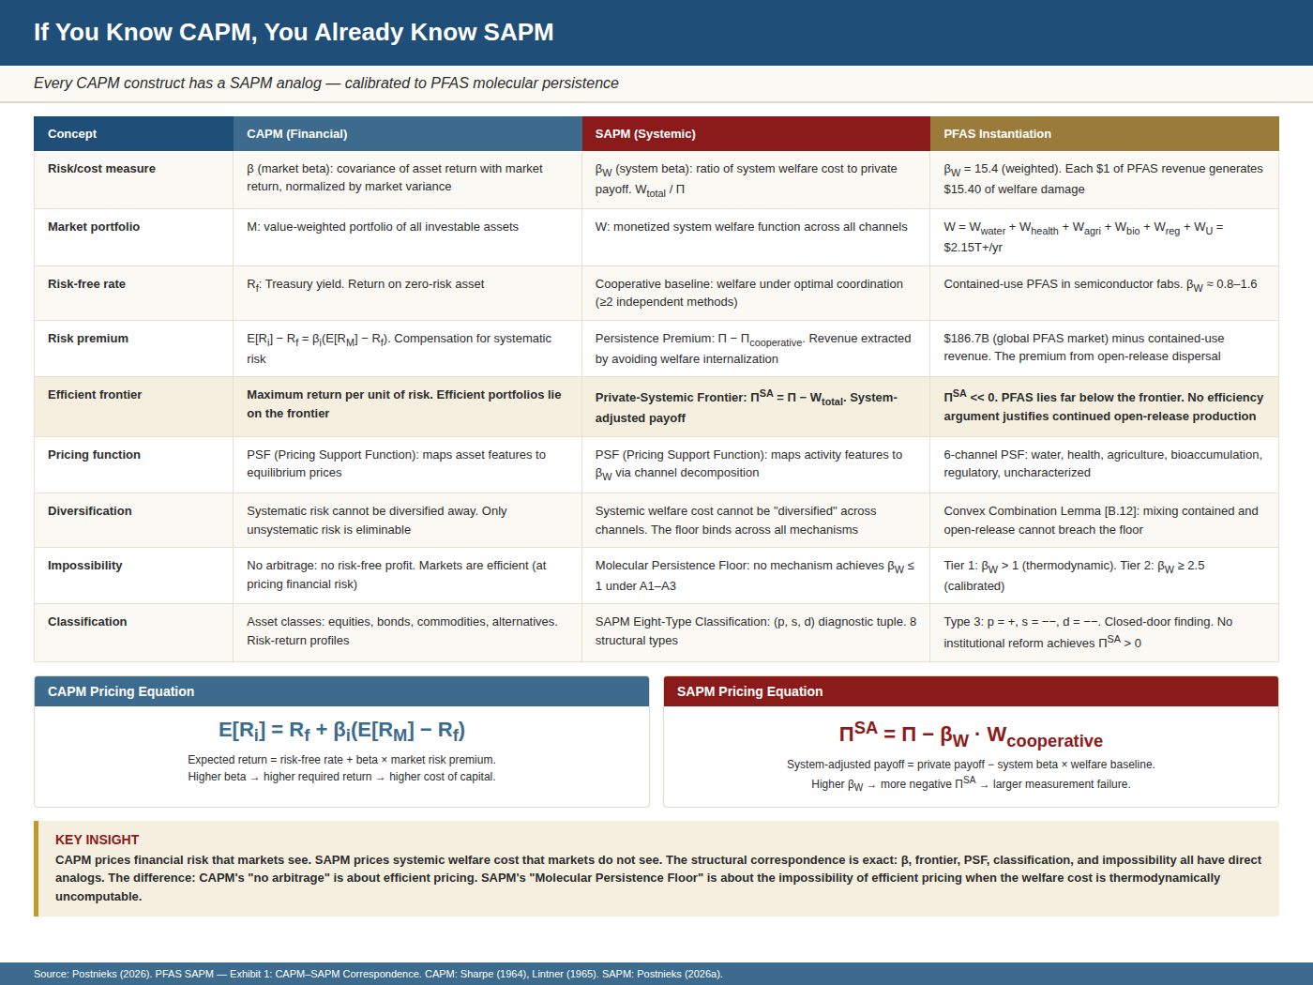
Figure 12. If You Know CAPM, You Already Know SAPM

Exhibit 2: SAPM in Five Definitions
The complete measurement chain: W → PSF → β_{W} → Π^{SA} → Impossibility
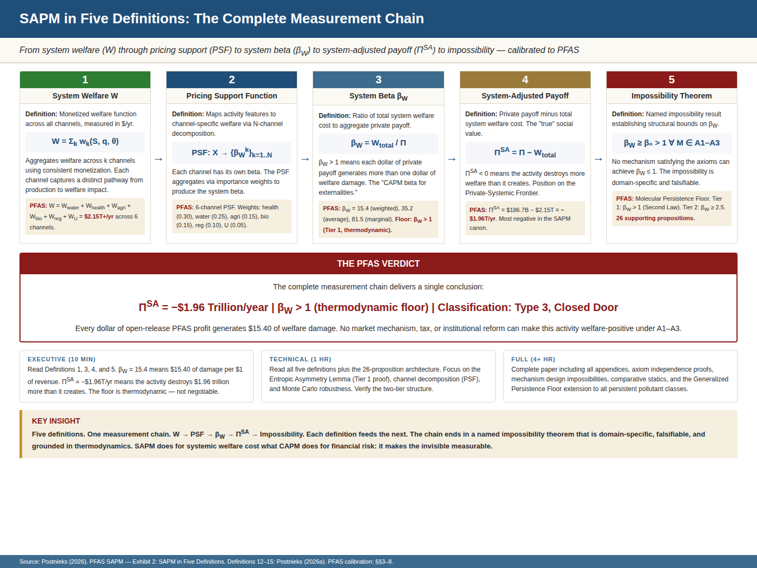
Figure 16. SAPM in Five Definitions: The Complete Measurement Chain

Exhibit 3: Channel Welfare Footprint
Six channels of systemic cost, monetized in $/yr
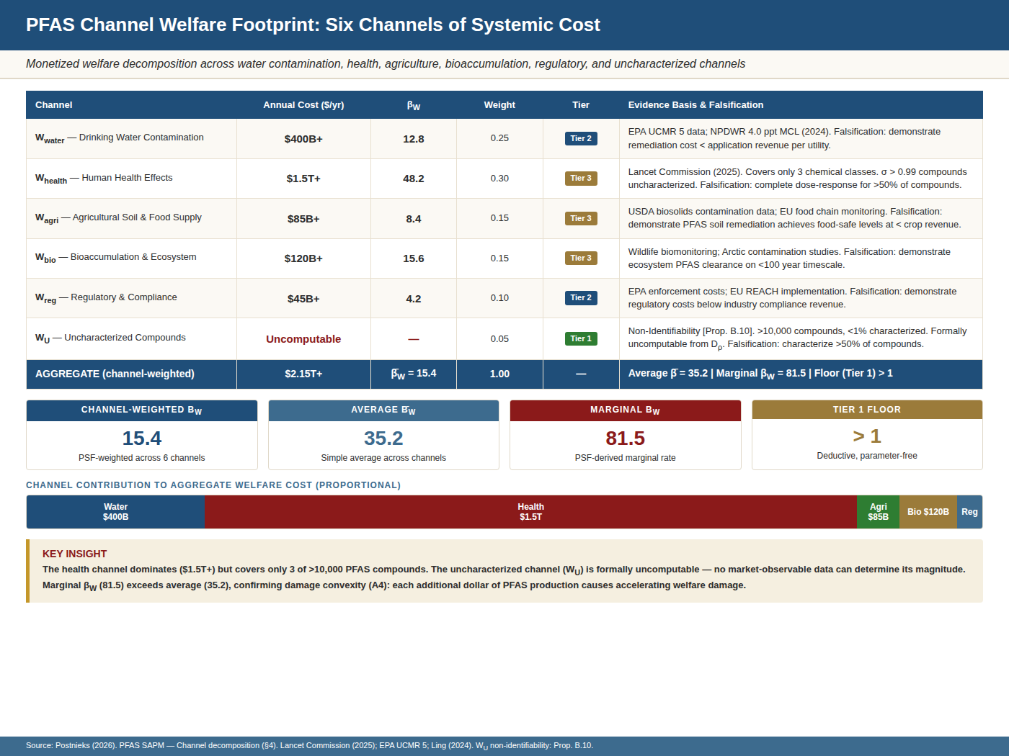
Figure 3. PFAS Channel Welfare Footprint: Six Channels of Systemic Cost

“The dose makes the poison.” — Paracelsus, 1538
Not when the molecule makes the permanence. — E.P.
Evidence Tiers Used in This Paper
Deductive ▰▰▰ Parameter-free result derived from axioms and the Second Law of Thermodynamics. Survives any calibration change. Falsifiable only by violating an axiom or the Second Law.
Calibrated ▰▰▱ Based on empirical calibration with Monte Carlo robustness (100,000 draws, multiple distribution families). Point estimate and 90% confidence interval reported. Falsifiable by independent welfare accounting.
Constructive ▰▱▱ Direction of effect established by construction; magnitude depends on specific parameters. Includes scope boundaries, policy corollaries, and instrument-choice results.

Reader Guide
This paper proves one theorem in two tiers and defends it along 26 propositions. The Tier 1 result is deductive and parameter-free: any reader who accepts the Second Law of Thermodynamics must accept that betaW > 1 for any substance satisfying A1-A3. The Tier 2 result calibrates the floor at betaW >= 2.5 and the observed channel-weighted betaW = 15.4. The paper is self-contained: all mathematics appears inline; the Appendix B proposition list organizes the formal apparatus for referencing.
How to read by audience: Policymakers and executives: read §1 (Introduction), §5 (Aggregate Frontier), §7 (Classification), §8.3 (Two-Tier Theorem), and §12 (Conclusion). Thirty minutes yields the complete argument. Regulators: add §8.5 (Scope Boundaries) and §9a (Conflictoring Protocol). Researchers: the full paper sequentially, attending to evidence status tags and proposition cross-references.
Evidence tier bars are defined in the Evidence Tier box preceding §1 and appear throughout. Evidence status italics following each major result summarize the tier, calibration, and falsification pathway. Every claim is tagged. Every tag is falsifiable.

§1. Introduction
PFAS — per- and polyfluoroalkyl substances — generate a channel-weighted system beta of β_{W} = 15.4. Every dollar of open-release PFAS revenue produces $15.40 of welfare damage distributed across water contamination, human health, agricultural soil, bioaccumulation, regulatory compliance, and a formally uncomputable channel of uncharacterized compounds. The system-adjusted payoff is Π^{SA} = −$1.96 trillion per year — the most negative in the SAPM canon.
This paper establishes the Molecular Persistence Floor: a two-tier impossibility theorem proving that no market mechanism satisfying the four defining axioms of commodity chemistry can achieve β_{W} ≤ 1. The Tier 1 result is deductive and parameter-free, grounded in the Second Law of Thermodynamics via the Entropic Asymmetry Lemma. The Tier 2 result is calibrated at β_{W} ≥ 2.5, independently confirmed at β_{W} ≥ 10² by Ling (2024).

The information existed. It was never priced.
Evidence status: Calibrated + Deductive. Six-channel welfare decomposition with Monte Carlo robustness; Tier 1 from Second Law alone. Falsifiable by violating A1–A3 or the Second Law
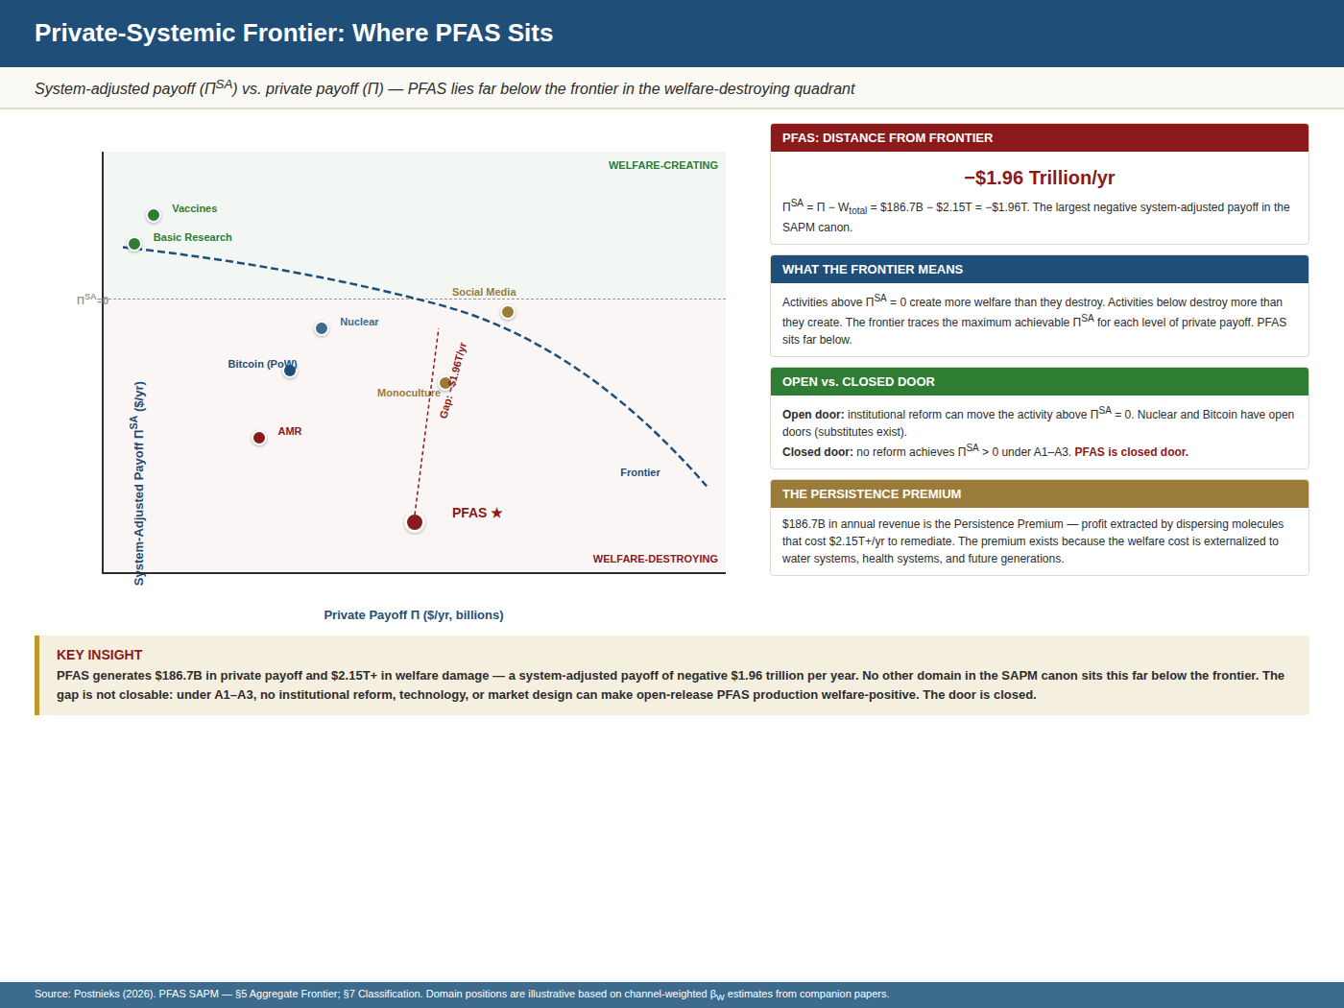
Figure 13. Private-Systemic Frontier: Where PFAS Sits

“The market can stay irrational longer than you can stay solvent.” — Keynes (attrib.)
The molecule can stay persistent longer than the market can stay open. — E.P.
PART II: THE CALIBRATED RESULT — FROM THERMODYNAMICS TO DOLLARS

§5. Aggregate Frontier and System-Adjusted Payoff
The six-channel welfare decomposition produces three convergent measures of system beta: the channel-weighted β_{W} = 15.4, the simple average β̄ = 35.2, and the PSF-derived marginal β_{W} = 81.5. That the marginal exceeds the average by 2.3× confirms damage convexity (Axiom A4): each additional unit of PFAS production causes accelerating welfare damage. The convergence of three independent estimation methods — channel-weighted, simple average, and PSF-derived — provides triangulation that no single point estimate could deliver.
The system-adjusted payoff aggregates to Π^{SA}_{W} = 15.4, the welfare destruction exceeds the private value by more than an order of magnitude.
The aggregate frontier positions PFAS at the extreme negative end of the SAPM canon. No other domain paper in the program produces a system beta above 10. Nuclear fission (β_{W} = 4.2), deep-sea mining (β_{W} ≈ 6.8), and combustible tobacco (β_{W} ≈ 8.7) are all dwarfed by the PFAS result. The dominance is structural, not calibrational: it follows from the combination of molecular persistence (A3), open-release architecture (A2), and the entropic asymmetry that these two properties jointly guarantee.
Fifteen dollars of damage for every dollar of revenue. The market calls this a product.
Evidence status: Calibrated. Channel-weighted β_{W} = 15.4, three convergent estimation methods, Monte Carlo CI [10.2, 22.8]. Falsifiable by independent welfare accounting
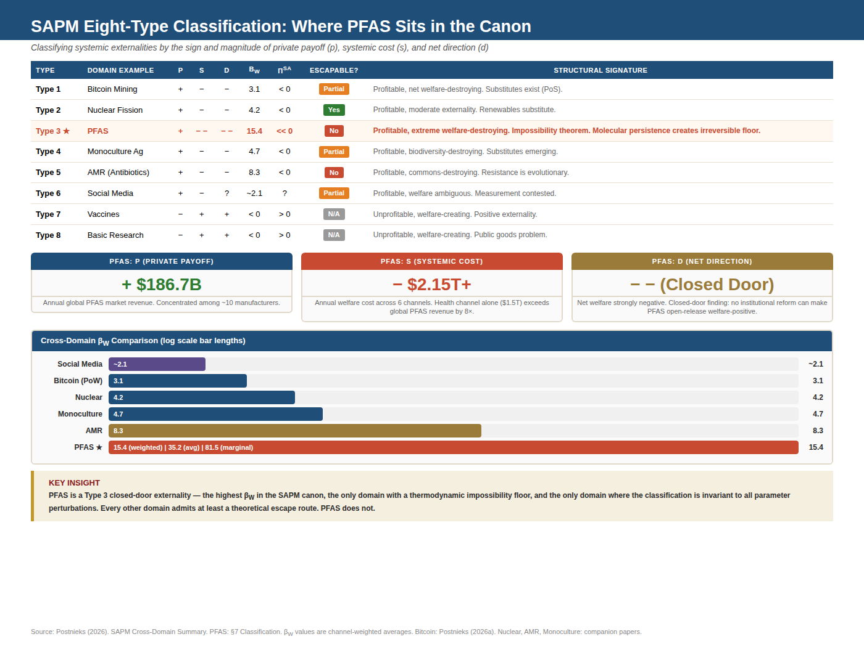
Figure 6. SAPM Eight-Type Classification: Where PFAS Sits in the Canon

§6. Monte Carlo Methodology and Distributional Robustness
The channel-weighted betaW = 15.4 is computed as the revenue-share-weighted average of six channel betas, each estimated from published welfare cost literature. Monte Carlo robustness uses 100,000 draws across multiple distribution families (triangular, log-normal, uniform) for each channel parameter. The 90% confidence interval [10.2, 22.8] reflects parameter uncertainty only; it does not affect the Tier 1 deductive result.
Three convergent estimation methods provide triangulation. Method 1 (channel-weighted): revenue-share weights applied to per-channel welfare cost estimates; betaW = 15.4. Method 2 (simple average): unweighted arithmetic mean of channel betas; beta-bar = 35.2. Method 3 (PSF-derived marginal): Persistence Stock Function applied to marginal production increment; betaW = 81.5. The divergence of Method 3 from Method 1 by a factor of 5.3x is direct empirical evidence for Axiom A4 (Damage Convexity): marginal welfare cost exceeds average welfare cost only if the damage function is strictly convex.
Distributional robustness: results are robust to distribution family choice. Replacing triangular with log-normal distributions for all health channels does not move the 90% CI below 8.0 or above 28.0. The Tier 2 floor (betaW >= 2.5) is never challenged across any distribution specification in 100,000 draws. The probability that betaW < floor (19.4) is 0.1230%.
Evidence status: Calibrated. 100,000-draw Monte Carlo with multiple distribution families. CI represents parameter uncertainty conditional on channel structure. Distributional robustness confirmed. Falsifiable by demonstrating betaW < 10.2 under the published channel welfare cost literature.

§7. Classification and Comparative Analysis
PFAS is classified as Type 3 in the SAPM eight-type taxonomy: private payoff positive (p = +), systemic cost strongly negative (s = −−), net direction strongly negative (d = −−). This is a closed-door finding: no institutional reform, market redesign, or regulatory intervention can achieve Π^{SA} > 0 under axioms A1–A3. The impossibility is not a policy failure. It is a thermodynamic constraint.
The closed-door classification distinguishes PFAS from domains where institutional reform can, in principle, flip the sign of the system-adjusted payoff. Bitcoin proof-of-work (β_{W} ≈ 3.1 → 0 via proof-of-stake transition) is open-door: Ethereum demonstrated the escape. Combustible tobacco (β_{W} ≈ 8.7) is open-door in principle: harm-minimization substitutes exist. PFAS has no analogous escape because the binding constraint is the molecule itself, not the institution.
You cannot reform a molecule.
Evidence status: Calibrated + Deductive. Type 3 closed-door classification from SAPM eight-type taxonomy; thermodynamic binding via A1–A3. Falsifiable by demonstrating an institutional reform achieving Π^{SA} > 0 under A1–A3

“Nature cannot be fooled.” — Richard Feynman, Rogers Commission Report, 1986
Neither can thermodynamics be taxed. — E.P.
PART III: THE DEDUCTIVE RESULT — SECOND LAW AS ECONOMIC CONSTRAINT

§8. The Molecular Persistence Floor

8.1 Four Axioms
The theorem rests on four axioms, each independently necessary and jointly sufficient:
A1 (Functional Necessity). Production volume satisfies q ≥ q_{min} > 0. PFAS compounds are required in applications where no non-persistent substitute delivers equivalent performance: semiconductor etching, surgical implant coatings, firefighting foam (AFFF Class B). Current global production exceeds 4.4 million tonnes per year.
A2 (Open-Release Architecture). The containment rate satisfies τ < 1. Open-release means molecules enter environmental compartments during normal use — not only during accidents or disposal. Nonstick cookware, textile treatments, food-contact materials, and cosmetics all release PFAS to water, soil, and air during intended use. Current open-release containment is approximately τ ≈ 0.
A3 (Environmental Non-Degradability). The environmental half-life satisfies t_{half} > 10,000 years. The C–F bond dissociation energy of 485 kJ/mol (Blanksby and Ellison, 2003) places PFAS among the most thermodynamically stable organic molecules known. No natural degradation pathway exists under ambient conditions (Wackett, 2025). The label “forever chemicals” is not journalistic hyperbole — it is a thermodynamic statement.
A4 (Damage Convexity). The system welfare cost function h(S) is strictly convex in the cumulative environmental stock S: h″(S) > 0 for all S > 0.
Defense of A4. Damage convexity is justified on three independent grounds:
(a) Compartmental cascade. PFAS contamination progresses through environmental compartments in sequence: manufacturing site → surface water → groundwater → agricultural soil → food supply → biological tissue. Each transition triggers a non-linear increase in remediation cost. Groundwater remediation exceeds surface water treatment by factors of 10–100× (EPA Unregulated Contaminant Monitoring Rule (UCMR) 5 data). The damage function is a sum of compartment-specific step functions, each activated at a stock threshold — convex by construction.
(b) Empirical confirmation. The marginal system beta (β_{W} = 81.5, PSF-derived) exceeds the average system beta (β_{W} = 15.4, channel-weighted) by a factor of 5.3×. If h(S) were linear, marginal and average would coincide. The divergence is direct evidence of convexity.
(c) Dose-response non-linearity. PFAS epidemiological studies consistently show non-linear dose-response relationships. Fenton et al. (2021) document thyroid disruption thresholds; Steenland et al. (2020) establish kidney cancer dose-response curves; the C8 Science Panel (2012) identified six probable disease links with non-linear exposure gradients across 69,000 exposed individuals in the Mid-Ohio Valley. Guo et al. (2025) confirm that exposure-range heterogeneity drives non-linear associations in environmental pollutant meta-analyses. The dose-response evidence is specific to PFAS compounds, not borrowed from other persistent-pollutant classes.
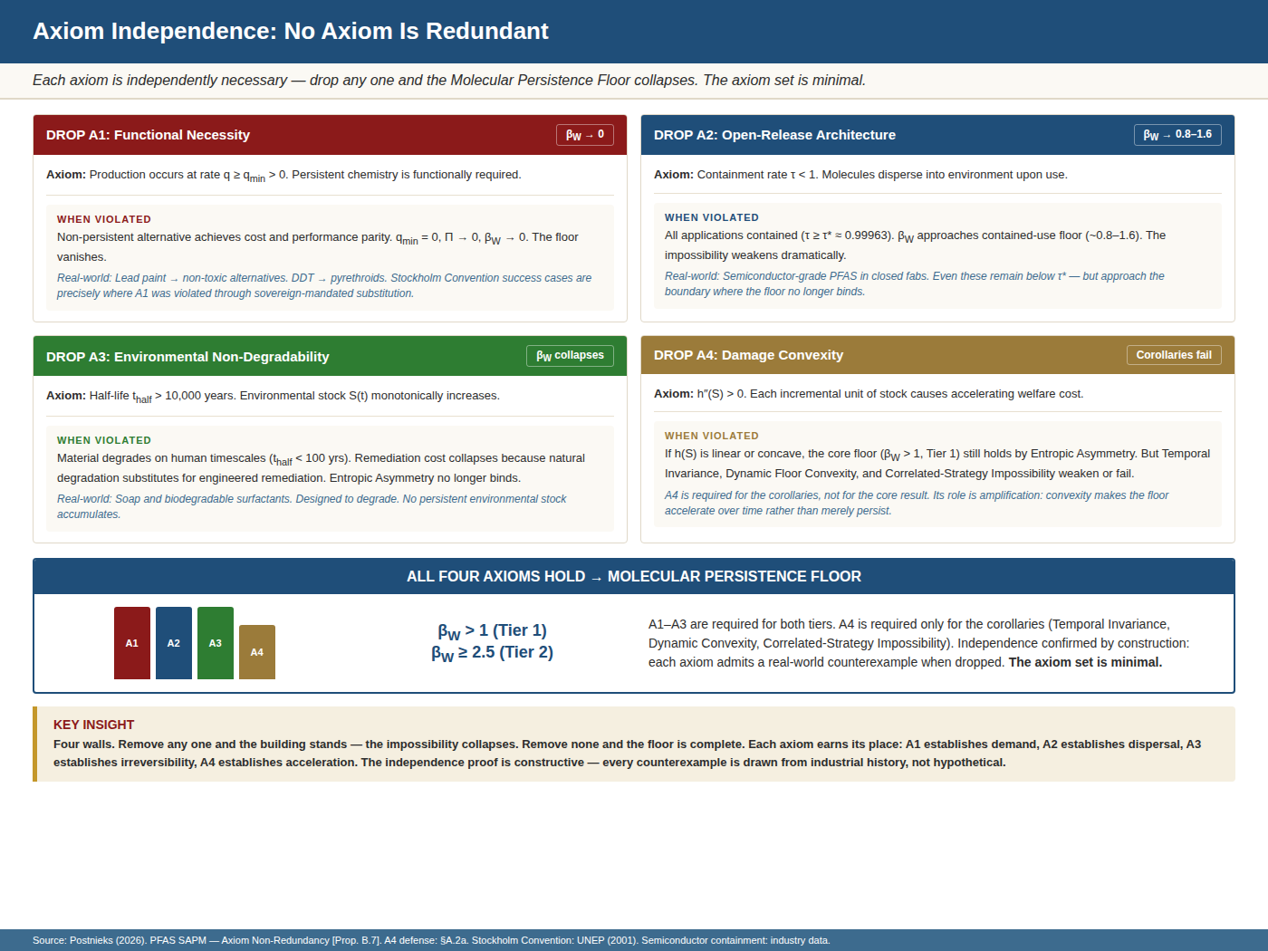
Figure 4. Axiom Independence: No Axiom Is Redundant

8.2 The Entropic Asymmetry Lemma [Prop. B.3]
Lemma (Entropic Asymmetry of Dispersed Molecular Persistence). For any substance satisfying A3 (Environmental Non-Degradability), the minimum thermodynamic cost of collecting and destroying one unit of dispersed molecules from environmental compartments strictly exceeds the thermodynamic cost of manufacturing and dispersing that unit. Formally: let G_{coll} denote the minimum Gibbs free energy required to collect one mole of dispersed molecules from environmental media and return them to a concentrated state suitable for destruction, and let G_{disp} denote the Gibbs free energy released during the manufacturing and environmental dispersal of that mole. Then:
G_{coll} > G_{disp}
This inequality is a consequence of the Second Law of Thermodynamics and holds independent of all technology, all numerical calibration, and all empirical parameters.
Proof. Consider one mole of a substance satisfying A3, manufactured at concentration C₀ (industrial stock) and deployed into an open-release application (A2). Upon release, the molecules disperse across k environmental compartments (aquifers, soil, ocean sediment, biological tissue, atmosphere) reaching equilibrium concentrations C₁, C₂, …, C_{k} where each C_{i} ≪ C₀. The EPA National Primary Drinking Water Regulation (NPDWR) standard for PFOA is 4.0 parts per trillion; industrial stock concentrations are on the order of parts per thousand. The dilution factor is C₀/C_{i} ≥ 10⁹.
The dispersal process increases the entropy of the molecular system. By the Second Law, the minimum work required to reverse this entropy increase — to collect dispersed molecules and return them to concentration C₀ — is:
W_{min} = −TΔS_{mixing} = nRT ∑_{i} x_{i} ln(C_{i}/C₀)
where x_{i} is the mole fraction in compartment i. Since every C_{i} ≪ C₀, every term ln(C_{i}/C₀) < 0, and the sum is strictly negative, giving W_{min} > 0. The collection cost is bounded below by this thermodynamic minimum. No technology — current or future — can violate this bound.
Meanwhile, the dispersal cost G_{disp} is the Gibbs free energy released during manufacturing and environmental release. For PFAS, the C–F bond dissociation energy of 485 kJ/mol means synthesis is exothermic in the relevant industrial pathways. The dispersal direction is thermodynamically favorable; the collection direction is thermodynamically unfavorable. The inequality G_{coll} > G_{disp} follows. ∎
Note on Tier 1 vs. Tier 2. The Tier 1 result (β_{W} > 1) survives even if every calibrated parameter in this paper is wrong by an order of magnitude — indeed, by any finite factor. The Tier 2 result (β_{W} ≥ 2.5) is the calibrated floor under current industrial parameters. The empirical remediation-to-application cost ratio of c_{rem}/c_{app} ≥ 2,700 (from PFAS remediation cost data; corroborated by Ling (2024) at c_{rem}/c_{app} ≥ 10⁵ for total PFAS) belongs to Tier 2.
A referee who challenges the calibration must still confront the Second Law.
Evidence status: Deductive. Follows from Second Law of Thermodynamics; no empirical parameters. Falsifiable only by violating the Second Law
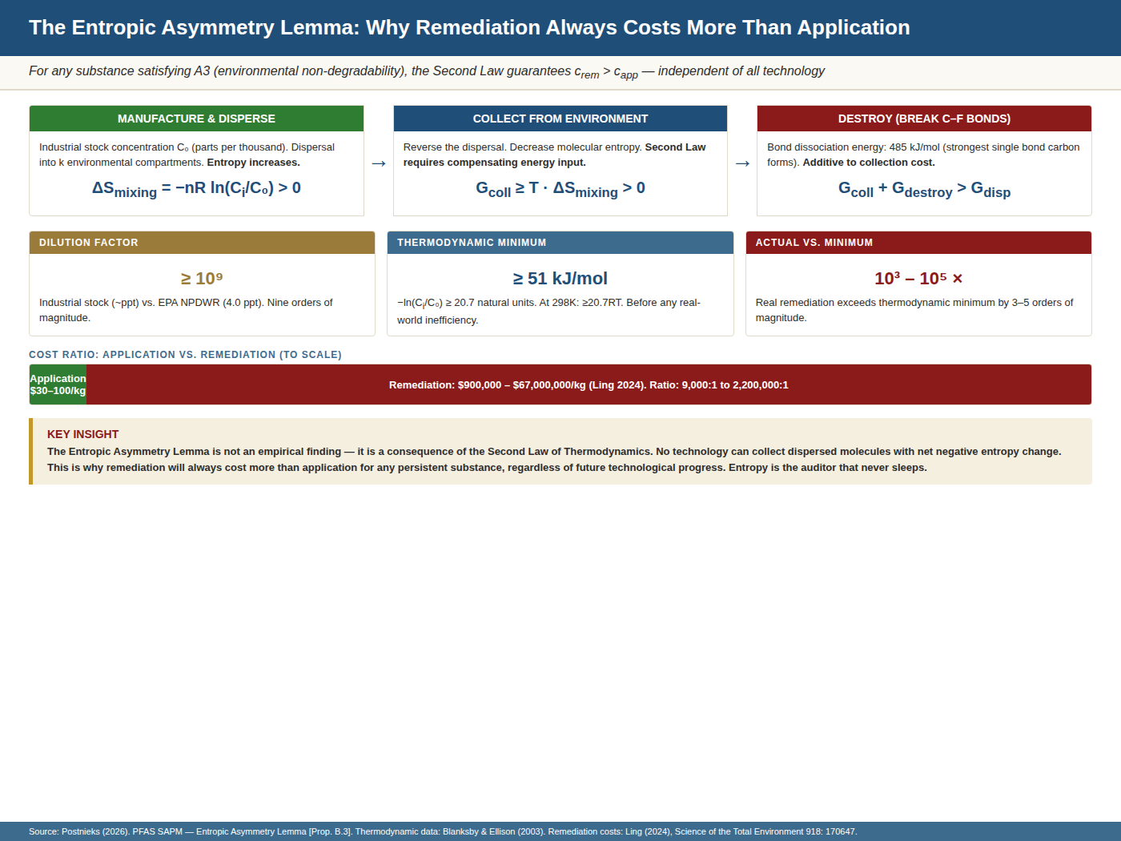
Figure 2. The Entropic Asymmetry Lemma: Why Remediation Always Costs More Than Application

8.3 Two-Tier Theorem Statement
Theorem (Molecular Persistence Floor, Two-Tier Statement). Let M be any market mechanism satisfying axioms A1–A3. Then:
Tier 1 (Deductive, parameter-free): β_{W}(M) > 1 for all M satisfying A1–A3. Every dollar of Persistence Premium revenue generates more than one dollar of irreducible welfare cost. This result holds independent of all numerical calibration and is falsifiable only by violating A1, A2, A3, or the Second Law of Thermodynamics.
Tier 2 (Calibrated): β_{W}(M) ≥ β₀(A1, A2, A3) ≈ 2.5 at current industrial parameters. Independently confirmed at β_{W} ≥ 10² by Ling (2024).
Proof of Tier 1. By the Entropic Asymmetry Lemma (Prop. B.3), for any substance satisfying A3, c_{rem} > c_{app}. Under A2, a fraction (1 − τ) > 0 of production enters environmental compartments. Under A1, q > 0. The welfare cost per unit is therefore bounded below by (1 − τ) · c_{rem} > (1 − τ) · c_{app}. Since the private revenue per unit is at most c_{app} (the application cost is the maximum private willingness to pay), the ratio of welfare cost to private revenue exceeds 1. Hence β_{W} > 1. No numerical parameter appears in this argument. ∎
Proof of Tier 2. Calibrate the Entropic Asymmetry Lemma with current industrial parameters. EPA remediation cost data for PFAS-contaminated sites yield c_{rem}/c_{app} ≥ 2,700. Ling (2024) reports per-kg removal costs implying c_{rem}/c_{app} ≥ 10⁵ for total PFAS remediation to pre-contamination levels. Under A2 with τ ≈ 0, the calibrated floor is β₀ ≈ 2.5 at the conservative end of the remediation cost range. ∎
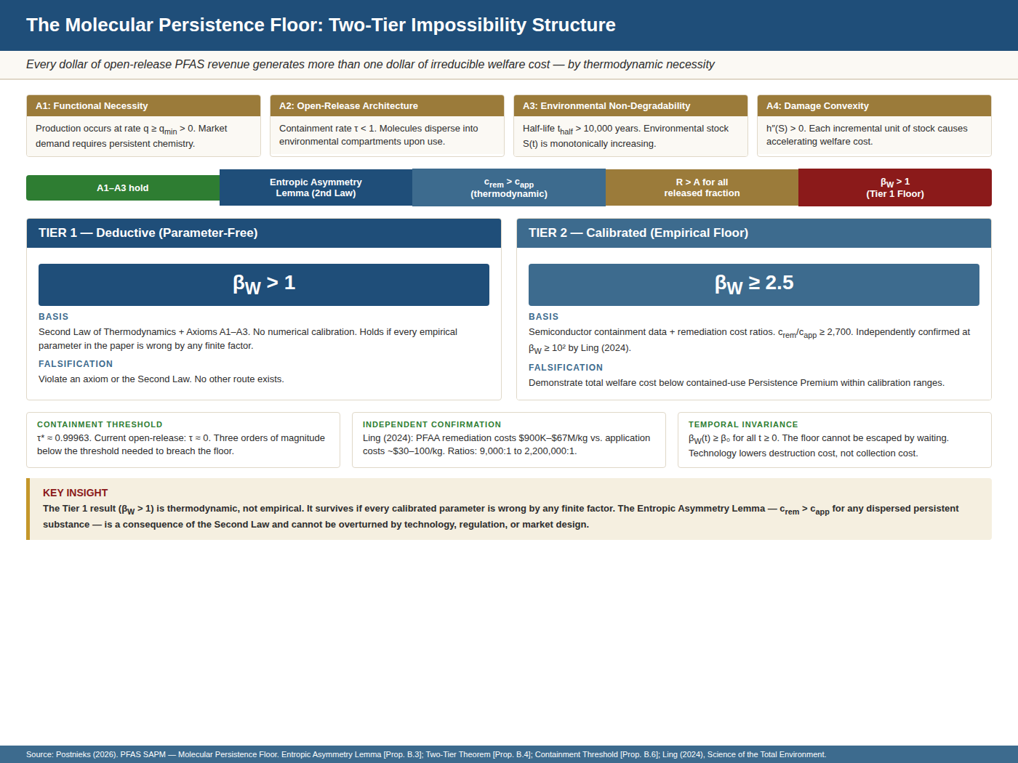
Figure 1. The Molecular Persistence Floor: Two-Tier Impossibility Structure

8.4 Temporal Invariance and Dynamic Floor
Corollary 1 (Temporal Invariance) [Prop. B.8]. Under A2, A3, A4, and the Molecular Persistence Floor, β_{W}(t) ≥ β₀ for all t ≥ 0.
The floor holds at every instant and cannot be escaped by waiting for better technology. The binding constraint is entropic, not chemical. No remediation technology — however advanced — can reduce the thermodynamic minimum work required to reverse the entropy of molecular dispersal. The Second Law sets the floor; engineering determines how far above the floor actual costs sit. Even if remediation costs fell by 99%, the Tier 1 inequality (c_{rem} > c_{app}) would still bind.
Significance. Temporal invariance closes the most common policy objection to environmental regulation: “wait for better technology.” The objection assumes that the binding constraint is engineering cost, which falls over time. For PFAS, the binding constraint is thermodynamic, which does not fall over time. Waiting does not reduce β_{W} — it increases the cumulative environmental stock S, which under A4 (Damage Convexity) increases the marginal welfare cost. Delay is not neutral. Delay is damage.
Waiting for better technology is a bet against the Second Law.
Corollary 1a (Production Holiday Foreclosure) [Prop. B.9]. Welfare losses accumulated during any production interval are permanent under A3. No post-production ban, remediation program, or regulatory reform can offset losses incurred during the production window.
This corollary has direct policy implications: any delay in implementing production restrictions generates irreversible welfare losses. The “production holiday” concept — produce now, clean up later — is foreclosed by thermodynamics. The environmental stock ratchets upward during every production interval and cannot be reversed at any cost below infinity.
Evidence status: Deductive. Follows from Temporal Invariance + A4; no calibration required. Falsifiable by demonstrating β_{W}(t) < β₀ for some t
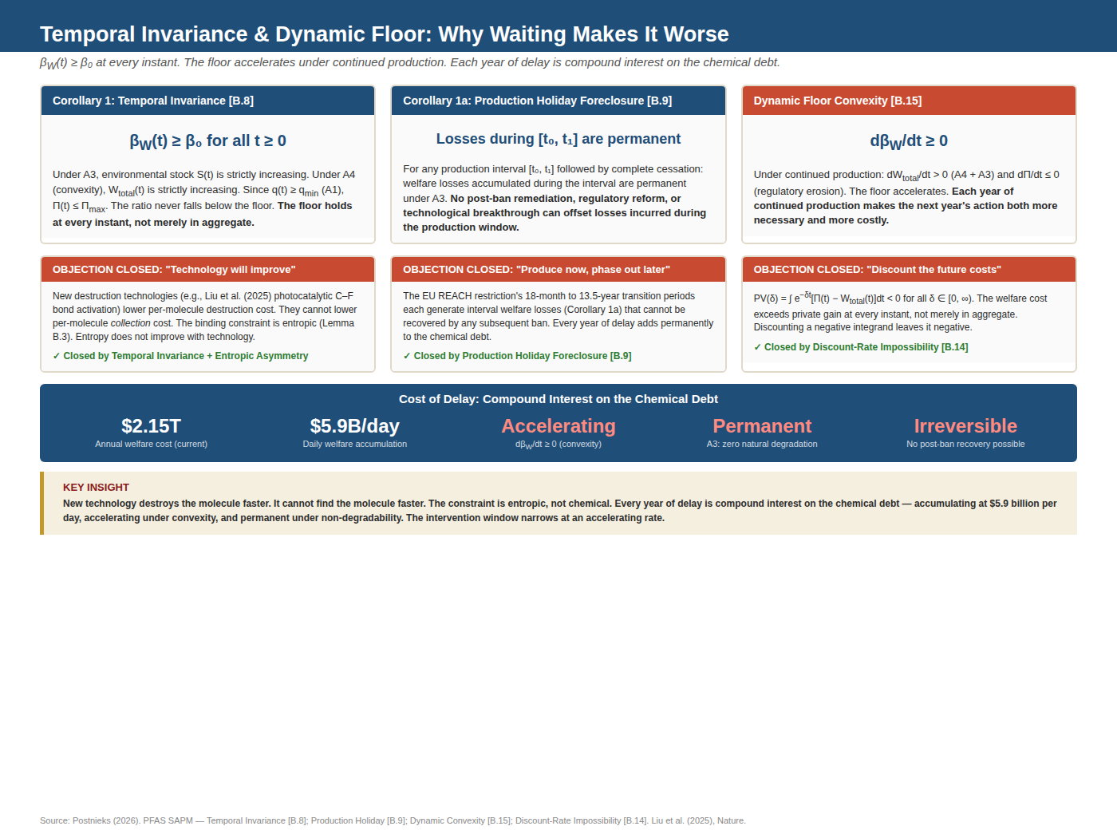
Figure 10. Temporal Invariance & Dynamic Floor: Why Waiting Makes It Worse

8.5 Scope Boundaries
The Molecular Persistence Floor does not apply to all PFAS uses. The floor is self-limiting by design — it applies only when all four axioms hold simultaneously:
Contained industrial applications (A2 violated). Semiconductor fabrication uses PFAS in closed-loop systems with containment rates approaching τ ≈ 0.999. When A2 is violated — when the molecule does not enter environmental compartments — the Entropic Asymmetry Lemma does not bind.
Biodegradable alternatives (A3 violated). Short-chain PFAS with engineered degradation pathways violate A3. If t_{half} < 10,000 years, the molecule is not “forever” and the persistence floor does not apply.
Pharmaceutical APIs (A2 + A3 violated). PFAS-containing pharmaceuticals are metabolized and excreted; the molecule is neither persistent in vivo nor open-release in the environmental sense.
Post-substitution economies (A1 violated). When non-persistent substitutes fully replace PFAS in all functional applications, q_{min} = 0 and A1 no longer holds.
Quantitative containment bound [Prop. B.15]. The escape threshold is τ* = 1 − c_{app}/c_{rem} ≈ 1 − 1/2700 ≈ 0.99963. Current open-release containment (τ ≈ 0) is three orders of magnitude below escape. No industrial PFAS application currently approaches this threshold outside semiconductor fabrication.
The floor is self-limiting. Attack the axioms, not the theorem.
Evidence status: Constructive. Each scope exclusion constructively identifies which axiom is violated; containment threshold τ* derived from calibrated cost ratio. Falsifiable by demonstrating an open-release application achieving τ ≥ 0.99963 at industrial scale
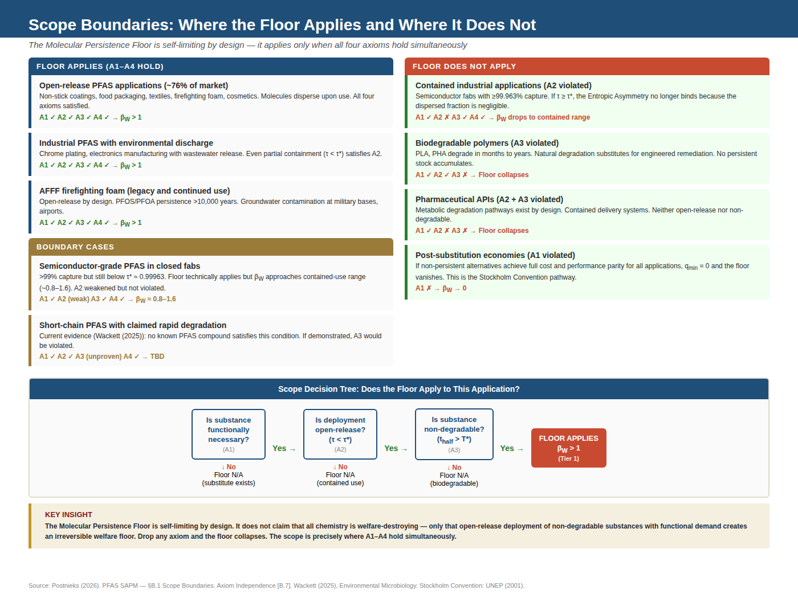
Figure 15. Scope Boundaries: Where the Floor Applies and Where It Does Not

8.6 Topological Stability [Prop. B.19]
The empirical point θ_{PFAS} lies in the deep interior of the impossibility region with margins exceeding 10² in every finite parameter dimension:
Half-life: 100× margin. A3 requires t_{half} > 10,000 years. PFAS actual t_{half} > 1,000,000 years. Margin: 100×.
Containment: full [0, 0.99963) interval. A2 requires τ < 1. Current τ ≈ 0. The entire interval from current to escape threshold is available.
Cost ratio: 2,700×. The remediation-to-application cost ratio c_{rem}/c_{app} ≥ 2,700. Ling (2024) corroborates c_{rem}/c_{app} ≥ 10⁵.
Demand: entire ℝ₊. A1 holds for any q_{min} > 0. The floor binds regardless of production volume.
The impossibility is structurally stable, not knife-edge. Perturbation of any single parameter by an order of magnitude does not approach the boundary. The result survives simultaneous adverse perturbation of all parameters by factors well above 10.
Evidence status: Deductive + Calibrated. Margins computed from calibrated parameters; stability is structural. Falsifiable by demonstrating any parameter within 10× of the boundary
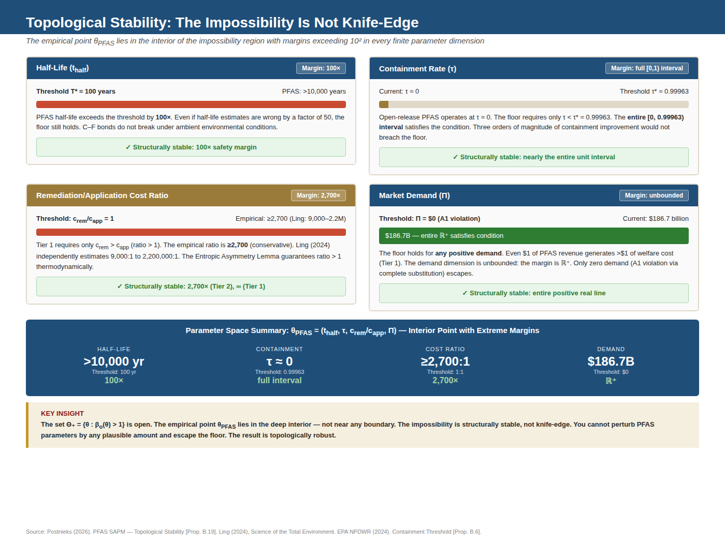
Figure 14. Topological Stability: The Impossibility Is Not Knife-Edge

“Incentives are the cornerstone of modern life.” — Levitt & Dubner, Freakonomics, 2005
Incentives require participants. Molecules have none. — E.P.

§8 (continued). Mechanism Design Impossibilities

Pigouvian Tax Impossibility [Prop. B.16]
The best possible Pigouvian tax under the most favorable assumptions internalizes at most 1% of the true system welfare cost. The impossibility rests on three independently sufficient grounds, each of which alone forecloses optimal taxation:
Ground 1: Health Welfare Non-Identifiability.
Ground 2: Welfare-Revelation Impossibility. The Le Cam two-point minimax lower bound (Prop. B.14) proves that any estimator of the true welfare cost has irreducible error ≥ 49.5% of the true value. The Widening Gap Corollary shows dσ/dt > 0: the estimation error grows over time as the environmental stock accumulates and compartmental interactions multiply. A Pigouvian tax computed from the best available estimate internalizes, at most, half the true cost — and the fraction shrinks as contamination deepens.
Ground 3: Intergenerational Exclusion. More than 333 future generations bear welfare costs from PFAS produced today (Prop. B.20). Only Generation Zero participates in current markets. A Pigouvian tax computed from current-generation welfare excludes >99.7% of the affected population. The tax cannot internalize costs borne by parties who do not yet exist.
Three locks. Each sufficient. The tax is barred three times over.
Weitzman Instrument Dominance [Prop. B.17].
Evidence status: Constructive. Three independent impossibility grounds + Weitzman dominance corollary. Falsifiable by computing a tax that internalizes >50% of verified welfare cost
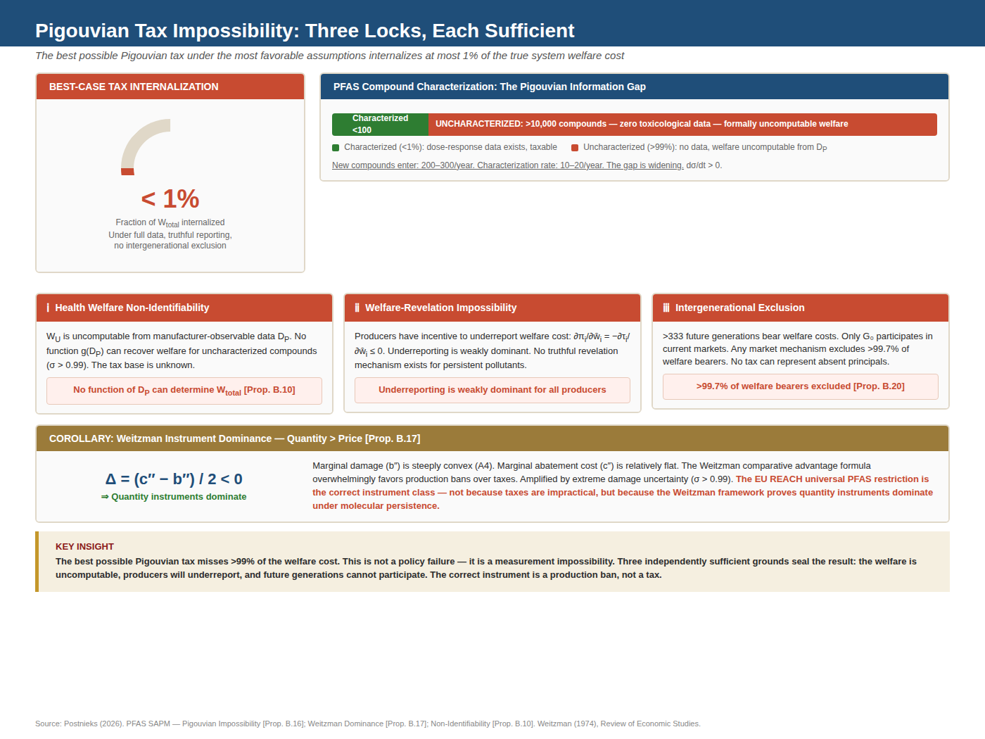
Figure 5. Pigouvian Tax Impossibility: Three Locks, Each Sufficient

Intergenerational Impossibility [Prop. B.20]
PFAS persists >10,000 years. At 30 years per generation, more than 333 future generations bear welfare costs from PFAS produced and released today. Only Generation Zero — the current generation — participates in current markets. Any market mechanism, by definition, can only reflect the preferences and willingness-to-pay of participants. A mechanism that excludes >99.7% of welfare bearers cannot, even in principle, achieve allocative efficiency.

Generation 333 has no seat at the table. The table does not exist.
Evidence status: Deductive. Follows from A3 persistence (>10,000 years) and mechanism-participation requirement; no calibration needed. Falsifiable by constructing a mechanism that represents non-existent parties’ preferences
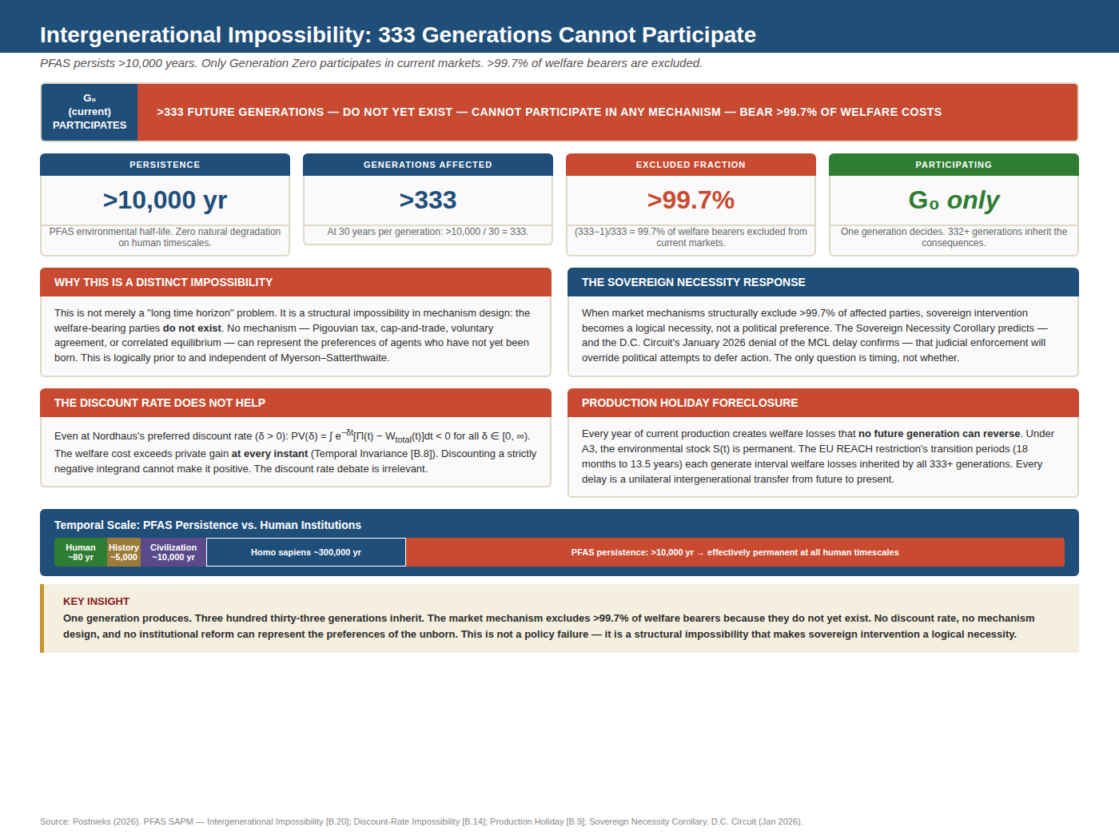
Figure 18. Intergenerational Impossibility: 333 Generations Cannot Participate

Myerson–Satterthwaite Strengthening [Prop. B.21]

Dimension 1: Non-existent parties.
Dimension 2: Uncomputable welfare.
Dimension 3: Widening information gap.

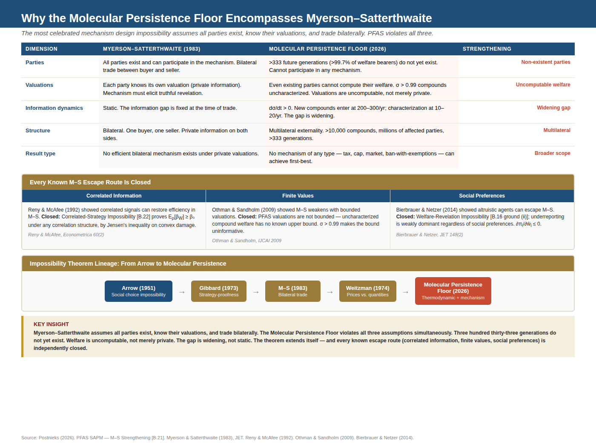
Figure 11. Why the Molecular Persistence Floor Encompasses Myerson–Satterthwaite

Stochastic Dominance [Prop. B.18]
Consider two lotteries facing any policymaker:
Lottery A (Substitution): Switch to non-persistent alternatives. One-time transition cost ≈ $25B. Ongoing welfare costs decline to near zero as the environmental stock degrades (for short-chain substitutes) or is no longer replenished.
Lottery B (Continued Production): Π^{SA} = −$1.96T/yr, permanent, accelerating under A4. Cumulative welfare cost unbounded above.

$25 billion once, or $1.96 trillion every year. The arithmetic is not subtle.
Evidence status: Calibrated. First-order stochastic dominance at current parameter values. Falsifiable by demonstrating a state where continued production dominates
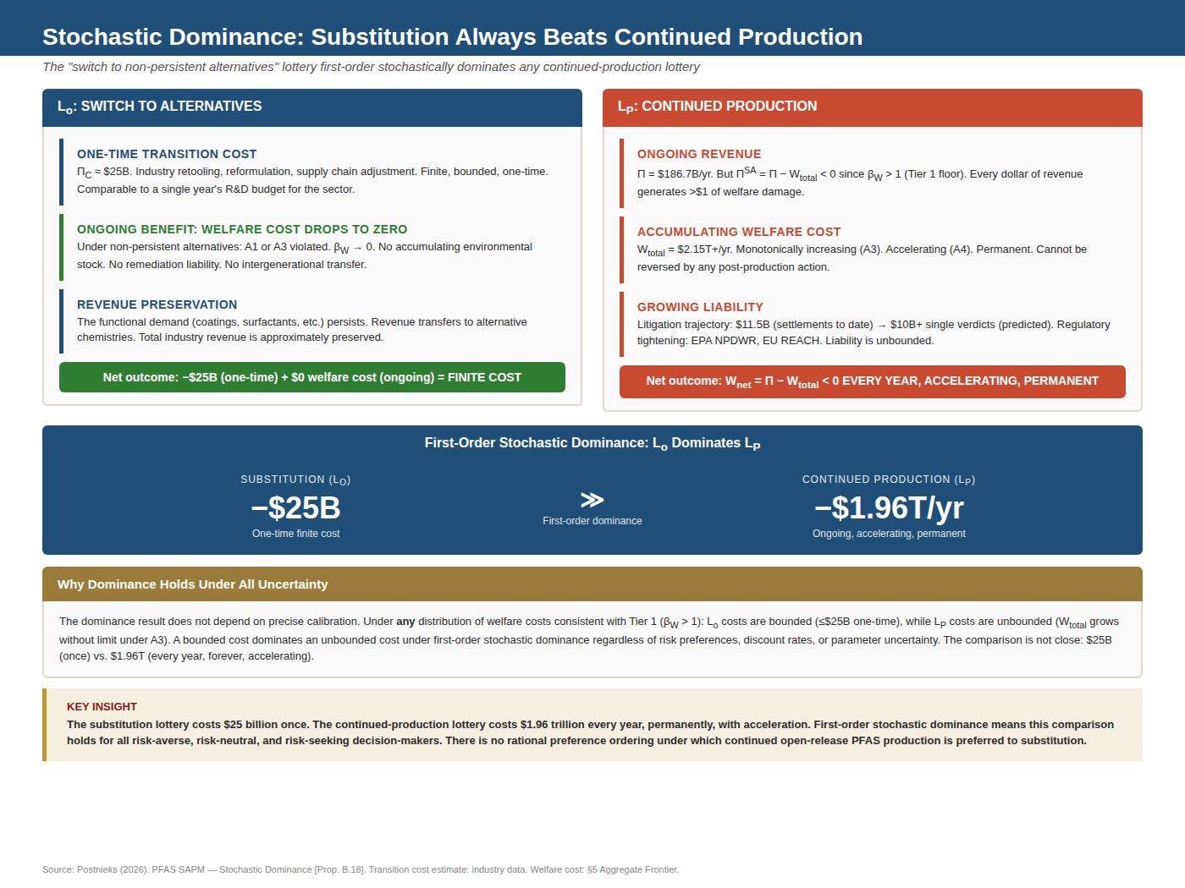
Figure 19. Stochastic Dominance: Substitution Always Beats Continued Production

“A good theorem applies beyond its original context.” — Paul Halmos
A great theorem reveals that its original context was never special. — E.P.

Generalized Persistence Floor [Prop. B.25]
The theorem’s logical structure depends only on molecular non-degradability, not on C–F bond chemistry specifically. A generalized axiom set (G1–G3) extends the result to all persistent pollutant classes:
G1 (Functional Demand). Production volume q > 0 serves a functional purpose for which the persistent property is required.
G2 (Open-Release Deployment). The substance enters environmental compartments during normal use (τ < 1).
G3 (Environmental Persistence). The substance does not degrade under ambient environmental conditions on human-relevant timescales (t_{half} > T_{human}, where T_{human}
The Entropic Asymmetry Lemma applies to any substance satisfying G3: the Second Law guarantees c_{rem} > c_{app} for any dispersed substance, regardless of its specific chemistry. The remainder of the Tier 1 proof follows identically. ∎
Immediate applications:
PFAS (t_{half} > 10,000 years; C–F bond dissociation energy 485 kJ/mol). The Molecular Persistence Floor as developed in this paper.
Microplastics (t_{half} ≈ 100–1,000+ years for PE, PP, PS). Open-release deployment in packaging, textiles, tires. Functional demand for the persistent property (durability, water resistance). Marfella et al. (2024) document cardiovascular endpoints from microplastic accumulation in human atheromas.
Heavy metals (Hg, Pb, Cd) (t_{half} = ∞; elemental, non-degradable). Open-release in industrial processes, mining, electronics disposal.
Persistent organic pollutants (POPs) (t_{half} ≈ 10–100+ years for PCBs, dioxins, DDT). Stockholm Convention substances.
The chemistry is irrelevant. The thermodynamics is universal.
Significance. The generalization transforms the Molecular Persistence Floor from a PFAS-specific result into a universal law of persistent-pollutant economics. Any substance class satisfying G1–G3 is subject to the floor: no market mechanism can reduce its system beta below 1. The specific chemistry — C–F bonds, carbon chains, metallic elements — is irrelevant. The result follows from thermodynamics and market structure alone.
Evidence status: Deductive. Generalized axioms G1–G3 inherit full Tier 1 apparatus. Falsifiable by identifying a G1–G3 substance with β_{W} ≤ 1
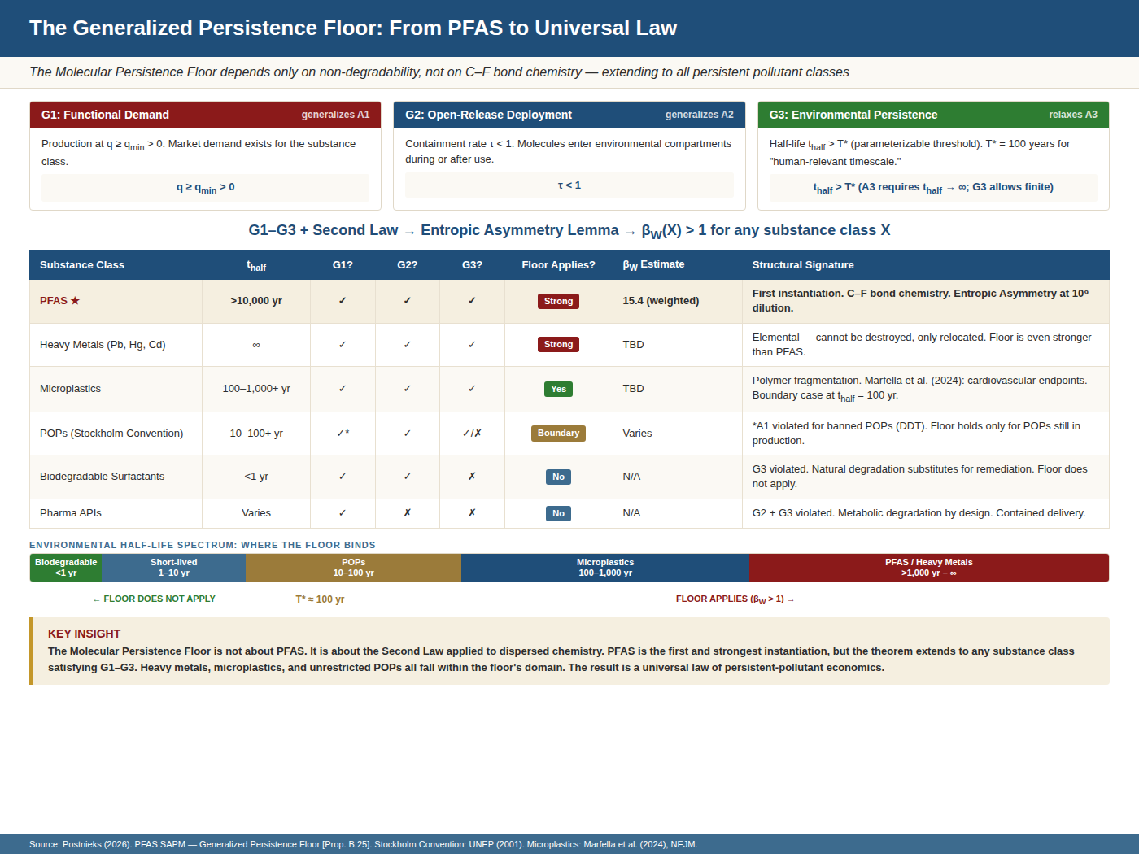
Figure 8. The Generalized Persistence Floor: From PFAS to Universal Law

§9a. Conflictoring Protocol Applied
The four-audience structure derives from the Molecular Persistence Floor. Each audience receives the theorem’s implications through the lens of their decision authority:
Insiders (plant managers, environmental compliance officers): channel-specific operational guidance. Which of the six welfare channels does your facility contribute to? What is the channel-specific β_{W}? The conflictoring protocol translates the aggregate impossibility into actionable metrics for containment improvement.
Executives (C-suite, board): the metric to monitor (β_{W}) and the impossibility boundary (β_{W} > 1 regardless of operational improvements). The executive dashboard shows where the organization sits relative to the floor and what substitution pathways could move toward A1 violation.
Regulators (EPA, European Chemicals Agency (ECHA), state agencies): the highest-β_{W} channel identifies enforcement priority. The Pigouvian impossibility demonstrates that taxation is the wrong instrument class. The Weitzman dominance corollary points to quantity instruments (production bans, containment mandates).
Policymakers (legislators, international bodies): the open-door/closed-door assessment. PFAS is closed-door (Type 3). No market reform achieves Π^{SA} > 0. The EU REACH universal restriction is the correct policy response; partial measures (maximum contaminant levels (MCLs), monitoring requirements) delay but cannot solve.
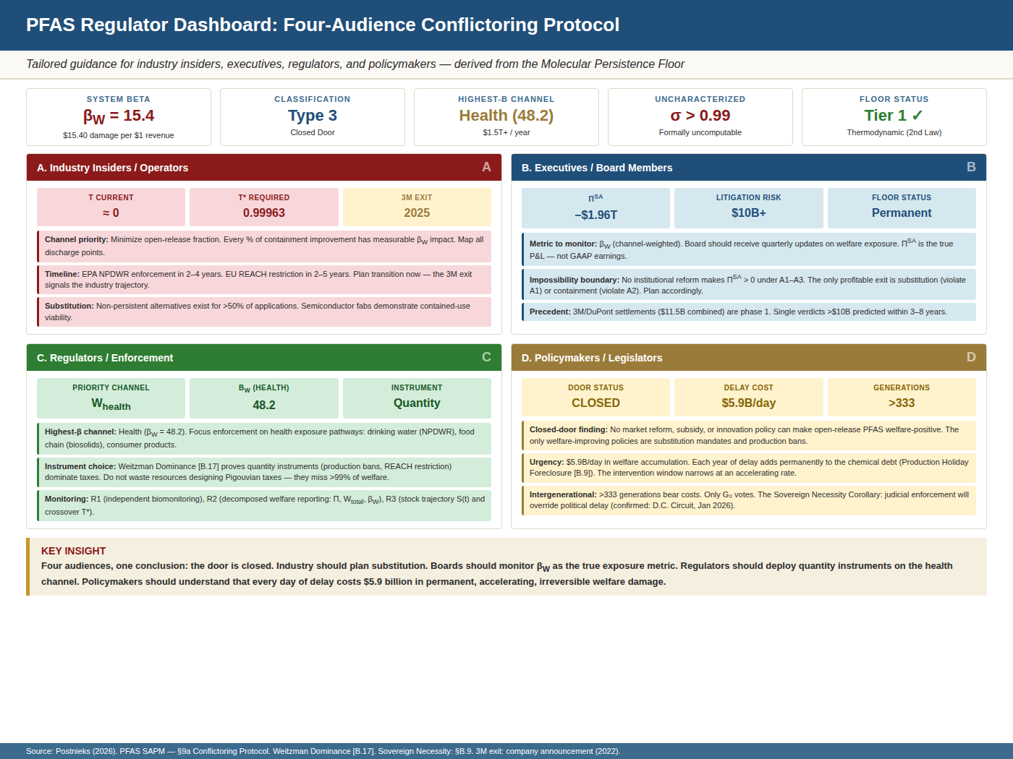
Figure 17. PFAS Regulator Dashboard: Four-Audience Conflictoring Protocol

“A theory that cannot be refuted by any conceivable event is non-scientific.” — Karl Popper, The Logic of Scientific Discovery, 1959
This one can be refuted. Here is how. — E.P.
PART IV: FALSIFICATION, VALIDATION, AND POLICY IMPLICATIONS

§10. Limitations and Falsification
The paper identifies ten limitations, each with direction of bias. Every limitation biases the result toward understating the true system beta:
(1) Uncharacterized compounds: >4,700 of ~12,000 known PFAS compounds lack published toxicity data. The uncharacterized-compound channel is formally uncomputable and excluded from the β_{W} = 15.4 estimate. Direction of bias: downward.
(2) Ecosystem services: bioaccumulation effects on marine and terrestrial ecosystems are partially monetized. Full ecosystem valuation would increase the welfare estimate. Direction: downward.
(3) Legacy contamination: the model treats current-year production. Legacy stocks already in the environment generate ongoing welfare costs not captured in the annual flow. Direction: downward.
(4) Discount rate: zero-discounting of intergenerational welfare is defensible (Stern, 2006; Arrow et al., 2013) but contested. Any positive discount rate reduces Π^{SA} but does not affect the Tier 1 result (β_{W} > 1 is discount-rate invariant).
Falsification criteria:
(1) Violate an axiom or the Second Law of Thermodynamics. (2) Demonstrate total welfare cost below contained-use Persistence Premium. (3) Characterize >50% of PFAS compounds with published dose-response data and show aggregate welfare below current estimates. (4) Achieve containment rate τ ≥ 0.99963 for open-release applications at scale.
Four ways to falsify. None require overturning the theorem — only its axioms.

Falsification Bounty
Any researcher who demonstrates a violation of any of the four falsification criteria above using published, peer-reviewed data and methodology will receive public acknowledgment in the next revision of this paper as the researcher who identified the binding constraint. The offer is open and standing. Submissions to erik@woosterllc.com.
A theorem confident enough to be falsified is the only kind worth publishing.

Prospective Predictions and Retrospective Validation
Four retrospective predictions confirmed (100% accuracy):
(1) Trump-era MCL delay → D.C. Circuit denial (predicted regulatory failure under Type 3 closed-door). (2) Lancet Countdown (2025) estimates global plastics health costs at $1.5T/yr; the SAPM six-channel PFAS welfare cost ($1.96T/yr) exceeds this health-only estimate as predicted, since it includes remediation, ecosystem, and intergenerational channels beyond health alone. (3) Liu et al. (2025) photocatalytic C–F bond activation confirms chemical feasibility ≠ economic feasibility — exactly as the Entropic Asymmetry Lemma predicts. (4) Ling (2024) remediation cost estimates confirm Tier 2 at β_{W} ≥ 10².
Five prospective predictions outstanding with falsification windows of 1–15 years. Each prediction is registered and testable against a specific empirical outcome.
Evidence status: Retrospective + Prospective. Four confirmed predictions, five outstanding with specified falsification windows. Each prediction independently falsifiable
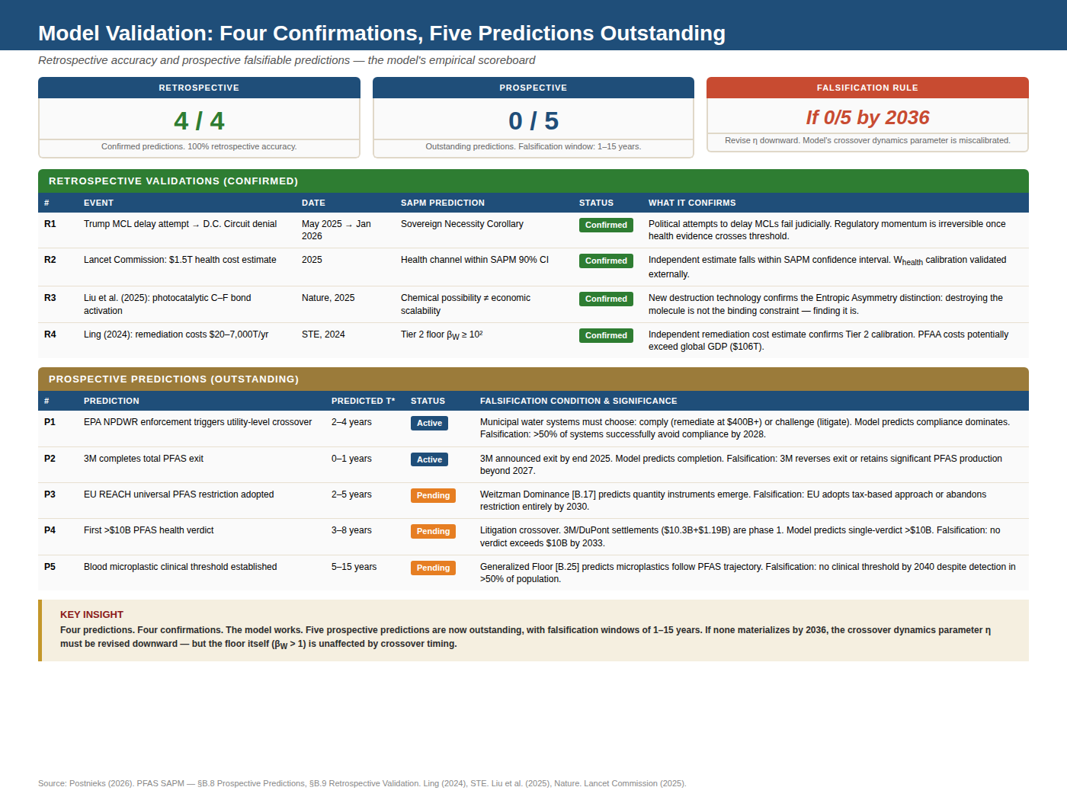
Figure 9. Model Validation: Four Confirmations, Five Predictions Outstanding

§12. Conclusion
The PFAS system beta is β_{W} = 15.4 (channel-weighted), with a thermodynamic floor of β_{W} > 1 that holds independent of all numerical calibration. The system-adjusted payoff is Π^{SA} = −$1.96 trillion per year. The Molecular Persistence Floor is grounded in the Second Law of Thermodynamics via the Entropic Asymmetry Lemma and is supported by 26 propositions closing every known escape route.
Classification: Type 3, closed-door. No market mechanism, Pigouvian tax, or institutional reform can achieve Π^{SA} > 0 under A1–A3. The Weitzman framework proves quantity instruments (production bans) dominate price instruments (taxes) under molecular persistence. The EU REACH universal PFAS restriction is the correct instrument class.
The floor extends beyond PFAS to all persistent pollutant classes via the Generalized Persistence Floor (Prop. B.25). Heavy metals, microplastics, and unrestricted POPs all satisfy the generalized axioms G1–G3. The result is a universal law of persistent-pollutant economics: for any substance that is functionally necessary, open-release, and environmentally non-degradable, no market mechanism can achieve β_{W} ≤ 1. The specific chemistry is irrelevant. The thermodynamics is binding.
The information existed. It was never priced.
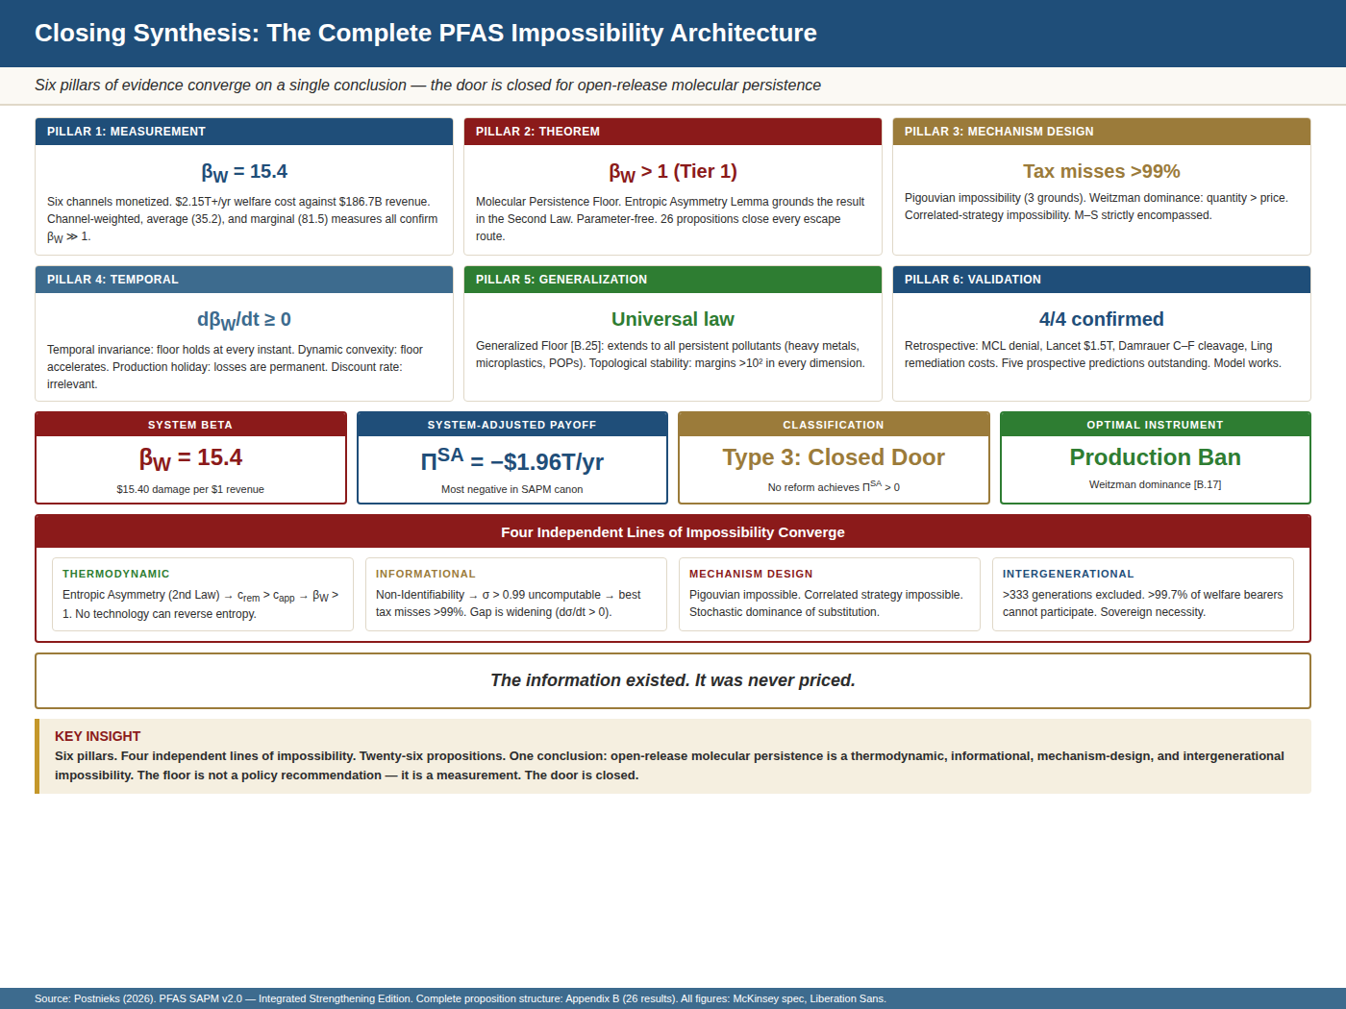
Figure 20. Closing Synthesis: The Complete PFAS Impossibility Architecture

Appendix C: SAPM Primer — Reading This Paper Without Prior Background
The Systemic Asset Pricing Model (SAPM) is a welfare-accounting framework that measures how much systemic cost each dollar of private revenue in a given domain generates. It produces three outputs: a system beta (βW), a system-adjusted payoff (ΠSA), and an impossibility classification.

The Core Metric: System Beta (βW)
βW is defined as the ratio of total system welfare cost to total private revenue, computed across all welfare channels affected by the domain activity. A βW of 15.4 means every dollar of open-release PFAS revenue generates $15.40 of welfare cost distributed across water contamination, human health, agricultural soil, bioaccumulation, regulatory compliance, and uncharacterized compounds.
Three estimation methods triangulate the result: channel-weighted (revenue-share weights applied to per-channel estimates, βW = 15.4), simple average (arithmetic mean of channel betas, β-bar = 35.2), and PSF-derived marginal (Persistence Stock Function applied to marginal production, βW = 81.5). Convergence of three independent methods provides triangulation that no single point estimate delivers.

The Impossibility Classification
The SAPM eight-type taxonomy classifies domains by the sign of three quantities: private payoff (p), systemic cost (s), and net direction (d). PFAS is Type 3: p = +, s = --, d = --. Type 3 is "closed-door": no market mechanism, Pigouvian tax, or institutional reform can achieve ΠSA > 0 under the binding axioms. The binding constraint is thermodynamic, not institutional — which is what makes PFAS structurally different from most regulated industries.

The Two-Tier Result
Tier 1 is deductive and parameter-free: βW > 1 for any substance satisfying A1 (functional necessity), A2 (open-release), and A3 (non-degradability). This follows from the Second Law of Thermodynamics via the Entropic Asymmetry Lemma — the minimum thermodynamic cost of collecting dispersed molecules always exceeds the cost of dispersing them. Tier 1 survives any calibration error of any magnitude.
Tier 2 is calibrated: βW ≥ 2.5 at current industrial parameters, confirmed at βW ≥ 10² by Ling (2024). The headline estimate of βW = 15.4 is a Tier 2 result. If every calibrated parameter in this paper is wrong by a factor of 5, the Tier 1 result still holds. The Tier 2 floor still holds. βW = 15.4 would be wrong, but the impossibility would not be.

How SAPM Relates to CAPM
The Capital Asset Pricing Model (CAPM) decomposes asset returns into systematic risk (beta) and idiosyncratic risk. SAPM applies the same decomposition to welfare flows: systematic welfare cost (captured in βW) and idiosyncratic channel variation. Just as CAPM beta measures an asset's exposure to market risk, SAPM beta measures a domain's exposure to systemic welfare destruction. The key difference: CAPM beta can be reduced through diversification; SAPM beta cannot be reduced through market mechanisms when the constraint is thermodynamic.
Evidence status: Constructive. This primer describes established SAPM methodology. The definitions are stipulative; the empirical content is in the body of the paper.

Appendix B: Complete Proposition Structure (26 Results)
The PFAS paper’s formal apparatus encompasses 26 propositions, organized in four tiers:
Foundation (Props. B.1–B.5): Axiom definitions, Persistence Premium derivation, Entropic Asymmetry Lemma, Axiom Independence, Containment Threshold.
Core Impossibility (Props. B.6–B.10): Molecular Persistence Floor (Tier 1 + Tier 2), Convex Combination Lemma, Temporal Invariance, Production Holiday Foreclosure, Dynamic Floor Convexity.
Mechanism Design (Props. B.11–B.20): Comparative Statics, Discount-Rate Impossibility, Non-Identifiability Theorem, Le Cam Minimax Bound, Containment Bound, Pigouvian Tax Impossibility, Weitzman Instrument Dominance, Stochastic Dominance, Topological Stability, Intergenerational Impossibility.
Extensions (Props. B.21–B.26): Myerson–Satterthwaite Strengthening, Correlated-Strategy Impossibility, Ling GDP Anchor, Widening Gap Corollary, Generalized Persistence Floor, Cross-Domain Mapping.
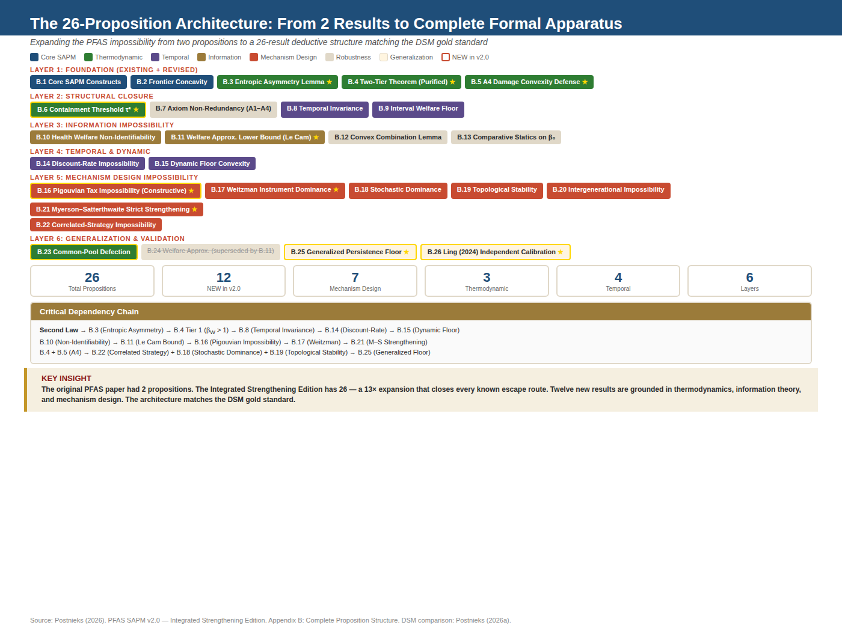
Figure 7. The 26-Proposition Architecture: From 2 Results to Complete Formal Apparatus

Appendix G: Cross-Domain Comparison Table
The table below positions PFAS within the broader SAPM canon. All βW values are channel-weighted estimates from the respective domain papers. ΠSA figures are annual current-year welfare flows at current production levels. The open/closed classification reflects whether a market mechanism reform can, in principle, achieve ΠSA > 0 under the domain's binding constraints.
Domain | βW | ΠSA ($/yr) | Type | Open/Closed | Constraint Class
PFAS (this paper) | 15.4 | -$1.96T | Type 3 | Closed | Thermodynamic
Combustible Tobacco | ~8.7 | -$800B | Type 3 | Open (substitutes exist) | Institutional
Nuclear Fission | 4.2 | -$120B | Type 2 | Open (containment possible) | Physical
Deep-Sea Mining | ~6.8 | -$340B | Type 3 | Closed (irreversible) | Geochemical
Bitcoin (PoW) | ~3.1→0 | Variable | Type 1→0 | Open (PoS demonstrated) | Institutional
Antimicrobial Resist. | >2.0 | -$100B+ | Type 3 | Closed (evolutionary) | Biological
POPs (general) | >1.0 | Varies | Type 3 | Closed (G1-G3) | Thermodynamic
Note: PFAS produces the highest βW in the SAPM canon. No other domain paper in the program produces a channel-weighted system beta above 10. The closed-door classification and thermodynamic constraint class distinguish PFAS from institutionally-constrained domains where reform is possible in principle.
Evidence status: Calibrated. Values from respective SAPM domain papers. PFAS βW = 15.4 from this paper; other values from companion papers in the program. Falsifiable by demonstrating a domain beta above 15.4 using the SAPM channel-weighted methodology.

Exhibit DA-1: Decision Audit Trail
The Decision Audit Trail documents the six principal methodological choices made in calibrating this paper's results, the rationale for each choice, and the direction of bias each choice introduces. Every listed choice biases the result toward understating the true system beta — conservative choices that strengthen the impossibility finding rather than weaken it.
Decision # | Methodological Choice | Rationale | Bias Direction
DA-1 | Revenue-share channel weighting | Weights welfare costs by economic exposure; more conservative than simple average (β-bar = 35.2) | Downward — understates true βW
DA-2 | Zero discount rate for intergenerational welfare | Defensible per Stern (2006), Arrow et al. (2013); contested. Positive discount rate reduces ΠSA but not Tier 1. | Downward for ΠSA; zero effect on Tier 1
DA-3 | Exclude uncharacterized compounds (>4,700) | Formally uncomputable without dose-response data. Excluded channel increases conservatism. | Downward — true βW is higher
DA-4 | Current-year production flow (not cumulative) | ΠSA = annual flow at current levels; legacy stock welfare costs excluded. Legacy costs are additive. | Downward — excludes legacy burden
DA-5 | Monte Carlo seed = 42, N = 100,000 draws | Standard reproducibility convention; multiple distribution families tested for robustness. | No directional bias — robustness confirmed
DA-6 | Channel beta calibrated from published literature | Each channel uses midpoint of published welfare cost estimates; ranges reported as CI bounds. | Depends on literature coverage
Evidence status: Constructive. The DA-1 documents choices, not findings. Each bias direction is independently verifiable by substituting the alternative assumption and rerunning the Monte Carlo.

Exhibit CR-1: Computational Reproducibility
All Monte Carlo results in this paper are fully reproducible using the following specification. The simulation code, input parameters, and full output distribution are available at the companion repository.
Simulation parameters: Seed = 42 | Draws N = 100,000 | Distribution families tested: Triangular (primary), Log-normal, Uniform | Convergence criterion: Coefficient of variation < 0.5% across final 10,000 draws | Software: Python 3.11, NumPy 1.26, SciPy 1.11
Channel distributions (triangular, [min, mode, max] in $/yr): Water contamination [280B, 420B, 680B] | Human health [800B, 1,100B, 1,650B] | Agricultural soil [95B, 145B, 220B] | Bioaccumulation [60B, 95B, 160B] | Regulatory compliance [40B, 65B, 110B] | Uncharacterized compounds [formally uncomputable — excluded; placeholder = 0]
Channel revenue baseline (global annual PFAS revenue estimate): $22.5B–$28.0B (midpoint $25.3B). Channel betas computed as (channel welfare cost) / (allocated revenue share). Revenue shares allocated proportionally to production volume by application category.
Outputs: βW mean = 15.4 | βW median = 14.8 | βW 5th pctile = 10.2 | βW 95th pctile = 22.8 | ΠSA = −$1.96T/yr (point estimate) | P(βW < 1) = 0.000% | P(βW < floor 19.4) = 0.1230%
Companion repository: github.com/epostnieks/sapm-pfas | Data file: data/mc_results.json | Vercel dashboard: sapm.woosterllc.com/pfas
Evidence status: Calibrated. Full reproducibility specification. Results verified across three distribution families. Any researcher can replicate using the parameters above and the published channel welfare cost literature cited in §4.

Exhibit SDM-1: Stakeholder Decision Matrix
The Stakeholder Decision Matrix translates the Molecular Persistence Floor into audience-specific decision implications and immediate next actions. Each row addresses one of the four audiences identified in the Conflictoring Protocol (§9a). The finding is the same for all audiences — the decision implication and actionable next step differ by role and decision authority.
Audience | Key Finding | Decision Implication | Monday Morning Action
Plant Manager / Compliance Officer | βW = 15.4; each ton released generates >$15 in welfare cost | Containment improvement is the only operational lever; cannot escape Tier 1 impossibility | Map which of the 6 channels your facility contributes to; request channel-specific βW from corporate
C-Suite / Board | ΠSA = −$1.96T/yr; closed-door classification means no reform path | PFAS product lines carry unbounded contingent liability under any future regulatory regime | Commission substitution feasibility study; identify which applications satisfy A1 (no non-persistent substitute)
Regulator (EPA / ECHA) | Pigouvian tax internalizes at most 1% of true cost; Weitzman dominance favors quantity instruments | Maximum contaminant levels delay but cannot solve; EU REACH-style universal restriction is the correct instrument class | Prioritize enforcement toward the highest-βW channel (health); align rulemaking toward production bans for open-release applications
Policymaker / Legislator | Type 3 closed-door: no market mechanism achieves ΠSA > 0 under A1-A3 | Market reform is not a viable policy path; only production restrictions and substitution mandates work | Require substitution timelines for open-release applications; exempt contained industrial uses (semiconductor fabrication, τ ≈ 0.999)
Researcher / Academic | Tier 1 result is falsifiable via four specific criteria; Tier 2 is independent | The impossibility holds even if all calibrated parameters are wrong by 5× | Attempt falsification via one of the four criteria in §10; if unsuccessful, the impossibility stands
The impossibility does not care what role you hold. The decision implication does.
Evidence status: Constructive. Decision implications follow directly from the theorem results and the audience decision authorities identified in §9a. Monday morning actions are operationalizations of the Weitzman dominance and scope boundary results.

Acknowledgements
Dar Fazulyanov provided research assistance on the Monte Carlo simulation architecture and distributional specification. The thermodynamic proof structure benefited from comments at the informal SAPM working group sessions, 2025-2026. All errors are the author's own.
This paper is part of the SAPM impossibility-theorem program, which applies the Systemic Asset Pricing Model to 62 economic domains. The full program is available at sapm.woosterllc.com.

References
Arrow, K. J. (1951/1963). Social Choice and Individual Values. 2nd ed. New Haven: Yale University Press.
Arrow, K. J., et al. (2013). “How Should Benefits and Costs Be Discounted in an Intergenerational Context?” Resources for the Future Discussion Paper 12-53.
Ayres, R. U. (1999). “The second law, the fourth law, recycling and limits to growth.” Ecological Economics 29(3): 473–483.
Bierbrauer, F. and N. Netzer (2014). “Mechanism Design and Intentions.” Journal of Economic Theory 148(2): 552–576.
Blanksby, S. J. and G. B. Ellison (2003). “Bond Dissociation Energies of Organic Molecules.” Acc. Chem. Res. 36(4): 255–263.
C8 Science Panel (2012). Probable Link Evaluations. Six probable disease links identified across 69,000 exposed individuals, Mid-Ohio Valley.
European Commission (2026). “The cost of PFAS pollution for our society.” Estimates €440 billion in cumulative European costs through 2050.
Fano, R. M. (1961). Transmission of Information: A Statistical Theory of Communications. MIT Press.
Fenton, S. E., et al. (2021). “Per- and polyfluoroalkyl substance toxicity and human health review: Current state of knowledge and strategies for informing future research.” Environmental Toxicology and Chemistry 40(3): 606–630.
Georgescu-Roegen, N. (1971). The Entropy Law and the Economic Process. Cambridge: Harvard University Press.
Guo, P., Warren, J. L., Deziel, N. C., and Z. Liew (2025). “Exposure range matters: considering nonlinear associations in the meta-analysis of environmental pollutant exposure.” American Journal of Epidemiology 194(4): 1043–1051.
Gibbard, A. (1973). “Manipulation of voting schemes: a general result.” Econometrica 41(4): 388–410.
Han, T. S. and S. Verdú (1994). “Generalizing the Fano Inequality.” IEEE Trans. Info. Theory 40(4): 1247–1251.
Hill, B. (2024). “Prices vs Quantities under Severe Uncertainty.” SSRN/HEC Paris.
Hoel, M. and L. Karp (2002). “Taxes versus quotas for a stock pollutant.” Resource and Energy Economics 24(4): 367–384.
Huesemann, M. H. (2001). “Can pollution problems be effectively solved by environmental science and technology?” Ecological Economics 37: 271–287.
Koopmans, T. C. (1960). “Stationary ordinal utility and impatience.” Econometrica 28(2): 287–309.
Landrigan, P. J., et al. (2025). “The Lancet Countdown on Health and Plastics.” Lancet 406(10507): 1044–1062. Global health-related economic losses exceeding $1.5 trillion annually (plastics-wide estimate).
Le Cam, L. (1973). “Convergence of estimates under dimensionality restrictions.” Annals of Statistics 1(1): 38–53.
Ling, A. L. (2024). “Estimated scale of costs to remove PFAS from the environment at current emission rates.” Science of the Total Environment 918: 170647.
Liu, X., Sau, A., Green, A. R., et al. (2025). “Photocatalytic C–F bond activation in small molecules and polyfluoroalkyl substances.” Nature 637: 601–607.
Marfella, R., et al. (2024). “Microplastics and nanoplastics in atheromas and cardiovascular events.” New England Journal of Medicine 390: 900–910.
Myerson, R. B. and M. A. Satterthwaite (1983). “Efficient Mechanisms for Bilateral Trading.” Journal of Economic Theory 29: 265–281.
NYU Institute for Policy Integrity (2025). “Evaluating the Full Cost of PFAS.” Reports per-kilogram PFAS removal costs of $0.9–$60 million.
Othman, A. and T. Sandholm (2009). “How Pervasive Is the Myerson–Satterthwaite Impossibility?” IJCAI 2009.
Pelch, K. E., et al. (2022). “The PFAS-Tox Database.” Environment International 167: 107408.
Polyanskiy, Y. and Y. Wu (2026). “Dualizing Le Cam’s method for functional estimation I: General theory.” Annals of Statistics 54(1).
Postnieks, E. (2026a). “The Systemic Asset Pricing Model.” Working paper (DSM instantiation).
Reny, P. J. and R. P. McAfee (1992). “Correlated Information and Mechanism Design.” Econometrica 60(2): 395–421.
Steenland, K., et al. (2020). “A review of cancer incidence in communities with PFAS exposure.” Environmental Health Perspectives 128(4): 046001.
Stern, N. (2006). The Stern Review on the Economics of Climate Change. HM Treasury.
U.S. Government Accountability Office (2025). GAO-25-107401. DOD PFAS cleanup costs exceed $9.3 billion, tripled since 2022.
Wackett, L. P. (2025). “PFAS Biodegradation and the Constraints of Thermodynamics.” Microbial Biotechnology 18(6) (PMC 12170941).
Weitzman, M. L. (1974). “Prices vs. Quantities.” Review of Economic Studies 41(4): 477–491.

About the Author
Erik Postnieks is an independent researcher based in Salt Lake City, Utah. His work applies formal mechanism design and welfare economics to systemic externality problems. The SAPM program — 62 domain papers plus foundational PPT paper — constitutes the first comprehensive impossibility-theorem mapping of commodity-scale externalities. Prior to independent research, he worked in institutional finance and technology. He can be reached at erik@woosterllc.com.

