Table of Contents
Version:
Date 14 - 03 - 2012
Authors: Tomas Selldén, Anton Palmqvist, Marcus Thyrén, Henrik Andersson
This version overrides all previous versions.
1. Introduction
This section gives a brief overview of the project.
1.1 Purpose of application
This project is a 2D-game that reminds a bit of BomberMan. It is a multiplayer game there the goal is to be the last player alive. You kill each other with bombs that you can put out at the board, but be careful! your own bombs could kill you as well. There is also a “monster” walking around, that you have to avoid or kill. It should be a fun time playing the game, competing with a friend.
1.2 General characteristics of application
The application will be a desktop, standalone (non-networked), multiplayer game, with a graphical user interface for Windows, Mac, Linux platforms.
In the game you control the player using the keyboard, we are using different sets of keys for the two players. There are no time constraints in the game. The application will end when someone is killed, either by the monster or hit by the bombfire. You will be able to choose among ten characters to play as and six different gameboards. The GUI will look somewhat like the “real” game.

1.3 Scope of application
The game will keep track of player wins which you can see after each single game. It is also possible to reset the score. The game is intended for two players and is more fun that way, if you want to play alone that is possible though. The application does not save interrupted games or collect any statistics after you shut it down.

1.4 Objectives and success criteria of the project
1: It should be possible to play a full multiplayer game on any of the platforms using a graphical user interface. You have to download the framework Slick2D to play though.

2: The game should be possible to play with different sprites and different boards.
1.5 Definitions, acronyms and abbreviations
• GUI, graphical user interface.
• Java, platform independent programming language.
• JRE, the Java Run time Environment. Additional software needed to run an Java application.
• Host, a computer where the game will run.
• Round, one complete game ending in a winner or possible canceled
• Resources (for players), one bomb and one firepower, the player can pick up extra bombs and extra firepower during the game.

2 Requirements
In this section we specify all requirements
2.1 Functional requirements
1.Start a new game with two players and one AI.
a) Select the players, and which board you want to play
2.Play a game
a)Move the character around.
b)Place bombs to kill the enemy or the opponent.
c)Pick-up power-ups.
3.When finished, put the winning player on a podium and show the playerscore.
4.Exit the application, that will end the current game session.
2.2 Non-functional requirements
2.2.1 Usability
Usability is high priority. Normal users should be able to play the game within a very short period. As it’s a fairly known title for most people they would already know how to play it, but as for our own tweaks we’ll see how well we’ve done them.
2.2.3 Performance
Any actions initiated by a player should not exceed a two sec response time in the main menu. It does take a while to load at first because it takes a while to initialize all music. In-game the response time should, at all times, be immediate so the playing-experience do not suffer.
2.2.4 Supportability
There are tests verifying that all our use case works good.
2.2.5 Implementation
To achieve platform independence the application will use the Java environment. All hosts must have the JRE installed and configured. The application needs to be installed on all hosts where it will run (possibly downloaded). Another requirement is the Slick2D-framework which is used to run the program as well.
2.2.6 Packaging and installation
The application will be delivered as an zip-archive containing:
1. A file for the application code (a standard Java jar-file).
2. All needed resources (except from the framework Slick2D, that you have to install by yourself. How to install Slick 2D will be found in a README file)
3: A README-file documenting installation for the Slick2D-framework and start of the application.
2.2.7 Legal
There could be legal issues regarding rights to the Bomberman-game and trade mark. This is not covered here.
2.3 Application models
2.3.1 Use case model
UML and a list of UC names (text for all in appendix)
2.3.2 Use cases priority
1. Move (navigate the player).
2. Place bomb
3. Explode bomb
4. GameOver
5. Pick up powerItems
2.3.3 Domain model
See DomainModel Appendix
UML, possible some text.
2.3.4 User interface
Application will use a fixed (non skinable) GUI following standard conventions. Runs in a only one size (660 * 660) windows.
Text to motivate a picture.
2.4 References
http://en.wikipedia.org/wiki/Bomberman
APPENDIX
Use case Model

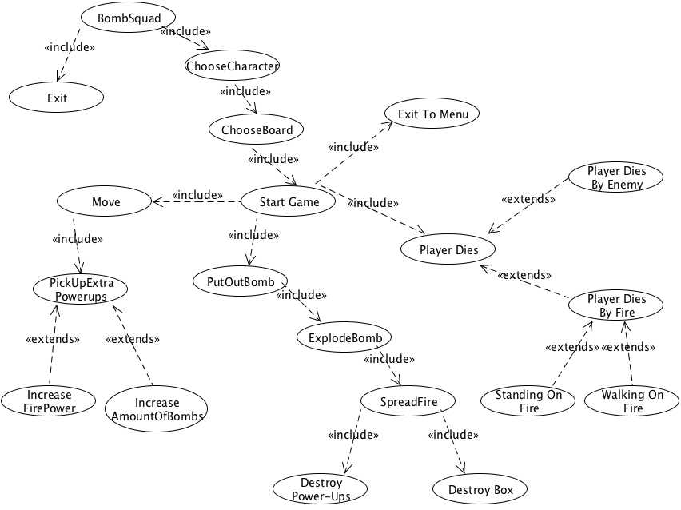
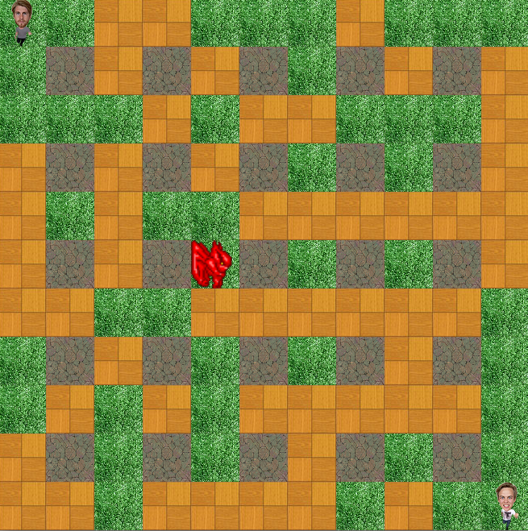
GUI

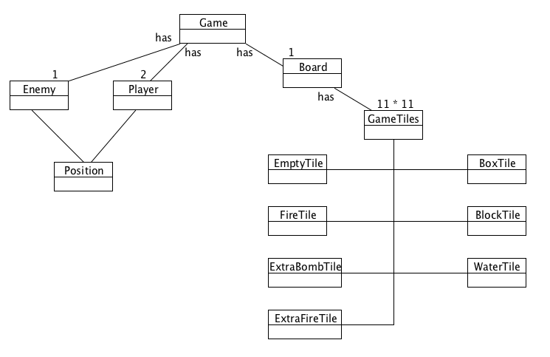
Domain model
Use case
See the Documents map, all use cases is found there.

