System design document for the BombSquad project (SDD)

Contents:
1 Introduction
2 System design
3 Resources
Version: 1.0
Date: 21-05-2012
Authors: Henrik Andersson, Anton Palmqvist, Tomas Selldén och Marcus Thyrén
This version overrides all previous versions.

1 Introduction.
1.1 Design goals
The design must be testable and should be able to isolate parts for test. See RAD for usability.
1.2 Definitions,acronyms and abbreviations
• GUI, graphical user interface.
• Java, platform independent programming language.
• JRE, the Java Run time Environment. Additional software needed to run an Java application.
• Host, a computer where the game will run and the framework Slick 2D.
• Round, one complete game ending in a winner or possible canceled.
• Resources (for players), one bomb and one firepower, the player can pick up extra bombs and extra firepower during the game.
• Power-up, an item the player can pickup to enhance himself.

2 System design
2.1. Overview
We use a framework called Slick 2D. Every GUI class, for example menuGUI and GameGUI uses their own init, render and update method. The init method is called when you start the application and the render and update method is frequently updated by the framework itself during the whole application. The application strives after using a MVC model, but because we are using the framework Slick 2D the view and control part of the MVC pattern are the same classes.
2.1.1 Rules
It´s a multiplayer game but both players are using the same keyboard so you have to stick to your own keys. All other rules are implicit in this game.
2.1.2 The model functionality
The model functionality exists in class Game and is accessible by the GUI and controller class GamePlayState because it has an instance of Game. Game knows the board that consist of different tiles.
2.1.3 Value objects
All tiles have a common interface called GameTile so from the class Game can we invoke methods from gameTile and reach all tiles own implementations, for example if a tile can receive a player or not which is decided by the specific implementation of the “canRecieveFire” that exists in every tile!
2.1.4 Unique identifiers, global look-ups
Identifiers are used when we create and invoke the players. For example the identifiers are used when the user interacts with the keyboard to control a specific player.
2.1.5 Tiles
To have a uniform handling of tiles, all kinds of tiles are kept in an 10 * 10 array. This array is kept in the chosen board and is updated while the game goes on.
2.1.6 Event handling
Many events, state changing or not, can happen during the play (player killed, enemy killed, music/sound started etc.) This requires a flexible event handling. To solve this problem we decided to use an “event-bus” and modify it to fit our needs. All connections of sender/receivers and transmitting of events is handled by the event-bus.
2.2 Software decomposition
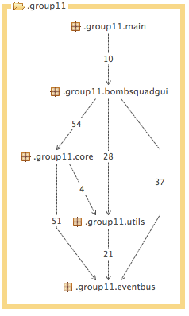
2.2.1 General
The application is decomposed into the following modules
main, is the top level package, it initialize all the states, also it is the applications entry class.
- gui, contains all the states, because of Slick 2D this is also our controller.
- core, all game logic is found here.
- utils, general utilities.
- eventbus, classes related to event handling.
Figure 1

2.2.2 Decompositions into subsystems
There are no subsystems in the project
2.2.3 Dependency analysis
Dependencies are as shown above in the the picture Figure one. There are no circular dependencies between our package.
2.3 Persistent data management
We don´t have any persistent data management
3 References
http://en.wikipedia.org/wiki/Bomberman

