**Emma Prager**

**ITMD 411**

**Lab 02**

**February 28, 2019**

Complete program for Bank of IIT that parses data from bank-Detail.csv, which contains valuable raw data to allow the bank to process loans based on client details from the file.

An abstract class, Client.java, allows for the creation of three abstract methods used by the bank to readData(), processData(), and printData(). BankRecords.java uses the Client abstract methods to generate client records from the csv file. BankRecordsTest.java allows for the testing and output of the parsed information.

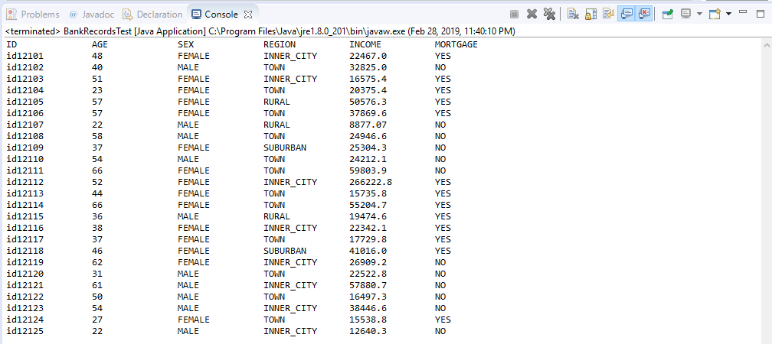

/*

* Emma Prager

* 02/28/2019

* Client.java

* Lab 02

*/

**public** **abstract** **class** Client {

**public** **abstract** **void** readData(); //read file detail

**public** **abstract** **void** processData(); //process file detail

**public** **abstract** **void** printData(); //print file detail

}

/*

* Emma Prager

* 02/28/2019

* BankRecords.java

* Lab 02

*/

**import** java.io.BufferedReader;

**import** java.io.File;

**import** java.io.FileNotFoundException;

**import** java.io.FileReader;

**import** java.io.IOException;

**import** java.util.ArrayList;

**import** java.util.Arrays;

**import** java.util.List;

**public** **class** BankRecords {

**static** BankRecords *robjs* [] = **new** BankRecords[600];

**static** ArrayList<List<String>> *array* = **new** ArrayList<>();

**private** String id;

**private** **int** age;

**private** String sex;

**private** String region;

**private** **double** income;

**private** String married;

**private** **int** children;

**private** String car;

**private** String save_act;

**private** String current_act;

**private** String mortgage;

**private** String pep;

/**

* **@return** the id

*/

**public** String getId() {

**return** id;

}

/**

* **@param** id the id to set

*/

**public** **void** setId(String id) {

**this**.id = id;

}

/**

* **@return** the age

*/

**public** **int** getAge() {

**return** age;

}

/**

* **@param** age the age to set

*/

**public** **void** setAge(**int** age) {

**this**.age = age;

}

/**

* **@return** the sex

*/

**public** String getSex() {

**return** sex;

}

/**

* **@param** sex the sex to set

*/

**public** **void** setSex(String sex) {

**this**.sex = sex;

}

/**

* **@return** the region

*/

**public** String getRegion() {

**return** region;

}

/**

* **@param** region the region to set

*/

**public** **void** setRegion(String region) {

**this**.region = region;

}

/**

* **@return** the income

*/

**public** **double** getIncome() {

**return** income;

}

/**

* **@param** income the income to set

*/

**public** **void** setIncome(**double** income) {

**this**.income = income;

}

/**

* **@return** the married

*/

**public** String getMarried() {

**return** married;

}

/**

* **@param** married the married to set

*/

**public** **void** setMarried(String married) {

**this**.married = married;

}

/**

* **@return** the children

*/

**public** **int** getChildren() {

**return** children;

}

/**

* **@param** children the children to set

*/

**public** **void** setChildren(**int** children) {

**this**.children = children;

}

/**

* **@return** the car

*/

**public** String getCar() {

**return** car;

}

/**

* **@param** car the car to set

*/

**public** **void** setCar(String car) {

**this**.car = car;

}

/**

* **@return** the save_act

*/

**public** String getSave_act() {

**return** save_act;

}

/**

* **@param** save_act the save_act to set

*/

**public** **void** setSave_act(String save_act) {

**this**.save_act = save_act;

}

/**

* **@return** the current_act

*/

**public** String getCurrent_act() {

**return** current_act;

}

/**

* **@param** current_act the current_act to set

*/

**public** **void** setCurrent_act(String current_act) {

**this**.current_act = current_act;

}

/**

* **@return** the mortgage

*/

**public** String getMortgage() {

**return** mortgage;

}

/**

* **@param** mortgage the mortgage to set

*/

**public** **void** setMortgage(String mortgage) {

**this**.mortgage = mortgage;

}

/**

* **@return** the pep

*/

**public** String getPep() {

**return** pep;

}

/**

* **@param** pep the pep to set

*/

**public** **void** setPep(String pep) {

**this**.pep = pep;

}

**public** **void** readData() {

BufferedReader br = **null**;

//initialize reader object and set file path to root of project

**try** {

br = **new** BufferedReader(**new** FileReader(**new** File("bank-Detail.csv")));

} **catch** (FileNotFoundException e2) {

// **TODO** Auto-generated catch block

e2.printStackTrace();

}

String line;

//read each record in csv file

**try** {

**while** ((line = br.readLine()) != **null**) {

//parse each record in csv file by a comma ( , )

//into a list stored in the arraylist-> Arrays

*array*.add(Arrays.*asList*(line.split(",")));

}

} **catch** (IOException e1) {

// **TODO** Auto-generated catch block

e1.printStackTrace();

}

**try** {

br.close();

} **catch** (IOException e) {

// **TODO** Auto-generated catch block

e.printStackTrace();

}

processData(); //call function for processing record data

}

**public** **void** processData() {

//create index for array while iterating thru arraylist

**int** idx=0;

//create for each loop to cycle thru arraylist of values

//and PASS that data into your record objects' setters

**for** (List<String> rowData: *array*) {

//initialize array of objects

*robjs*[idx] = **new** BankRecords();

//call setters below and populate them, item by item

*robjs*[idx].setId(rowData.get(0)); //get 1st column

*robjs*[idx].setAge(Integer.*parseInt*(rowData.get(1))); //get 2nd column

/*continue processing arraylist item values into each

array object-> robjs[ ] by index*/

*robjs*[idx].setSex(rowData.get(2));

*robjs*[idx].setRegion(rowData.get(3));

*robjs*[idx].setIncome(Double.*parseDouble*(rowData.get(4)));

*robjs*[idx].setMarried(rowData.get(5));

*robjs*[idx].setChildren(Integer.*parseInt*(rowData.get(6)));

*robjs*[idx].setCar(rowData.get(7));

*robjs*[idx].setSave_act(rowData.get(8));

*robjs*[idx].setCurrent_act(rowData.get(9));

*robjs*[idx].setMortgage(rowData.get(10));

*robjs*[idx].setPep(rowData.get(11));

idx++;

}

printData(); //call function to print objects held in memory

}

**public** **void** printData() {

//1. Set appropriate headings for displaying first 25 records

//2. Create for loop and print each record objects instance data

//3. Within for loop use appropriate formatting techniques to print

// output record detail

System.***out***.println("ID\t\tAGE\t\tSEX\t\tREGION\t\tINCOME\t\tMORTGAGE");

**int** i = 0;

**for**(i=0; i<25; i++) {

System.***out***.print(*robjs*[i].getId()+"\t\t"+

*robjs*[i].getAge() + "\t\t" +

*robjs*[i].getSex() + "\t\t");

**if**(*robjs*[i].getRegion().contentEquals("TOWN")| *robjs*[i].getRegion().contentEquals("RURAL")){

System.***out***.print(*robjs*[i].getRegion()+ "\t\t");

}

**else** {

System.***out***.print(*robjs*[i].getRegion()+ "\t");

}

String income = "" + *robjs*[i].getIncome();

**if**(income.length() >= 8) {

System.***out***.print(*robjs*[i].getIncome() + "\t");

}

**else** {

System.***out***.print(*robjs*[i].getIncome() + "\t\t");

}

System.***out***.println(*robjs*[i].getMortgage());

}

}

}

/*

* Emma Prager

* 02/28/2019

* BankRecordsTest.java

* Lab 02

*/

**public** **class** BankRecordsTest {

**public** **static** **void** main(String[] args) {

// **TODO** Auto-generated method stub

BankRecords test = **new** BankRecords();

test.readData();

}

}